**<Director> Create Project Use Case Diagram**

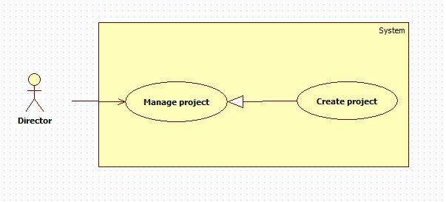

**Figure #: <Director> Create Project Use Case Diagram**

**Use Case Specification**

|  |  |  |  |
| --- | --- | --- | --- |
| **USE CASE -# SPECIFICATION** | | | |
| **Use-case No.** | EPS001 | **Use-case Version** | 2.0 |
| **Use-case Name** | Create Project | | |
| **Author** | Nguyen Huu Phuoc | | |
| **Date** | 19/05/15 | **Priority** | Medium |
| **Actor:**  Director  **Summary:**  This use case allows director to create a new project.  **Goal:**  Create a new project.  **Triggers**   * Director clicks on “Create new project” button on Project screen.   **Preconditions:**   * User must login as Director.   **Post Conditions:**   * **On Success**: New project will be shown in Working Projects table of Project screen. * **On Failure**: Show error message.   **Main Success Scenario:**   |  |  |  | | --- | --- | --- | | Step | Actor Action | System Response | | 1 | Director clicks on “Create new project” button. | Show pop-up for inputting following information:  - “Project Code”: textbox, min length: 3, max length: 5, required.  - “Project Name”: textbox, min length: 5, max length: 50, required.  - “Manager”: drop-down list.  - “Start date”: drop-down calendar, required.  - “End date”: drop-down calendar.  - “Customer”: textbox, min length: 5, max length: 50, required.  - “OK”: button.  - “Cancel”: button | | 2 | Input fields, then clicks on “OK” button. (một step có chấp nhận 2 động từ?)  [Alternative Scenario: 1] | All fields will be added to database and show “Create new project successfully” message.  System will navigate to “Project” screen.  [Exception: 1, 2, 3, 4, 5, 6] |   **Alternative Scenario:**   |  |  |  | | --- | --- | --- | | No | Actor Action | System Response | | 1 | Director clicks “Cancel” button. | Pop-up disappears and nothing change |   **Exceptions:**   |  |  |  | | --- | --- | --- | | No | Actor Action | System Response | | 1 | Length of project code is not in range. | Show error message: “Length of project code must be from 3 to 5 characters!” | | 2 | Director inputs existed project code. | Show error message: “This project code is existed. Try another!” | | 3 | Length of project name is not in range. | Show error message: “Length of project code must be from 5 to 50 characters!” | | 4 | Director inputs existed project name. | Show error message: “This project name is existed. Try another!” | | 5 | Start date is not specified. | Show error message: “You can’t leave this empty!” | | 6 | Length of customer is not in range. | Show error message: “Length of project code must be from 5 to 50 characters!” |   **Relationships:**   * N/A   **Business Rules:**   * In main success scenario, a new project will be added to database. * The manager who has been assigned to new project by director can modify this project. (câu này thuộc use case “edit project” ???) * New project will be shown in Working Projects table of Project screen. * Exception must not be violated. * (có cần lập lại precondition ở đây không?) | | | |