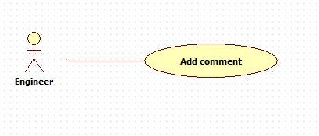

|  |  |  |  |
| --- | --- | --- | --- |
| **USE CASE – 005** | | | |
| **Use Case No.** | **005** | **Use Case Version** | 2.0 |
| **Use Case Name** | Add comment | | |
| **Author** | Nguyen Huu Phuoc | | |
| **Date** | 06/06/2015 | **Priority** | Low |
| **Actor:**   * Engineer, Manager or Director.   **Summary:**   * This use case allows user to add comment into particular knowledge.   **Goal:**   * A new comment is added.   **Triggers:**   * User click “Send” button.   **Preconditions:**   * ~~Guest~~ User logged in as Engineer, Manager or Director.   **Post condition:**   * **Success:** A new comment is added. * **Fail:** show message error.   **Main Success Scenario:**   |  |  |  | | --- | --- | --- | | Step | Actor Action | System Response | | 1 | User clicks on a knowledge on “Knowledge” page. | System opens “Knowledge Details” page:   * “Knowledge content” * “Previous comment” * “Add a new comment”: text-area, min length, max length * “Send” button. | | 2 | User inputs fields then clicks on “Send” button. | System adds a new comment into this knowledge.  [Exception: 1] |   **Alternative:** N/A  **Exception:**   |  |  |  | | --- | --- | --- | | No | Actor Action | System Response | | 1 | The inputted comment is not in range. | Show error message: “Your comment is too short! It should be at least 30 characters.” |   **Relationships:** N/A  **Business Rules:**   * User can add one or many comments. * A comment belongs to particular knowledge. * After adding a comment, user has to wait for 30 second if user wants to add a next comment. * After a comment is added, it’s knowledge will be on top of knowledge list. | | | |