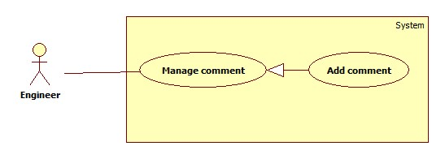

|  |  |  |  |
| --- | --- | --- | --- |
| **USE CASE- SPECIFICATION** | | | |
| **Use-case No.** | OHRM001 | **Use-case Version** | 2.0 |
| **Use-case Name** | Add comment | | |
| **Author** | Nguyen Thi Xuan Mai | | |
| **Date** | 19/05/15 | **Priority** | High |
| **Actor:**   * Engineer, Manager or Director.   **Summary:**   * This use case allows Engineer, Manager or Director to make a comment on “topic knowledge” page.   **Goal:**   * A comment is posted on “topic knowledge” page.   **Triggers**   * Engineer, Manager, Director types a comment on (“New comment” text-area) comment box at “topic knowledge” page.   **Preconditions:**   * User must log in as Engineer, Manager or Director.   **Post Conditions:**   * **On Success**: New comment appears on that topic knowledge * **On Failure**: Show error message.   **Main Success Scenario:**   |  |  |  | | --- | --- | --- | | Step | Actor Action | System Response | | 1 | Engineer, Manager or Director click on a “topic knowledge” link. | Topic knowledge’s details screen are shown:  “Topic knowledge’s details”: text  “Comment”: text-field (area), min length: 50 characters.  “Reply”: button | | 2 | Input comment text-field then click “Reply” button.  [Alternative Scenario: 1]  [Alternative 1] | Show new comment on topic knowledge page.  [Exceptions: 1, 2] |   **Alternative Scenario:**   |  |  |  | | --- | --- | --- | | No | Actor Action | System Response | | 1 | User clicks on “Back” button. | Navigate to “Knowledge” page and there is not new added comment. |   **Exceptions:**   |  |  |  | | --- | --- | --- | | No | Actor Action | System Response | | 1 | User inputs bellow 50 characters | Show error message: “Your comment is too short. It must be at least 50 characters.” | | 2 | User input more than 50000 characters | Show error message: “Your comment is too long. Try again, please.” |   **Relationships:**   * N/A   **Business Rules:**   * Engineer, Manager or Director are only people that can view or make a comment on a knowledge page. * Engineer, Manager or Director can comment many times as they want. * On success scenario, new comment will be added to database. * Exception must not be violated. | | | |