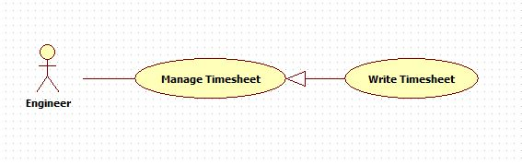

|  |  |  |  |
| --- | --- | --- | --- |
| **USE CASE – 005** | | | |
| **Use Case No.** | **005** | **Use Case Version** | 2.0 |
| **Use Case Name** | Write timesheet | | |
| **Author** | Nguyen Huu Phuoc | | |
| **Date** | 02/06/2015 | **Priority** | Low |
| **Actor:**   * Engineer, Manager   **Summary:**   * This use case allows engineer to write timesheets.   **Goal:**   * A new timesheet is added.   **Triggers:**   * Engineer adds timesheet.   **Preconditions:**   * Guest logged in as Engineer, Manager.   **Post condition:**   * **Success:** A new timesheet is added. * **Fail:** show message error.   **Main Success Scenario:**   |  |  |  | | --- | --- | --- | | Step | Actor Action | System Response | | 1 | Engineer clicks on “Timesheet” tab on navigation bar. | System opens “Timesheet” page:   * “Engineer Name”: label, shows engineer’s name who is logging in system. * “Project Code”: drop-down list, shows list of projects which this engineer is working, required. * “Date”: date-picker, required. * “Time”: text-box, required. * “hours”: label. * “Description”: text-area, min length: 30 characters, max length: 550 characters, required. * “Add Timesheet”: button. * “Reset”: button. * Data table shows list of rejected and pending timesheets. | | 2 | Engineer inputs fields then clicks on “Add Timesheet” button.  [Alternative 1] | * A new timesheet will be added to database. * System shows “Add timesheet successfully” message. * System reloads “Timesheet” page, a new timesheet will be add to data table with pending status.   [Exception: 1,2,3,4,5,6] |   **Alternative:**   |  |  |  | | --- | --- | --- | | No | Actor Action | System Response | | 1 | Engineer clicks on “Reset” button. | All fields will be clear. |   **Exception:**   |  |  |  | | --- | --- | --- | | No | Actor Action | System Response | | 1 | Engineer doesn’t choose “Project Code”. | Show error message: “You have to choose a project!” | | 2 | Engineer doesn’t choose “Date”. | Show error message: “You have to choose a date” | | 3 | Inputting “Time” text-box is not in range. | Show error message: “Time is from 0.5 to 8 hours a day” | | 4 | Engineer leaves “Time” text-box empty. | Show error message: “Time is from 0.5 to 8 hours a day” | | 5 | Length of “Description” text-area is not in range. | Show error message: “Description has to be from 30 to 550 characters.” | | 6 | Engineer leaves “Description” text-area empty. | Show error message: “You can not leave this field empty!” |   **Relationships:** N/A  **Business Rules:**   * An engineer can write one or ~~more~~ many timesheets. * The status of new timesheet is always “pending”. * One timesheet belongs to one engineer. Engineer can not write timesheet for others. * One timesheet describes working of one engineer in particular project. * Total timesheet time for a day can be lager than 8 hours. Time out of working-time day is called OT (overtime). | | | |