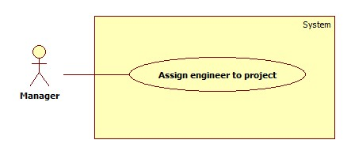

|  |  |  |  |
| --- | --- | --- | --- |
| **USE CASE -1 SPECIFICATION** | | | |
| **Use-case No.** | OHRM | **Use-case Version** | 2.0 |
| **Use-case Name** | Assign engineer to project | | |
| **Author** | Le Minh Hoang | | |
| **Date** | 19/05/15 | **Priority** | High |
| **Actor:**  Manager, Director  **Summary:**  This use case allows Manager, Director to assign engineer to a specific project.  **Goal:**  Assign engineers to project.  **Triggers**   * Click on “Select engineers” function.   **Preconditions:**   * User log in as Manager or Director.   **Post Conditions:**   * **On Success**: Engineer name is added to project. * **On Failure**: Show error message.   **Main Success Scenario:**   |  |  |  | | --- | --- | --- | | Step | Actor Action | System Response | | 1 | Clicks on “Assign engineer” button on “Project” screen. | System navigates to “Assign engineer” screen. | | 2 | Clicks on “Select engineers” button | System opens popup:   * Data of engineers: name, skills, interests, current projects, end date. * Check-boxes aside each Data of engineer to select the engineer. * “Assign” button. * “Cancel” button. | | 3 | Clicks on check-boxes then clicks “Assign” button.  [Alternative 1] | Update new information into database, popup disappear, new information update on “Assign engineer” screen. |   **Alternative Scenario:**   |  |  |  | | --- | --- | --- | | No | Actor Action | System Response | | 1 | Clicks on “Cancel” button. | Popup disappears and nothing change. |   **Exceptions:**   * N/A   **Relationships:**   * N/A   **Business Rules:**   * “Current projects” cell belongs to “Data of engineers” table will list all projects that an engineer is working on. “End date” cell will list all end date that according with those projects. * Only Manager assigned to current project or Director can see “Assign engineer” button. * Assigned engineers rows have gray color, assign accepted engineers row have green color, assign decline engineers row have red color. * The engineers that are more suitable will be at the top of the list. | | | |