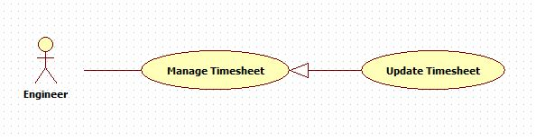

|  |  |  |  |
| --- | --- | --- | --- |
| **USE CASE – 005** | | | |
| **Use Case No.** | **005** | **Use Case Version** | 1.0 |
| **Use Case Name** | Delete timesheet | | |
| **Author** | Nguyen Huu Phuoc | | |
| **Date** | 02/06/2015 | **Priority** | Low |
| **Actor:**   * Engineer   **Summary:**   * This use case allows engineer to delete timesheet.   **Goal:**   * A selected timesheet is deleted.   **Triggers:**   * Engineer deletes timesheet.   **Preconditions:**   * Guest logged in as Engineer.   **Post condition:**   * **Success:** the selected timesheet is deleted. * **Fail:** show message error.   **Main Success Scenario:**   |  |  |  | | --- | --- | --- | | Step | Actor Action | System Response | | 1 | Engineer clicks on “Delete” link of timesheet that he/she wants to delete on timesheet table of “Timesheet” page. | * System shows confirmation pop-up: “Are you sure you want to delete this timesheet?” * “OK”: button * “Cancel”: button | | 2 | Engineer clicks on “OK” button.  [Alternative 1] | * System closes confirmation pop-up. * The data of selected timesheet will be deleted in database. * System will reload “Timesheet” page.   The deleted timesheet will not be shown on timesheet table any more. |   **Alternative:**   |  |  |  | | --- | --- | --- | | No | Actor Action | System Response | | 1 | Engineer clicks on “Cancel” button. | * System closes confirmation pop-up. * The selected timesheet will not be deleted. |   **Exception:** N/A  **Relationships:** N/A  **Business Rules:**   * Engineer can delete one or more timesheets. * Engineer just deletes one timesheet at a time. * Engineer just deletes timesheet with “pending” or “reject” status. * Engineer just deletes his/her timesheet on timesheet table. | | | |