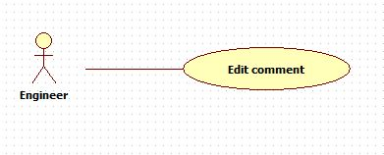

|  |  |  |  |
| --- | --- | --- | --- |
| **USE CASE – 005** | | | |
| **Use Case No.** | **005** | **Use Case Version** | 2.0 |
| **Use Case Name** | Edit comment | | |
| **Author** | Nguyen Huu Phuoc | | |
| **Date** | 06/06/2015 | **Priority** | Low |
| **Actor:**   * Engineer, Manager or Director.   **Summary:**   * This use case allows user to edit comment of particular knowledge.   **Goal:**   * The selected comment is edited.   **Triggers:**   * User click “Edit” button.   **Preconditions:**   * Guest logged in as Engineer, Manager or Director.   **Post condition:**   * **Success:** The selected comment is edited. * **Fail:** show message error.   **Main Success Scenario:**   |  |  |  | | --- | --- | --- | | Step | Actor Action | System Response | | 1 | User clicks on “Edit” button of particular comment on what screen? | System loads the selected comment to text-area.  Nút cancel đâu? | | 2 | User changes the content of comment then click “Send” button.  [Alternative: 1] | System updates the content of comment.  [Exception: 1] |   **Alternative:**   |  |  |  | | --- | --- | --- | | No | Actor Action | System Response | | 1 | User press “esc” key on keyboard. | System clear text-area. Nothing changes. |   **Exception:**   |  |  |  | | --- | --- | --- | | No | Actor Action | System Response | | 1 | The inputted comment is not in range. | Show error message: “Your comment is too short! It should be at least 30 characters.” |   **Relationships:** N/A  **Business Rules:**   * Users can only edit their comments. * Knowledge closed rồi thì có được edit comment ko? * ~~Users can edit one or many comments.~~ | | | |