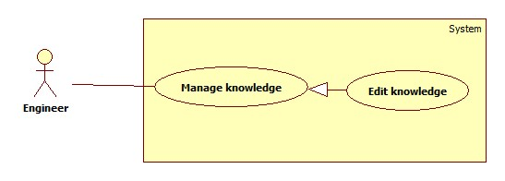

|  |  |  |  |
| --- | --- | --- | --- |
| **USE CASE -1 SPECIFICATION** | | | |
| **Use-case No.** | OHRM | **Use-case Version** | 2.0 |
| **Use-case Name** | Edit Knowledge | | |
| **Author** | Nguyen Thi Xuan Mai | | |
| **Date** | 19/05/15 | **Priority** | High |
| **Actor:**  Engineer, Manager, Director  **Summary:**  This use case allows Engineer, Manager or Director to edit their topic knowledge.  **Goal:**  Edit topic knowledge.  **Triggers**   * Manager chooses topic knowledge to edit.   **Preconditions:**   * User log in as Engineer, Manager, Director.   **Post Conditions:**   * **On Success**: Topic knowledge will be edited with new information. * **On Failure**: Show error message.   **Main Success Scenario:**   |  |  |  | | --- | --- | --- | | Step | Actor Action | System Response | | 1 | Click “Knowledge” on navigation bar. | Navigate to “Knowledge” page to view a list of knowledge.  “The list of knowledge”: are shown for Engineer, Manager or Director. | | 2 | Engineer, Manager or Director click on their topic knowledge. | Topic knowledge’s details are shown.  “Back” button Alternative[1] | | 3 | Input new information for fields. | System validates inputted values. | | 4 | Click on “Submit” button. | Topic knowledge will be edit to database and a message will be shown: “You have successfully edit topic knowledge”.  [Exception 1, 2, 3] |   **Alternative Scenario:**   |  |  |  | | --- | --- | --- | | No | Actor Action | System Response | | 1 | Engineer, Manager and Director click on “back” button. | Navigate to “Knowledge” page |   **Exceptions:**   |  |  |  | | --- | --- | --- | | No | Actor Action | System Response | | 1 | Fields are blank | Show error message: "Fields can’t be empty!" | | 2 | Input wrong format. | Show error message: “…..” |   **Relationships:**   * N/A   **Business Rules:**   * Topic knowledge can only be edited by who created it. * Only Engineer, Manager, Director can edit their own topic knowledge. * Exception must not violated | | | |