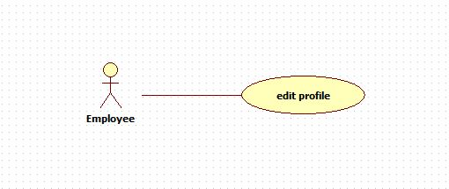

|  |  |  |  |
| --- | --- | --- | --- |
| **USE CASE – 005** | | | |
| **Use Case No.** | **005** | **Use Case Version** | 2.0 |
| **Use Case Name** | Edit profile | | |
| **Author** | Nguyen Huu Phuoc | | |
| **Date** | 06/06/2015 | **Priority** | Low |
| **Actor:**   * Engineer, Manager, Director, Admin, Customer and HR.   **Summary:**   * This use case allows user to edit profile.   **Goal:**   * User’s profile is changed.   **Triggers:**   * User click “Profile” link.   **Preconditions:**   * Guest logged in as Engineer, Manager, Director, Admin, Customer or HR.   **Post condition:**   * **Success:** User’s profile is changed. * **Fail:** show message error.   **Main Success Scenario:**   |  |  |  | | --- | --- | --- | | Step | Actor Action | System Response | | 1 | User clicks on “Profile” link on user drop bar. | System opens “Employee profile” page with following fields:   * “Employee name”: text-box, disable. * “Current password”: text-box, min length 6 characters, max length 10 characters. * “New password”: text-box, min length 6 characters, max length 10 characters. * “Confirm password”: text-box, min length 6 characters, max length 10 characters. * “Sex”: text-box, disable. * “Birthday”: date-picker * “Phone”: text-box. * “Email”: text-box * “Company”: text-box. * “Address”: text-box. | | 2 | User inputs fields then clicks on “Save” button.  [Alternative 1] | * System checks validation. * System updates employee’s information. * System reloads “Employee profile” page with new information.   [Exception: 1,2,3] |   **Alternative:**   |  |  |  | | --- | --- | --- | | No | Actor Action | System Response | | 1 | User clicks on “Save” button without inputting fields. | Current information of employee is not changed |   **Exception:**   |  |  |  | | --- | --- | --- | | No | Actor Action | System Response | | 1 | “Current password” is not valid. | Show error message: “Current password is not correct!” | | 2 | “New password”: is not in range | Show error message: “Password has to be from 6 to 10 characters” | | 3 | “Confirm password”: does not match to “New password” | Show error message: “Confirm password is not valid” |   **Relationships:** N/A  **Business Rules:**   * Engineer can not change name and sex. | | | |