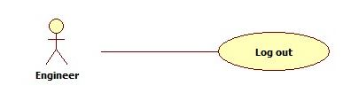

(Cái hình dùng actor nào thì chính xác, ko lẽ lôi hết các actor vao)

|  |  |  |  |
| --- | --- | --- | --- |
| **USE CASE – 005** | | | |
| **Use Case No.** | **005** | **Use Case Version** | 2.0 |
| **Use Case Name** | Logout | | |
| **Author** | Nguyen Huu Phuoc | | |
| **Date** | 05/06/2015 | **Priority** | Low |
| **Actor:**   * Engineer, Manager, Director, Admin, Customer and HR.   **Summary:**   * This use case allows all users of system log out of system.   **Goal:**   * Log out of system.   **Triggers:**   * User click “Log out” link.   **Preconditions:**   * Guest logged in as Engineer, Manager, Director, Admin, Customer or HR.   **Post condition:**   * **Success:** log out of system, back to “login” page. * **Fail:** show message error.   **Main Success Scenario:**   |  |  |  | | --- | --- | --- | | Step | Actor Action | System Response | | 1 | User clicks on “Log out” link on ????? | System clears session then navigate to “login” page. |   **Alternative:** N/A  **Exception:** N/A  **Relationships:** N/A  **Business Rules:** N/A | | | |