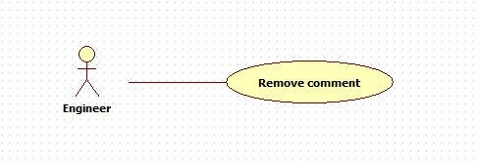

|  |  |  |  |
| --- | --- | --- | --- |
| **USE CASE – 005** | | | |
| **Use Case No.** | **005** | **Use Case Version** | 2.0 |
| **Use Case Name** | Remove comment | | |
| **Author** | Nguyen Huu Phuoc | | |
| **Date** | 06/06/2015 | **Priority** | Low |
| **Actor:**   * Engineer, Manager or Director.   **Summary:**   * This use case allows user to remove comment into particular knowledge.   **Goal:**   * The selected comment is removed.   **Triggers:**   * User click “Remove” button.   **Preconditions:**   * Guest logged in as Engineer, Manager or Director.   **Post condition:**   * **Success:** The selected comment is deleted. * **Fail:** show message error.   **Main Success Scenario:**   |  |  |  | | --- | --- | --- | | Step | Actor Action | System Response | | 1 | User clicks on “Remove” button of particular comment. | System shows confirm pop up:   * “OK”: button * “Cancel”: button | | 2 | User clicks on “OK” button  [Alternative: 1] | System removes this comment. |   **Alternative:**   |  |  |  | | --- | --- | --- | | No | Actor Action | System Response | | 1 | User clicks on “Cancel” button. | System closes pop up and nothing changes. |   **Exception:** N/A  **Relationships:** N/A  **Business Rules:**   * Users can only remove their comments. * Users can remove one or many comments. * Who has created the knowledge can remove every comments of his/her knowledge. * User can remove comments of close knowledge. * The removed comment can not be restored. | | | |