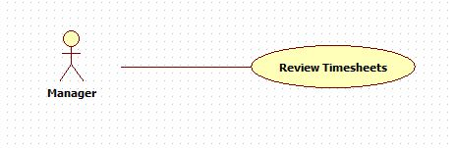

|  |  |  |  |
| --- | --- | --- | --- |
| **USE CASE – 005** | | | |
| **Use Case No.** | **005** | **Use Case Version** | 2.0 |
| **Use Case Name** | Review timesheets | | |
| **Author** | Nguyen Huu Phuoc | | |
| **Date** | 05/06/2015 | **Priority** | Low |
| **Actor:**   * Manager, Director   **Summary:**   * This use case allows user to review engineer’s timesheets.   **Goal:**   * User can approve or reject engineer’s timesheets.   **Triggers:**   * User clicks “Approve” or “Reject” button of timesheet’s row on timesheet table.   **Preconditions:**   * User logged in as Manager, Director.   **Post condition:**   * **Success:** the selected timesheet is approved or rejected. * **Fail:** show message error.   **Main Success Scenario:**   |  |  |  | | --- | --- | --- | | Step | Actor Action | System Response | | 1 | User clicks on “Timesheet” tab on navigation bar. | System opens “Review timesheets” page:   * Timesheet table includes columns: “No.”, “Engineer Name”, “Date”, “Description”, “Time”, “Project Code”, “Status”, “Action” * “Action” column has “Approve” and “Reject” buttons. | | 2 | User clicks on “Approve” button of a timesheet row on timesheet table.  [Alternative Scenario: 1] | System changes status of the selected timesheet to “Approve”. |   **Alternative:** N/A   |  |  |  | | --- | --- | --- | | No | Actor Action | System Response | | 1 | User clicks on “Reject” button of a timesheet row on timesheet table. | System changes status of the selected timesheet to “Reject”. |   **Exception:** N/A  **Relationships:** N/A  **Business Rules:**   * Manager can only review engineer’s timesheets which belong to his projects. * Manager can review his own timesheets. * The approved timesheet can not be modified. * Manager can sort timesheet table by all columns. * One timesheet can be reviewed many times. | | | |