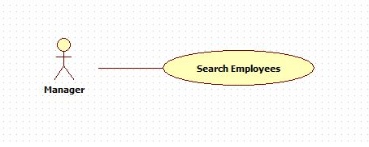

|  |  |  |  |
| --- | --- | --- | --- |
| **USE CASE – 005** | | | |
| **Use Case No.** | **005** | **Use Case Version** | 2.0 |
| **Use Case Name** | Search Employees | | |
| **Author** | Nguyen Huu Phuoc | | |
| **Date** | 05/06/2015 | **Priority** | Low |
| **Actor:**   * Manager, Director.   **Summary:**   * This use case allows user to search employees.   **Goal:**   * Searched employee is shown.   **Triggers:**   * User clicks on “Search” button on “Search Employee” page.   **Preconditions:**   * User logged in as Manager or Director.   **Post condition:**   * **Success:** searching result table is shown. * **Fail:** show error message.   **Main Success Scenario:**   |  |  |  | | --- | --- | --- | | Step | Actor Action | System Response | | 1 | User clicks on “EMPLOYEE” tab on navigation bar. | System opens “Search employee” page:   * “Employee name”: text-box, min length, max length. * “Search employee”: button | | 2 | User types in “Employee name” text-box then click “Search employee” button | System searches all employee with name likes inputted then shows in Employee table.  Employee table includes: “No.”, “Name”, “Role”, “Birthday”, “Mail” and “Phone” columns.  [Alternative 1] |   **Alternative:**   |  |  |  | | --- | --- | --- | | No | Actor Action | System Response | | 1 | No result is found. | System shows message “No record is matching” |   **Exception:** N/A  **Relationships:** N/A  **Business Rules:**   * User can only search like employee’s name. * Kết quả chỉ ra những employee active | | | |