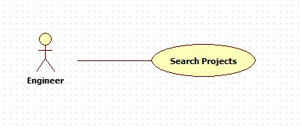

|  |  |  |  |
| --- | --- | --- | --- |
| **USE CASE – 005** | | | |
| **Use Case No.** | **005** | **Use Case Version** | 2.0 |
| **Use Case Name** | Search Projects | | |
| **Author** | Nguyen Huu Phuoc | | |
| **Date** | 06/06/2015 | **Priority** | Low |
| **Actor:**   * Engineer, Manager or Director.   **Summary:**   * This use case allows user to search projects.   **Goal:**   * Searching project is shown.   **Triggers:**   * User click “Search” button.   **Preconditions:**   * Guest logged in as Engineer, Manager or Director.   **Post condition:**   * **Success:** Searching projects is shown. * **Fail:** show message error.   **Main Success Scenario:**   |  |  |  | | --- | --- | --- | | Step | Actor Action | System Response | | 1 | User clicks on “PROJECT” tab on navigation bar. | System opens “List All Projects” page:   * “Project Name”: text-box * “in Year”: drop-down list * “Search”: button. | | 2 | User inputs fields then clicks on “Search” button.  [Alternative 1] | System searches project base on inputted fields then show searching result in project tables.  [Exception 1] |   **Alternative:** N/A  **Exception:**   |  |  |  | | --- | --- | --- | | No | Actor Action | System Response | | 1 | There is no marching result. | Show error message: “There is not marching projects!” |   **Relationships:** N/A  **Business Rules:**   * User can search project by project’s name and period time that those projects are running. * Engineers can only search projects which they have joined. * Managers or Director can search every projects. | | | |