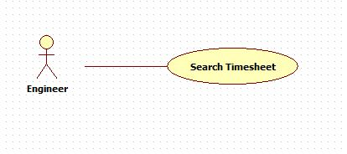

|  |  |  |  |
| --- | --- | --- | --- |
| **USE CASE – 005** | | | |
| **Use Case No.** | **005** | **Use Case Version** | 2.0 |
| **Use Case Name** | Search timesheet | | |
| **Author** | Nguyen Huu Phuoc | | |
| **Date** | 06/06/2015 | **Priority** | Low |
| **Actor:**   * Engineer, Manager, Driector.   **Summary:**   * This use case allows engineer to search timesheets.   **Goal:**   * Searching result timesheet is shown.   **Triggers:**   * User click “Search” button.   **Preconditions:**   * Guest logged in as Engineer, Manager or Director.   **Post condition:**   * **Success:** Searching result timesheet is shown. * **Fail:** show message error.   **Main Success Scenario:**   |  |  |  | | --- | --- | --- | | Step | Actor Action | System Response | | 1 | User clicks on “View all timesheet” tab on timesheet page. | System opens “View all timesheet” tab-content with following fields:   * “Date”: date-picker * “Search”: button | | 2 | User selects date and clicks on “Search” button  [Alternative: 1] | * System searchs timesheet of searching date and shows in timesheet table. * [Exception: 1] |   **Alternative:**   |  |  |  | | --- | --- | --- | | No | Actor Action | System Response | | 1 | User clicks on “Search” button without select a day. | System shows message: “Please select a day!” |   **Exception:**   |  |  |  | | --- | --- | --- | | No | Actor Action | System Response | | 1 | There is not timesheet in the searching day | Show error message: “There is not timesheet in this day” |   **Relationships:** N/A  **Business Rules:**   * Engineer can only search his/her timesheets on searching day. * Manager can only search engineer’s timesheets of his/her projects on searching day. * Director can search all engineer’s timesheets. | | | |