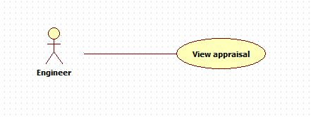

|  |  |  |  |
| --- | --- | --- | --- |
| **USE CASE – 005** | | | |
| **Use Case No.** | **005** | **Use Case Version** | 2.0 |
| **Use Case Name** | View appraisal | | |
| **Author** | Nguyen Huu Phuoc | | |
| **Date** | 06/06/2015 | **Priority** | Low |
| **Actor:**   * Engineer, Manager or Director.   **Summary:**   * This use case allows user to view appraisal.   **Goal:**   * The appraisal result is shown.   **Triggers:**   * ……..   **Preconditions:**   * Guest logged in as Engineer, Manager or Director.   **Post condition:**   * **Success:** The appraisal result is shown. * **Fail:** show message error.   **Main Success Scenario:**   |  |  |  | | --- | --- | --- | | Step | Actor Action | System Response | | 1 | User clicks on “View Appraisal Result” button. | System opens “Appraisal Result” pop up contents following information: “No.”, “Criterion”, “Point”, “Average point” and “OK” button. | | 2 | User clicks on “OK” button | System close “Appraisal Result” pop up. |   **Alternative:** N/A  **Exception:**  **Relationships:** N/A  **Business Rules:**   * User can only view his/her appraisal. * Không phải là User mà là engineer. * Manager/Director được tùy thích coi thế nào cũng được * User can only view his/her appraisal after manager appraised. * One appraisal belongs to one project. | | | |