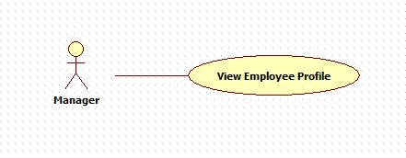

|  |  |  |  |
| --- | --- | --- | --- |
| **USE CASE – 005** | | | |
| **Use Case No.** | **005** | **Use Case Version** | 2.0 |
| **Use Case Name** | View Employee Profile | | |
| **Author** | Nguyen Huu Phuoc | | |
| **Date** | 05/06/2015 | **Priority** | Low |
| **Actor:**   * Manager, Director.   **Summary:**   * This use case allows user to view employee profile.   **Goal:**   * User can view employee profile details.   **Triggers:**   * User clicks on employee’s name on employee table.   **Preconditions:**   * User logged in as Manager or Director.   **Post condition:**   * **Success:** Employee’s profile is shown. * **Fail:** show error message.   **Main Success Scenario:**   |  |  |  | | --- | --- | --- | | Step | Actor Action | System Response | | 1 | User clicks on employee’s name on employee table. | System opens pop up which contains following information:   * Employee name: label * ID: label * Project: label * Role: label * Sex: male * Phone: label * Email: label * Skill: lable |   **Alternative:** N/A  **Exception:** N/A  **Relationships:** N/A  **Business Rules:**   * User can view profile of all employees. | | | |