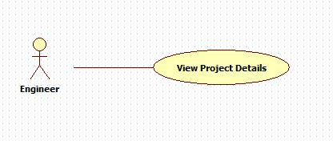

|  |  |  |  |
| --- | --- | --- | --- |
| **USE CASE – 005** | | | |
| **Use Case No.** | **005** | **Use Case Version** | 2.0 |
| **Use Case Name** | View Project Details | | |
| **Author** | Nguyen Huu Phuoc | | |
| **Date** | 05/06/2015 | **Priority** | Low |
| **Actor:**   * Engineer, Manager or Director.   **Summary:**   * This use case allows user to view employee profile.   **Goal:**   * User can view project details.   **Triggers:**   * User clicks on project’s name on project table.   **Preconditions:**   * User logged in as Engineer, Manager or Director.   **Post condition:**   * **Success:** Project detail is shown. * **Fail:** show error message.   **Main Success Scenario:**   |  |  |  | | --- | --- | --- | | Step | Actor Action | System Response | | 1 | User clicks on project’s name on project table. | System opens “Project Details” page:   * “Info: tab contents project name, project code, start date, end date, manager, customer, skill, status and “Edit” button. * “Feedback”” tab contents feedback details of this project’s customer. * “Appraisal”: tab contents information about appraising project’s engineers. * “Knowledge”: tab contents knowledge of this project. |   **Alternative:** N/A  **Exception:** N/A  **Relationships:** N/A  **Business Rules:**   * Engineer can not see “Appraisal” tab and “Edit” button on “Info” tab. * Different statuses have different colors. * If status is new, project detail will be only enable with director. * If status is working, “Appraisal” and “Feedback” tab are disable with engineer, manager and director. * If status is done or close, “Member” tab is disable. | | | |