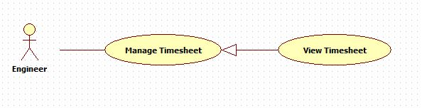

|  |  |  |  |
| --- | --- | --- | --- |
| **USE CASE – 005** | | | |
| **Use Case No.** | **005** | **Use Case Version** | 1.0 |
| **Use Case Name** | View timesheet | | |
| **Author** | Nguyen Huu Phuoc | | |
| **Date** | 02/06/2015 | **Priority** | Low |
| **Actor:**   * Engineer   **Summary:**   * This use case allows engineer to view all his/her timesheet.   **Goal:**   * Engineer can view all his/her timesheet.   **Triggers:**   * Engineer click “View all timesheet” tab.   **Preconditions:**   * Guest logged in as Engineer.   **Post condition:**   * **Success:** list of all timesheets is shown. * **Fail:** N/A   **Main Success Scenario:**   |  |  |  | | --- | --- | --- | | Step | Actor Action | System Response | | 1 | Engineer clicks on “View all timesheet” tab on “Timesheet” page. | System opens “View all timesheet” page:   * Timesheet table includes columns: “No.”, “Date”, “Description”, “Time”, “Project Code”, “Reviewer”, “Status” * Engineer can sort timesheet list by date, time, project code or status. |   **Alternative:** N/A  **Exception:** N/A  **Relationships:** N/A  **Business Rules:**   * List of timesheets is already sorted by status. The first priority is reject. The second is pending. The final is approve. * System just shows list of timesheets which belongs to running projects. | | | |