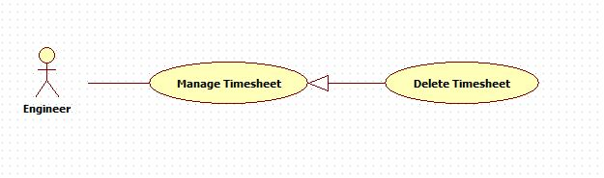

|  |  |  |  |
| --- | --- | --- | --- |
| **USE CASE -5 SPECIFICATION** | | | |
| **Use Case No.** | OHRM005 | **Use Case Version** | 2.0 |
| **Use Case Name** | Remove timesheet | | |
| **Author** | Nguyen Huu Phuoc | | |
| **Date** | 02/06/2015 | **Priority** | Low |
| **Actor:**   * Engineer, Manager.   **Summary:**   * This use case allows user to delete timesheet.   **Goal:**   * A selected timesheet is deleted from current screen.   **Triggers:**   * User clicks “Delete” ~~link~~ button on timesheet table.   **Preconditions:**   * User logged in as Engineer, Manager’s role.   **Post condition:**   * **Success:** the selected timesheet is deleted from ~~database~~ system. * **Fail:** show message error.   **Main Success Scenario:**   |  |  |  | | --- | --- | --- | | Step | Actor Action | System Response | | 1 | User clicks on “Delete” ~~link~~ button of timesheet that he/she wants to delete on timesheet table of “Timesheet” ~~page~~ screen. | System shows confirmation pop-up: “Are you sure you want to delete this timesheet?”   * “OK”: button * “Cancel”: button | | 2 | User clicks on “OK” button.  [Alternative 1] | System closes confirmation pop-up.  The data of selected timesheet will be deleted in ~~database~~ system.  System ~~will~~ reload “Timesheet” ~~page~~ screen.  The deleted timesheet ~~will not be shown on timesheet table any more~~ disappears from timesheet table. |   **Alternative:**   |  |  |  | | --- | --- | --- | | No | Actor Action | System Response | | 1 | User clicks on “Cancel” button. | System closes confirmation pop-up.  ~~The selected timesheet will not be deleted.~~ Nothing changes. |   **Exception:** N/A  **Relationships:** N/A  **Business Rules:**   * ~~User can delete one or more timesheets.~~ * ~~User just deletes one timesheet at a time~~. * User only can delete timesheet which has ~~with~~ “pending” or “rejected” status. * User just deletes his/her timesheets on timesheet table. | | | |