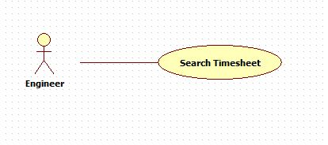

|  |  |  |  |
| --- | --- | --- | --- |
| **USE CASE -2 SPECIFICATION** | | | |
| **Use Case No.** | OHRM002 | **Use Case Version** | 2.0 |
| **Use Case Name** | Search timesheet | | |
| **Author** | Nguyen Huu Phuoc | | |
| **Date** | 06/06/2015 | **Priority** | Low |
| **Actor:**   * Engineer, Manager, Director.   **Summary:**   * This use case allows engineer to search timesheets in specific date.   **Goal:**   * Searching result timesheet is shown.   **Triggers:**   * User clicks “Search” button.   **Preconditions:**   * ~~Guest~~ User logged in as Engineer, Manager or Director.   **Post condition:**   * **Success:** Searching result timesheet is shown. * **Fail:** show message error.   **Main Success Scenario:**   |  |  |  | | --- | --- | --- | | Step | Actor Action | System Response | | 1 | User clicks on “View all timesheet” tab on timesheet page. | System opens “View all timesheet” tab-content with following fields:   * “Date”: date-picker. * “Search”: button. | | 2 | User selects date and clicks on “Search” button.  [Alternative 1] | ~~System searches timesheet of searching date and shows in timesheet table.~~  (timesheet thieu s)  (System shows all timesheets of that user on searching date)  [Exception 1] |   **Alternative:**   |  |  |  | | --- | --- | --- | | No | Actor Action | System Response | | 1 | ~~User clicks on “Search” button without select a day.~~ | ~~System shows message: “Please select a day!”~~ |   **Exception:**   |  |  |  | | --- | --- | --- | | No | Actor Action | System Response | | 1 | There is no timesheet in the searching day. | Show error message: “There is no timesheet in this day” |   **Relationships:** N/A  **Business Rules:**   * Engineer can only search his/her timesheets on searching day. * ~~Manager can only search engineer’s timesheets of his/her projects on searching day.~~ * Manager can search his own timesheets and his project’s engineer’s timesheets on searching day. * Director can search all engineer’s timesheets. | | | |