MODULAR GAME DESIGN DOCUMENT

BROKEN HORIZON
MODULE INDEX
  - Separable specifications for a cooperative multiplayer persistent-war FPS
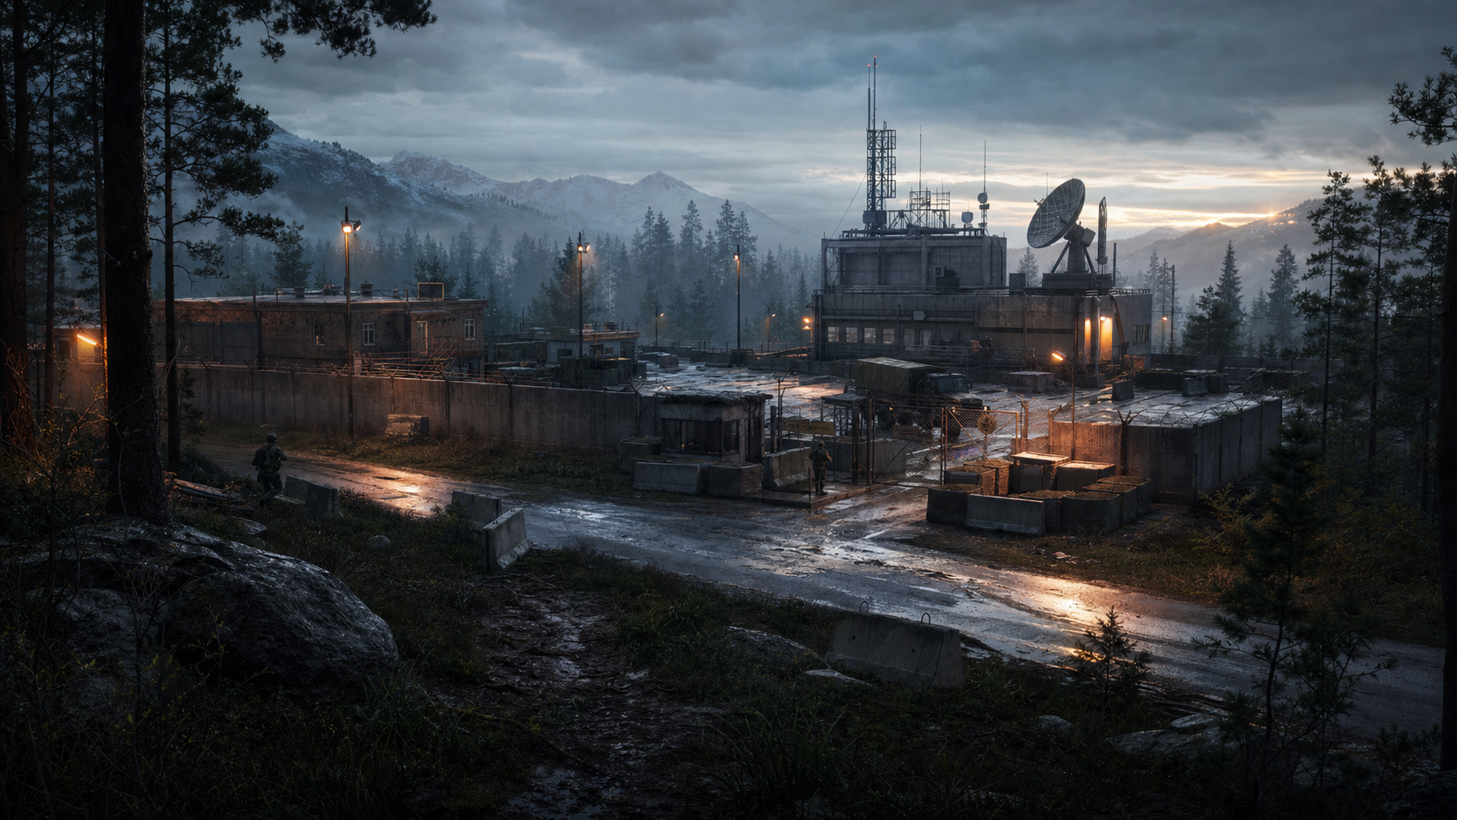

How to Use This Suite
- Start with GDD-00 and GDD-01 for product intent; assign later modules by discipline.
- A module owns only the decisions listed in its Publishes field.
- Dependencies are read-only inputs. If a dependent rule changes, update the owner module and review all consumers.
- GDD-13 centralizes numeric baselines and canonical IDs so other modules reference rather than duplicate contracts.
- The original integrated GDD remains the narrative reference; this suite is the production-control form.

Module Register
ID | Module | Owner | Depends on | File
GDD-00 | Product Foundation and Design Status | Creative Director / Design Lead | None | GDD-00_Product_Foundation.docx
GDD-01 | Vision, Pillars, and Player Fantasy | Creative Director | GDD-00 | GDD-01_Vision_and_Player_Fantasy.docx
GDD-02 | Multiplayer Session, Core Loop, and Campaign | Lead Game Designer / Network Lead | GDD-00, GDD-01 | GDD-02_Multiplayer_and_Campaign_Loop.docx
GDD-03 | Player Controls, Movement, Interaction, and Combat | Player Systems Designer | GDD-01, GDD-02 | GDD-03_Player_Combat.docx
GDD-04 | Health, Injuries, Equipment, and Field Logistics | Combat / Economy Designer | GDD-02, GDD-03 | GDD-04_Health_Equipment_Logistics.docx
GDD-05 | AI, Factions, Morale, and Tactical Command | AI Designer / AI Engineer | GDD-02, GDD-03, GDD-04 | GDD-05_AI_and_Tactical_Command.docx
GDD-06 | Mission Framework and Operation First Light | Mission Design Lead | GDD-02 through GDD-05 | GDD-06_Missions_and_First_Light.docx
GDD-07 | Persistent War, Sectors, Routes, and Strategic Map | Systems Design Lead | GDD-02, GDD-04, GDD-06 | GDD-07_Persistent_War.docx
GDD-08 | World, Level, Art, and Audio Direction | World Director / Art Director / Audio Director | GDD-01, GDD-03, GDD-05, GDD-06 | GDD-08_World_Art_Audio.docx
GDD-09 | UI/UX, Onboarding, Accessibility, and Settings | UX Lead | GDD-02 through GDD-08 | GDD-09_UI_UX_Accessibility.docx
GDD-10 | Progression, Difficulty, Economy, and Balance | Systems / Economy Designer | GDD-02 through GDD-07, GDD-09 | GDD-10_Progression_and_Balance.docx
GDD-11 | Technical Architecture, Content Pipeline, Analytics, and QA | Technical Director / QA Lead | All design modules | GDD-11_Technical_and_QA.docx
GDD-12 | Production Scope, Roadmap, Risks, and Acceptance | Producer / Discipline Leads | GDD-00 through GDD-11 | GDD-12_Production_Roadmap.docx
GDD-13 | Canonical Tuning and Content Contracts | Design Lead / Technical Design | GDD-03 through GDD-07, GDD-11 | GDD-13_Canonical_Contracts.docx

Dependency Flow
Stream | Flow
Foundation | GDD-00 -> GDD-01 -> every downstream module
Playable operation | GDD-02 + GDD-03 + GDD-04 + GDD-05 -> GDD-06
Persistent campaign | GDD-02 + GDD-04 + GDD-06 -> GDD-07
Presentation | GDD-01 + GDD-03 + GDD-05 + GDD-06 -> GDD-08 -> GDD-09
Balance | GDD-02 through GDD-07 + GDD-09 -> GDD-10
Implementation proof | All design modules -> GDD-11
Planning and release | GDD-00 through GDD-11 -> GDD-12
Shared contracts | GDD-13 is consumed by gameplay, mission, war, technical, and QA work

Change-Control Rules
- Gameplay tuning changes: update GDD-13, then review the owning gameplay module and GDD-10.
- Network authority or session changes: update GDD-02 and GDD-11, then review every interactive module.
- Objective or persistence contract changes: update GDD-06/GDD-07 and GDD-13; search all C++, Blueprint, Python, config, and save consumers.
- Visual or UX changes: update GDD-08/GDD-09 and require manual editor or playtest review.
- Scope changes: update GDD-12 only after affected owner modules accept the new exit criteria.

