Customer Churn Analysis Report
Telecom Sector | 2024 | github.com/TheGopalN/Customer-Churn-Analysis

7,032  Total Customers | 1,869  Churned | 26.58%  Churn Rate | $139.13K  Revenue Lost | 73.42%  Retention Rate
Executive Summary

This report analyses customer churn behaviour across 7,032 telecom subscribers. With a 26.58% churn rate and $139K in lost monthly revenue, retention is a critical business priority. Key risk factors include month-to-month contracts, fiber optic service, electronic check payment, and short tenure. The analysis covers three dashboards and concludes with six actionable recommendations.
1. Overview Dashboard

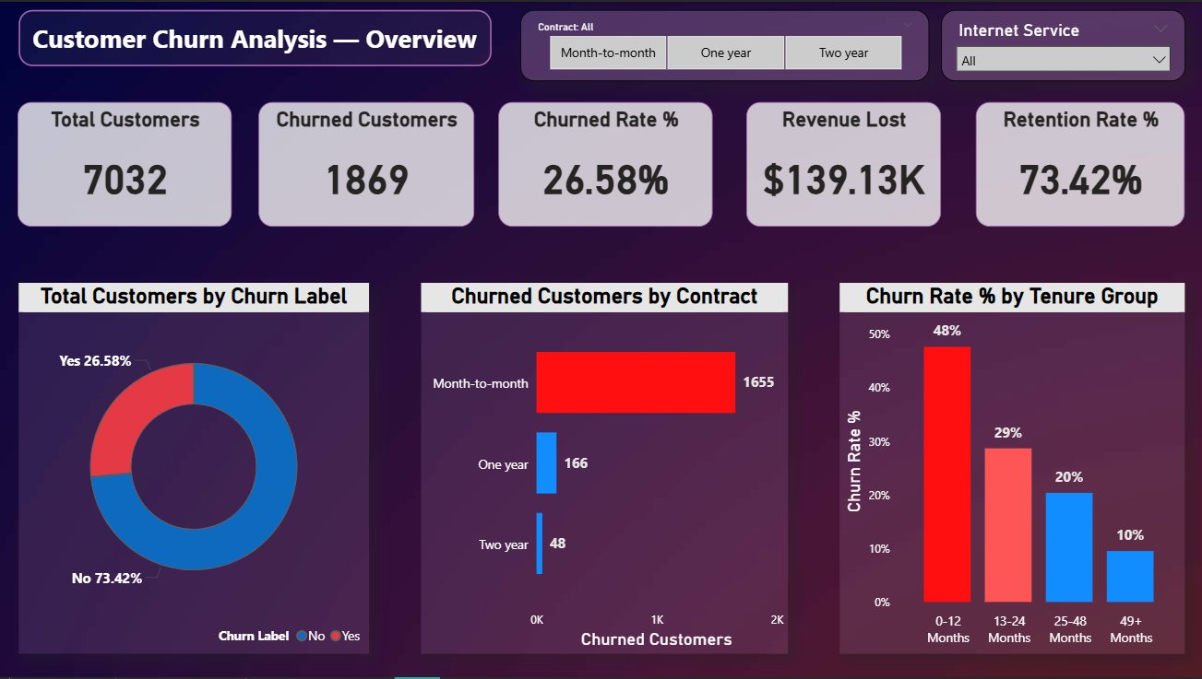
Month-to-month contracts account for 1,655 of 1,869 churned customers. New customers (0–12 months) churn at 48%, falling to 10% at 49+ months — making the first year the most critical retention window.
2. Key Findings at a Glance

Contract Type | Month-to-month: 43% churn · One year: 11% · Two year: 3% — contract length is the single strongest predictor of retention.
Internet Service | Fiber optic: 42% churn — more than twice the DSL rate (19%) despite carrying the highest monthly fees.
Payment Method | Electronic check: 45% churn · Auto-pay (bank transfer / credit card): 15–17% churn — a 28pp gap from friction alone.
Tenure | 0–12 months: 48% · 13–24 months: 29% · 25–48 months: 20% · 49+ months: 10% — loyalty compounds over time.
Senior Citizens | Senior customers (Yes) make up 63.8% of churned customers — age-specific needs are not being met.
Monthly Charges | Churned customers avg $74/month vs $61 for retained — higher-paying customers are more likely to leave.

Churn Drivers & Strategic Recommendations

3. Churn Drivers & Customer Profile Dashboards

Churn Drivers  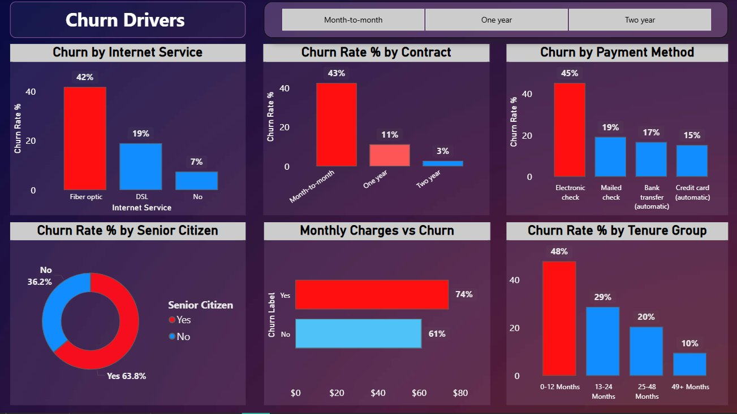  Fiber optic (42%), month-to-month (43%) and electronic check (45%) are the three highest-risk combinations. Senior citizens (63.8% of churned) and new customers (48% in yr 1) are the most vulnerable segments. | High-Risk Customer Profile  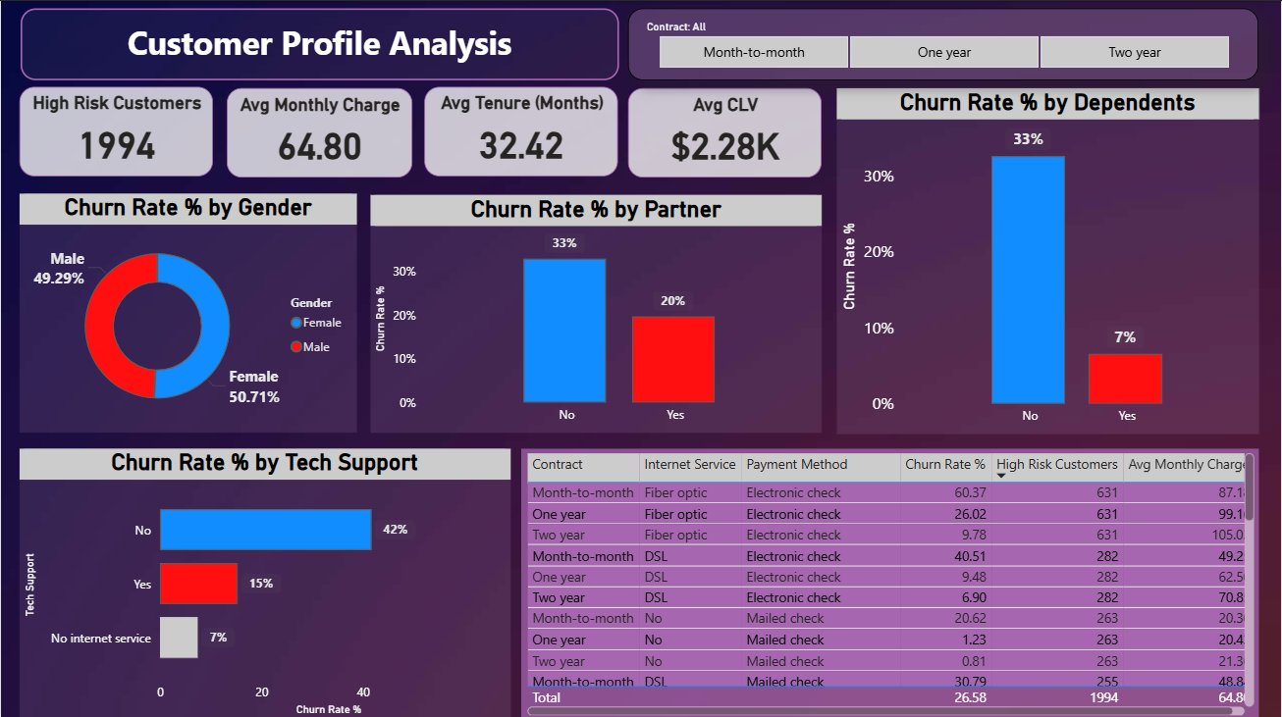  1,994 high-risk customers · Avg charge $64.80 · Avg CLV $2.28K. No tech support = 42% churn vs 15% with it. No partner = 33% churn vs 20%. No dependents = 33% vs 7%.
4. Strategic Recommendations

Priority | Action | Expected Impact
🔴 Critical | Contract upgrade campaign — offer discounted 1- or 2-year plans to month-to-month customers with personalised outreach. | 30–40% churn reduction in largest segment (1,655 churners)
🔴 Critical | Audit fiber optic quality; add SLA guarantees and loyalty credits for high-paying fiber subscribers. | Bring fiber churn from 42% toward DSL levels (~19%)
🟠 High | Incentivise switch from electronic check to auto-pay with billing discounts or one-month credit. | Cut payment-method churn from 45% to ~15–17%
🟠 High | Strengthen 0–12 month onboarding: proactive check-ins, free tech support trial, first-year loyalty rewards. | New-customer churn from 48% toward 29% (yr 2 band)
🟡 Medium | Bundle tech support into standard plans or provide free 3-month trials for customers currently without it. | Tech support linked to 27pp lower churn (42% → 15%)
🟡 Medium | Target single / no-dependent customers with value-add bundles in the first 6-month risk window. | Close the 26pp churn gap vs customers with dependents

Revenue Recovery Potential  Retaining 20% of the 1,994 high-risk customers at avg CLV $2.28K = ~$908K recovered annually. | Quick Win  Moving just 10% of electronic check users to auto-pay could prevent ~45 churns/month with minimal cost. | Long-term  Each customer retained past 48 months has a 90% retention rate — investing in loyalty pays compounding dividends.
Customer Churn Analysis · github.com/TheGopalN/Customer-Churn-Analysis · 2024

