***Request 1:***

We would like to bring back the functionality of the power button in the OS Level  
  
but we also want to having ability to control/disable the **Power Button** **and Physical Home Button** in the **app level**  
We want to minimize or user error and eliminate accidental down time

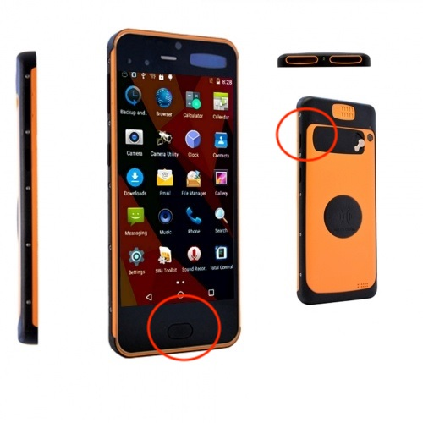

***Request 2:***

COSU Issue – the circle button and square reappear after restarting the device.

COSU Issue* Steps to replicate

Source code here: <https://github.com/TheGratefulDev/SPEEDATA_EXAMPLE>

Step 1:

Plug in your Android device and click the https://codelabs.developers.google.com/codelabs/cosu/img/74540ff4e857014c.png**Run** button. You should see the COSU App appear after a few seconds.

Step 2:

Open a command line terminal on your computer and enter this Android Debug Bridge command:

adb shell dpm set-device-owner com.google.codelabs.cosu/.DeviceAdminReceiver

Step 3: Load the app and click on “Start Lock Task”

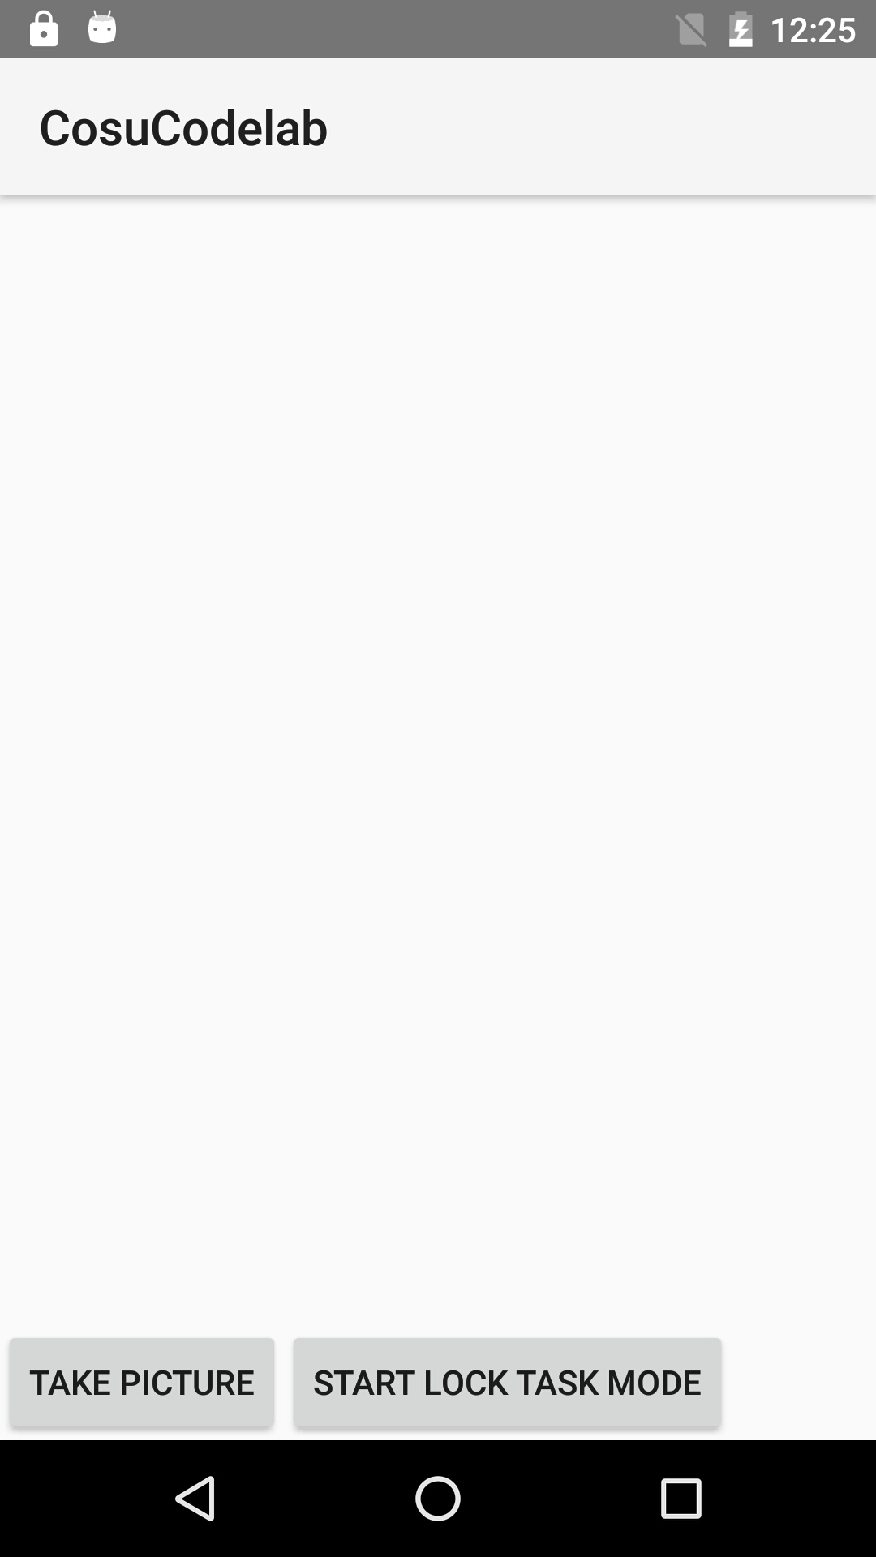

Step 4: the Circle Button and the Square Button are disappeared (this is correct)

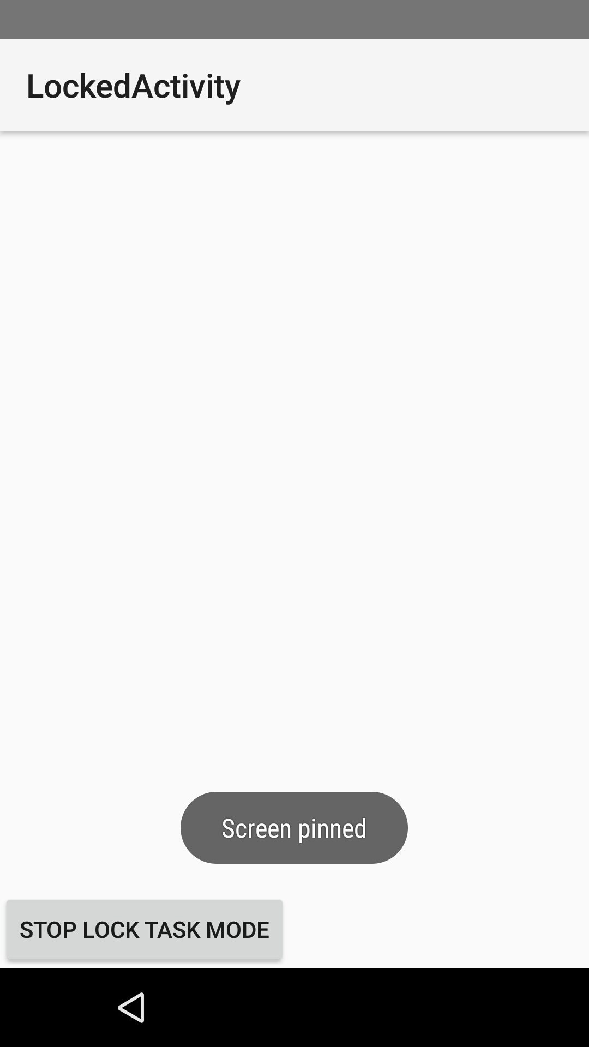

Step 5: turn off the device and turn back on   
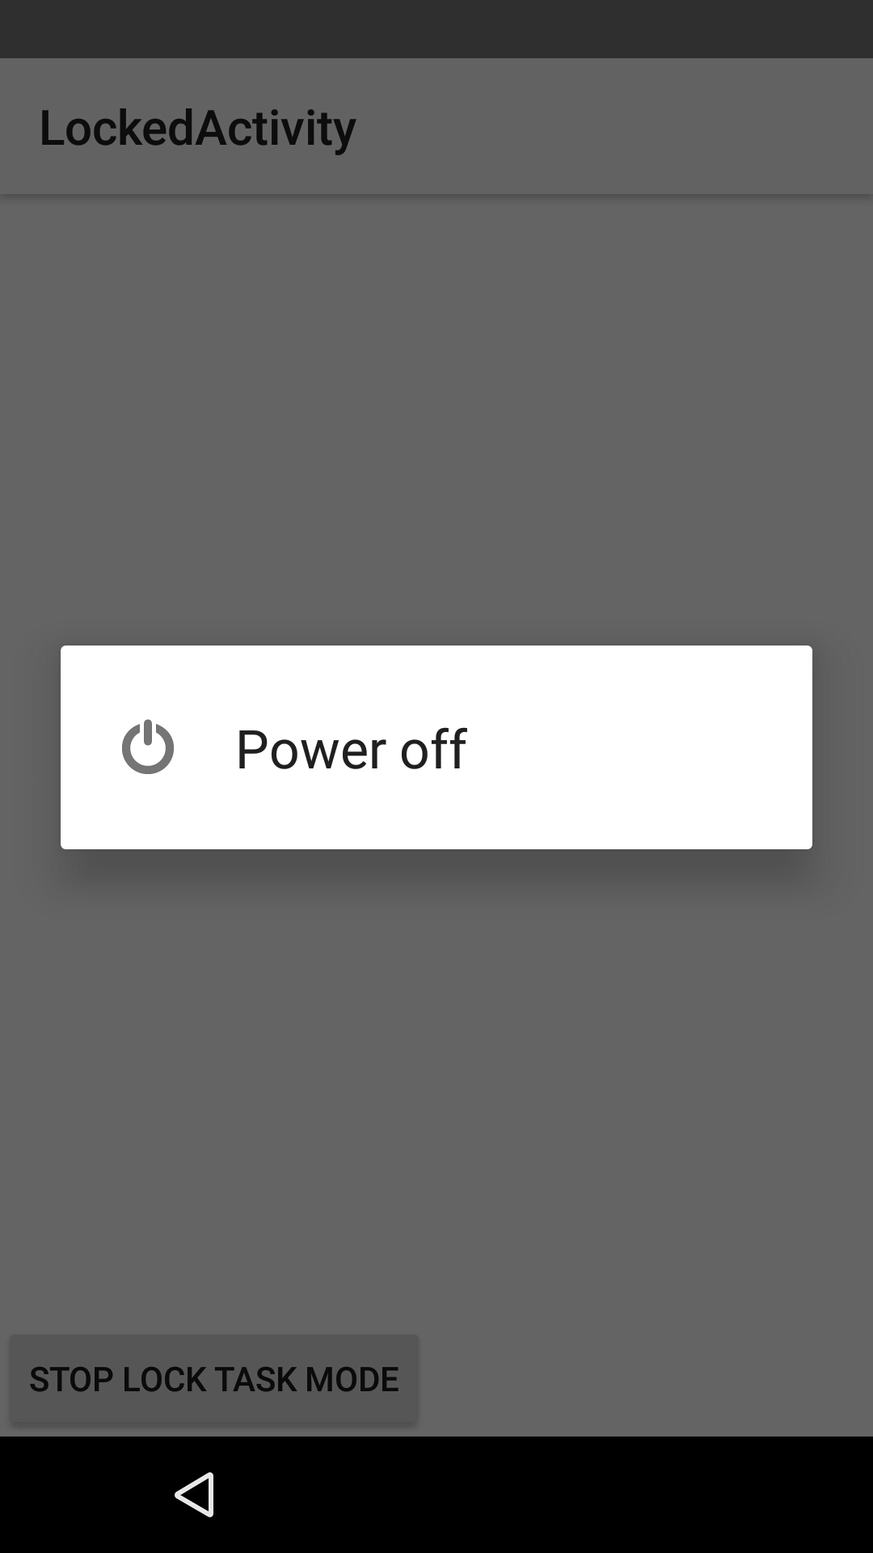

Step 6: It opens up the app right away and lock the app(that is correct)

But the Circle button and Square buttons appearing (That is not correct)

I tried the same steps with other android phone, the 2 button does not show up   
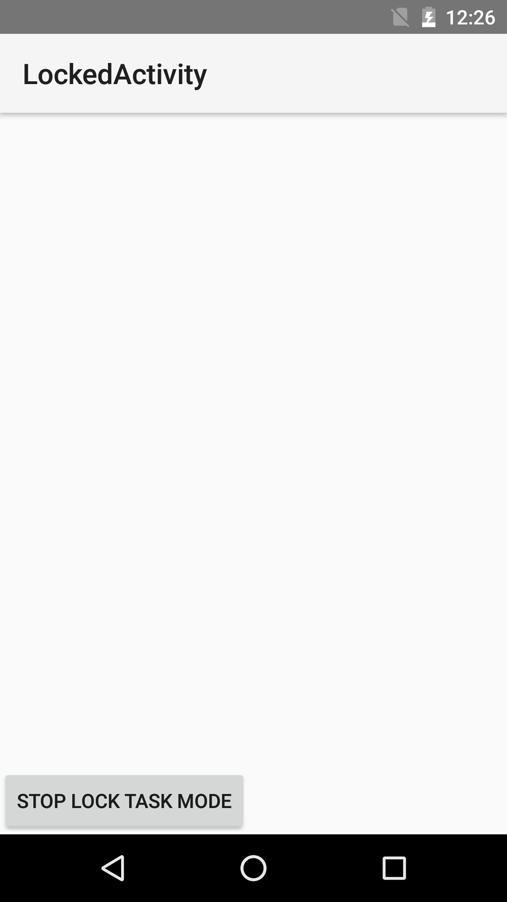

**Q/A**

For Sarah I talked to Raju about the LED you both discuss.   
  
It is more like Q/A then a request  
Raju wants to know if it is possible, he can add his own designed hardware LED light, powered from this pins. Also pragmatically control it within our app.

