|  |
| --- |
|  |
| AIR CONDITIONER PROJECT  BY: Momen Hassan, Ahmed Atef, and Ahmed Mohamed Hesham |
| |  |  |  | | --- | --- | --- | | 4/13/23 |  | Automotive Boot Camp | |

Contents

LAYERED ARCHITECTURE 2

PROJECT STATE MACHINE DIAGRAM 3

INTRODUCTION 4

MODULE, PERIPHERALS, & SUPPORTING DRIVERS DESCRIPTION 5

DRIVERS’ DOCUMENTATION 6

1. DIO 6

2. TIMERS 8

3. ADC 11

4. LCD 12

5. KEYPAD 15

6. LM35 16

7. BUZZEER 17

FUNCTIONS’ FLOWCHARTS 18

1. DIO 18

2. TIMERS 22

3. ADC 31

4. LCD 33

5. KEYPAD 36

6. LM35 38

7. BUZZER 39

AIR CONDITIONER DESIGN

# LAYERED ARCHITECTURE

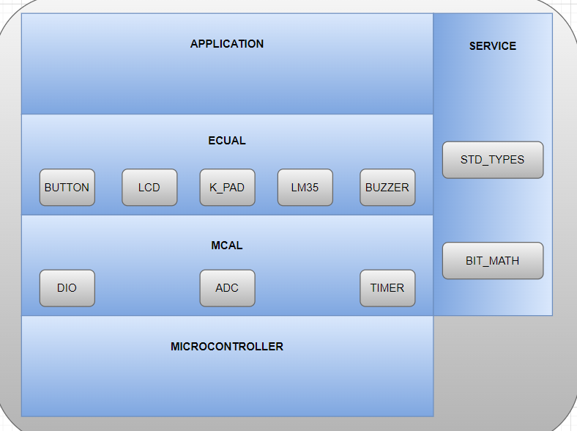

# PROJECT STATE MACHINE DIAGRAM

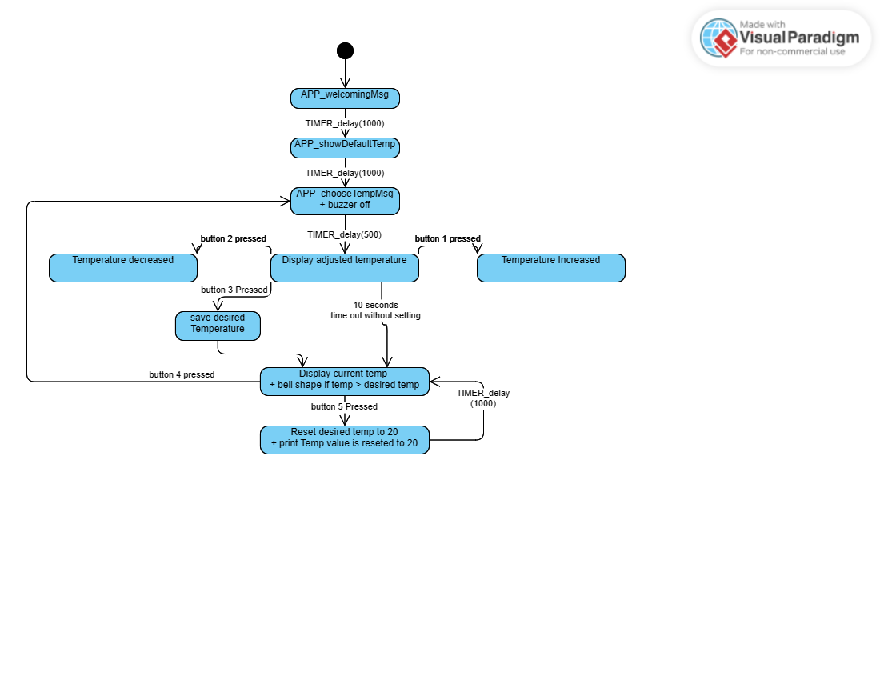

# INTRODUCTION

This project is developing software for temperature sensor integrated with ATMEGA32, 3*3 keypad, and LCD to make some functionalities similar to what happens with ACs.

So basically, the user will adjust the temperature he/she desires and the MC will compare it with the actual temperature and it buzzes if the actual temperature is higher than the desired temperature.

It consists of four layers:

1- APP

This layer is responsible for integrating application modules and peripherals to perform project functionality via using their APIs

2- ECUAL

In this layer modules' drivers are developed which are the keypad's driver, temperature sensor's driver, and LCD driver.

This layer is like a middle junction between the application layer and the microcontroller abstraction layer

3- MCAL

In this layer, peripherals' drivers are developed: DIO's driver, timers' driver, and ADC.

4- SERVICE

This layer consists of files.h which will serve the main three layers while developing, like it has important data types' type defs, and bit manipulation macros like functions

# MODULE, PERIPHERALS, & SUPPORTING DRIVERS DESCRIPTION

**DIO (Digital Input/Output):** This module deals with the digital input and output operations, such as reading and writing to digital pins of a microcontroller or a microprocessor. It may include functions for setting pin direction, reading and writing digital values, and handling interrupts related to digital pins.

**Timer:** This module deals with timer operations, such as configuring and handling timers in the microcontroller or microprocessor. It may include functions for setting timer intervals, handling timer interrupts, and measuring time. And This module deals with generating PWM signals using normal mode, which are used for controlling the intensity of an output signal, such as controlling the speed of motors or the brightness of LEDs. It may include functions for configuring and controlling PWM signals.

**ADC:** Through this module we can initialize ADC peripheral which is responsible for converting analog input signal to digital signal, and we check on the completion of the conversation by polling on interrupt flag.

**LM35:** This module is the temperature sensor used in our project. Its electrical output is proportional to the temperature in degrees Celsius. It is a linear device which means that the voltage at the output of the LM35 increases proportionally to the temperature. It is rated to operate over a -55°C to 150°C temperature range. The scale factor is 0.01 V/°C.

**LCD:** LCD stands for Liquid Crystal Display. LCD is a type of flat panel display which uses liquid crystals in its primary form of operation. It uses the light-modulating properties of liquid crystals combined with polarizers to display images. It has two pieces of polarized glass (also called substrate) that contain a liquid crystal material between them. A backlight or a reflector creates light that passes through the first substrate and the liquid crystal. The liquid crystals can twist or untwist depending on the electric voltage applied across them. This changes the angle of light passing through the second substrate and the polarizing film. The angel of light determines the color and brightness of the pixels that form the images on the LCD.

**Keypad:** We are using 3*3 keypad which means we have 3 rows and 3 columns, rows are connected to output high, and columns are connected to be inputs and enable internal pullups. For reading we pass low output simultaneously to the row pins and check if there is any change in the columns.

**Buzzer:** is an output module that buzzes when you write on it HIGH output.

**BIT_MATH**: This module provides functions for performing bitwise operations, such as AND, OR, XOR, and shifting, which are commonly used for manipulating individual bits in registers or memory locations.

**Standard Types:** This module includes standard data types, such as integer types, floating-point types, and Boolean types, which are used for representing data in a standardized way across the system.

# DRIVERS’ DOCUMENTATION

## DIO

DIO_init(uint8_t portNumber, uint8_t pinNumber, uint8_t direction);

|  |  |
| --- | --- |
| Function Name | DIO_init |
| Description | Initializes DIO pins’ direction, output current, and internal attach |
| Sync\Async | Synchronous |
| Reentrancy | Reentrant |
| Parameters (in) | uint8_t portNumber, uint8_t pinNumber, uint8_t direction |
| Parameters (out) | None |
| Return Value | WRONG_PORT_NUMBER, WRONG_PIN_NUMBER, WRONG_DIRECTION, E_OK |

DIO_write(uint8_t portNumber, uint8_t pinNumber, uint8_t value);

|  |  |
| --- | --- |
| Function Name | DIO_write |
| Description | Write on DIO pins’ a specific output High or Low |
| Sync\Async | Synchronous |
| Reentrancy | Reentrant |
| Parameters (in) | uint8_t portNumber, uint8_t pinNumber, uint8_t value |
| Parameters (out) | None |
| Return Value | WRONG_PORT_NUMBER, WRONG_PIN_NUMBER, WRONG_VALUE, E_OK |

DIO_toggle(uint8_t portNumber, uint8_t pinNumber);

|  |  |
| --- | --- |
| Function Name | DIO_toggle |
| Description | Toggle the output of a specific pin |
| Sync\Async | Synchronous |
| Reentrancy | Reentrant |
| Parameters (in) | uint8_t portNumber, uint8_t pinNumber |
| Parameters (out) | None |
| Return Value | WRONG_PORT_NUMBER, WRONG_PIN_NUMBER, E_OK |

DIO_read(uint8_t portNumber, uint8_t pinNumber, uint8_t *value);

|  |  |
| --- | --- |
| Function Name | DIO_read |
| Description | Read input from a pin and send it back in a pointer to uint8_t |
| Sync\Async | Synchronous |
| Reentrancy | Reentrant |
| Parameters (in) | uint8_t portNumber, uint8_t pinNumber |
| Parameters (out) | uint8_t *value |
| Return Value | WRONG_PORT_NUMBER,  WRONG_PIN_NUMBER,  E_OK |

## TIMERS

en_timerError_t TIMER_init(u8 u8_a_timerUsed);

|  |  |
| --- | --- |
| Function Name | TIMER_init |
| Description | Initializes a specific timer to work as a CTC or overflow timer |
| Sync\Async | Synchronous |
| Reentrancy | Reentrant |
| Parameters (in) | uint8_t timerUsed |
| Parameters (out) | None |
| Return Value | EN_timerError_t |

en_timerError_t TIMER_setTime(u8 u8_a_timerUsed, u32 u32_a_desiredTime);

|  |  |
| --- | --- |
| Function Name | TIMER_setTime |
| Description | Used to set time at which the timer interrupt will fires and execute a desired function |
| Sync\Async | Synchronous |
| Reentrancy | Reentrant |
| Parameters (in) | uint8_t timerUsed, uint32_t desiredTime |
| Parameters (out) | None |
| Return Value | EN_timerError_t |

en_timerError_t TIMER_start(u8 u8_a_timerUsed);

|  |  |
| --- | --- |
| Function Name | TIMER_start |
| Description | Start specific timer to count |
| Sync\Async | Synchronous |
| Reentrancy | Reentrant |
| Parameters (in) | uint8_t timerUsed |
| Parameters (out) | None |
| Return Value | EN_timerError_t |

en_timerError_t TIMER_stop(u8 u8_a_timerUsed);

|  |  |
| --- | --- |
| Function Name | TIMER_stop |
| Description | Stop specific timer from counting |
| Sync\Async | Synchronous |
| Reentrancy | Reentrant |
| Parameters (in) | uint8_t timerUsed |
| Parameters (out) | None |
| Return Value | EN_timerError_t |

en_timerError_t TIMER_pwmGenerator(u8 u8_a_timerUsed, u32 u32_a_desiredDutyCycle);

|  |  |
| --- | --- |
| Function Name | TIMER_pwmGenerator |
| Description | Generates PWM signal using normal mode for a specific timer |
| Sync\Async | Synchronous |
| Reentrancy | Reentrant |
| Parameters (in) | u8_a_timerUsed, u8_a_desiredDutyCycle |
| Parameters (out) | None |
| Return Value | en_timerError_t |

void TIMER_setCallBack(u8 u8_a_timerUsed, void (*funPtr)(void));

|  |  |
| --- | --- |
| Function Name | TIMER_setCallBack |
| Description | Initializes Sends pointer to function to be called when the timer’s interrupt fires |
| Sync\Async | Synchronous |
| Reentrancy | Reentrant |
| Parameters (in) | uint8_t portNumber, uint8_t pinNumber, uint8_t direction |
| Parameters (out) | None |
| Return Value | None |

en_timerError_t TIMER_stopInterrupt(u8 u8_a_timerUsed);

|  |  |
| --- | --- |
| Function Name | TIMER_stopInterrupt |
| Description | Disable a specific timer’s peripheral interrupt |
| Sync\Async | Synchronous |
| Reentrancy | Reentrant |
| Parameters (in) | u8_a_timerUsed |
| Parameters (out) | None |
| Return Value | en_timerError_t |

en_timerError_t TIMER_delay(u8 u8_a_timerUsed, u32 u32_a_timeInMS);

|  |  |
| --- | --- |
| Function Name | TIMER_enableInterrupt |
| Description | Generates a delay using a specific timer |
| Sync\Async | Synchronous |
| Reentrancy | Reentrant |
| Parameters (in) | u8_a_timerUsed, u32_a_timeInMS |
| Parameters (out) | None |
| Return Value | en_timerError_t |

en_timerError_t TIMER_enableInterrupt(u8 u8_a_timerUsed);

|  |  |
| --- | --- |
| Function Name | TIMER_enableInterrupt |
| Description | Enables a specific timer’s peripheral interrupt |
| Sync\Async | Synchronous |
| Reentrancy | Reentrant |
| Parameters (in) | u8_a_timerUsed |
| Parameters (out) | None |
| Return Value | en_timerError_t |

## ADC

void ADC_init (void);

|  |  |
| --- | --- |
| Function Name | ADC_init |
| Description | Initialize ADC according to preprocessed configured definitions |
| Sync\Async | Synchronous |
| Reentrancy | Reentrant |
| Parameters (in) | None |
| Parameters (out) | None |
| Return Value | None |

u16 ADC_read (void);

|  |  |
| --- | --- |
| Function Name | ADC_read |
| Description | Pulls on ADC interrupt flag till it rises to start returning a conversion to the user |
| Sync\Async | Synchronous |
| Reentrancy | Reentrant |
| Parameters (in) | None |
| Parameters (out) | None |
| Return Value | u16 |

## LCD

void LCD_Init(void);

|  |  |
| --- | --- |
| Function Name | LCD_Init |
| Description | Initialize LCD according to preprocessed configured definitions |
| Sync\Async | Synchronous |
| Reentrancy | Reentrant |
| Parameters (in) | None |
| Parameters (out) | None |
| Return Value | None |

void LCD_PinsInit ();

|  |  |
| --- | --- |
| Function Name | LCD_PinInit |
| Description | Initialize LCD pins directions according to preprocessed configured definitions |
| Sync\Async | Synchronous |
| Reentrancy | Reentrant |
| Parameters (in) | None |
| Parameters (out) | None |
| Return Value | None |

void LCD_WriteChar(u8 u8_a_ch);

|  |  |
| --- | --- |
| Function Name | LCD_WriteChar |
| Description | Prints Character on LCD |
| Sync\Async | Synchronous |
| Reentrancy | Reentrant |
| Parameters (in) | U8_a_ch |
| Parameters (out) | None |
| Return Value | None |

void LCD_WriteString(u8 *u8_a_str);

|  |  |
| --- | --- |
| Function Name | LCD_WriteString |
| Description | Prints string on LCD |
| Sync\Async | Synchronous |
| Reentrancy | Reentrant |
| Parameters (in) | *u8_a_str |
| Parameters (out) | None |
| Return Value | None |

void LCD_WriteNumber(i32 i32_a_num);

|  |  |
| --- | --- |
| Function Name | LCD_WriteNumber |
| Description | Prints a specific number on LCD |
| Sync\Async | Synchronous |
| Reentrancy | Reentrant |
| Parameters (in) | i32_a_num |
| Parameters (out) | None |
| Return Value | None |

void LCD_SetCursor(u8 u8_a_line,u8 u8_a_cell);

|  |  |
| --- | --- |
| Function Name | LCD_SetCursor |
| Description | Changes Cursor’s Location |
| Sync\Async | Synchronous |
| Reentrancy | Reentrant |
| Parameters (in) | u8_a_line, u8_a_cell |
| Parameters (out) | None |
| Return Value | None |

void LCD_Clear(void);

|  |  |
| --- | --- |
| Function Name | LCD_Clear |
| Description | Clears LCD’s screen and set cursor at line 0 cell 0 |
| Sync\Async | Synchronous |
| Reentrancy | Reentrant |
| Parameters (in) | None |
| Parameters (out) | None |
| Return Value | None |

void LCD_ClearLoc(u8 u8_a_line ,u8 u8_a_cell,u8 u8_a_num);

|  |  |
| --- | --- |
| Function Name | LCD_ClearLoc |
| Description | Clear specific cells from a specific location |
| Sync\Async | Synchronous |
| Reentrancy | Reentrant |
| Parameters (in) | u8_a_line, u8_a_cell_, u8_a_num |
| Parameters (out) | None |
| Return Value | None |

void LCD_CustomChar(u8 u8_a_loc,u8 *u8_a_pattern);

|  |  |
| --- | --- |
| Function Name | LCD_CustomChar |
| Description | Creates a customized character |
| Sync\Async | Synchronous |
| Reentrancy | Reentrant |
| Parameters (in) | u8_a_loc, *u8_a_pattern |
| Parameters (out) | None |
| Return Value | None |

## KEYPAD

void KEYPAD_init (void);

|  |  |
| --- | --- |
| Function Name | KEYPAD_init |
| Description | Initialize KEYPAD according to preprocessed configured definitions |
| Sync\Async | Synchronous |
| Reentrancy | Reentrant |
| Parameters (in) | None |
| Parameters (out) | None |
| Return Value | None |

u8 KEYPAD_read (void);

|  |  |
| --- | --- |
| Function Name | KEYPAD_read |
| Description | returns 0 if there is no key pressed or equivalent value for the key if there is a key pressed |
| Sync\Async | Synchronous |
| Reentrancy | Reentrant |
| Parameters (in) | None |
| Parameters (out) | None |
| Return Value | U8 |

## LM35

void LM35_init (void);

|  |  |
| --- | --- |
| Function Name | LM35_init |
| Description | Initialize LM35 according to preprocessed configured definitions |
| Sync\Async | Synchronous |
| Reentrancy | Reentrant |
| Parameters (in) | None |
| Parameters (out) | None |
| Return Value | None |

u16 LM35_read (void);

|  |  |
| --- | --- |
| Function Name | LM35_read |
| Description | returns Degree Celsius after Conversion |
| Sync\Async | Synchronous |
| Reentrancy | Reentrant |
| Parameters (in) | None |
| Parameters (out) | None |
| Return Value | u16 |

## BUZZEER

en_buzzerError_t BUZZER_init (u8 u8_a_buzzerNumber);

|  |  |
| --- | --- |
| Function Name | BUZZER_init |
| Description | Initialize Buzzer according to preprocessed configured definitions |
| Sync\Async | Synchronous |
| Reentrancy | Reentrant |
| Parameters (in) | u8_a_buzzerNumber |
| Parameters (out) | None |
| Return Value | BUZZER_OK, WRONG_BUZZER. |

en_buzzerError_t BUZZER_on (u8 u8_a_buzzerNumber);

|  |  |
| --- | --- |
| Function Name | BUZZER_on |
| Description | Switches Buzzer On |
| Sync\Async | Synchronous |
| Reentrancy | Reentrant |
| Parameters (in) | u8_a_buzzerNumber |
| Parameters (out) | None |
| Return Value | BUZZER_OK, WRONG_BUZZER. |

en_buzzerError_t BUZZER_off (u8 u8_a_buzzerNumber);

|  |  |
| --- | --- |
| Function Name | BUZZER_off |
| Description | Turns Buzzer off |
| Sync\Async | Synchronous |
| Reentrancy | Reentrant |
| Parameters (in) | u8_a_buzzerNumber |
| Parameters (out) | None |
| Return Value | BUZZER_OK, WRONG_BUZZER. |

# FUNCTIONS’ FLOWCHARTS

## DIO

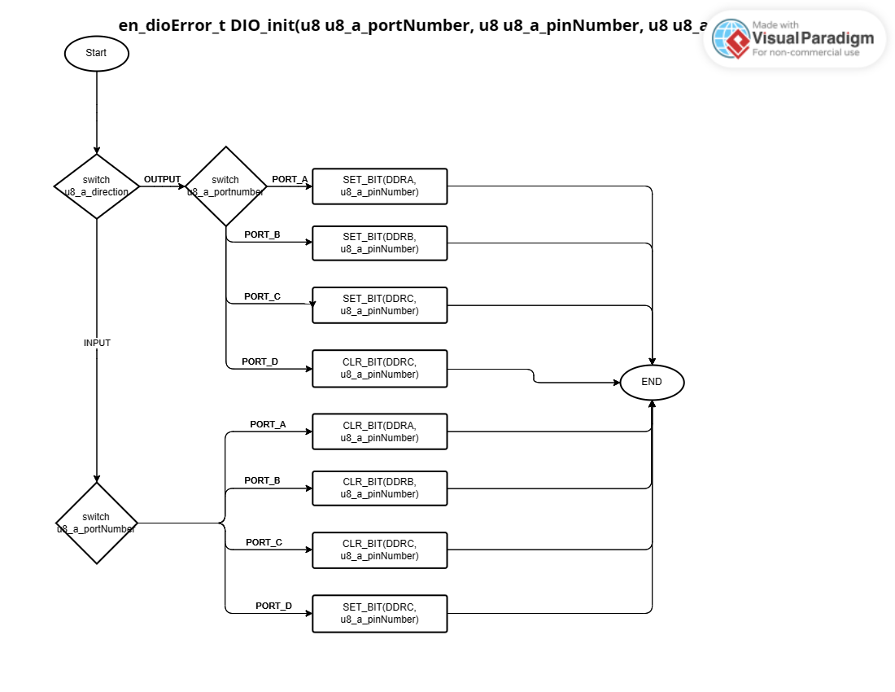

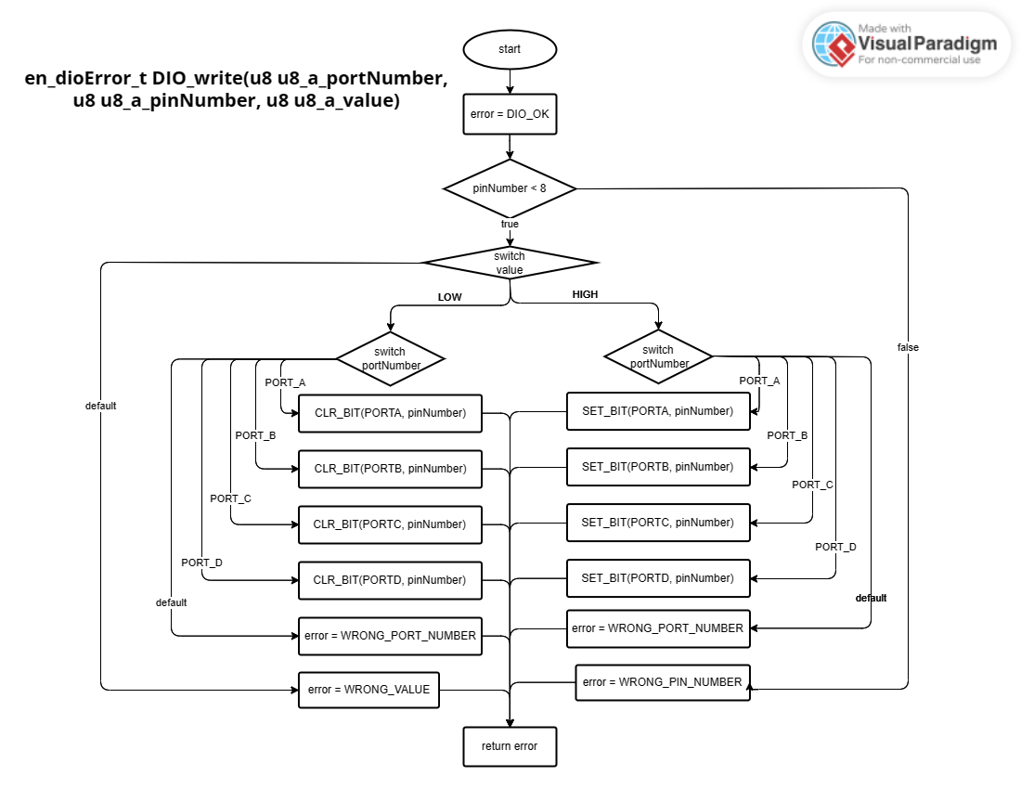

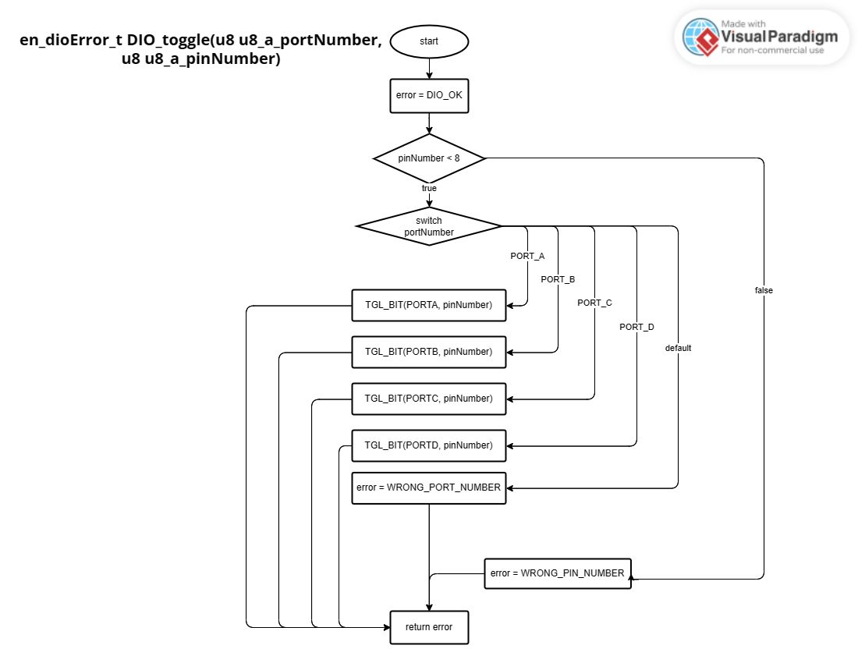

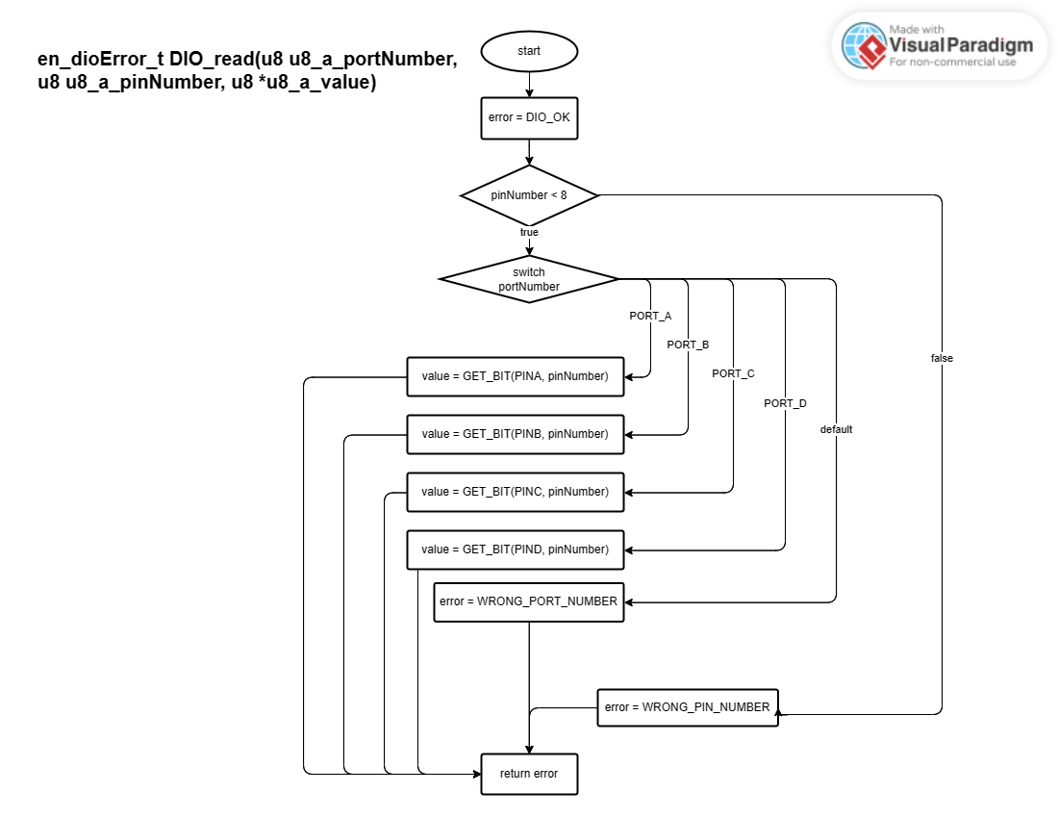

## TIMERS

en_timerError_t TIMER_init(u8 u8_a_timerUsed);

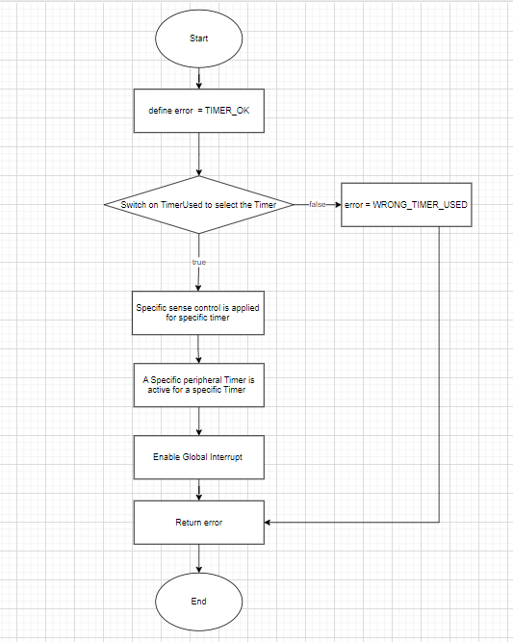

en_timerError_t TIMER_start(u8 u8_a_timerUsed);

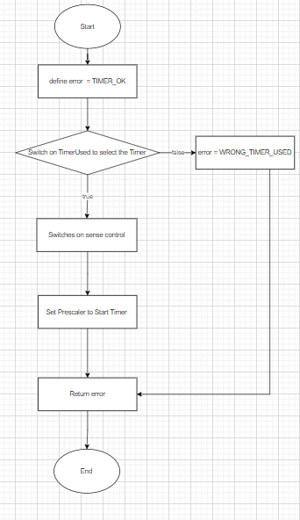

en_timerError_t TIMER_setTime(u8 u8_a_timerUsed, u32 u32_a_desiredTime);

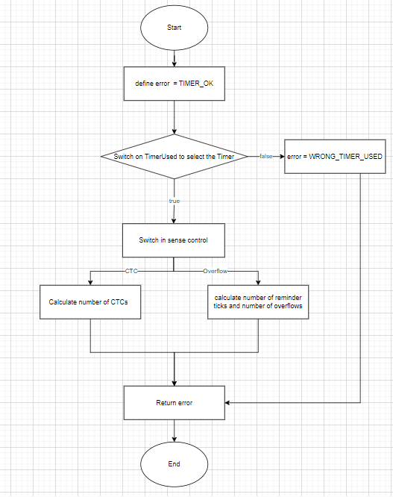

en_timerError_t TIMER_stop(u8 u8_a_timerUsed);

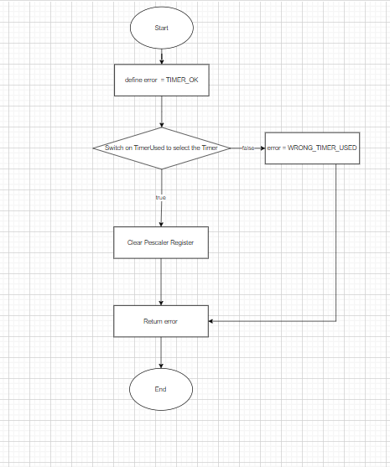

en_timerError_t TIMER_pwmGenerator(u8 u8_a_timerUsed, u32 u32_a_desiredDutyCycle);

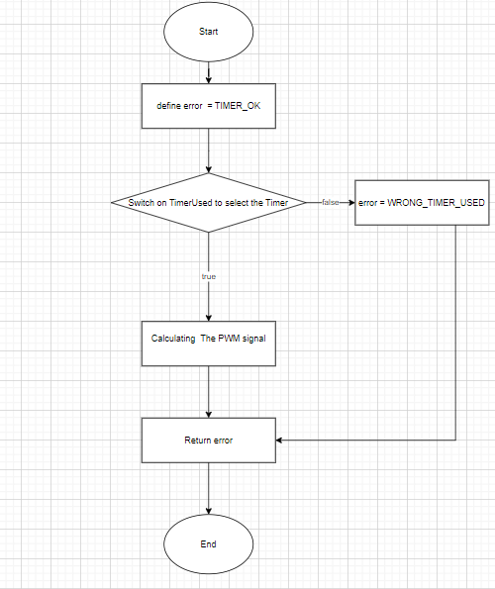

Void TIMER_setCallBack(u8 u8_a_timerUsed, void (*funPtr)(void));

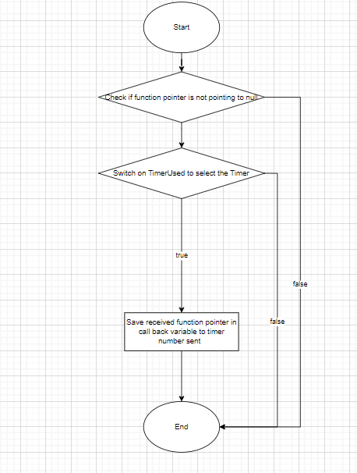

en_timerError_t TIMER_stopInterrupt(u8 u8_a_timerUsed);

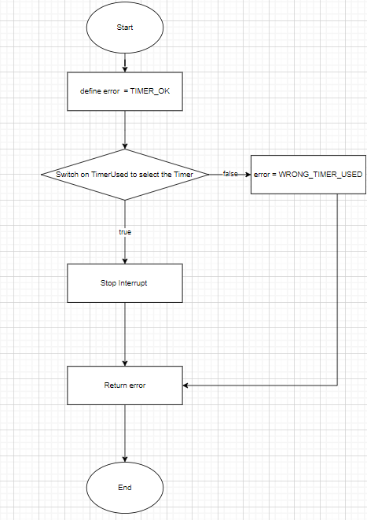

en_timerError_t TIMER_delay(u8 u8_a_timerUsed, u32 u32_a_timeInMS);

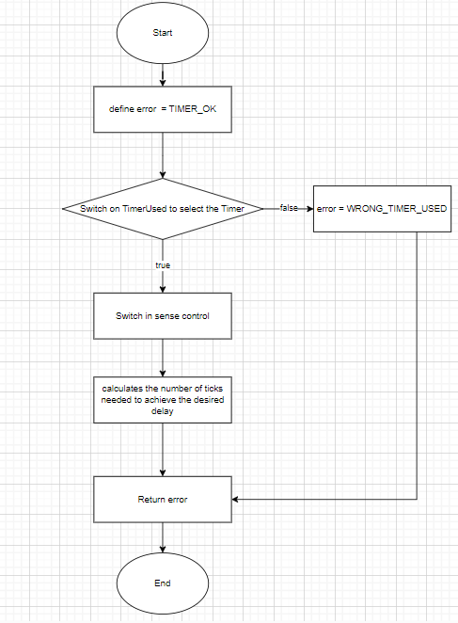

en_timerError_t TIMER_enableInterrupt(u8 u8_a_timerUsed);

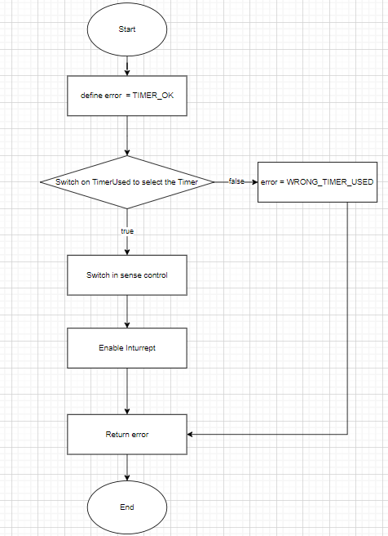

## ADC

ADC_init()

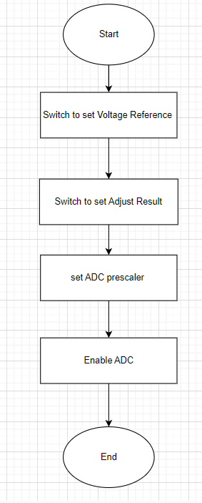

u16 ADC_read()

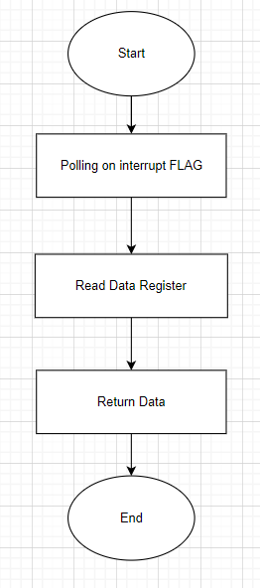

## LCD

LCD_Init()

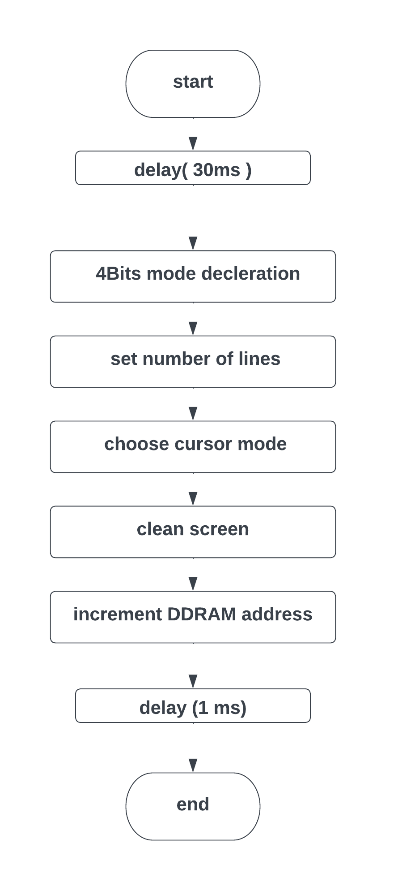

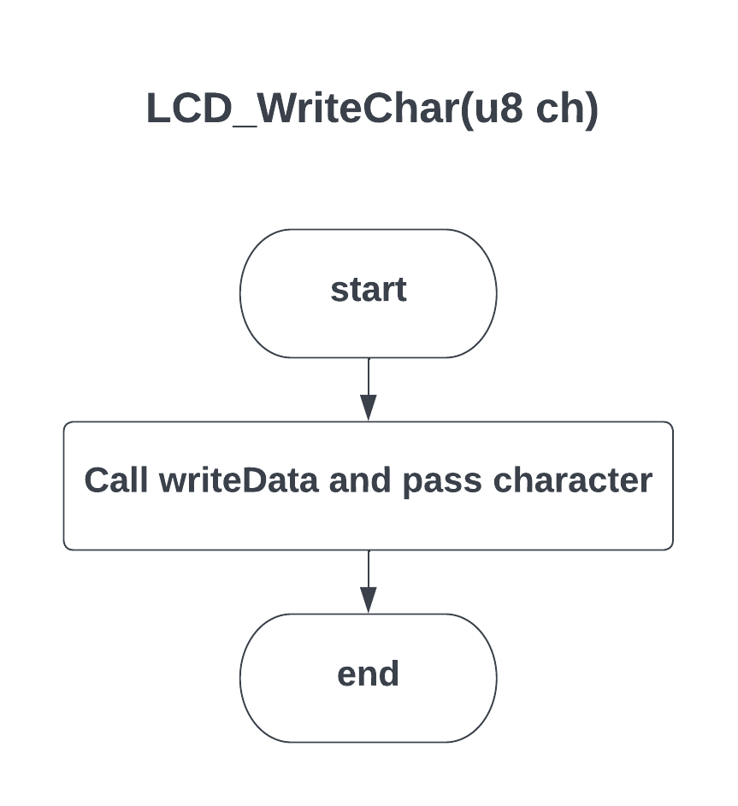

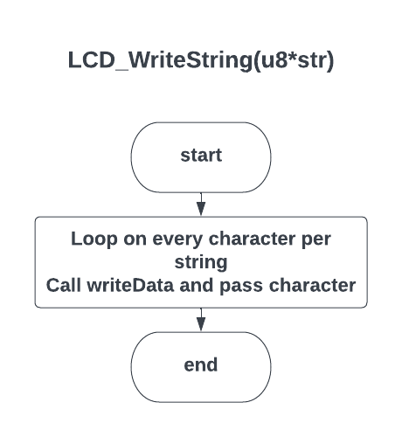

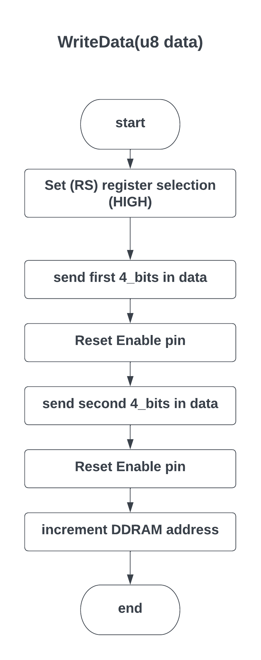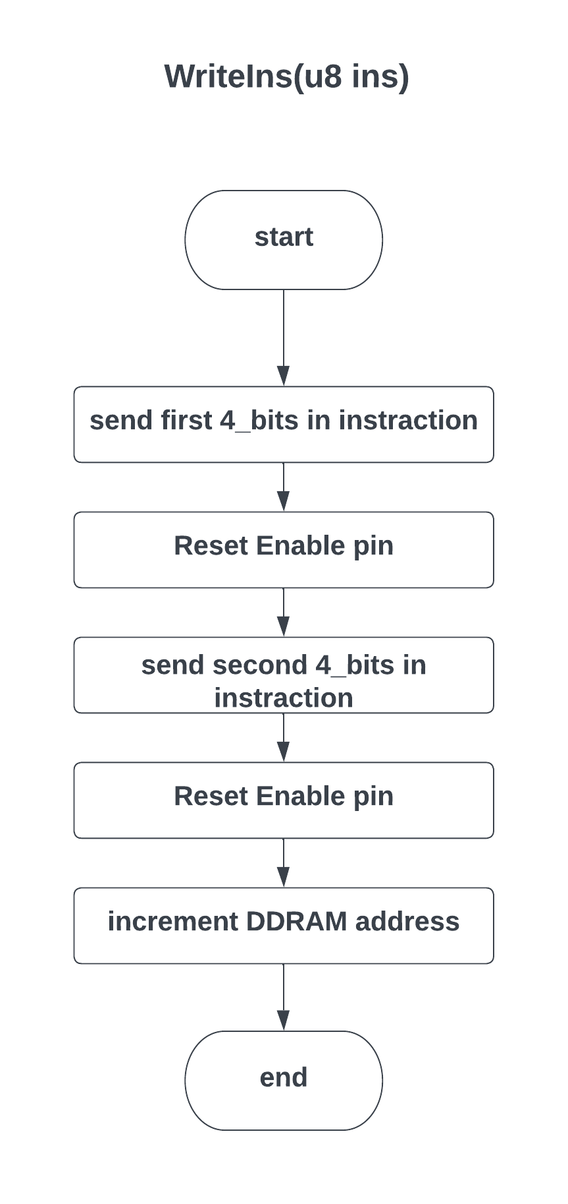

## KEYPAD

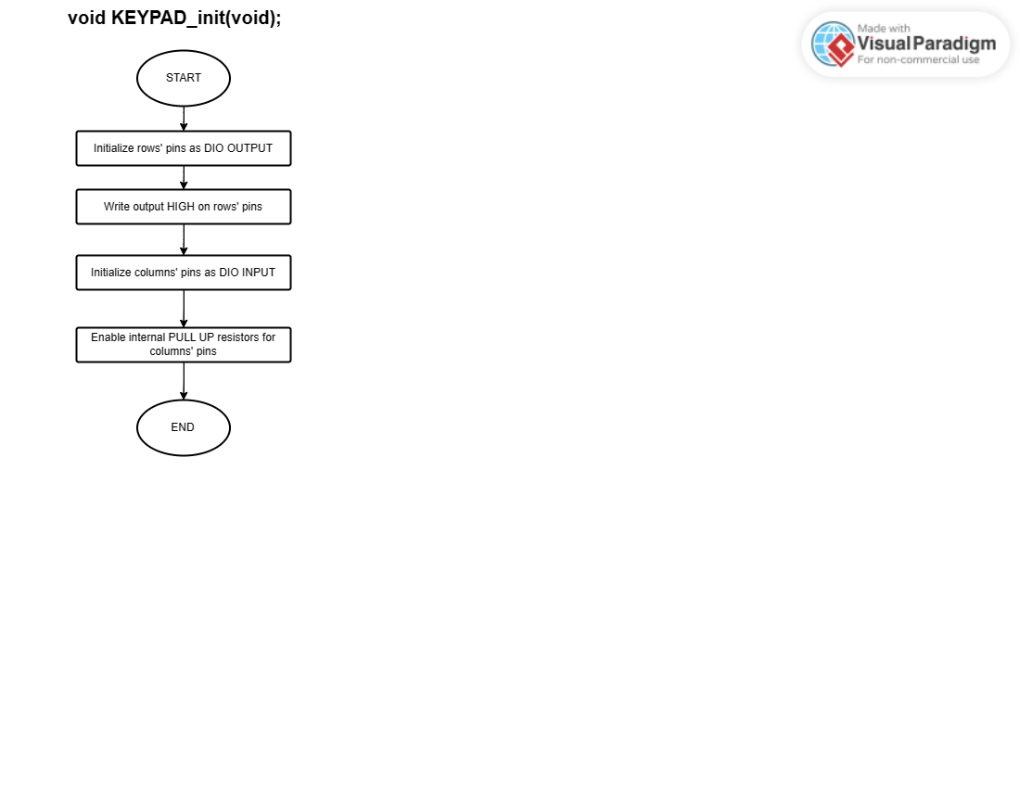

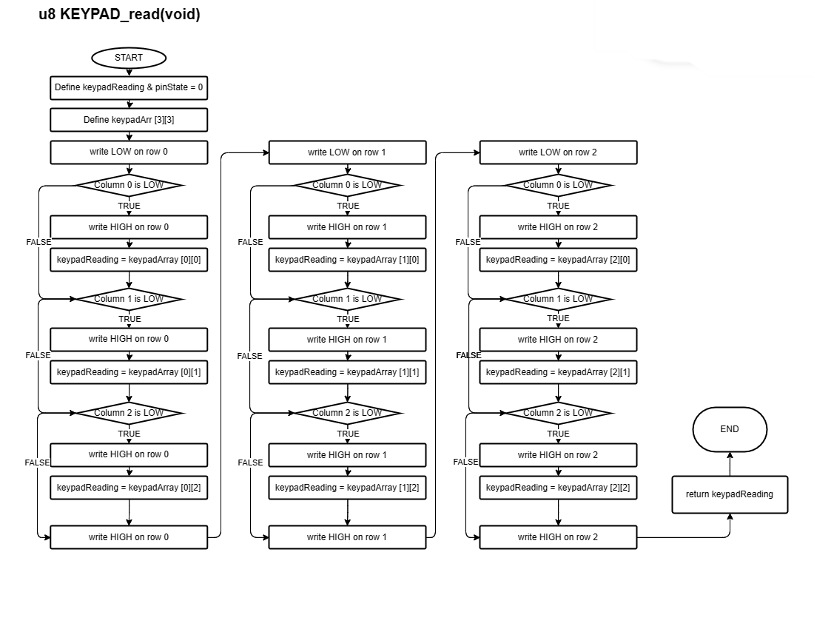

## LM35

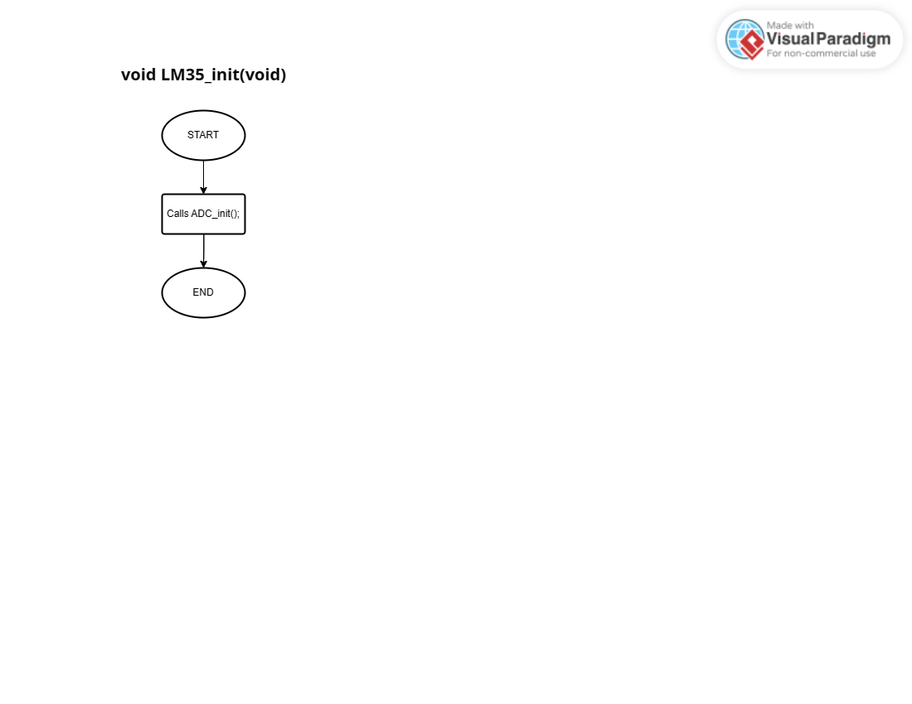

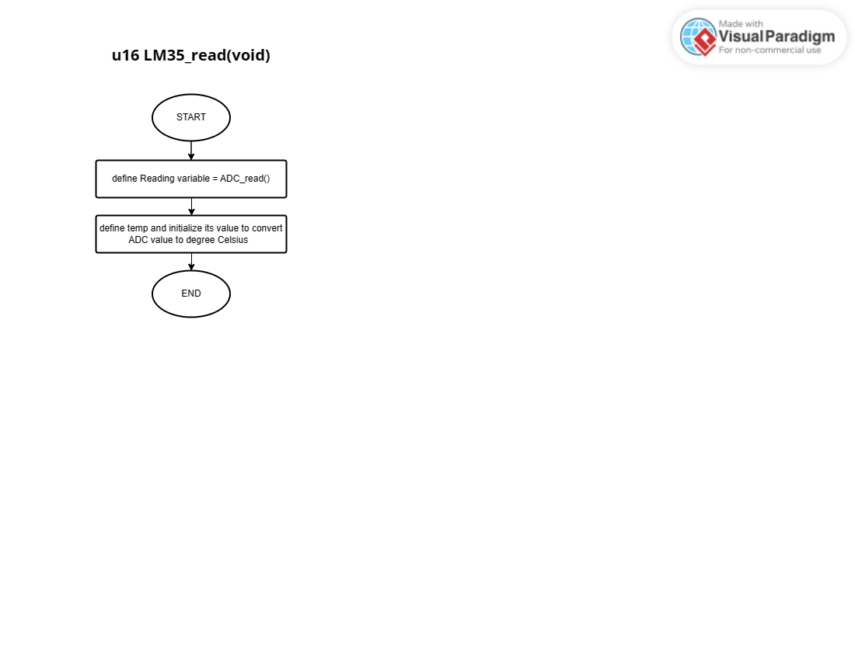

## BUZZER

BUZZER_init()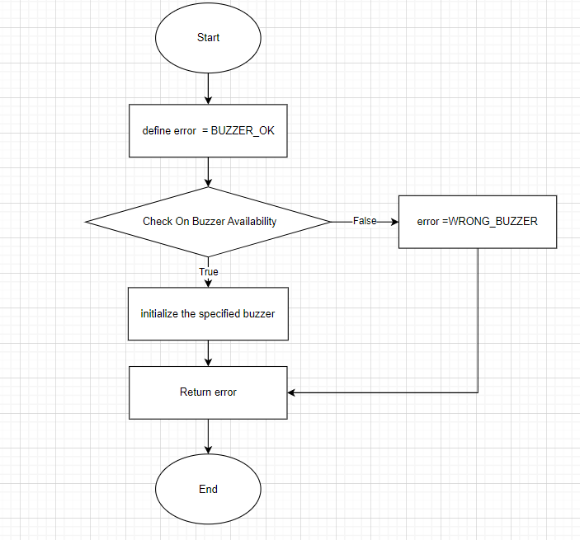

BUZZER_on

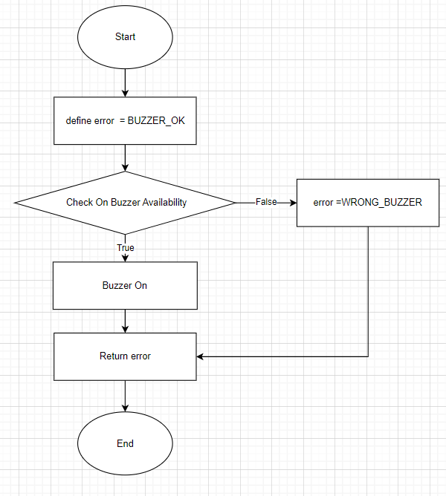

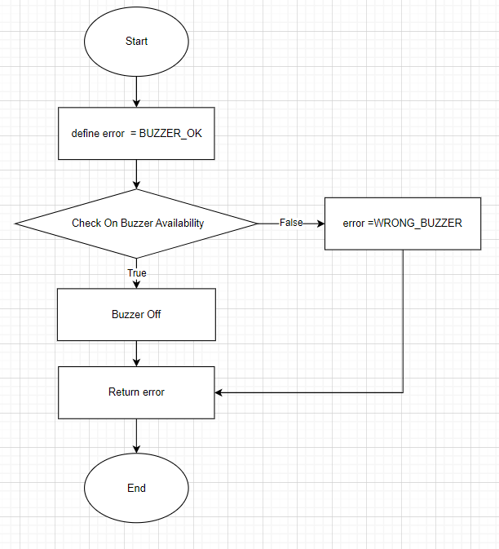BUZZER_OFF