

Contents

1. Project Introduction 3

1.1. Project Components 3

2. High Level Design 3

2.1. System Architecture 3

2.1.1. Layered Architecture 3

2.1.2. Design 4

2.2. Sequence Diagram 5

2.3. State Machine Diagram 8

2.4. BCM Data Buffer 9

2.5. Modules Description 9

2.5.1. DIO (Digital Input/Output) Module 9

2.5.2. UART 9

2.5.3. LED 9

2.5.4. BCM 9

2.6. Drivers’ Documentation 10

2.6.1. MCAL Drivers’ Functions 10

2.6.2. HAL Drivers’ Functions 14

2.6.3. SERVER Drivers’ functions 16

Low Level Design 21

2.7. MCAL Layer 21

2.7.1. DIO Module 21

2.7.2. UART 26

2.8. Server Layer 29

2.8.1. BCM 29

# Project Introduction

This project is aiming to deliver a BCM -Basic Communication Manager- which will manage the data which the user wants to transmit/receive to make a specific task. I implemented the project to send data using UART protocol which is up to 512 byte and it can be from 0 to 255

## Project Components

* 2 ATmega32 microcontroller
* 2 LEDS for each microcontroller

# High Level Design

## System Architecture

### Layered Architecture

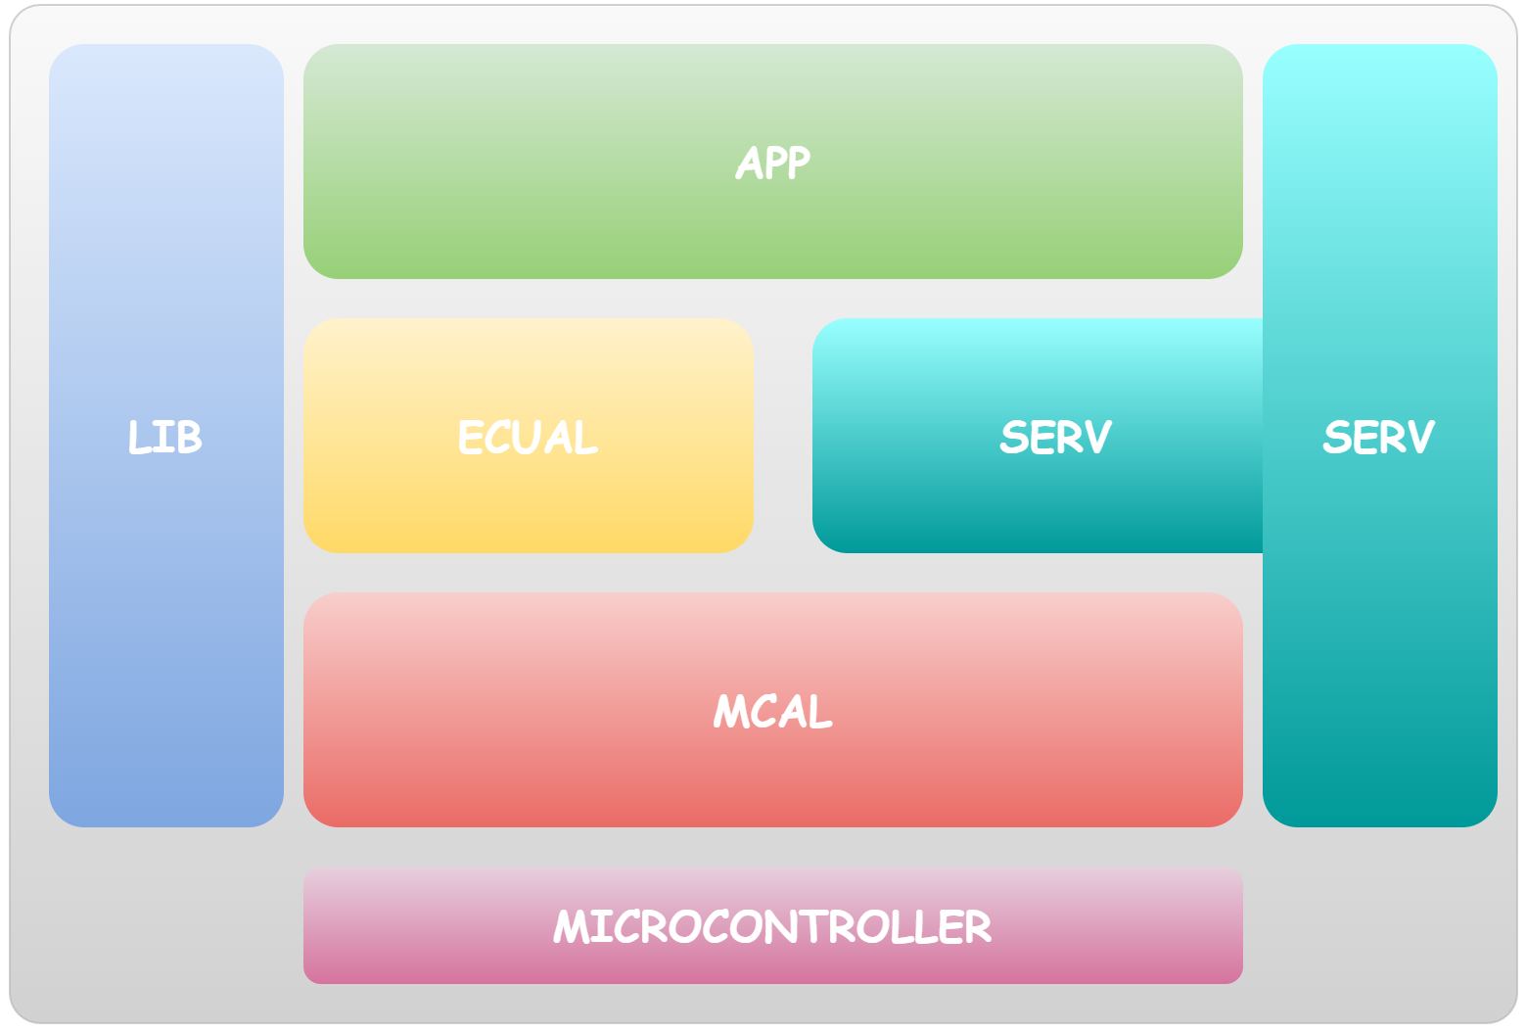

### Design

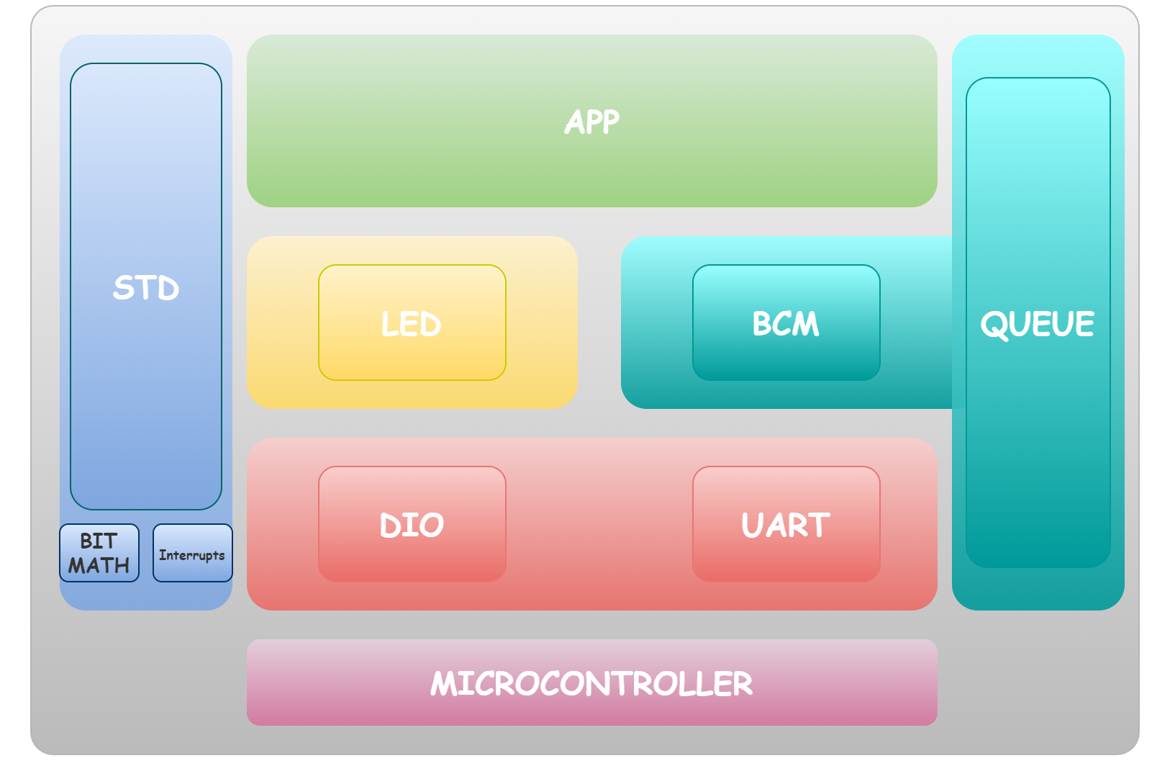

## Sequence Diagram

This whole of the sequence, you can find a zoomed parts in the next pages.

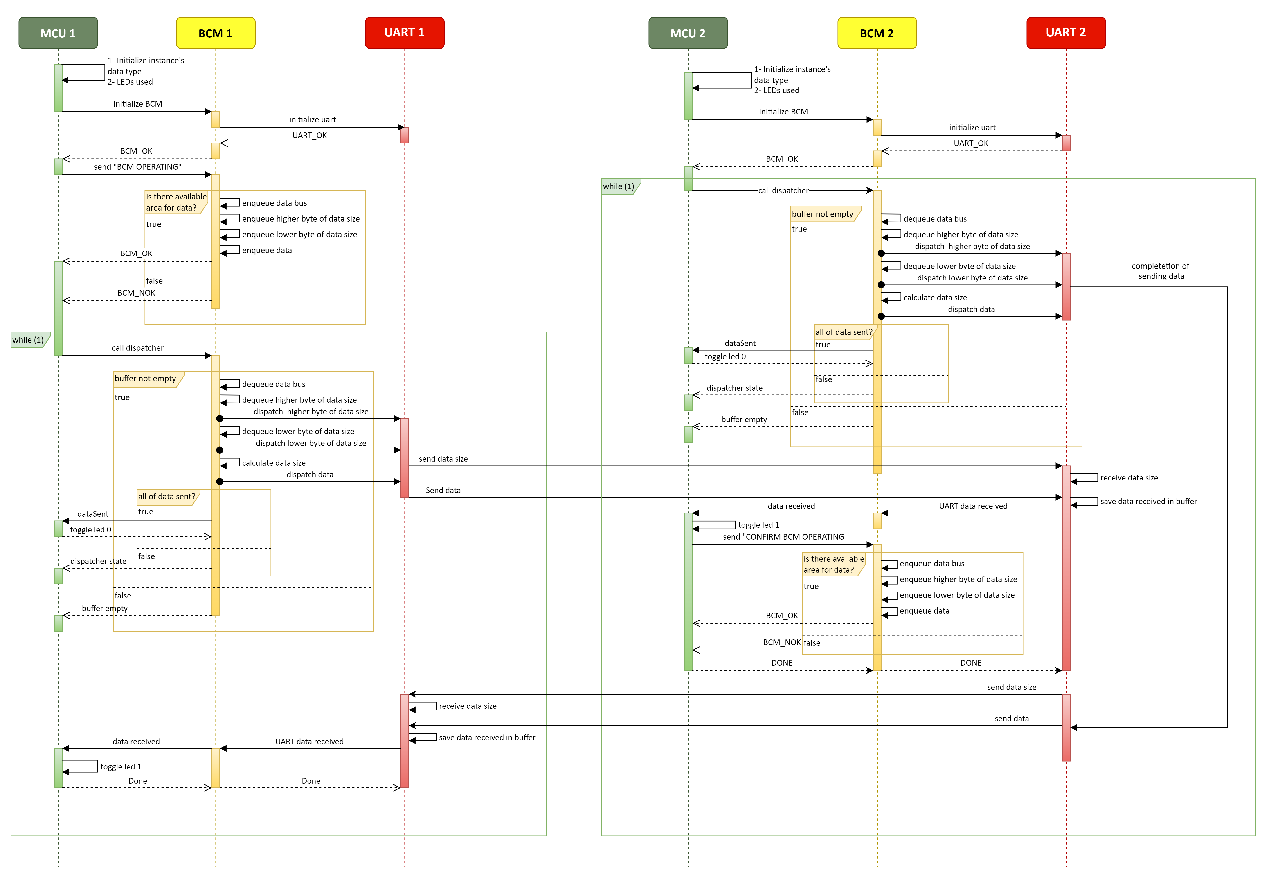

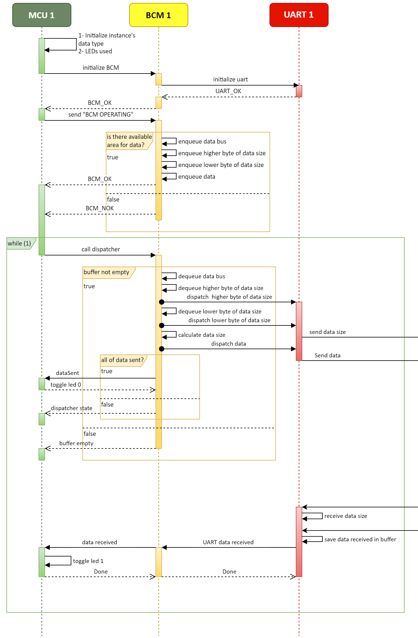MCU 1 - please zoom to 150-200% to see a better quality -

MCU 2 - please zoom to 150-200% to see a better quality -

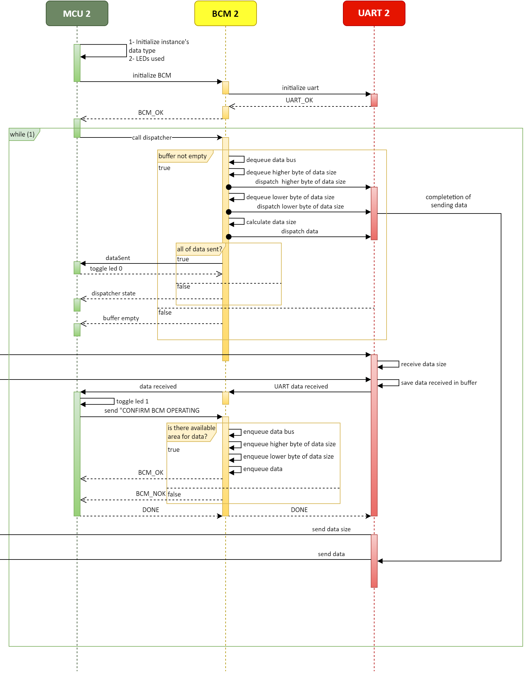

## State Machine Diagram

Zoom in for a better quality.

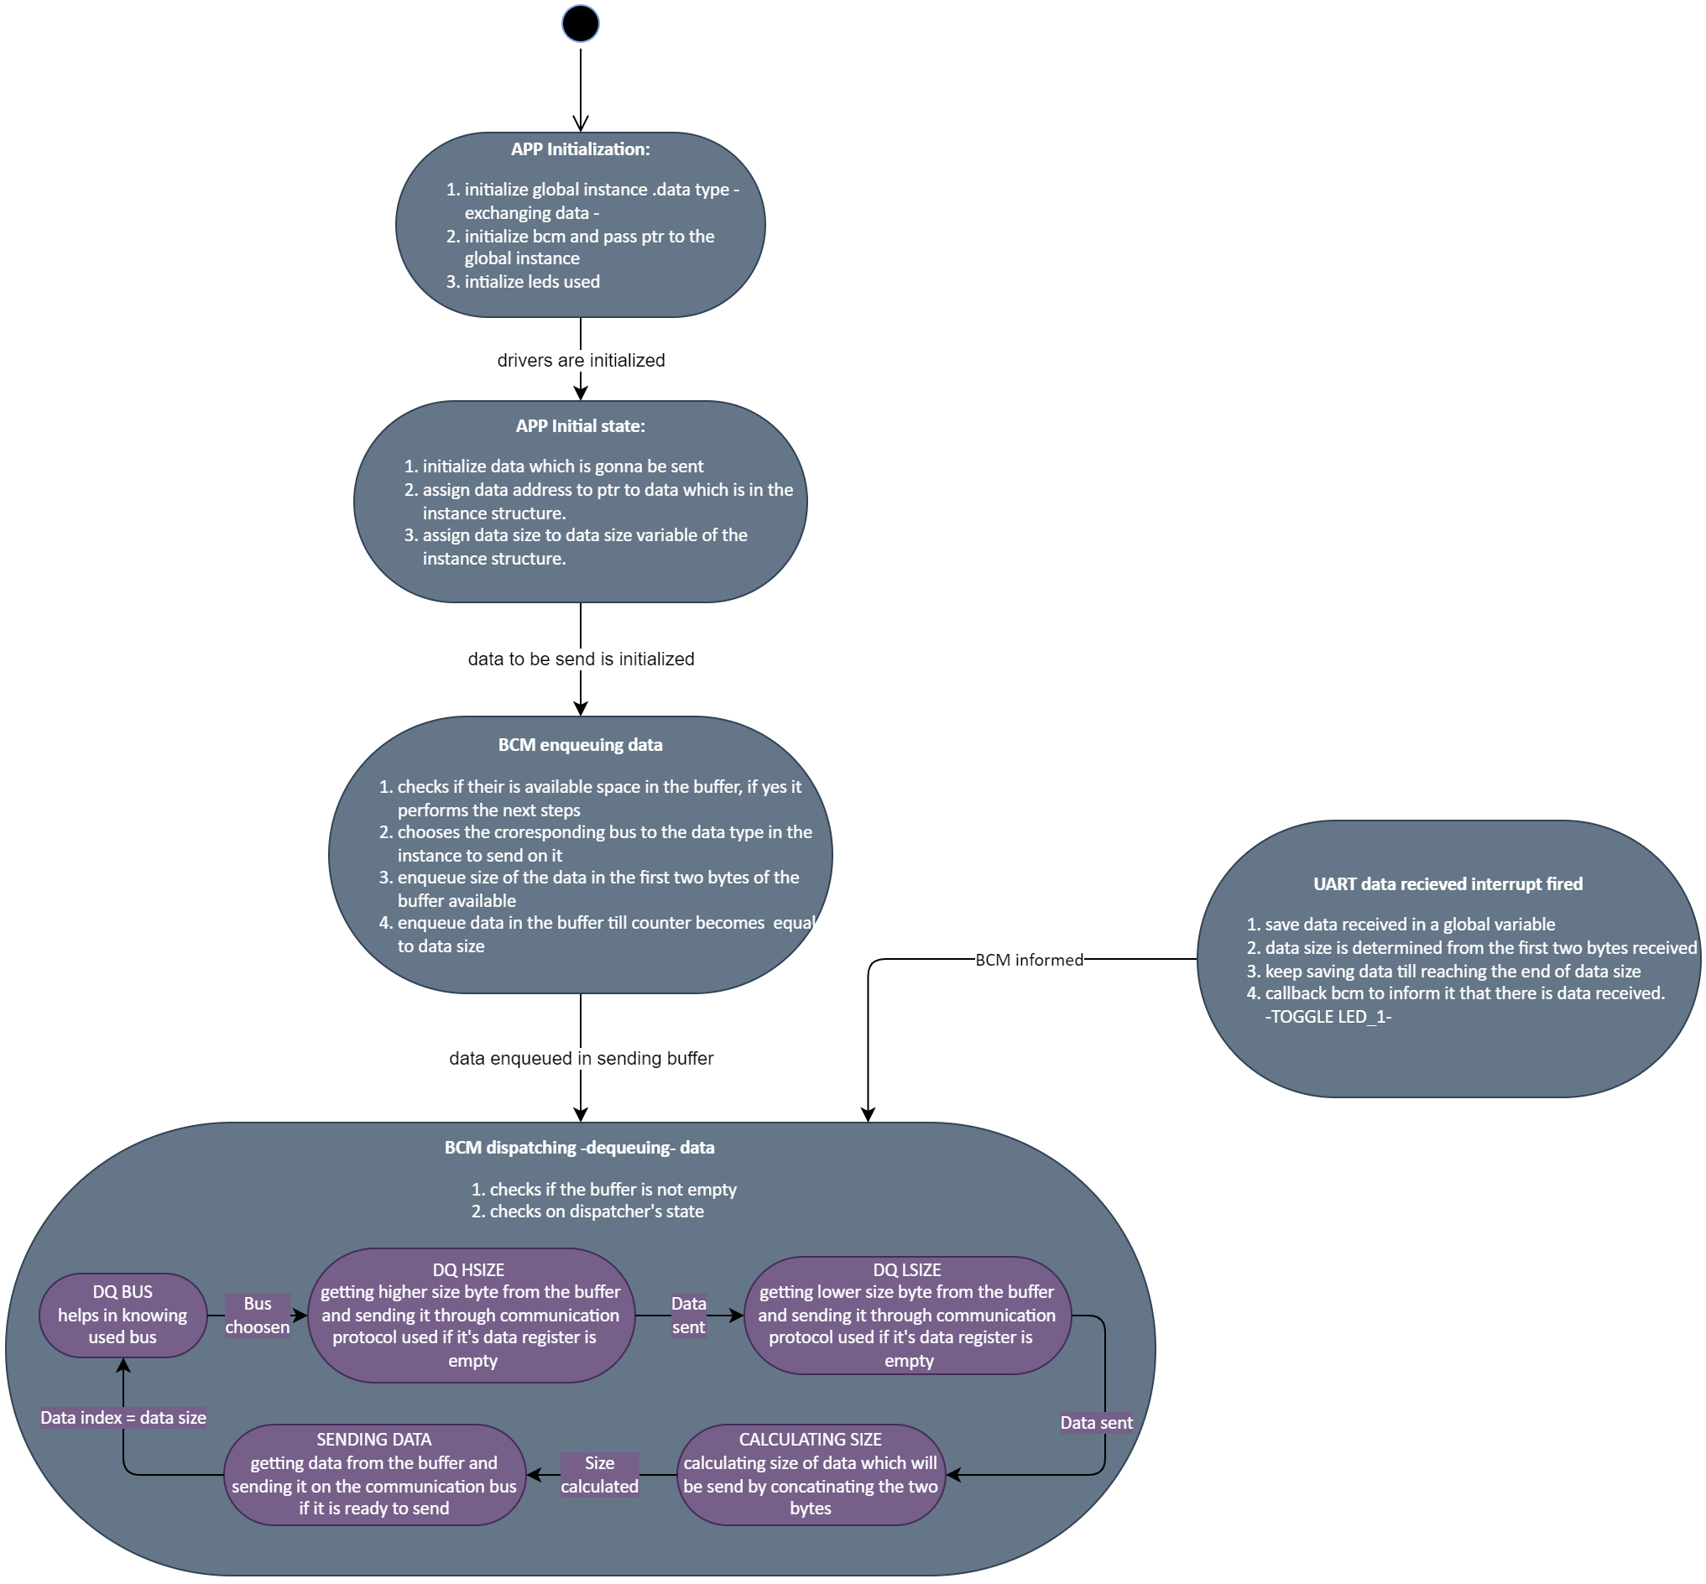

## BCM Data Buffer

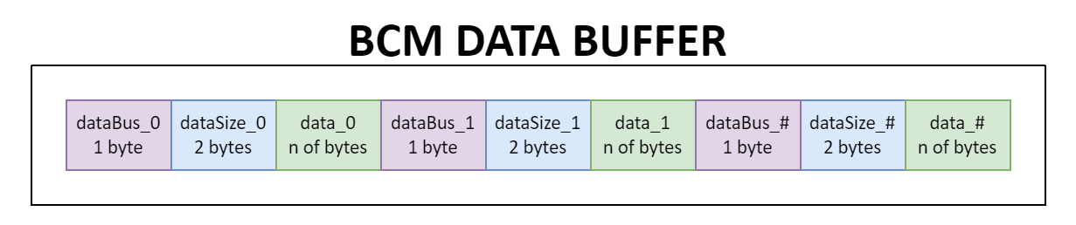

## Modules Description

### DIO (Digital Input/Output) Module

The DIO driver is responsible for reading input signals from the system's sensors (such as buttons) and driving output signals to the system's actuators (such as LEDs). It provides a set of APIs to configure the direction and mode of each pin (input/output, pull-up/down resistor), read the state of an input pin, and set the state of an output pin.

### UART

The UART driver is responsible for initializing UART channel to configured specifications, it is used to send data through it and receive data too. All of its tasks are non-blocking.

### LED

The LED driver is used to initialize LEDs used as output and control them as it can turn them on or off or toggle them.

### BCM

The BCM driver is used to initialize communication protocols used to send/receive specific data types, its responsible to manage the communication process.

## Drivers’ Documentation

### MCAL Drivers’ Functions

#### DIO Driver

DIO_init

|  |  |
| --- | --- |
| Syntax | DIO_init(uint8_t uint8_portNumber, uint8_t uint8_pinNumber, uint8_t uint8_direction) |
| Description | Initializes DIO pins’ direction, output current. |
| Sync\Async | Synchronous |
| Reentrancy | Reentrant |
| Parameters (in) | uint8_portNumber port number used  uint8_pinNumber pin number used  uint8_direction direction of the pin |
| Parameters (out) | None |
| Return value | enu_DIO_status_t DIO_OK  WRONG_PIN_NUMBER  WRONG_PORT_NUMBER  WRONG_DIRECTION |

DIO_write

|  |  |
| --- | --- |
| Syntax | DIO_write(uint8_t uint8_portNumber, uint8_t uint8_pinNumber, uint8_t uint8_value) |
| Description | Write on DIO pins’ a specific output High or Low. |
| Sync\Async | Synchronous |
| Reentrancy | Reentrant |
| Parameters (in) | uint8_portNumber port number used  uint8_pinNumber pin number used  uint8_value level of the pin |
| Parameters (out) | None |
| Return value | enu_DIO_status_t DIO_OK  WRONG_PIN_NUMBER  WRONG_PORT_NUMBER  WRONG_VALUE |

DIO_toggle

|  |  |
| --- | --- |
| Syntax | DIO_toggle(uint8_t uint8_portNumber, uint8_t uint8_pinNumber) |
| Description | Toggle the output of a specific pin. |
| Sync\Async | Synchronous |
| Reentrancy | Reentrant |
| Parameters (in) | uint8_portNumber port number used  uint8_pinNumber pin number used |
| Parameters (out) | None |
| Return value | enu_DIO_status_t DIO_OK  WRONG_PIN_NUMBER  WRONG_PORT_NUMBER |

DIO_read

|  |  |
| --- | --- |
| Syntax | DIO_read(uint8_t uint8_portNumber, uint8_t uint8_pinNumber, uint8_t *uint8_value) |
| Description | Read input from a pin and send it back in a pointer to uint8_t |
| Sync\Async | Synchronous |
| Reentrancy | Reentrant |
| Parameters (in) | uint8_portNumber port number used  uint8_pinNumber pin number used |
| Parameters (out) | uint8_value input value will be returned in that parameter |
| Return value | enu_DIO_status_t DIO_OK  WRONG_PIN_NUMBER  WRONG_PORT_NUMBER |

DIO_pinPullUp

|  |  |
| --- | --- |
| Syntax | DIO_pinPullUp(uint8_t uint8_portNumber, uint8_t uint8_pinNumber, uint8_t uint8_pullUpState) |
| Description | Disables/enables a pull up resistor to a specific input pin |
| Sync\Async | Synchronous |
| Reentrancy | Reentrant |
| Parameters (in) | uint8_portNumber port number used  uint8_pinNumber pin number used  uint8_pullUpState pullup state |
| Parameters (out) | None |
| Return value | enu_DIO_status_t DIO_OK  WRONG_PIN_NUMBER  WRONG_PORT_NUMBER  WRONG_VALUE |

#### UART Driver

UART_init

|  |  |
| --- | --- |
| Syntax | UART_init (void) |
| Description | Initializes UART pins’ direction, and specifications |
| Sync\Async | Synchronous |
| Reentrancy | Reentrant |
| Parameters (in) | None |
| Parameters (out) | None |
| Return value | enu_UART_status_t UART_OK = 0,  UART_NOK |

UART_deinit

|  |  |
| --- | --- |
| Syntax | UART_deinit (void) |
| Description | Deinitializes UART |
| Sync\Async | Synchronous |
| Reentrancy | Reentrant |
| Parameters (in) | None |
| Parameters (out) | None |
| Return value | enu_UART_status_t UART_OK = 0,  UART_NOK |

UART_sendByte

|  |  |
| --- | --- |
| Syntax | UART_sendByte (uint8_t byte) |
| Description | Sending one byte through UART channel |
| Sync\Async | Asynchronous |
| Reentrancy | Reentrant |
| Parameters (in) | uint8_byte |
| Parameters (out) | None |
| Return value | enu_UART_status_t UART_OK = 0,  UART_SENDING = 1,  UART_NOK |

UART_setCallBack

|  |  |
| --- | --- |
| Syntax | UART_setCallBack (void (*ptr_func)(void)) |
| Description | Set callback function |
| Sync\Async | Synchronous |
| Reentrancy | Reentrant |
| Parameters (in) | void (*ptr_func)(void) |
| Parameters (out) | None |
| Return value | enu_UART_status_t UART_OK = 0,  UART_NOK |

UART_receiveData

|  |  |
| --- | --- |
| Syntax | UART_receiveData(uint8_t** ptr_uint8_receivedData, uint16_t* uint16_dataSize) |
| Description | Receives data buffer |
| Sync\Async | Synchronous |
| Reentrancy | Reentrant |
| Parameters (in) | None |
| Parameters (out) | ptr_ptr_uint8_receivedData  ptr_uint16_dataSize |
| Return value | enu_UART_status_t UART_OK = 0,  UART_NOK |

UART_isEmpty

|  |  |
| --- | --- |
| Syntax | UART_isEmpty (void) |
| Description | Checks if data register is empty |
| Sync\Async | Synchronous |
| Reentrancy | Reentrant |
| Parameters (in) | None |
| Parameters (out) | ptr_uint8_receivedData  ptr_uint16_dataSize |
| Return value | enu_UART_bufferStatus_t UART_BUFFER_NEMPTY  UART_BUFFER_EMPTY |

### HAL Drivers’ Functions

#### LED

LED_init

|  |  |
| --- | --- |
| Syntax | LED_init(void) |
| Description | Initializes LED pins’ direction as output |
| Sync\Async | Synchronous |
| Reentrancy | Reentrant |
| Parameters (in) | None |
| Parameters (out) | None |
| Return value | enu_LED_status_t LED_OK= 0,  LED_WRONG_LED_PORT  LED_WRONG_LED_PIN |

LED_on

|  |  |
| --- | --- |
| Syntax | LED_on(uint8_t uint8_ledID) |
| Description | Turns on a specific LED |
| Sync\Async | Synchronous |
| Reentrancy | Reentrant |
| Parameters (in) | uint8_ledID |
| Parameters (out) | None |
| Return value | enu_LED_status_t LED_OK= 0,  LED_WRONG_LED_PORT  LED_WRONG_LED_PIN |

LED_off

|  |  |
| --- | --- |
| Syntax | LED_off(uint8_t uint8_ledID) |
| Description | Turns off a specific LED |
| Sync\Async | Synchronous |
| Reentrancy | Reentrant |
| Parameters (in) | uint8_ledID |
| Parameters (out) | None |
| Return value | enu_LED_status_t LED_OK= 0,  LED_WRONG_LED_PORT  LED_WRONG_LED_PIN |

LED_toggle

|  |  |
| --- | --- |
| Syntax | LED_toggle(uint8_t uint8_ledID) |
| Description | Toggles a specific LED |
| Sync\Async | Synchronous |
| Reentrancy | Reentrant |
| Parameters (in) | uint8_ledID |
| Parameters (out) | None |
| Return value | enu_LED_status_t LED_OK= 0,  LED_WRONG_LED_PORT  LED_WRONG_LED_PIN |

### SERVER Drivers’ functions

#### BCM

BCM_init

|  |  |
| --- | --- |
| Syntax | BCM_init (str_BCM_instance_t* ptr_str_BCM_instance) |
| Description | Initializes a specific communication protocol |
| Sync\Async | Synchronous |
| Reentrancy | Reentrant |
| Parameters (in) | ptr_str_BCM_instance |
| Parameters (out) | None |
| Return value | enu_BCM_status_t BCM_OK = 0,  BCM_NOK |

BCM_deinit

|  |  |
| --- | --- |
| Syntax | BCM_deinit (str_BCM_instance_t* ptr_str_BCM_instance) |
| Description | Deinitializes a specific communication protocol |
| Sync\Async | Synchronous |
| Reentrancy | Reentrant |
| Parameters (in) | ptr_str_BCM_instance |
| Parameters (out) | None |
| Return value | enu_BCM_status_t BCM_OK = 0,  BCM_NOK, |

BCM_send_n

|  |  |
| --- | --- |
| Syntax | BCM_send_n (str_BCM_instance_t* ptr_str_BCM_instance) |
| Description | Enqueue any amount of data in data buffer to be send through a specific communication protocol using dispatcher |
| Sync\Async | Synchronous |
| Reentrancy | Reentrant |
| Parameters (in) | ptr_str_BCM_instance |
| Parameters (out) | None |
| Return value | enu_BCM_status_t BCM_OK = 0,  BCM_NOK,  BCM_FULL |

BCM_dispatcher

|  |  |
| --- | --- |
| Syntax | BCM_dispatcher (void) |
| Description | Dequeue the data from data buffer and send it through a specific communication protocol |
| Sync\Async | Asynchronous |
| Reentrancy | Reentrant |
| Parameters (in) | ptr_str_BCM_instance |
| Parameters (out) | None |
| Return value | enu_BCM_status_t BCM_OK = 0,  BCM_NOK,  BCM_EMPTY |

BCM_receiveData

|  |  |
| --- | --- |
| Syntax | BCM_receiveData (uint8_t**ptr_ptr_uint8_receivedData, uint16_t* ptr_uint16_dataSize) |
| Description | Receives address of data received to a specific communication protocol and the size of it |
| Sync\Async | Synchronous |
| Reentrancy | Reentrant |
| Parameters (in) | None |
| Parameters (out) | ptr_ptr_uint8_receivedData  ptr_uint16_dataSize |
| Return value | enu_BCM_status_t BCM_OK = 0,  BCM_NOK, |

BCM_setCallBack

|  |  |
| --- | --- |
| Syntax | BCM_setCallBack(str_BCM_instance_t* ptr_str_BCM_instance, void(*ptr_func) (void)) |
| Description | Set callback function, which is called when there is data received through any communication protocol |
| Sync\Async | Synchronous |
| Reentrancy | Reentrant |
| Parameters (in) | ptr_str_BCM_instance  void(*ptr_func) (void) |
| Parameters (out) | None |
| Return value | enu_BCM_status_t BCM_OK = 0,  BCM_NOK, |

BCM_dataSentCallBack

|  |  |
| --- | --- |
| Syntax | BCM_ dataSentCallBack (void(*ptr_func) (void)) |
| Description | Set callback function, which is called when there is data transmitted through any communication protocol |
| Sync\Async | Synchronous |
| Reentrancy | Reentrant |
| Parameters (in) | void(*ptr_func) (void) |
| Parameters (out) | None |
| Return value | enu_BCM_status_t BCM_OK = 0,  BCM_NOK |

#### Queue

QUEUE_isFull

|  |  |
| --- | --- |
| Syntax | QUEUE_isFull(sint16_t sint16_front, sint16_t sint16_rear, uint16_t uint16_queueSize) |
| Description | Checks if the queue is full or not |
| Sync\Async | Synchronous |
| Reentrancy | Reentrant |
| Parameters (in) | sint16_front  sint16_rear  uint16_queueSize |
| Parameters (out) | None |
| Return value | enu_BCM_status_t QUEUE_NFULL = 0,  QUEUE_FULL, |

QUEUE_isEmpty

|  |  |
| --- | --- |
| Syntax | QUEUE_isEmpty(sint16_t sint16_front) |
| Description | Checks if the queue is empty or not |
| Sync\Async | Synchronous |
| Reentrancy | Reentrant |
| Parameters (in) | sint16_front |
| Parameters (out) | None |
| Return value | enu_BCM_status_t QUEUE_NEMPTY,  QUEUE_EMPTY |

QUEUE_enQueue

|  |  |
| --- | --- |
| Syntax | QUEUE_enQueue( sint16_t* ptr_sint16_front, sint16_t* ptr_sint16_rear, uint8_t* ptr_uint8_queue, uint16_t uint16_queueSize, uint8_t uint8_element) |
| Description | Enqueue an element in the queue |
| Sync\Async | Synchronous |
| Reentrancy | Reentrant |
| Parameters (in) | ptr_uint8_queue  uint8_element  uint16_queueSize |
| Parameters (out) | ptr_sint16_front  ptr_sint16_rear |
| Return value | enu_BCM_status_t QUEUE_NFULL = 0,  QUEUE_FULL |

QUEUE_deQueue

|  |  |
| --- | --- |
| Syntax | QUEUE_deQueue(sint16_t* ptr_sint16_front, sint16_t* ptr_sint16_rear, uint8_t* ptr_uint8_queue, uint16_t uint16_queueSize, uint8_t* ptr_uint8_element) |
| Description | Dequeue an element from the queue |
| Sync\Async | Synchronous |
| Reentrancy | Reentrant |
| Parameters (in) | ptr_uint8_queue  uint16_queueSize |
| Parameters (out) | ptr_sint16_front  ptr_sint16_rear  ptr_uint8_element |
| Return value | enu_BCM_status_t QUEUE_NEMPTY,  QUEUE_EMPTY |

# Low Level Design

## MCAL Layer

### DIO Module

#### DIO_init

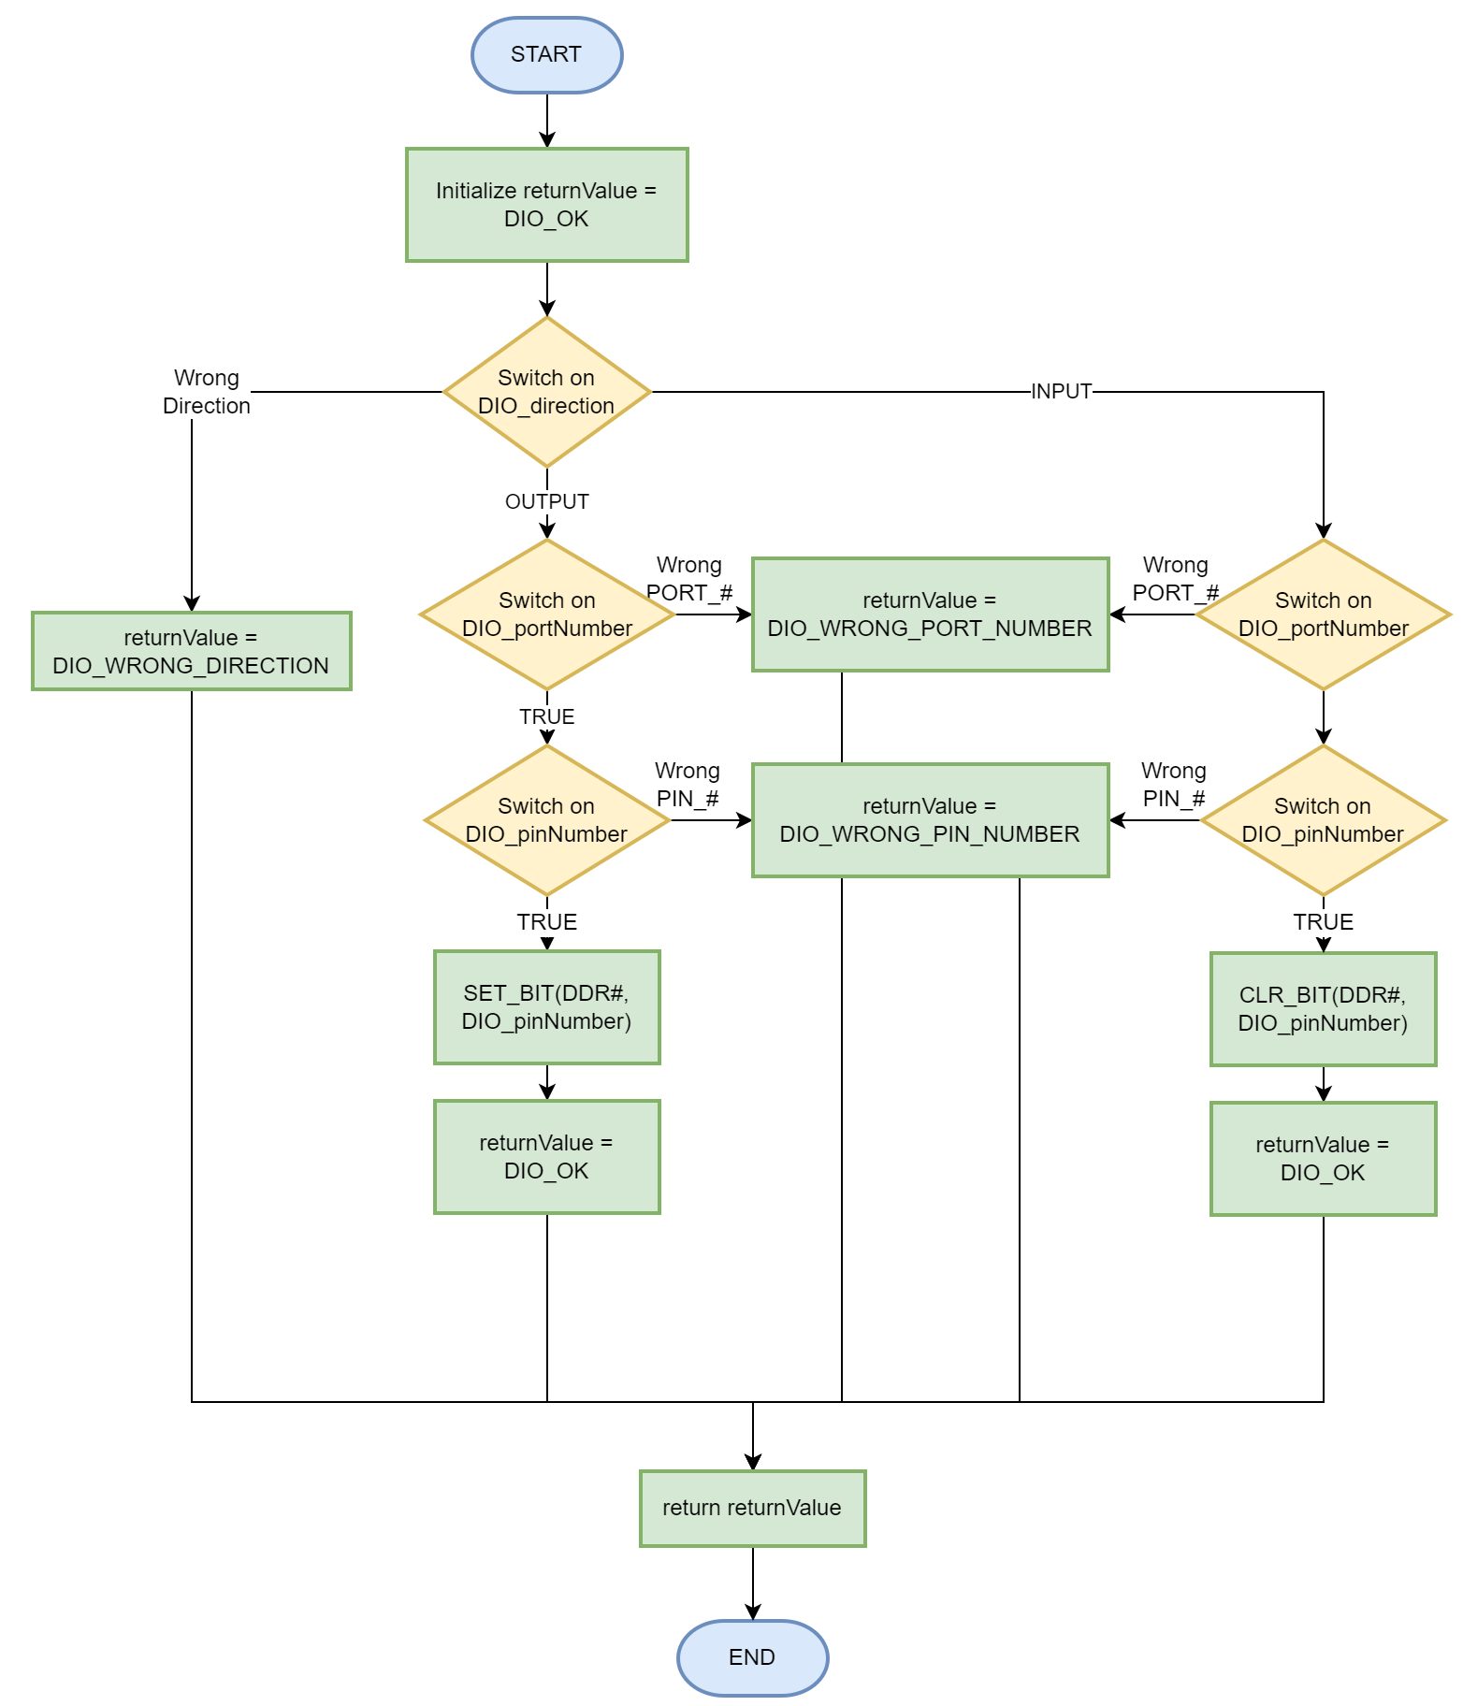

#### DIO_write

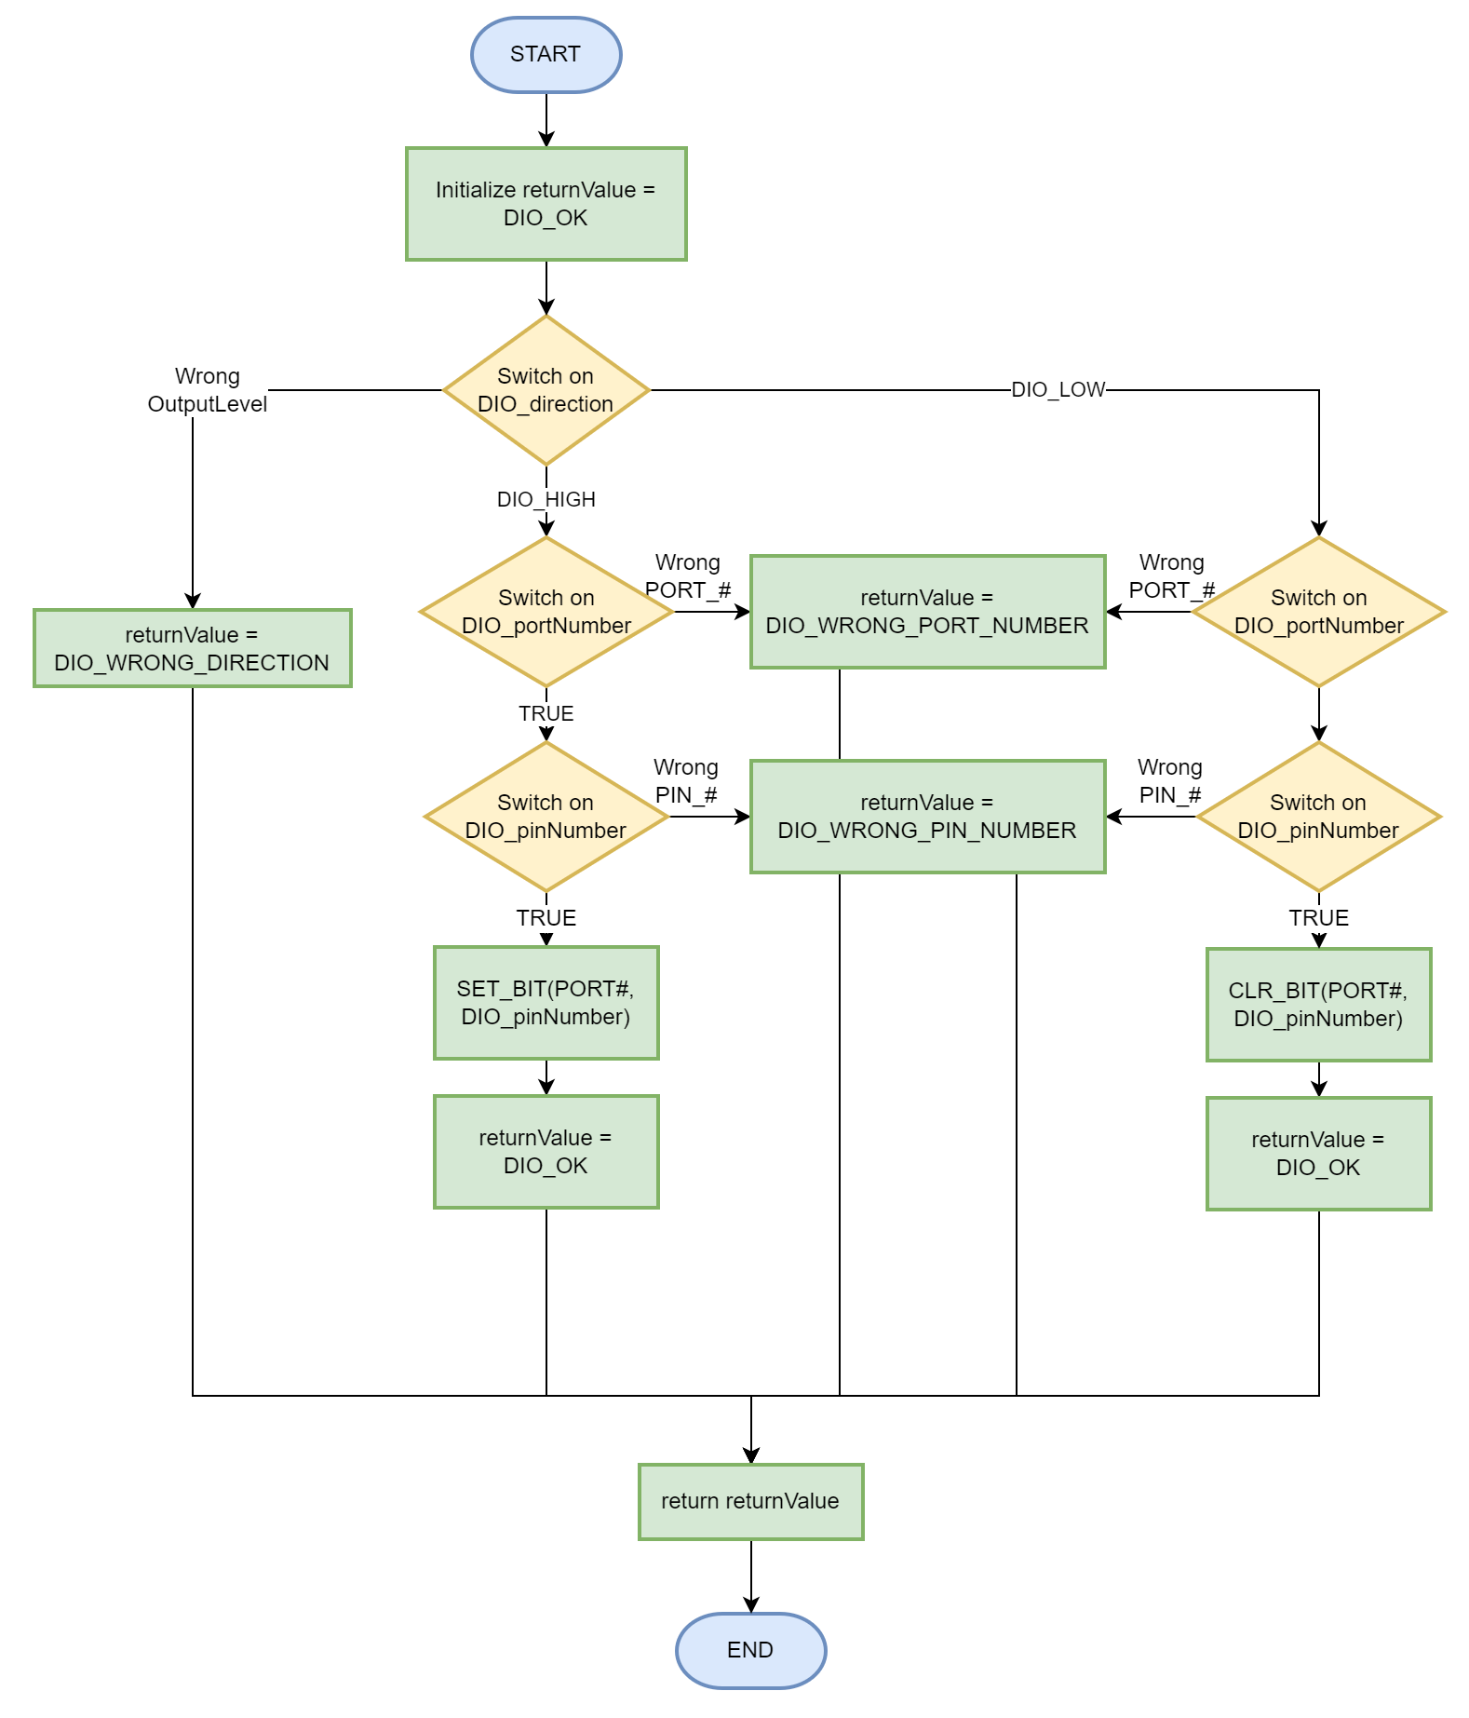

#### DIO_read

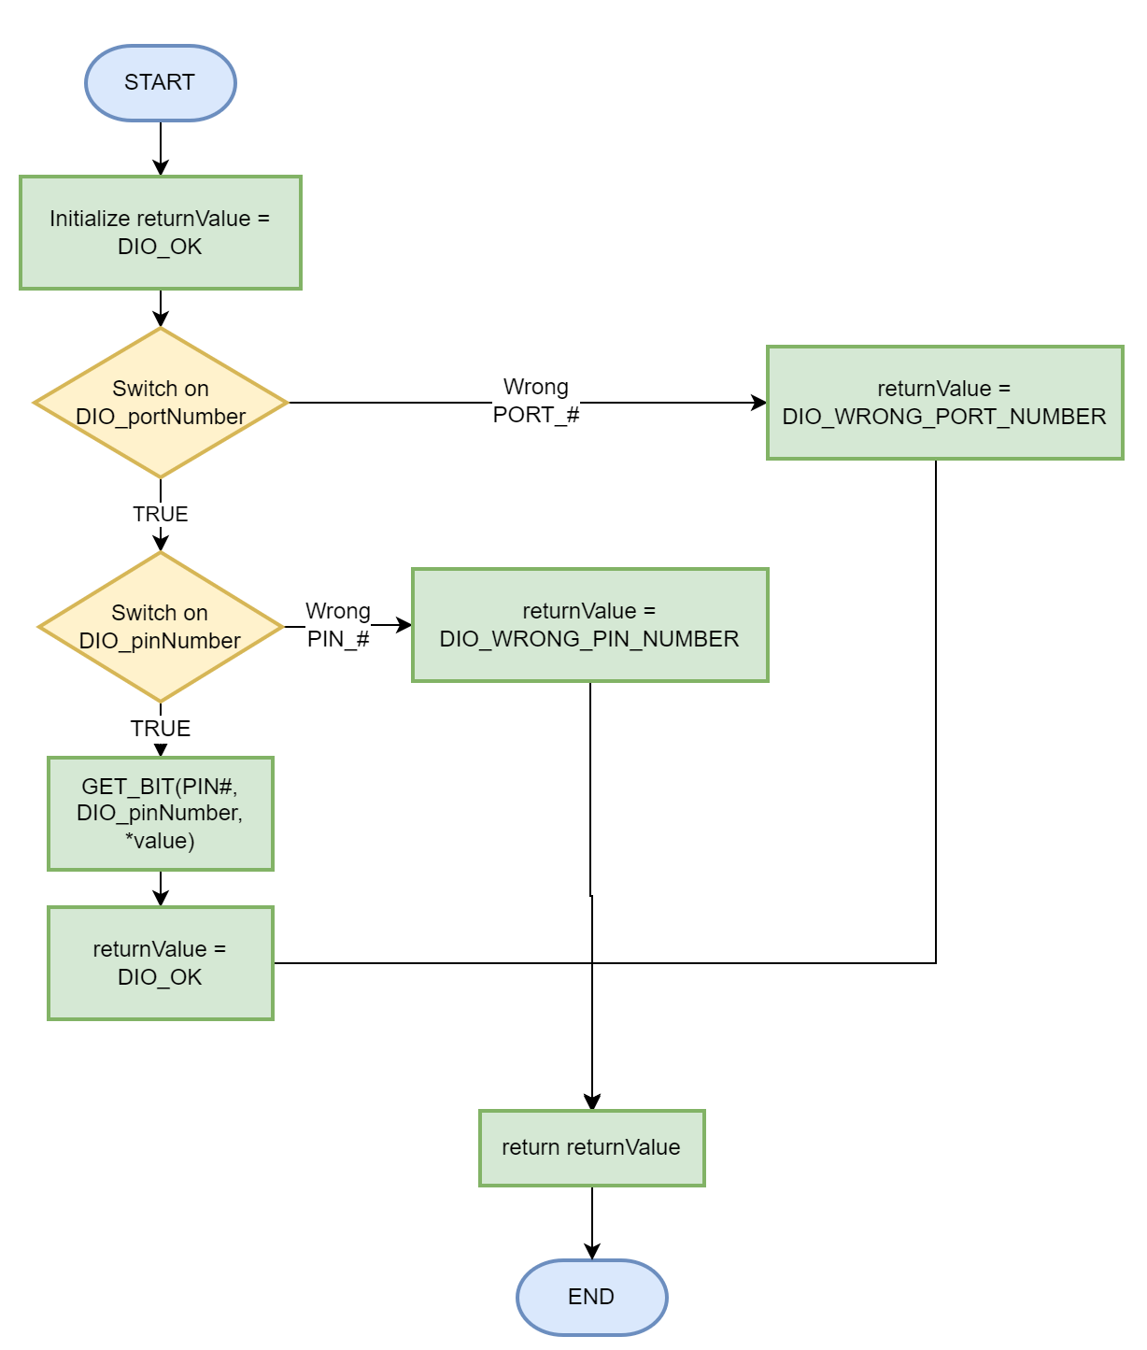

#### DIO_toggle

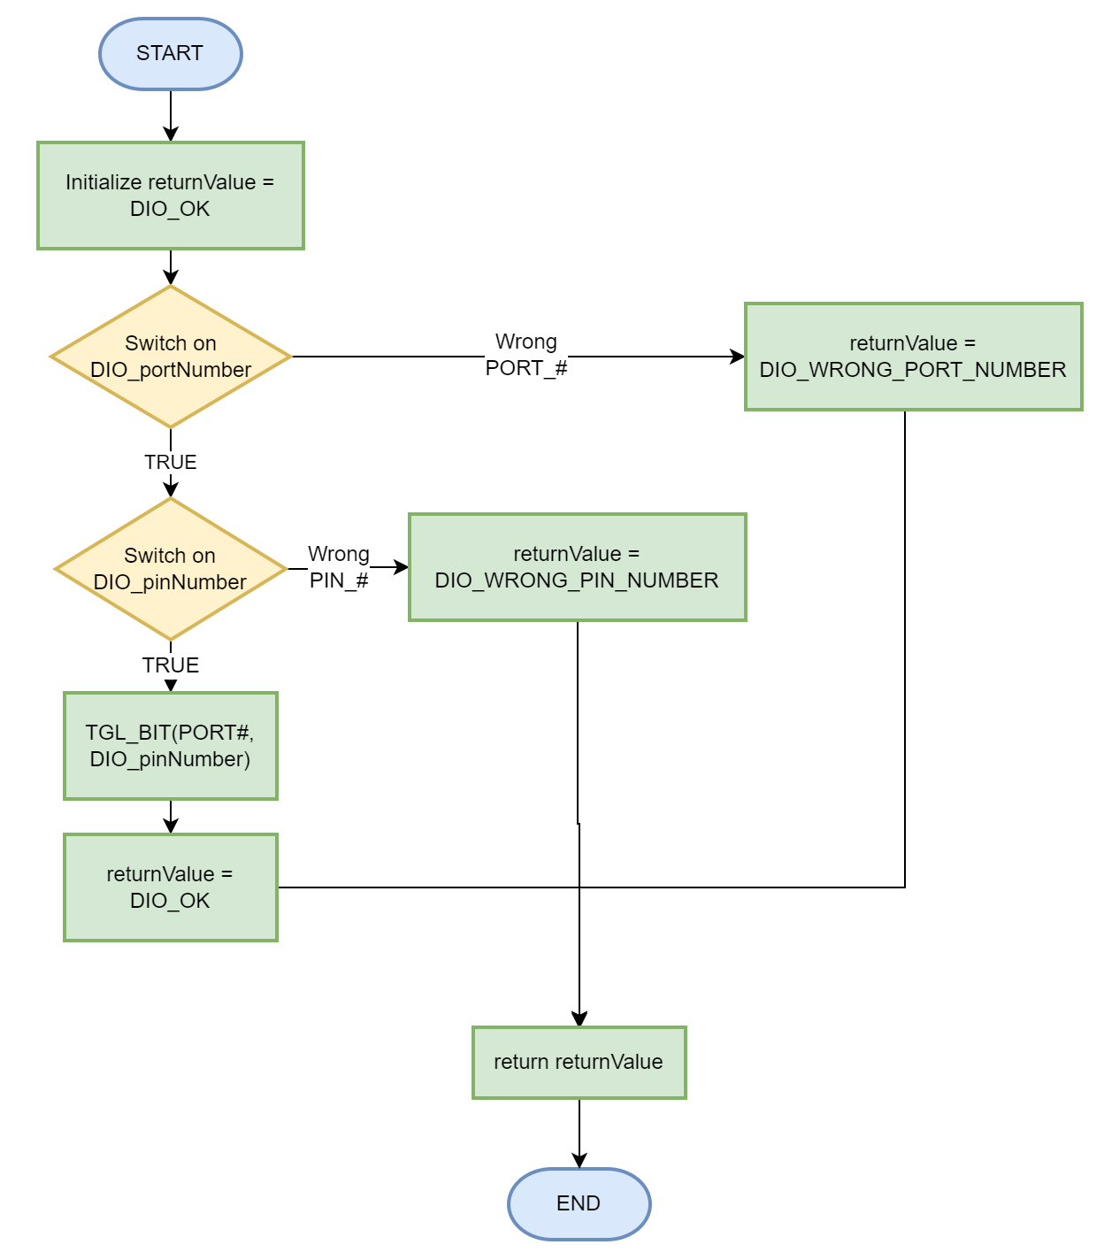

#### DIO_pinPullUp

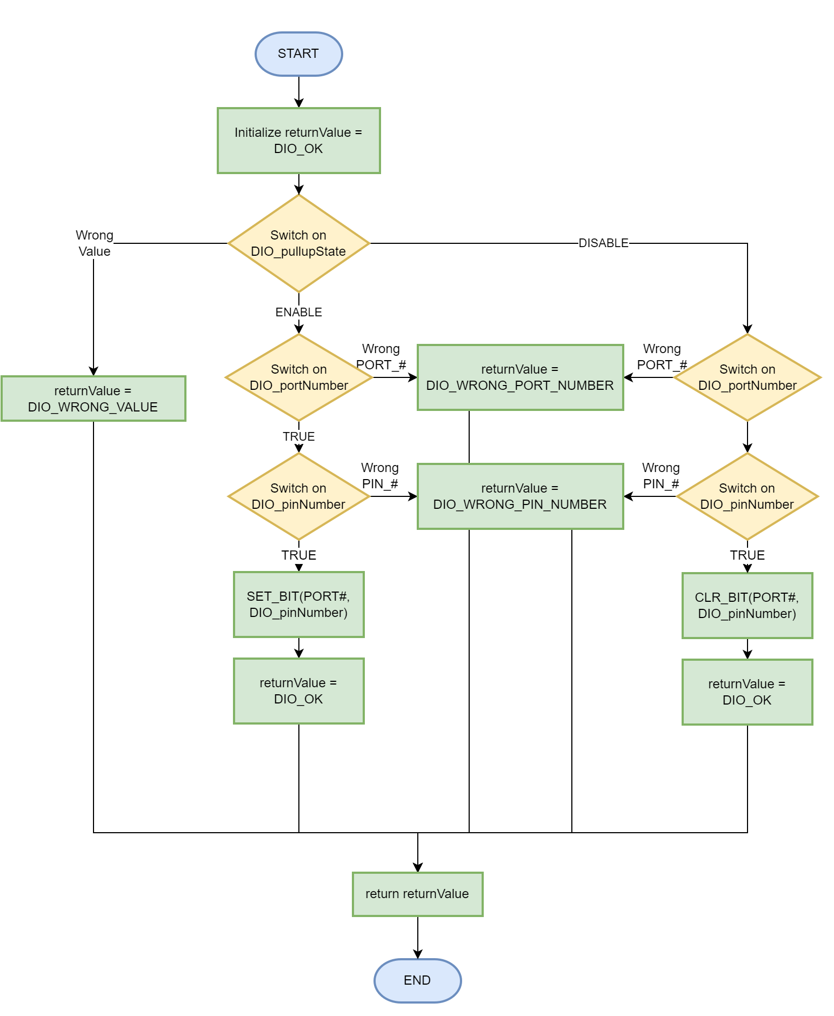

### UART

#### UART_init

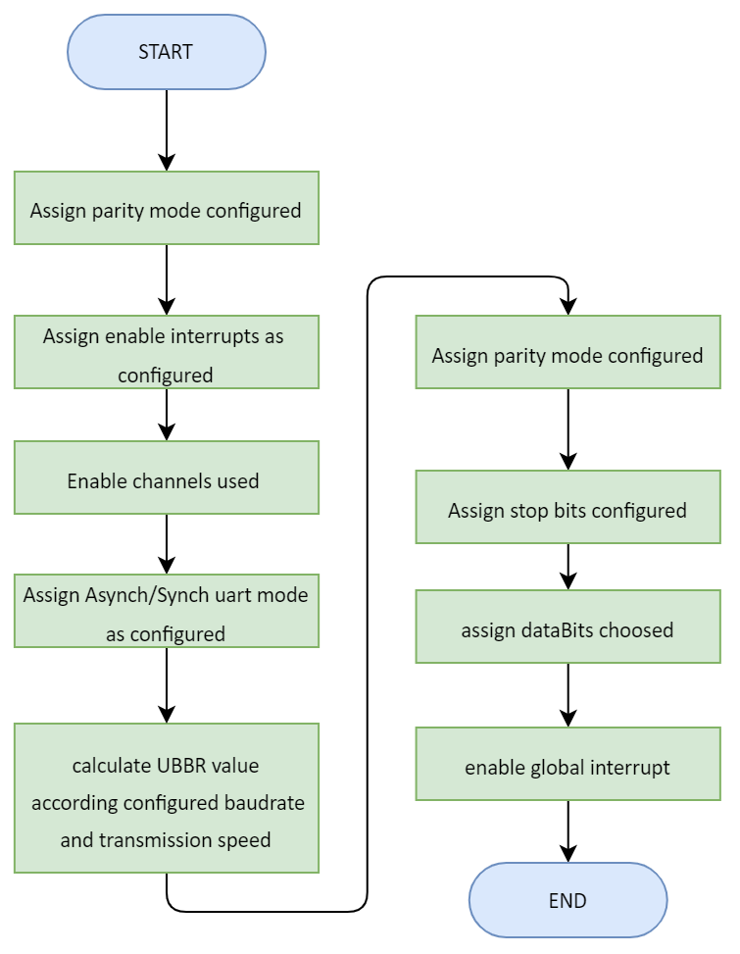

#### UART_deinit

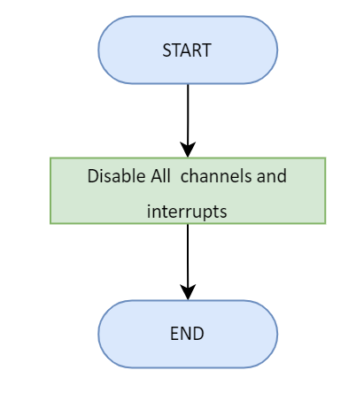

##### UART_sendByte

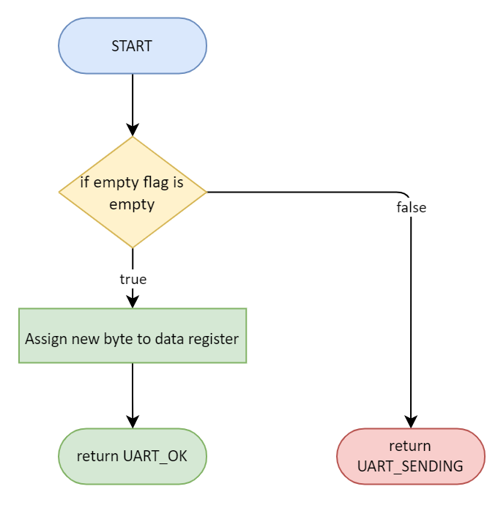

#### ISR(USART_RXC_INT)

## Server Layer

### BCM

#### Send a specific byte process

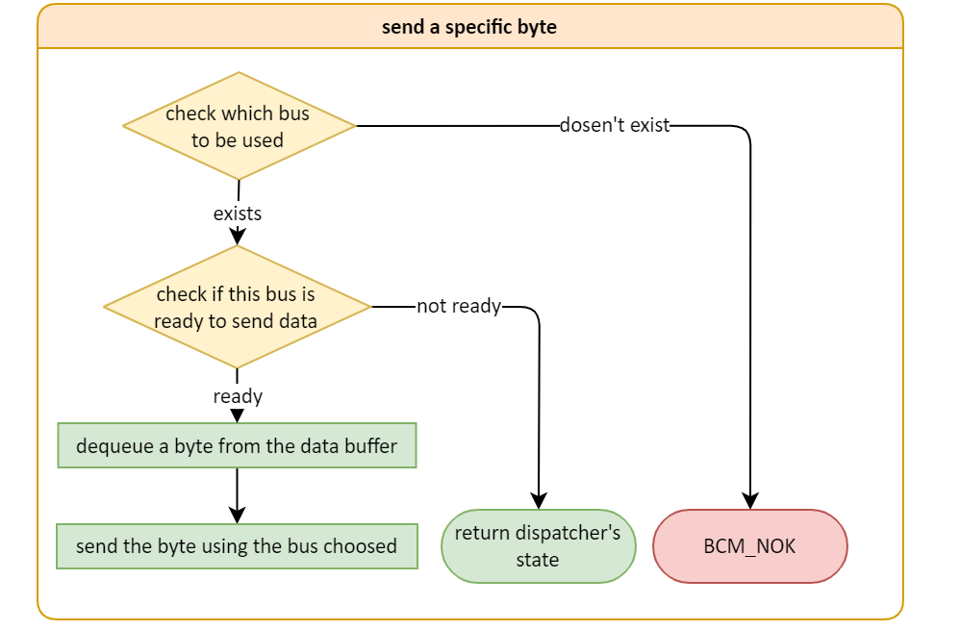

#### BCM_init

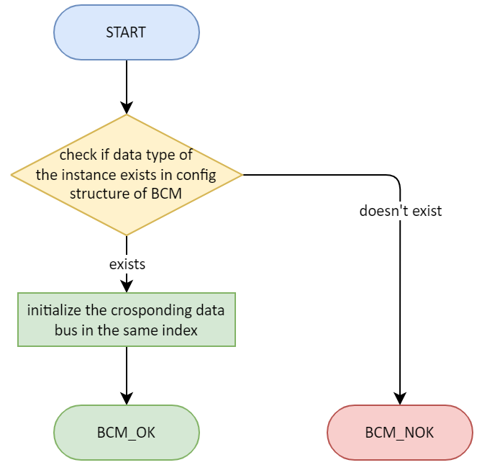

#### BCM_deinit

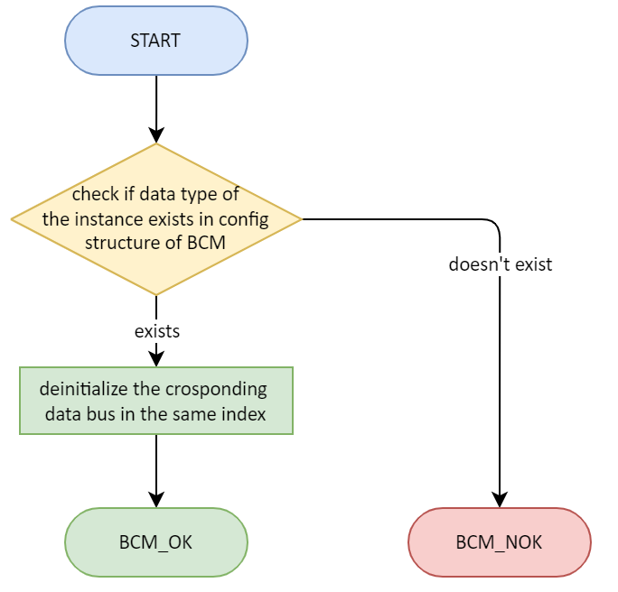

#### BCM_send_n

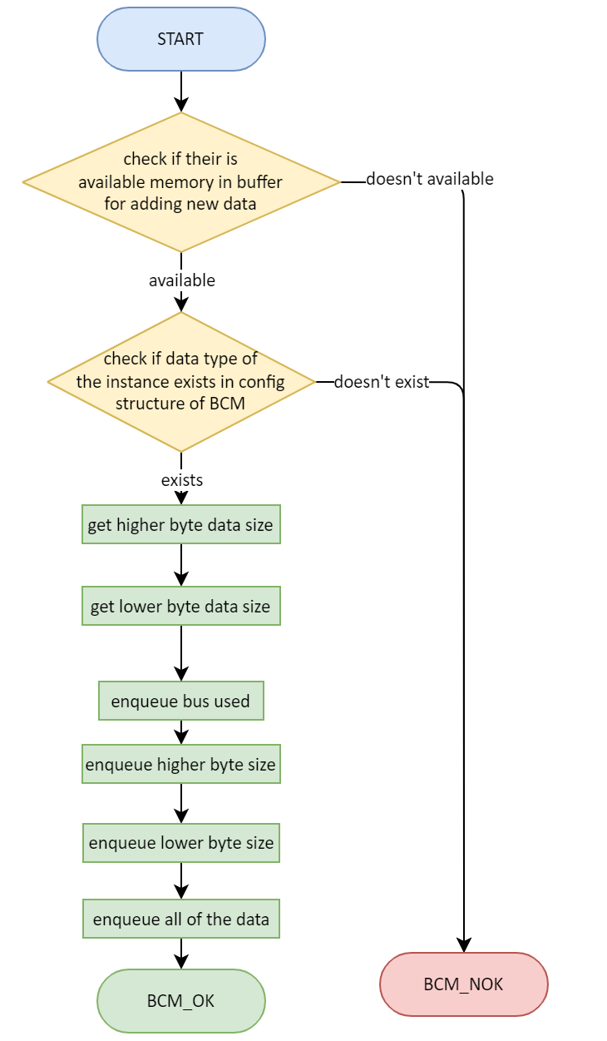

#### BCM_dispatcher

