**Research Question**

Public transportation plays an important role in terms of efficiently moving crowd from A to B. Each kind of vehicles e.g. tram, bus, taxi have different characteristics which in turn provides diverse functionalities. The one drives faster usually take less people, while other slow moving vehicles carry more passengers. With all these distinct elements working together, a traffic system is formed. Resembling the ants moving foods back to the nest, a group of different transportations roaming in the city can also be treated as agents transporting passengers individually. In this project, the main interest is to study the emergent behavior of three kinds of vehicles transporting people at the same time. These agents, namely, the tram, bus and taxi are set in a scenario where a concert is over and crowds are waiting to be lifted to some destinations. The overall dynamics of transportation process will be simulated, and it is influenced by the number of people (audience in concert), the performance of collision avodidance as well as some random factors introduced.

The simulate environment will be a closed world with places for entertainment, offices, schools and homes. The simulation will be of the traffic of a typical working day in an urban environment. The time and space will be scaled.

The environment will be modeled using nodes for junctions and the pathways as links, in which some pathways have more than 2 lanes to allow overtaking behavior. This environment will be randomly generated in a predefined space.

Each individual (agents) will have their goals designed to imitate a regular life of a person. There will be different personalities such as aggressive, defensive, speedy, and drunk.

**State of the Art**

More popular models include to follow. Models such as the cellular automata model designed by Nagel and Schreckenberg treats the vehicles as individual agents with a set of given rules, also exhibit the complex phenomena associated with real traffic [1][2]. The interactions are largely governed by car-following and lane-changing logic [3][4][5]. One well-known model, among various vehicle following models, which attempt to describe vehicle following based on anti-collision concept is the “Gipps model”, developed in 1981 [5][6]. In this model a vehicle always aims to be able to stop safely if the vehicle it is following performs an emergency stop [6]. Another class of models, known as the “Psycho-physical” vehicle models attempt to capture both the physical and human components of vehicle control. They do this by maintaining a vehicle state, where the current state is determined through the differences in speed and distance to the leading vehicle [4].

Chen and Zhan evaluate simultaneous and staged evacuation strategies in their paper related to urban evacuation. This problem is analogous to our goal to evaluate the time taken by all attendees of a concert to reach their home/destination. In the paper Chen and Zhan, models the roads as links and junctions as nodes with two different types of networking – ring and grid as they are widely used in many cities. They modeled the agents to know the shortest route to reach their destination and also had a timing plan implemented for the agents leaving the site. However, the paper only evaluates two types of driver – aggressive and conservative, thus simplifying the real-world scenario. There was no best evacuation strategy found using simulation, but for high population density in a grid networked city staged evacuation works better. For free flow traffic situation with no traffic, the simultaneous evacuation strategy yielded better result [11].

**Methodology**

Initially a fixed number of people(subjects) at the concert location are assigned. The idea is to have the subjects leave the Concert Location by taking either of the three forms of Transportation (*Tram, Bus, Taxi*) to their specific destinations.

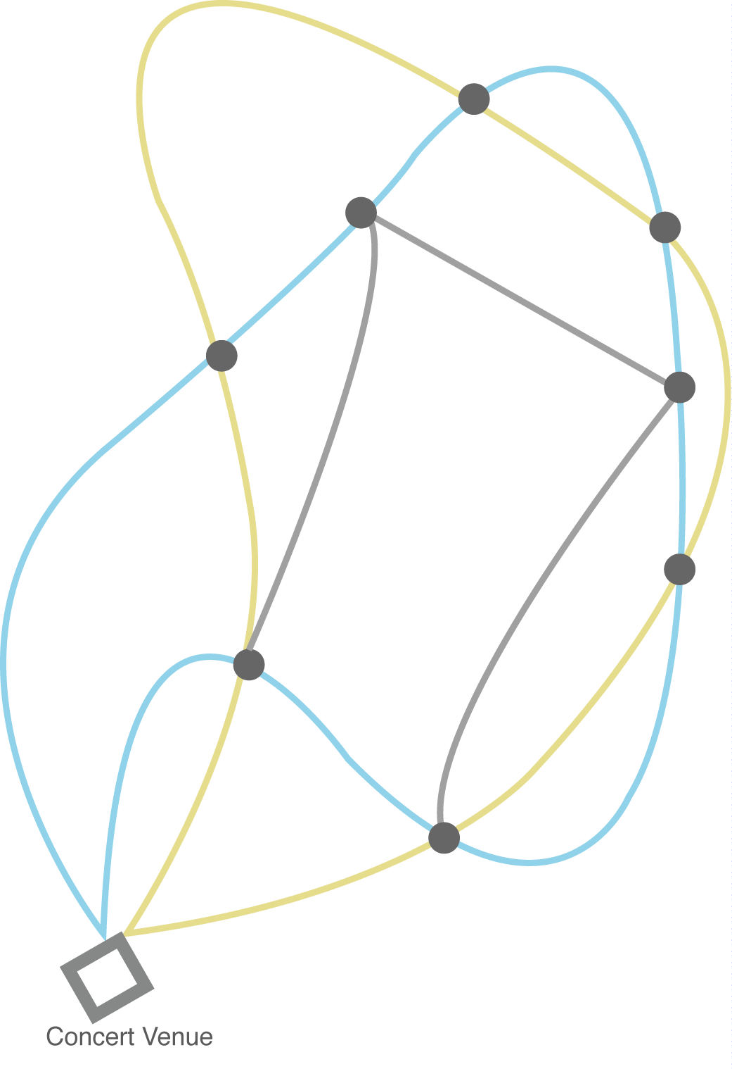A map of a part of the city is defined with a fixed road network. The various elements of the environment, the Concert location, Tram/bus stations etc. all are defined within that network. All forms of Transportations use the road network. The Tram has a fixed looped route where different fixed stoppages are defined within that route.

The Busses also have a fixed looped route with fixed stops within that route.

The Taxis however have no fixed route and can take any route available depending on the destinations to be served.

The routes of all the three modes of transportation can also intersect.

Example Road map

The properties of vehicles are listed below:

|  |  |  |  |  |  |
| --- | --- | --- | --- | --- | --- |
| Transportation | Route | Speed | Capacity | Amount | Destination |
| *Tram* | Fixed | Slow | 50 | fixed | Stops/Bahnhof |
| *Bus* | Fixed | Decent | 30 | fixed | Bus Stop/U-Bahn/Bahnhof |
| *Taxi* | Random | Fast | 4 | fixed | Random coordinates |

Also, some basic behaviors are also assigned to the drivers of these three different modes of transportations.

*The Trams* drivers are defined as to be more defensive in their operations where they usually will follow one fixed path, catering to subjects with final destinations only in that path.

*The Buses* drive although in one fixed path however has a 10%(say) chance that the drivers are drunk. This will cause the driver to miss one stop and the subject(s) who had to get down at that stop will now have to wait for the bus to reach that stop again in the next loop(journey), thus reducing the total number of new people to board into the bus to the next trip.

*The Taxi* driver is defined to be more aggressive and will always tend to take the shortest path to the destinations assigned by the passengers.

The simulation starts with the number of People(subjects), leaving the Concert, entered and ends when the number of people left at the concert venue is 0. The output of the simulation will give, among other things, the time required for all the people to leave the concert location. The subjects are only allowed to use the three forms of transportation and choose the one appropriate as per their destination. The vehicles can also carry only fixed number of passengers, equal or less to the total capacity. The trams will always move with a slower than average speed and will essentially follow a fixed path. Since there is a probability of the Bus driver being drunk, the Bus may miss one or more of its Stops and then they are penalized accordingly. The Taxis will always tend to take the shortest route.

Since there are fixed number of roads and there is always a possibility of a collision between the various vehicle types. Owing to that a collision avoidance system is also considered. This means that a vehicle must stop at the junction if another vehicle is approaching. When two kinds of transportation meet at the crossroad, the priority to have the way is suggested to be ***TRAM > BUS > TAXI.***

References

[1] P. Ball, Critical Mass: How One Thing Leads to Another. London: Arrow, 2005.

[2] K. Nagel and M. Schreckenberg, “A cellular automaton model for freeway traffic,” J. Phys. I, vol. 2, no. 12, pp. 2221–2229, Dec. 1992.

[3] G. Lind et al., “Best Pratice Manual,” Deliv. D8 SMARTEST Proj. Disponível Em Httpwww Its Leeds Ac Ukprojectssmartestdelivd8 Html Acessado Cm 05 Maio 2002, 1999.

[4] T. Schulze and T. Fliess, “Urban Traffic Simulation with Psycho-physical Vehicle-following Models,” in Proceedings of the 29th Conference on Winter Simulation, Washington, DC, USA, 1997, pp. 1222–1229.

[5] “Traffic Simulation using Agent-Based Modelling | Andrew Lansdowne.” .

[6] G.-L. Chang and T. Junchaya, “Simulating Network Traffic Flows with a Massively Parallel Computing Architecture,” in Proceedings of the 25th Conference on Winter Simulation, New York, NY, USA, 1993, pp. 762–770.

[7] J. Ferber, Multi-agent systems: An introduction to distributed artificial intelligence, 1 edition. Harlow: Addison-Wesley Professional, 1999.

[8] M. Kolp, B. Henderson-Sellers, H. Mouratidis, A. Garcia, A. Ghose, and P. Bresciani, Agent-Oriented Information Systems IV: 8th International Bi-Conference Workshop, AOIS 2006, Hakodate, Japan, May 9, 2006 and Luxembourg, Luxembourg, June 6, 2006, Revised Selected Papers. Springer, 2008.

[9] Tesla, “Tesla Press Information”, Tesla, 04/2017. [Online] Available:

<Https://www.tesla.com/presskit/autopilot>. [Accessed 2017]

[10] Al-Sultan, S., Al-Doori, M., Al-Bayatti, A.H., Zedan, H. (2013). A comprehensive survey on vehicular Ad Hoc network . Journal of Network and Computer Applications 37(1):380–392. January 2014. <https://www.researchgate.net/publication/259520963_A_comprehensive_survey_on_vehicular_Ad_Hoc_network>

[11] Chen, X. , Zhan, F.B. (2008). Agent-based modelling and simulation of urban evacuation: relative effectiveness of simultaneous and staged evacuation strategies. Journal of the Operational Research Society, 59, pp. 25-33. <https://www.researchgate.net>

Timeline

|  |  |  |  |  |  |  |  |  |  |  |  |
| --- | --- | --- | --- | --- | --- | --- | --- | --- | --- | --- | --- |
|  | April | | | May | | | | | June | | |
| 4/10 | 4/17 | 4/24 | 5/1 | 5/8 | 5/15 | 5/22 | 5/29 | 6/5 | 6/12 | 6/19 |
| Expose |  |  |  |  |  |  |  |  |  |  |  |
| - Research questions |  |  |  |  |  |  |  |  |  |  |  |
| - Project timeline |  |  |  |  |  |  |  |  |  |  |  |
| - Research State of the art |  |  |  |  |  |  |  |  |  |  |  |
| - Project structure |  |  |  |  |  |  |  |  |  |  |  |
| Model the system |  |  |  |  |  |  |  |  |  |  |  |
| - UML-diagrams |  |  |  |  |  |  |  |  |  |  |  |
| Implementation |  |  |  |  |  |  |  |  |  |  |  |
| - Set up platform |  |  |  |  |  |  |  |  |  |  |  |
| - Implement the world |  |  |  |  |  |  |  |  |  |  |  |
| - Implement a single car |  |  |  |  |  |  |  |  |  |  |  |
| - Test run |  |  |  |  |  |  |  |  |  |  |  |
| - Expand the population |  |  |  |  |  |  |  |  |  |  |  |
| Project Report |  |  |  |  |  |  |  |  |  |  |  |
| Project Presentation |  |  |  |  |  |  |  |  |  |  |  |