Predicting Mental Health Risk Levels
Using Sociodemographic and Mental Disorder Factors:
A Classification-Based Assessment Model

A Manuscript Document presented to
the Faculty of the College of Information and Computing Sciences
Mindanao State University
in Partial Fulfillment
of the Requirements for the course
ISY115

by:

Abdulkarim, Hamad D.
Ansary, Sausanah M.
Macarandas, Rohaimah S.

Ms. Nornina J. Dia

December 11, 2025
Abstract
This study aims to predict mental health risk levels—categorized as low, medium, or high—using basic demographic factors (age and gender) along with participants’ responses on stress level, depression score, and anxiety score from a survey. By analyzing cleaned survey data and applying simple predictive techniques, the study identifies patterns that show how these variables relate to mental health outcomes. The model helps highlight vulnerable groups and supports early awareness. Results show that even limited demographic data can produce meaningful risk estimates that may guide future mental-health-related programs or research.

Keywords: Mental Health, Age, Gender, Machine Learning, Classification Model, Decision Tree, Sociodemographic Factor.

Introduction
Mental illness is a health problem that undoubtedly impacts emotions, reasoning, and social interaction of a person. These issues have shown that mental illness gives serious consequences across societies and demands new strategies for prevention and intervention. According to the World Health Organization, over 1 billion people globally are estimated to live with a mental disorder. In 2019 alone, nearly 970 million people (about 13% of the world population) experienced a mental health condition. Mental disorders also contribute heavily to disability: they account for a large portion of years lived with disability (YLD) globally.
In the Philippines, mental health challenges are also significant and rising. Depression is the most common mental health condition in the country, with about 3.3 million Filipinos (roughly 3.3% of the population) estimated to live with depressive disorders (World Health Organization, 2021). Anxiety disorders affect about 3 million Filipinos (around 3.1% of the population). Suicide mortality is estimated at 3.2 per 100,000 people in the Philippines (World Health Organization, 2021). Given this rising burden — combined with limited resources — using even simple predictors like age and gender to estimate risk levels could help identify at-risk groups and guide early interventions.
Machine learning is a branch of artificial intelligence that uses statistical and computational techniques to develop systems that improve through data-driven experience. In the context of mental health, machine learning has shown promise in predicting risk levels and identifying vulnerable groups using available demographic and behavioral data (Jordan & Mitchell, 2015). Commonly used algorithms such as decision trees, logistic regression, and random forests can be applied to classify individuals into risk categories and provide actionable insights (Dabek & Caban, 2015).
This study aims to predict mental health risk levels—low, medium, or high—using age and gender as predictive variables. By applying a structured machine learning approach, specifically the SEMMA framework (Sample, Explore, Modify, Model, Assess), the study seeks to identify patterns and provide a simple yet effective predictive model. The research will evaluate model performance using metrics such as accuracy, confusion matrix, and class-specific measures to determine how well demographic factors predict mental health risk.

Related Literature
Machine learning has been increasingly applied in mental health research to predict risk and identify individuals who may need intervention. Garriga et al. (2022) developed a predictive model using electronic health record (EHR) data to forecast mental health crises. Their model achieved an AUROC of 0.797 for predicting a crisis within 28 days and demonstrated practical value by helping prevent crises in 19% of cases. This study highlights how structured clinical data can be effectively leveraged with machine learning algorithms to support timely interventions and improve mental health outcomes, emphasizing the potential of predictive analytics in healthcare settings.
In another study, Jain et al. (2021) explored various machine learning algorithms—including Support Vector Machines, Random Forest, Logistic Regression, XGBoost, and Artificial Neural Networks—on survey-based datasets to predict depression risk. Their results showed a maximum accuracy of 87.38% in classifying individuals at risk, demonstrating that even non-clinical or self-reported datasets can yield meaningful predictions. The study also emphasized the importance of feature selection, model comparison, and validation strategies, providing evidence that predictive models can be adapted to different data types beyond clinical records, making them applicable to wider populations.
Further, Chung and Teo (2022) discussed the use of machine learning techniques in mental health prediction, focusing on key methodological challenges such as feature engineering, handling class imbalance, and ensuring model interpretability. Their work highlighted the need for transparent and reliable models, particularly in mental health applications where ethical considerations and decision-making impact real human outcomes. This study reinforces the importance of addressing methodological limitations in predictive modeling and demonstrates that even relatively simple models can be valuable when designed carefully. Together, these studies illustrate the feasibility and promise of machine learning in mental health prediction, supporting the rationale for the current study’s focus on using accessible demographic variables, such as age and gender, for early risk estimation.

Research Questions
1. How do age, gender, and mental-health related scores relate to mental health risk levels?
2. Which factors are most useful in predicting whether a person falls under Low, Medium, or High mental health risk?
3. Can Decision Tree Model using age, gender, and mental health scores accurately estimate a person’s overall mental health risk level?

Materials and Methods
SEMMA is a data mining methodology developed by SAS that stands for Sample, Explore, Modify, Model, and Assess. Below is the illustration of SEMMA.
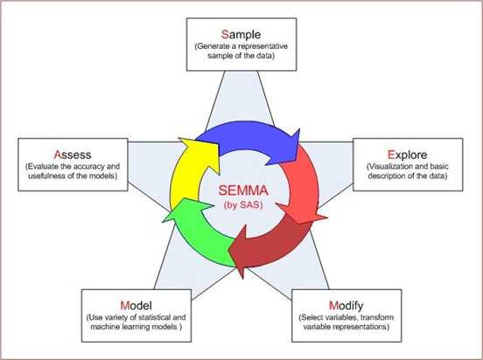
Figure 1. Illustration of SEMMA Process Model

SEMMA intends to make it easy to apply exploratory statistical and visualization techniques, select and transform the most significant predictive variables, model the variables to predict outcomes, and finally confirm a model’s accuracy (Olson & Delen, 2008).
The dataset consists of 9,000 participants (4,500 men and 4,500 women) aged 18–65, with mental health risk labeled as low, medium, or high. The SEMMA process was used to guide the analysis. Sample: The data was randomly divided into training (70%), validation (15%), and testing (15%) sets using stratified sampling. Explore: Basic statistics were checked, including age distribution, gender counts, and the frequency of each risk level. Modify: Data was cleaned by encoding categorical fields such as the gender and mental health risk into numbers and coarse binning of stress level, depression score, and anxiety score to avoid data leakage. Model: Simple classification models, such as decision tree, were trained on the prepared data and tuned using the validation set. Assess: The final model was evaluated on the test set using accuracy, confusion matrix, and class-based performance scores to measure how well the factors predicted mental health risk.

- Data Source and Acquisition
The dataset used in this study comes from a publicly available synthetic mental health dataset designed for academic research and machine learning practice, with data representing participants from various countries around the world. It contains responses from 9,000 individuals collected within a simulated time frame. The dataset includes five input variables—age, gender, stress level, depression score, and anxiety score—which serve as the X-variables, and one output variable, the assigned mental health risk category labeled as Low, Medium, or High, which serves as the Y-variable or the target to be predicted. The sample is balanced by gender with 4,500 males and 4,500 females, and participant ages range from 18 to 65. All data was provided in a clean Excel format with no missing values, making it ready for analysis.

- Exploratory Data Analysis
The dataset contains 9,000 records with complete values across all variables. No missing values were detected. There were no duplicated rows and no inconsistent entries in any column. Age ranges from 18 to 65, and values fall within a realistic range. No extreme outliers were found in age or in the three score variables.
The gender distribution is balanced. Fifty percent of the participants are male and fifty percent are female. The mental health risk labels are distributed across Low, Medium, and High categories without signs of data errors.
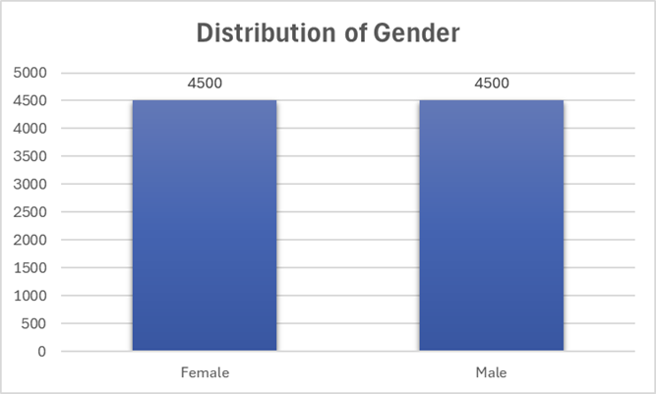
Figure 2. Distribution of Gender

Figure 3. Distribution of Stress Level

Figure 4. Distribution of Depression Score

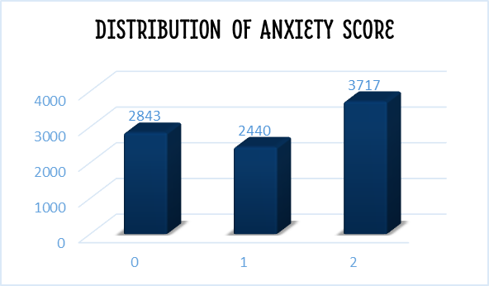
Figure 5. Distribution of Anxiety Score

- Data Preprocessing
The dataset required minimal cleaning because all variables were complete and showed no missing value. Each column was checked for incorrect entries, duplicated rows, and unrealistic values. No data quality issues were found. Basic preprocessing steps were still applied to prepare the dataset for modeling.
The mental health risk variable was standardized by converting all labels into a consistent format. The labels Low, Medium, and High were then mapped to numeric codes (Low = 0, Medium = 1, High = 2) to allow the models to process them. Gender entries were formatted into a single style to remove variations in text. Gender was converted into numeric form (Male = 0, Female = 1) through label encoding to make it usable by the models.
All numeric variables, including age and the three score variables, were scaled using standardization to place them on a similar range. This helped improve model training and prevented features with larger values from dominating the model. After cleaning and encoding, the dataset was divided into training and testing sets using stratified sampling to preserve the original class proportions.

- Machine Learning Model(s):
The goal was to predict whether a person belongs to Low, Medium, or High mental health risk. This is a classification problem because the target has three distinct categories. Classification is appropriate when the output is a discrete label.
A Decision Tree classifier was used. It is a simple and interpretable model that matches the study’s focus on basic sociodemographic variables. A decision tree learns rules by splitting the input space into smaller regions.
A decision tree is represented by repeated if-else rules.
Each split is based on a condition such as age less than a threshold or gender equals a category.
The model selects splits that produce the highest information gain or lowest Gini impurity.
Gini impurity:
Gini = $1-\sum{\left({ρi}^{2}\right)}$
where pᵢ is the proportion of samples belonging to class i inside a node.
The model chooses splits that reduce this value.
The SEMMA method guided the workflow.
- Sample: The dataset was divided into 70 percent training and 15 percent validation, and 15 percent testing. Stratified sampling kept the class proportions stable.
- Explore: Age and gender distributions were reviewed.
- Modify: Gender and mental health risk were encoded into numeric values and coarse binning of stress level, depression score, and anxiety score.
- Model: A Decision Tree classifier was trained using the training set.
- Assess: Model performance was evaluated using precision, recall, F1 score, and accuracy. The validation set was used to check performance before final testing.

Results
Model Performance
Table 1. Validation and Test Results
MODEL | DATASET | ACCURACY | PRECISION | RECALL | F1-SCORE
Decision Tree | Validation | 80.9% | 80.8% | 80.9% | 80.8%
 | Test | 82.4% | 82.3% | 82.4% | 82.2%

The Decision Tree model showed stable and reliable performance, with 80.9% accuracy in validation and slightly higher 82.4% in testing as shown in the table above, meaning it predicts mental health risk well without overfitting. Precision, recall, and F1-scores are almost equal, showing balanced predictions. While age and gender were included, their low influence indicates that mental health risk is shaped more by personal experiences and psychological factors rather than basic demographics.

Table 2. Rule of thumb or interpretation of Pearson’s correlation value
Size of Correlation | Interpretation
0.00 to 0.10 | No Relationship
0.11 to 0.30 | Weak Relationship
0.31 to 0.60 | Moderate Relationship
0.61 to 1.00 | Strong Relationship

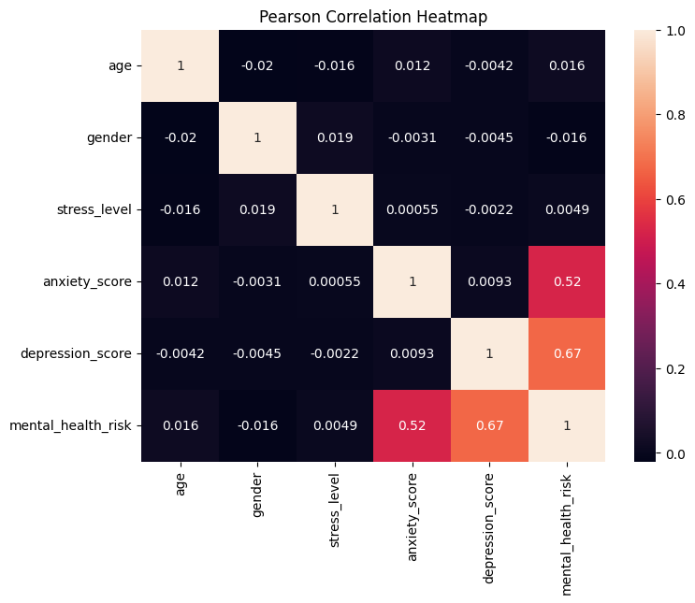
Figure 6. Pearson Correlation Heatmap

Based on the rule of thumb for Pearson correlation, the dependent variable mental_health_risk shows the strongest relationship with depression_score (0.67), which falls under strong correlation (0.61–1.00). This means depressive symptoms have the highest influence on the predicted mental health risk. Meanwhile, anxiety_score (0.52) shows a moderate correlation (0.31–0.60) with mental health risk, indicating that anxiety levels also contribute notably but not as strongly as depression. On the other hand, age, gender, and stress_level all fall between 0.00 and 0.10, meaning they demonstrate no relationship with mental health risk based on correlation values. This suggests that demographic factors like age and gender do not directly determine risk levels; instead, psychological experiences and internal emotional states play a more significant role in shaping an individual’s mental health condition..

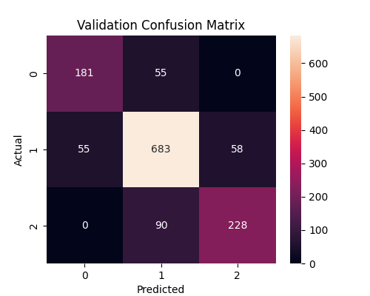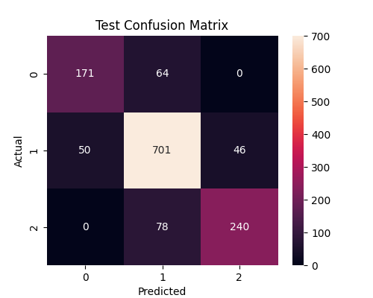
Figure 7. Confusion Matrices

For the validation confusion matrix, 181 cases were correctly classified as low risk, while 55 low-risk cases were misclassified as medium and none as high. For medium risk, 683 were correctly predicted, with 55 misclassified as low and 58 as high. For high risk, 228 were correctly identified, while 90 were labeled as medium and none as low. These results indicate that medium-risk classification shows the highest correct identification, while high-risk cases are occasionally confused with medium but never with low.
For the test confusion matrix, 171 cases were correctly predicted as low risk, with 64 misclassified as medium and none as high. For medium risk, 701 were correctly classified, with 50 labeled as low and 46 as high. For high risk, 240 were correctly identified, while 78 were misclassified as medium and none as low. The model maintained consistent behavior, demonstrating strong accuracy in detecting medium-risk cases and avoiding extreme misclassification between low and high categories.

Model Interpretation
The SHAP values measure how much each feature pushes the model toward predicting Low, Medium, or High risk. Larger SHAP values mean stronger influence.
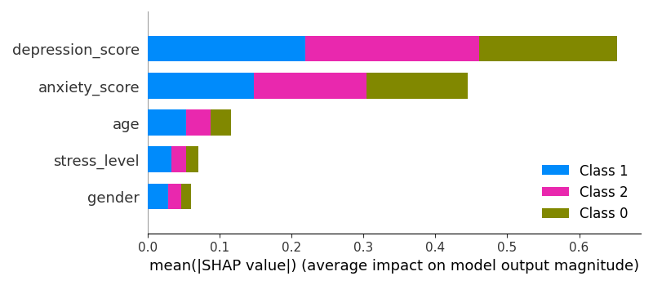
Figure 8. SHAP Model Interpretation
The graph shows that depression score has the biggest impact across all three classes. Anxiety score is the second strongest contributor. These two features change the model’s output more than the other variables. Age, stress level, and gender have very small SHAP values, so they add little to the prediction.
The wide bars for depression and anxiety mean the model relies on these features when separating the three risk groups. The narrow bars for age, stress level, and gender mean they do not improve the model’s decision process. This pattern matches the correlation results and the behavior of the decision tree. Depression and anxiety provide clear signals, while the other features give weak or inconsistent information.

Discussion and Conclusion
- Interpretation of Findings

The model showed that depression level and anxiety level are the strongest indicators of mental health risk. These two features had the highest correlation values and contributed most to the predictions. Age, gender, and stress level had minimal influence. Their correlation values were near zero, and the model used them less often in its splits.

The confusion matrices confirmed this pattern. Most medium risk cases were identified correctly. Many low and high risk cases shifted toward medium. This shows that the model recognized the importance of the middle category and treated it as the most stable pattern in the data.

The accuracy values of the validation and test sets were consistent. This means the model did not overfit and handled unseen data well. The results answered the research question by showing that mental health risk is influenced mainly by depression and anxiety levels, not by sociodemographic factors.

- Conclusion

The project showed that mental health risk can be predicted with reasonable accuracy using a decision tree model and five selected features. Depression and anxiety levels provided the most useful information. Age, gender, and stress level added little to the prediction. The model reached stable performance on both the validation and test sets, which confirmed that the approach was reliable. The main takeaway is that behavioral indicators carry more value than sociodemographic factors when estimating mental health risk.

- Limitations

The study used synthetic data, which limits how well the results apply to real cases. The coarse bins for stress, anxiety, and depression reduced detail in the scores. The model relied on simple features and did not include social, environmental, or clinical factors that may influence risk. The decision tree did not use advanced tuning, which may have lowered accuracy. The dataset was balanced, which may not reflect real populations. These limits affect how far the findings can be generalized.

- Future Work
Future studies can use real survey data and more data to capture more accurate patterns. Adding more behavioral and social features may improve the prediction of risk levels. Testing other models like random forests or gradient boosting can provide stronger performance. Feature tuning and model optimization can also help increase accuracy. Collecting time based data can support early detection and trend analysis.

REFERENCES:

Chung, J., & Teo, J. (2022). Mental health prediction using machine learning: Taxonomy, applications, and challenges. Applied Computational Intelligence and Soft Computing, 2022, Article ID 9970363. https://doi.org/10.1155/2022/9970363
Dabek, F., & Caban, J. J. (2015). A neural network based model for predicting psychological conditions. In Brain Informatics and Health (pp. 252–261). Springer. https://doi.org/10.1007/978-3-319-23344-4_25
Garriga, R., Mas, J., Abraha, S., et al. (2022). Machine learning model to predict mental health crises from electronic health records. Nature Medicine, 28, 1240–1248. https://doi.org/10.1038/s41591-022-01811-5
Jain, T., Jain, A., Hada, P. S., Kumar, H., Verma, V. K., & Patni, A. (2021). Machine learning techniques for prediction of mental health. In Proceedings of the 2021 Third International Conference on Inventive Research in Computing Applications (ICIRCA) (pp. 1606–1613). IEEE. https://doi.org/10.1109/ICIRCA51532.2021.9545061
Jordan, M. I., & Mitchell, T. M. (2015). Machine learning: Trends, perspectives, and prospects. Science, 349(6245), 255–260. https://doi.org/10.1126/science.aaa8415
Olson, D. L., & Delen, D. (2008). Data Mining Process. In Advanced Data Mining Techniques (pp. 9-35). Springer. https://doi.org/10.1007/978-3-540-76917-0_2
World Health Organization. (2025, September 2). Over a billion people living with mental health conditions – services require urgent scale up. World Health Organization. https://www.who.int/news/item/02-09-2025-over-a-billion-people-living-with-mental-health-conditions-services-require-urgent-scale-up
World Health Organization. (2021). Investment case report: Mental health Philippines 2021. World Health Organization. https://www.who.int/docs/default-source/wpro---documents/countries/philippines/reports/investment-case-report-mental-health-philippines-2021.pdf

