

CMPS270

Web Project Report

Fadi Atwi

Fatima Miriam Scheib

Home page:

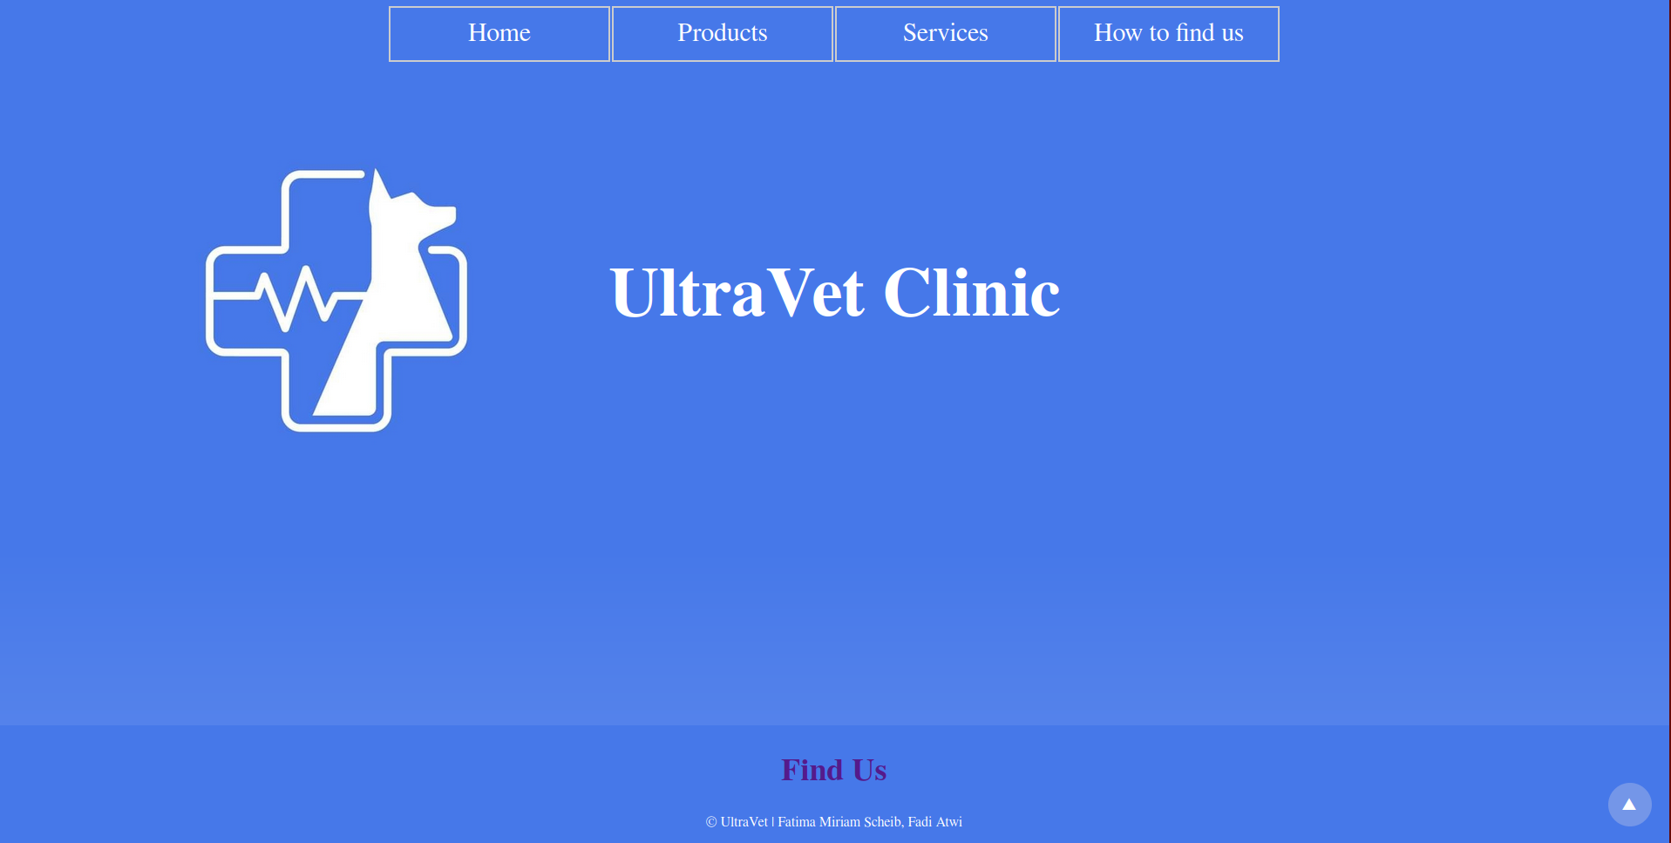The initial home view pages starts showing:

* the Navigation bar at the top with links to all 4 pages
* The header consisting of the logo and “UltraVet Clinic” taking up most of the screen
* The sticky footer at the bottom with another link to the Find Us page

The background of the body Is a gradient from t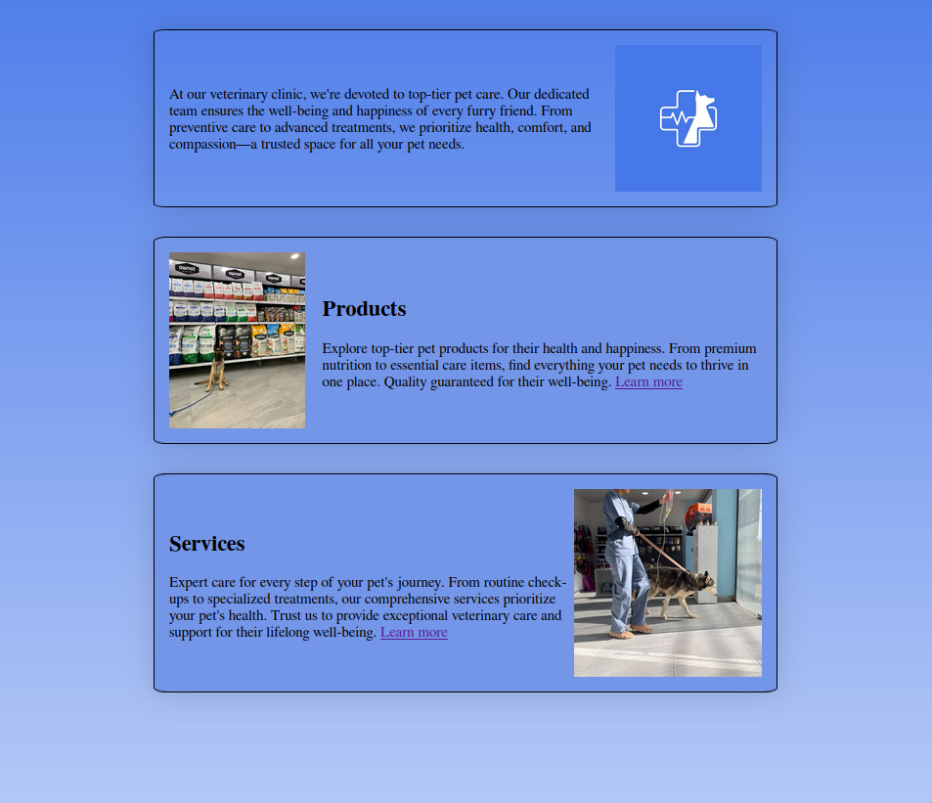op to bottom fading into white.

Scrolling down the user is greeted with several box divs:

1. A general introduction
2. A products introduction with a link to the products page
3. A services introduction with a link to the services page
4. Several glowing reviews of the clinic

These divs transition upwards as they come into the viewport from 0 opacity to 100 opacity

This is the CSS and JS script responsible for this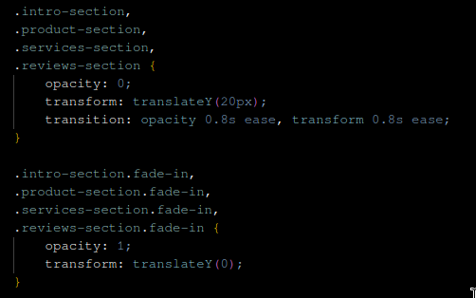 transition

The sections go from the default state:

opacity = 0 and 20px offset on Y axis

to the fade-in state

opacity = 1 and 0 offset on Y axis

the rect.left and rect.right conditions in the IsElementInViewPort() fn is reduntant now. As the original version of the page would have the sections be on 1 row and be scroll to the side

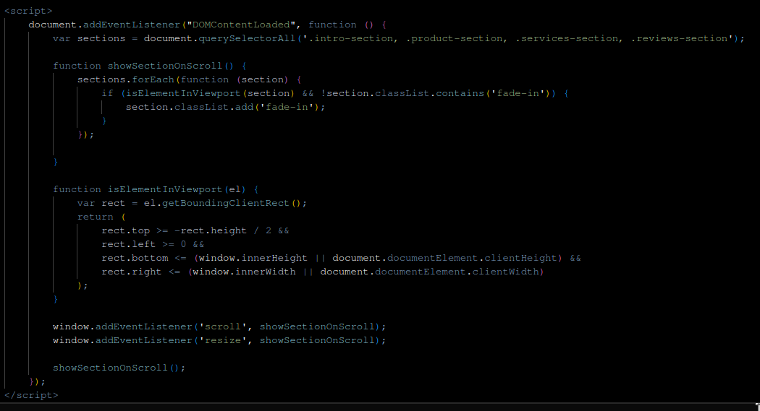

Products Page:

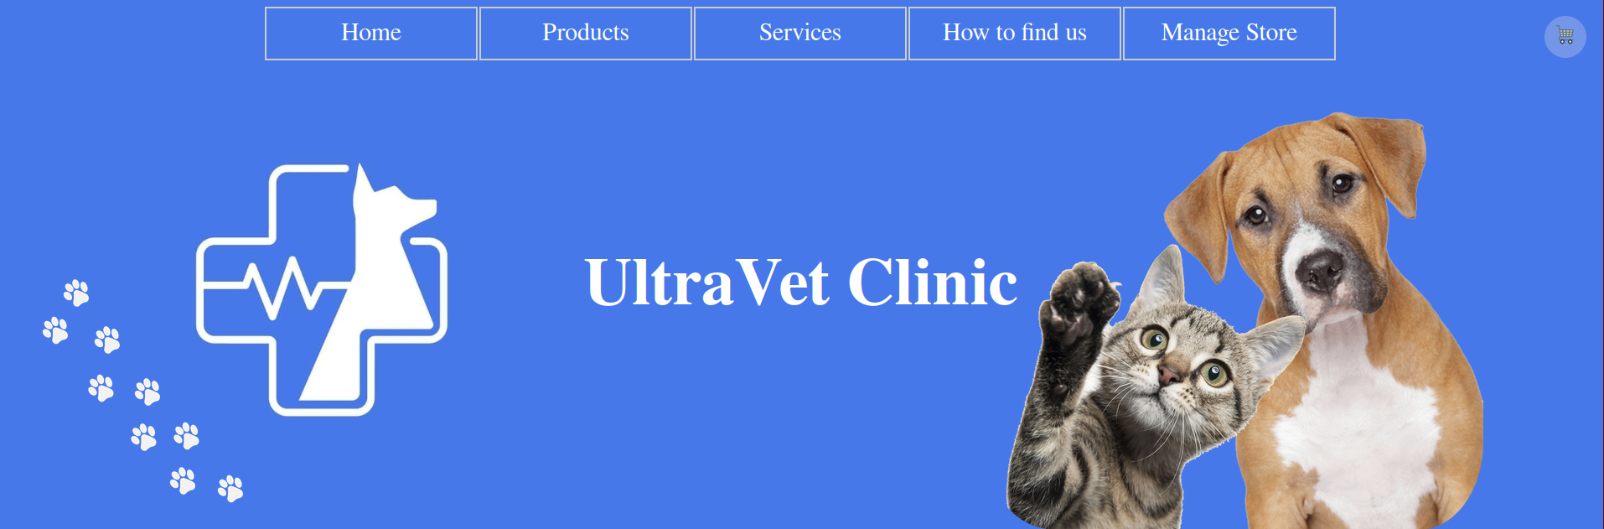

The header on this page has 3 additional images

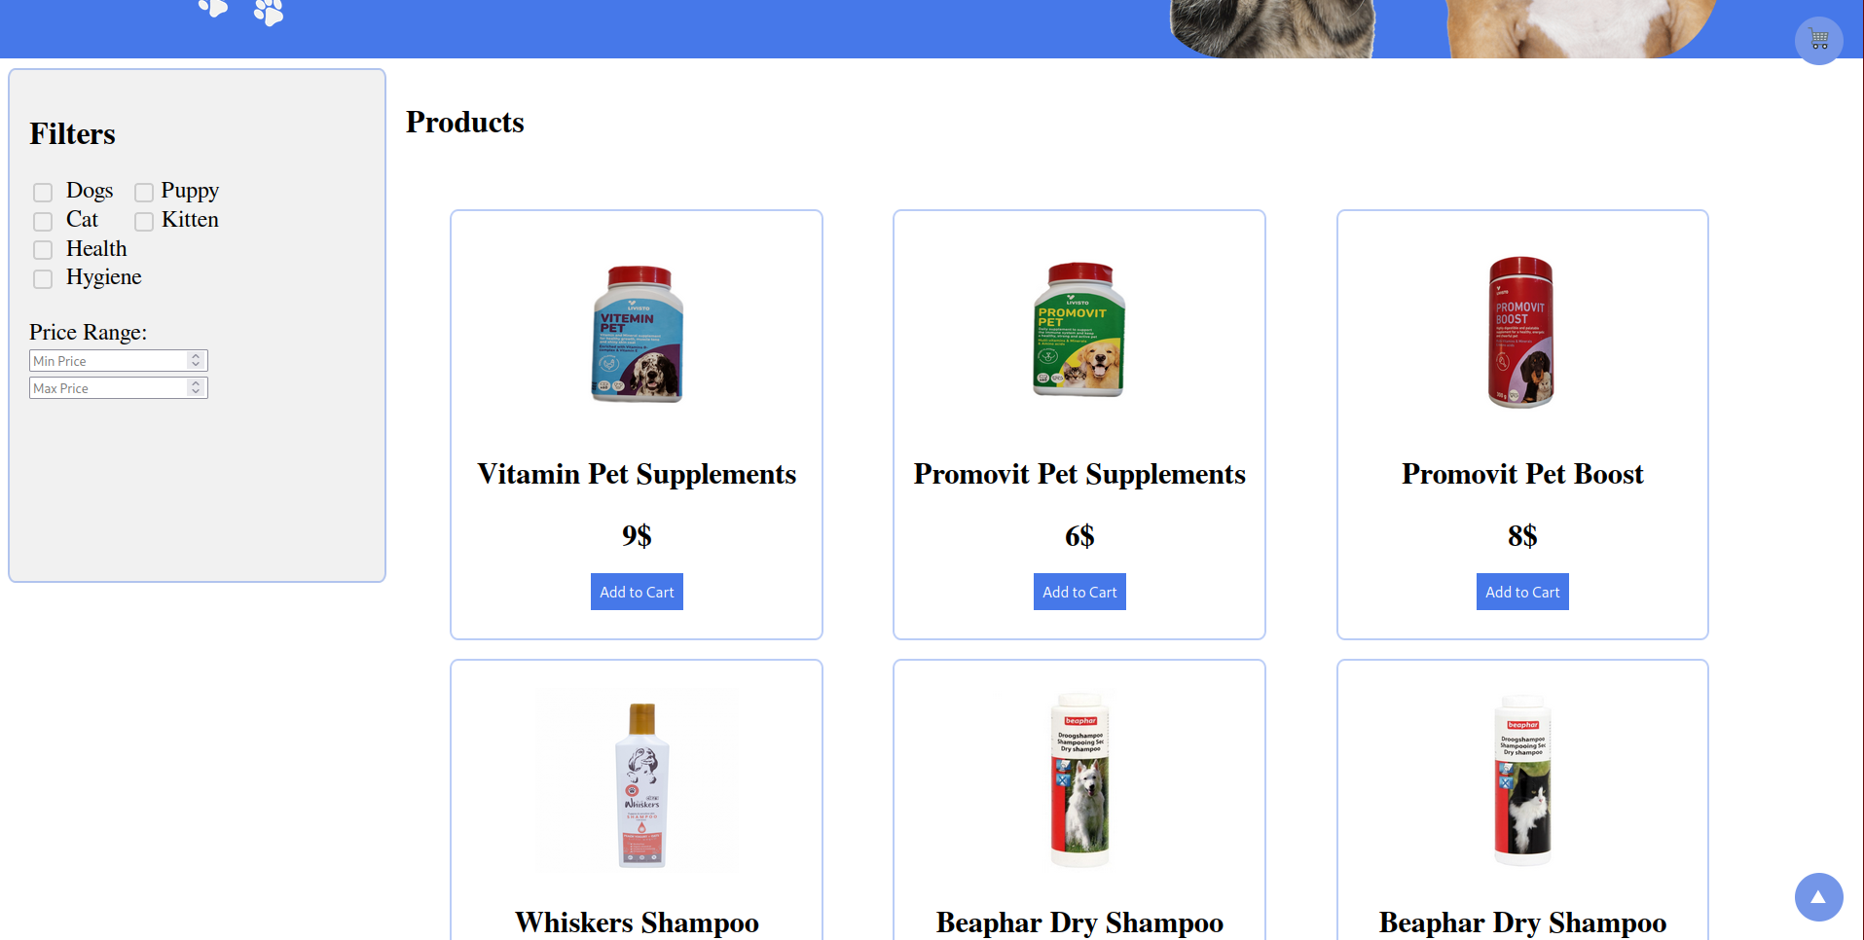

The page includes a 3 column grid of products

with a side bar on the left with some filters such as tags and a price range selector.

Since a functional backend was out of the scope of this project

All the products are object instances of a class all stored within a script tag inside the html of the page

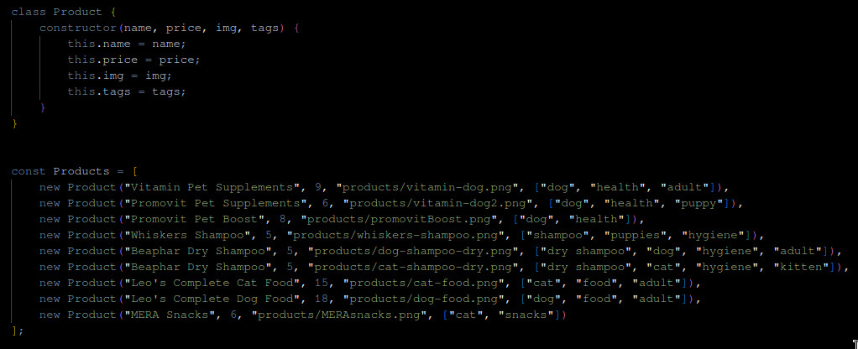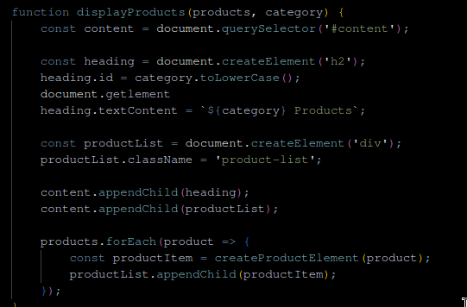

**displayProducts() fn** is used for initial display of the products

It creates a list div and places the product divs inside it

the **createProductElement() fn** creates a div for each product to be added to the grid list.

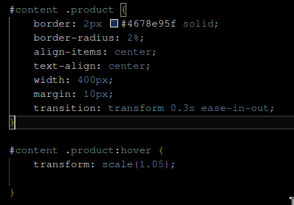

Additionally hovering over any product div has a visual effect where it scales the div up by 1.05x

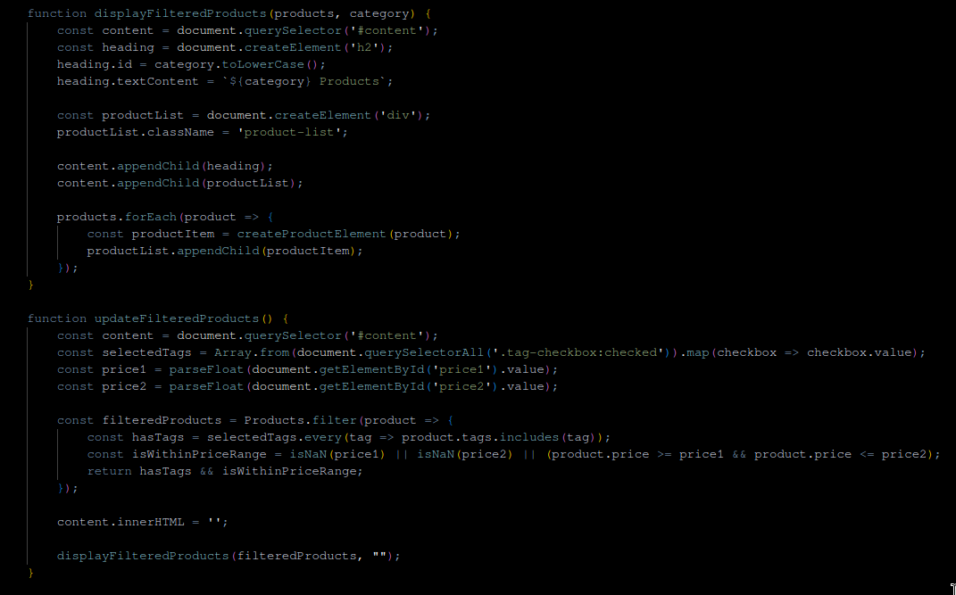

Interacting with any of the filter buttons calls these functions to create a new list of products according to the added filters

And then redisplay it in the products list.

This page also features a sticky button on the top right for the cart.

Each product div has a button to add to cart with a hover effect changing the background color to a slightly lighter version

Clicking this button Adds the chosen product to a cart list and increm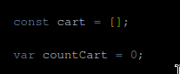ents a countCart variable by 1

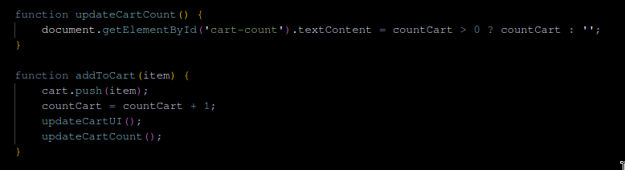

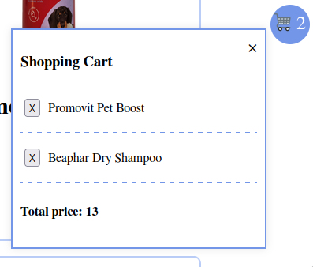

clicking the cart button opens a menu that displays each added product’s name in rows

as well as the sum of the prices of these products

An additional button “X” to remove a product from the cart

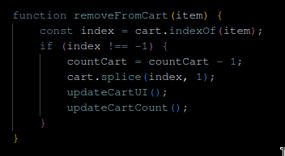

A copy of this page titled Products-Admin.html can be reached from the modified Nav menu in the products page

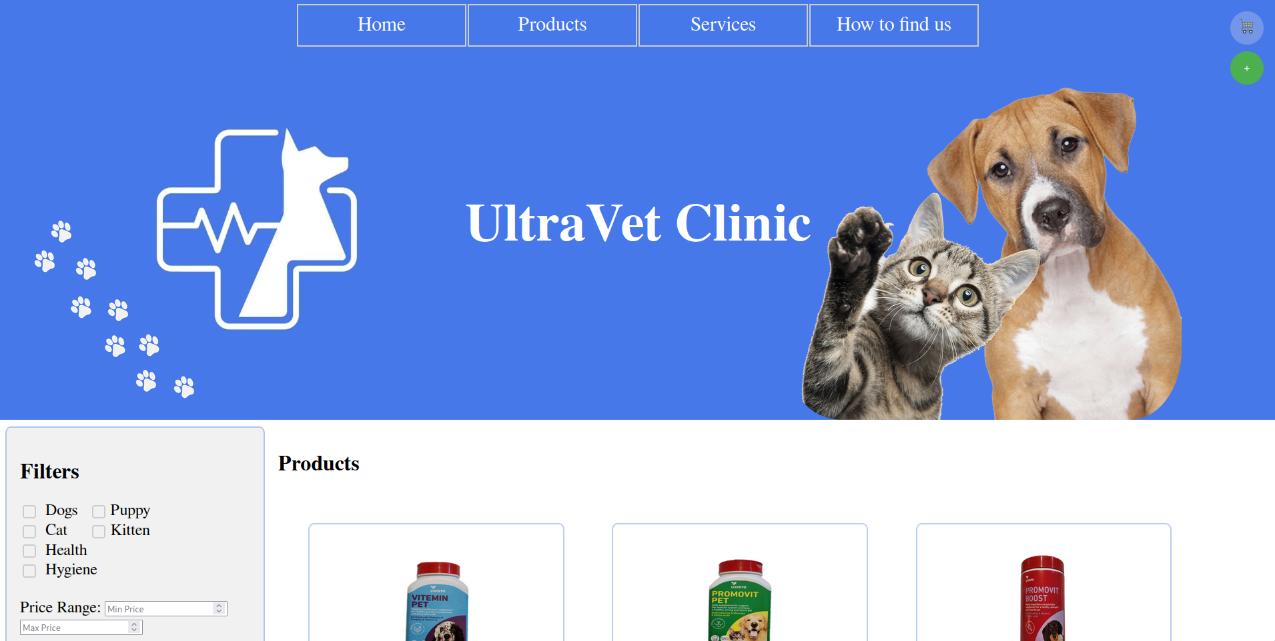

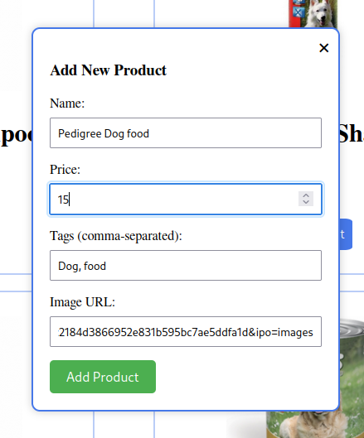It is identical to the products page except for the addition of a sticky green “+” button under the cart button

Clicking this button opens a window in the middle of the screen with the necessary text boxes to add a new item

The added product:

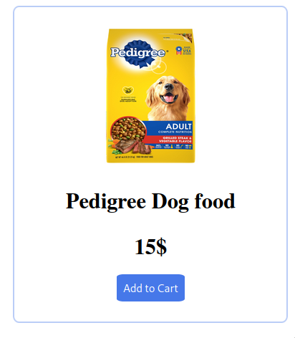

**Services page:**

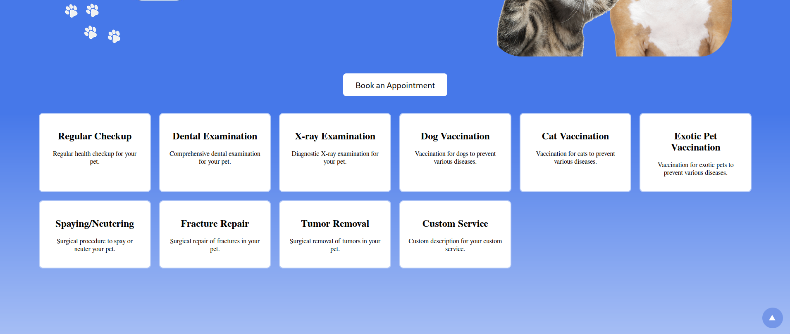

This page has the same header as the Products page

It includes a grid of Service Divs that include each service as well as a short description of each service

Ontop of them is a button to book an appointment

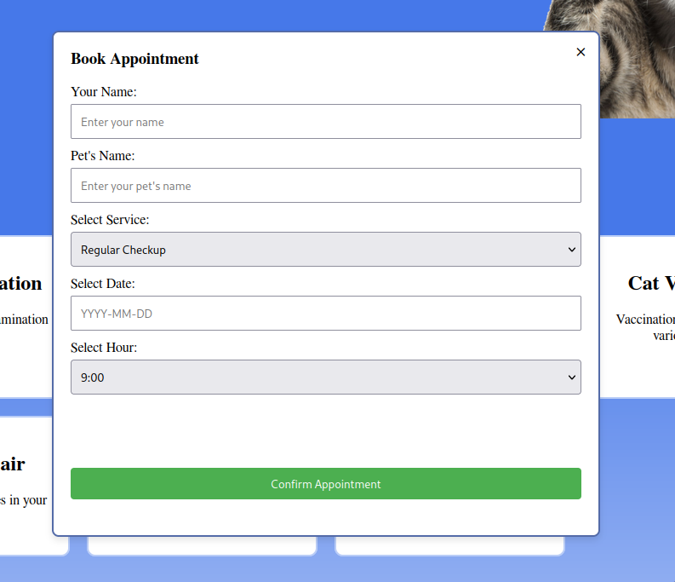

where you input your and your pet’s names

The desired service

as well as a time and date

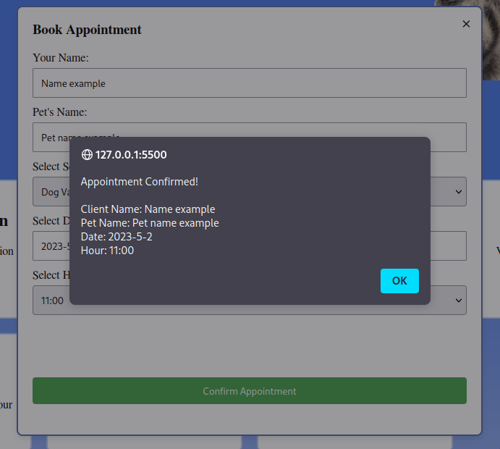

**Find us page:**

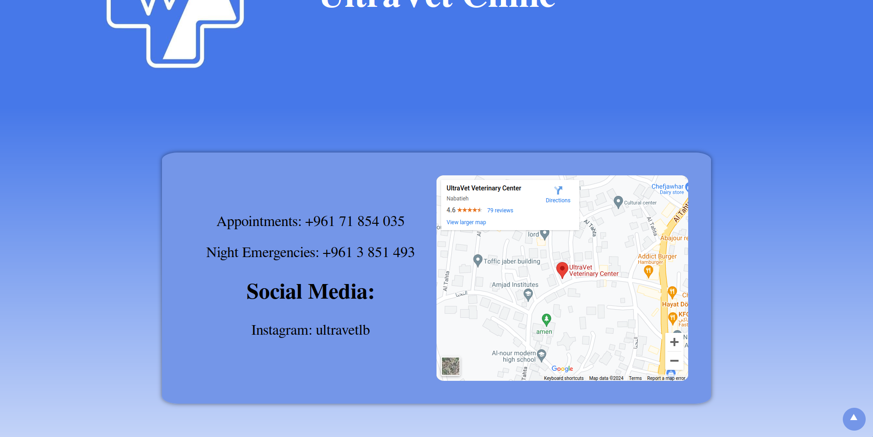

This page includes one big box div in the center, on the left is contact information, on the right is a google maps embed location of the clinic.

**Additional Features:**



All pages include a sticky button on the bottom left to go to the top of the curent page.

This button becomes visible when scrolling down from the header

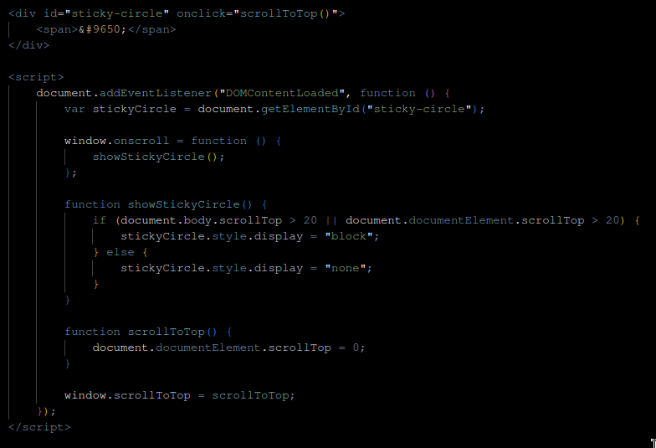

using this script for this behaviour