Plantsdom -
Database Systems Project

by Greco Francesco

a. Y. 2020/21 - Database Systems

Prof. Michelangelo Ceci


Index
1 Introduction 4
1.1 Specifications 4
2 Conceptual Design 5
2.1 Synonyms and homonyms 5
2.2 Ambiguities filtering 6
2.3 Standardized sentences 6
2.4 Glossary 7
2.5 Conceptual E-R Schema 8
2.6 Project Extension: Supplies 9
2.7 Other constraints not expressed by the ER model 11
3 Logical Design 12
3.1 Volumes table 13
3.2 Access tables 14
3.2.1 Operation 1 14
3.2.2 Operation 2 15
3.2.3 Operation 3 16
3.2.4 Operation 4 17
3.2.5 Operation 5 20
3.3 Redundancies analysis 21
3.4 Logical schema 23
4 Physical Design 25
4.1 Database Implementation 25
4.2 Operations implementation 26
4.3 Queries optimization 26
4.3.1 Operation 3 26
4.3.2 Operation 4 27
4.3.3 Operation 5 28
5 Additional features 29
5.1 Populate Procedures 29
5.2 Triggers 30
5.3 Other functionalities 31
6 Deployment, Website and Servlet 31
6.1 System Deployment 31
6.2 Website front-end 32
6.3 Website back-end: Servlet 36
7 Conclusions 38

Introduction
This is the documentation of the final project for the Database Systems course of the “Computer Science” master degree, a.Y. 2020/2021, held by Professor M. Ceci in University of Bari “A. Moro”. The project is based on the specifications given in the written exam of 07/04/2021.
In section 2 the conceptual schema will be explained and the respective diagrams will be reported; in section 3 the logical schema will be reported, as well as the table of accesses and volumes; in section 4 the physical schema will be reported, explaining the choices made; in section 5 the SQL code for the triggers will be reported; in section 6 the additional implemented features will be discussed; in section 7 conclusions will be drawn, also discussing missing features and possible future works on the application.

Specifications
Here are reported the specifications of the database system to develop:
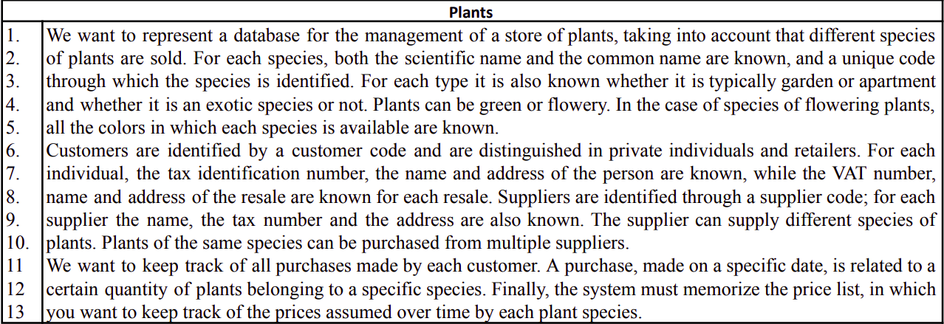Figure 1: Database specifications
The operations that regard the database system are the following:
Op1: Register of new purchases (300 times a day)
Op2: Register a new sale (1000 times a day)
Op3: Printing of the number of plants and properties of plants available for a given species (10000 times a day)
Op4: Printing of the purchases of a given customer (150 times a day)
Op5: Printing of the plants, ordered by the number of items sold (10 times a month)

Conceptual Design

Synonyms and homonyms
We begin by identifiying synonyms:
- “plant”,“species”, “species of plants” and “plant species” are all synonyms. In line 3 the word “type” is used as well to refer to the concept of “plant”. In line 12 “plants belonging to a specific species” is just another way to refer to the concept of “plant”.
- “private individuals” and “individual” are used as synonyms.
- “retailers” and “resale” are synonyms.

Ambiguities filtering
In line 7, we assume that with “name” is intended the pair name and surname of a customer.
In line 11, we assume that other than the “date”, also the time of the purchase has to be stored.
We assume that a Plant can be exclusively Green or Flowery.
For Customers, as well, we can deduce the division into the two groups is exclusive.
It isn’t clear if a purchase can refer only to a single species of plants or to many of them. With common sense, a customer can buy more than just a single species in a purchase, so we will follow this idea in the design.
To keep track of the prices assumed by each plant over time, we suppose that it’s needed to store, for each plant, a price list containing: the amount (in euros), the start date and the ending date for which that price has been valid for the plant; the ending date is optional so that a price with no ending date is considered being the current price.

Standardized sentences
To have a better understanding of the specifications, we restructure the sentences of the specifications in order to have a standard and organized form for each concept.
- For plants we want to represent the scientific name, the common name, a unique code (ID), the type (“garden” or “apartment”), the fact that one is exotic or not and the price lists (containing both the current price and the old prices). A plant can be either green or flowery.
- For flowering plants we want to represent the possible colors.
- For price lists we want to store the amount (in euros) of the price for a single plant, the start date and the ending date (optional) for which that price has been valid for the plant.
- For customers we want to represent the customer code and the purchases they make. A customer can be either a private individual or a retailer.
- For private individuals we want to represent the tax identification number, the name and the address.
- For retailers we want to represent the VAT number, the name and the address.
- For purchases we want to represent the date and time of the purchase, the plants and the respective quantity purchased.
- For suppliers we want to represent the supplier code, the name, the tax identification number, the address and the plants they supply.

Glossary
Term | Description | Synonyms | Connections
Plants | A plant sold in the store. A plant is supplied by one or more suppliers and it can be purchased by many customers. A plant can be green or flowery. It has a scientific name, a common name, a unique code, a type (“garden” or “apartment”) and the exoticness (“yes” or “no”). | Species, species of plants, plant species | Listing prices, Green plants, Flowery plants, Suppliers, Purchases
Green plants | A type of plant. It has no additional properties with respect to plants. | - | Plants, Purchases, Listing prices
Flowery plants | A type of plant. It has one or more possible colors. | - | Plants, Purchases, Listing prices, Colors
Customers | A customer of the store. It can be a private individual or a retailer. A customer can make one or more purchases in which it buys one or more plants. It has a customer code. | - | Private individuals, Retailers, Purchases
Private individuals | A type of customer, which is a physical person who buys plants for him/herself. A private individual has a tax identification number, a name, a surname and an address. | Private | Customer, Purchases
Retailers | A type of customer, which is a trader who buys plants to resell them. A retailer has a VAT number, a name and an address. | Resale | Customer, Purchases
Suppliers | A supplier, from which the store buys one or more species of plants it sells. A supplier has a supplier code, a name, a tax identification number, an address and the plants he/she supply. | - | Plants
Price lists | The list of prices for a plant. It contains both the current price and the old prices for the plant. | - | Plants

Conceptual E-R Schema
Here is reported the Conceptual Entity-Relationship schema for the system. It was designed with a bottom up methodology, given that the system doesn’t involve a lot of entities and relationships: indeed, no difficulties were encountered in the merging phase.
A sidenote on notation: the multi-field keys are represented by multiple single primary keys. Thus, if an entity has more than one primary key in the schema, they are not to be considered many candidate keys, but one multi-attribute primary key.
The E-R schemas in this documentation are made with the software JDER1.41 updated by Dr. Gianvito Pio (originally developed by Alessandro Ballini). The original schema files will be available as attachments.
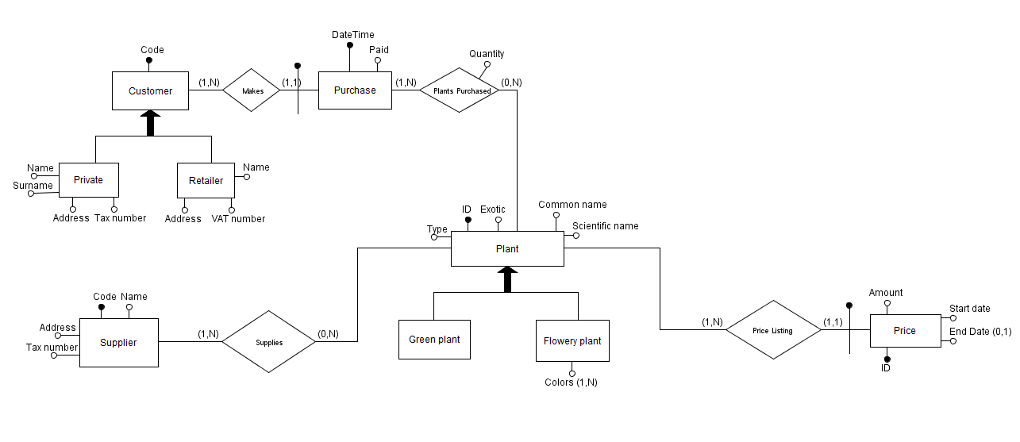Figure 2: Conceptual E-R Schema

Project Extension: Supplies
In the specification the role of the Supplier is defined as a static concept, being like just a list of suppliers that supply certain species of plants to the store. As a project extension, this concept is going to be revised to be more in line with the Operation 1 that will be seen in Section 3: in fact we will introduce some entities, relationships and attributes that will better capture the dynamicity of the supplies. Some concepts will be managed in the system with this extension:
- The Plants stock: the Plant entity will have a Stock attribute which represents its quantity in stock;
- The Supply concept: a Supplier sells to the store a stock of plants, containing one or more differente species of plants; a Supply can be considered as an order placed by the plants store.
- Regarding a Supply, the price at which the plants are bought by the store: each supply contains a certain quanitity of a specified plant, which is bought at a certain price. Also the total cost of the supply can be stored (this redundancy will be better analyzed in Section 3).
- The date of purchase of a Supply, that is the date (and time) in which the store makes the order for the supply.
- The date of arrival of a Supply, which is the estimate date in which the supply will physically arrive at the store.
In the Figure below is reported the Conceptual E-R schema including these extensions. We can observe in particular the new In stock attribute of Plants and the reification of the Supplies relationship that was present in the first Conceptual schema.
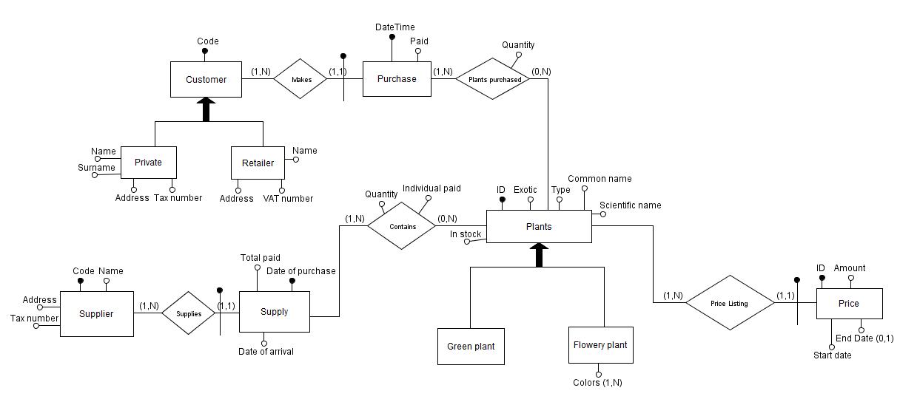Figure 3: Conceptual E-R Schema with the “Supply” Extension

Other constraints not expressed by the ER model
- In Supply we must have Date of arrival > Date of purchase;
- In Price we must have End Date > Start Date, and each Price must have and End Date, apart from 1 and 1 only, which is the current price. Moreover, apart from the first (in order by date) price, the Start date of each price must be the end date of another one.
- The Total paid of Supply must be equal to the sum of the Individual paid of each record in Contains, multiplied by the respective quantity.
- Quantities cannot be <1.

Logical Design
In this section we are going to consider the translation of the Conceptual E-R schema defined in the previous section with a Logical schema (made in UML) for an Object-Relational model. Since we are not opting for a pure relational model, there’s no need to restructure the Conceptual schema by removing generalizations and composite attributes. However, we decide to remove the generalization on Plant by collapsing the child entities into the parent, since all the operations involve both the children and the waste of memory should not be very impactful. Moreover, the Green Plant entity doesn’t have any additional attribute. The attributes will be modified in this way:
- the attribute Garden: which is the old type attribute of Plant; it indicates if it is a garden plant or an apartment plant;
- the attribute Plant type is introduced to distinguish between flowery and green plants was introduced;
- the Colors attribute now has a 0..N cardinality, so that green plants can have no value for that attribute.
The other generalization, on Customer, can be solved in the same way as before, since every operation involve both the types of Customer. In this way the join operations between Private Individuals and Retailers are minimized. We can also find a way to minimize the waste of memory by using the same attributes for representing slightly different concepts:
- attribute Name: will be long enough to represent both the name of a Retailer and the first and last name of a Private Individual;
- attribute Address: is the same for both children entities;
- attribute Identification Number: will contain either the Tax number for Privates, or the VAT number for Retailers;
- finally an attribute Type will be introduced to distinguish between the two.

Volumes table
We assume 1 year of activity of the system.
Concept | Type | Volume | Notes
Plant | E | 800 | Volume given in the specifications
Green Plant | E | 400 | Assuming 50% of Plants
Flowery Plant | E | 400 | Assuming 50% of Plants
Supplier | E | 500 | Assumed by hypothesis
Supplies | R | 108’000 | From Op.1 we know that each day we have 300 purchases from suppliers. Assuming 1 year of life of the system: 300*30*12
Supply | E | 108’000 | 1-1 relationship with Supplies
Contains | R | 324’000 | Assuming each Supply contains 3 different plants in average
Price | E | 8’000 | Assuming that after 1 year the price for a plant has changed in average 10 times.
Price Listing | R | 8’000 | 1-1 relationship with Price
Customer | E | 1’200 | Volume given in the specifications
Private | E | 400 | Assuming 1/3 of the Customers
Retailer | E | 800 | Assuming 2/3 of the Customers
Makes | R | 360’000 | From Op.2 we know that each day we have 1000 purchases. Assuming 1 year of activity of the system: 1000*30*12
Purchase | E | 360’000 | 1-1 relationship with Makes
Plants purchased | R | 1’080’000 | Assuming that in average a purchase involves 3 plants

Access tables
Here, for each of the queries given in the specifications, the relative access table will be reported. We assume that a Write operation weights double the cost of a Read operation.

Operation 1
Register of new purchases (300 times a day)
Concept | E/R | #Accesses | Read/Write | Notes
Supplier | E | 1 | R | Read the supplier from which the store is buying
Supplies | R | 1 | W | Connect the Supplier to the Supply it supplies
Plant | E | 3 | R | Read the plants that must be supplied (the “In stock” attribute will not be written in this moment)
Contains | R | 3 | W | Writes the plants that are being purchased
Supply | E | 1 | W | Finally writes the Supply entity
- Cost (Op1) = 1 + 1*2 + 3 + 3*2 + 1*2 = 14 accesses
- Daily cost (Op1) = 300 * cost = 4200 accesses/day

Operation 2
Register a new sale (1000 times a day)
Concept | E/R | #Accesses | Read/Write | Notes
Customer | E | 1 | R | Read the customer that is making the purchase
Makes | R | 1 | W | Connect the Customer to its Purchase
Plant | E | 3 | R | Read the plants that must be purchased (we assumed that in average a purchase involves 3 plants)
Price Listing | R | 30 | R | In average there are 10 prices per plant
Price | E | 30 | R | 1-1 relationship with Price Listing
Plant | E | 3 | W | Update the “In stock” attribute of the purchased plants
Plants purchased | R | 3 | W | Connect the Plants to the Purchase
Purchase | E | 1 | W | Finally write the purchase
- Cost (Op2) = 1 + 1*2 + 3 + 30 + 30 + 3*2 + 3*2 + 1*2 = 80 accesses
- Daily cost (Op2) = 1000 * cost = 80’000 accesses/day
Let’s try including the redundant attribute Price on Plant with the current price of the plant: it is a redundancy because it is also present in the Price entity (is the one without the attribute End Date).
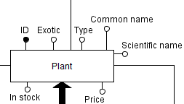Figure 4: Plant entity with the Price attribute
The accesses table for Operation 2 would become:
Concept | E/R | #Accesses | Read/Write | Notes
Customer | E | 1 | R | Read the customer that is making the purchase
Makes | R | 1 | W | Connect the Customer to its Purchase
Plant | E | 3 | R | Read the plants that must be purchased (we assumed that in average a purchase involves 3 plants). It has now also the current Price
Plant | E | 3 | W | Update the “In stock” attribute of the purchased plants
Plants purchased | R | 3 | W | Connect the Plants to the Purchase
Purchase | E | 1 | W | Finally write the purchase
With the redundancies the costs are:
- Cost (Op2) = 1 + 1*2 + 3 + 3*2 + 3*2 + 1*2 = 20 accesses
- Daily cost (Op2) = 1000 * cost = 20’000 accesses/day

Operation 3
Printing of the number of plants and properties of plants available for a given species (10000 times a day)
Concept | E/R | #Accesses | Read/Write | Notes
Plant | E | 1 | R | Read the species of plants to print, with all of these attributes
Price Listing | R | 10 | R | Assuming that each plant has in average 10 prices
Price | E | 10 | R | Accessing the prices of the plant
- Cost (Op3) = 1 + 10 + 10 = 21 accesses
- Daily cost (Op3) = 10’000 * cost = 210’000 accesses/day
Considering the previous redundancy of the Price attribute on Plant, we would have:
Concept | E/R | #Accesses | Read/Write | Notes
Plant | E | 1 | R | Read the species of green plant to print, with all of these attributes
The costs would be:
- Cost (Op3) = 1 access
- Daily cost (Op3) = 10’000 * cost = 10’000 accesses/day

Operation 4
Printing of the purchases of a given customer (150 times a day)
Concept | E/R | #Accesses | Read/Write | Notes
Customer | E | 1 | R | Read the customer data
Makes | R | 3’000 | R | From the table of volumes we have that in average a customer has made 360’000/1200 = 3000 purchases.
Purchase | E | 3’000 | R | Reading each purchase for the given customer
Plants purchased | R | 9’000 | R | Accessing the purchased plants (in average 3 per purchase)
- Cost (Op4) = 1 + 3000 + 3000 + 9000 = 15’001 accesses
- Daily cost (Op4) = 150 * cost = 2’250’150 accesses/day
This operation is truly problematic, given its high cost and high daily frequence. We can try to break down the N to N relationship between Purchase and Plant to make every Purchase regard a single Plant; a Purchase with more than one plant bought will be split in two or more purchases with the same date and customer, but different plant.
Now we have more records in Purchase:
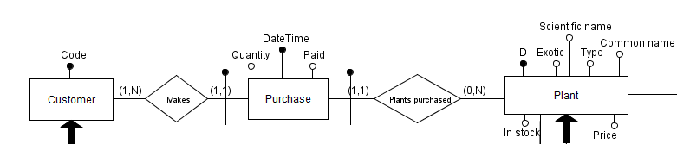Figure 5: Restructured Purchase in the E-R schema
Concept | Type | Volume | Notes
Makes | R | 1’080’000 | From Op.2 we know that each day we have 1000 purchases. Assuming 1 year of activity of the system: 1000*30*12. Assuming that in average a purchase involves 3 plants: 1000*30*12* 3
Purchase | E | 1’080’000 | 1-1 relationship with Makes
Plants purchased | R | 1’080’000 | 1-1 relationship with Purchase
In the accesses table for Operation 4, however we would have:
Concept | E/R | #Accesses | Read/Write | Notes
Customer | E | 1 | R | Read the customer data
Makes | R | 9’000 | R | Reading each purchase for the given customer
Purchase | E | 9’000 | R | Accessing the purchase data
And the cost would still be high (actually even higher than before).
But since we are using an Object-Relational model, we can take advantage of the aggregation concept and incorporate the Purchases of one Customer to the Customer itself: in this way Operation 4 will become much more efficient. We would have the following accesses table:
Concept | E/R | #Accesses | Read/Write | Notes
Customer | E | 1 | R | Read the customer data, including their Purchases
Purchase | E | 9’000 | R | Reading each purchase for the given customer
We wouldn’t have to navigate the Makes relationship and the cost would be of:
- Cost (Op4) = 1 + 9000 = 9’001 accesses
- Daily cost (Op4) = 150 * cost = 1’350’150 accesses/day
Aggregating at yet another level, that is, clumpsing together the records involving the same purchase (but regarding different plants), theoretically we could make the cost 3 times lower: this is due to the fact that, considering that a purchase involves in average 3 different plants, we could just access to the purchase and get all 3 different plants references together.
Concept | E/R | #Accesses | Read/Write | Notes
Customer | E | 1 | R | Read the customer data, including their Purchases
Purchase | E | 3’000 | R | Reading each purchase for the given customer: this time each purchase includes the full transaction (each plant purchased with the quantity and the price)
- Cost (Op4) = 1 + 3000 = 3’001 accesses
- Daily cost (Op4) = 150 * cost = 450’150 accesses/day
The attribute of the Purchase entity would be:
- DateTime
- List of plants purchased: each element of the list would have the quantity, the price and the plant purchased.
The total cost of the purchase could be computed by summing each of the element in the list of plants. If frequently accessed, a redundant attribute Total paid could be introduced in the Purchase entity.

Operation 5
Printing of the plants, ordered by the number of items sold (10 times a month)
Concept | E/R | #Accesses | Read/Write | Notes
Plant | E | 800 | R | Read the plants data
Plants purchased | R | 1’080’000 | R | Read each one of the records in the relationship to count the total number of sales
- Cost (Op5) = 800 + 1080000 = 1’800’800 accesses
- Monthly cost (Op5) = 10 * cost = 10’800’800 accesses/month
By introducing a redundant attribute Number sold on the Plant attribute we could drastically reduce the number of accesses in this operation.
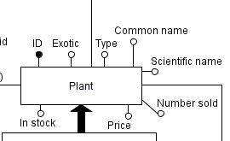Figure 6: Plant entity with the redundant attribute Number sold
In fact, we would only need in total 800 accesses to the Plant entity:
Concept | E/R | #Accesses | Read/Write | Notes
Plant | E | 800 | R | Read the plants data (and the counter of sold items)
- Cost (Op5) = 800 accesses
- Monthly cost (Op5) = 10 * cost = 8’000 accesses/month

Redundancies analysis
- If we add the redundancy on Plant with the Price attribute both Operation 2 and Operation 3 become much faster: in Operation 2 we have 80’000 accesses/day (without redundancies) and 20’000 accesses/day (with redundancies); in Operation 3 we have 210’000 accesses/day (without redundancies) and 10’000 accesses/day (with redundancies). The downside is the little loss of memory of 4 bytes (size of a float) * 800 (#plants) = 3,2 KiB, which is truly irrelevant. The other downside is the additional cost for those rare operations of updating the price of a plant, but benefits outweight the disadvantages.
- The attribute Paid in the Purchase entity can be retrieved by accessing to the Plant price and making a product between the price and the quantity of the Purchase. This would require too many accesses and it’s better just to spend
4 bytes * 1.080.000 = about 4 MB to avoid this operation. Also, this value is never modified, so there’s no situation in which we need to keep this redundancy updated.
- If we add the redundancy on Plant with the Number sold attribute we have great advantages on Operation 5 as we have seen: 10’800’800 accesses/month (without redundancies) vs. 8’000 (with redundancies). On the other hand, the updating of this value is not even problematic, since in Operation 2 we already write on the Plant entity when a purchase is made (to update the In stock attribute). So there are no disadvantages other than the spacial one: 4 bytes (standard size of int) * 800 (#plants) = 3,2 KiB. So the redundancy is kept.

Logical schema
The Object-Relational Logical schema at the end of the day would be as follows:
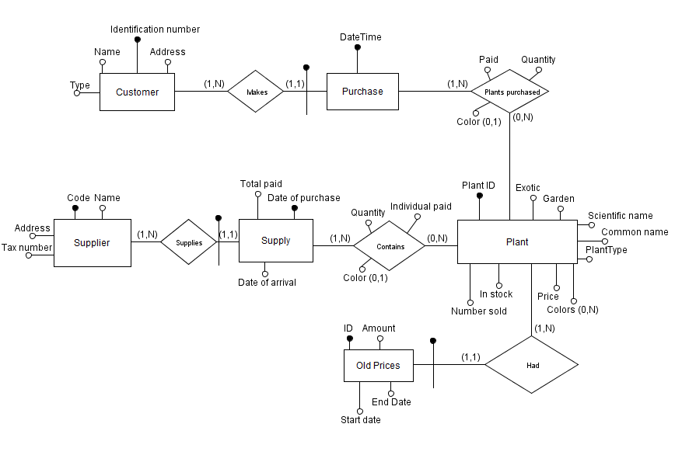Figure 7: Logical schema with the E-R model
As it can be seen, there are a couple of modifications we have not talked about:
- the Customer code was dropped, as the Identification number will be sufficient to uniquely distinguish each customer;
- the Plant ID which is simply the renaming of the ID attribute on Plant;
- the Color attribute was added in the Contains and Plants purchased relations: in fact, it’s necessary to specify the color for each plant purchased/supplied. This leads to the problem of not having more than one pair Purchase-Plant, as we represented this concept in the ER model above. This will be fixed with the introduction of OIDs.
We want the Plants Purchased concept to be represented as a composition entity that depends on Purchases: in fact the former has meaning only in relation with the latter. In turn, also the Purchases exist only if in relation with some Customer, so the same logic applies.
Furthermore, we also want to have the composition paradigm to a Supply and the Plants supplied.
As we can see, it is better to leave the E-R model in favour of an UML diagram, in which composition relations can be represented.
Finally, we can also see the Old prices entity as an entity which exists only if associated with some Plant.
The logical schema has been translated in UML using the software Visual Paradigm.
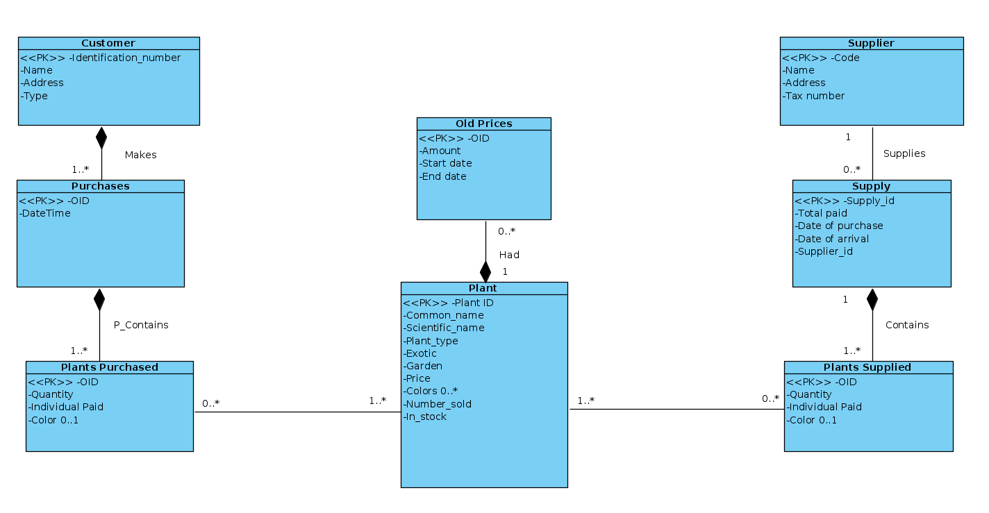Figure 8: Logical model with an UML diagram

Physical Design

Database Implementation
The database has been implemented in Oracle 10g.
To not clog this document, the types and tables definitions are reported as an attachment of this documentation, respectively in the create_tables.sql and create_types.sql files.

Operations implementation
Operation 1 and 2 were implemented as PL/SQL stored procedures in the operations.sql file, which can be found in attachment. In this file also Operations 3,4 and 5 are reported as queries, which are later called by the Java Servlet to retrieve the result sets from the database.

Queries optimization
Looking at the query operations, we can try hands-on to insert some index in order to optimize the operations 3-4-5 (since operations 1 and 2 are insertions).

Operation 3
Printing of the number of plants and properties of plants available for a given species (10000 times a day)
For operation 3, which is the most frequent (10000 times a day), we have to try to squeeze out the most performance we can; the query looks like this:
SELECT * FROM Plants WHERE in_stock>0;

This is the autotrace took from Oracle SQL Developer. As we can see we have a cost of 7, where the biggest load comes from the full scan of the table Plants. Let’s try to create a test b-tree index on the attribute in_stock:
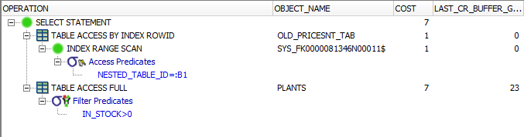Figure 9: Operation 3 autotrace - without index on in_stock
CREATE INDEX ix_plants_instock ON plants(in_stock);
and let’s see how it performs:
We can see that the cost is the same, so that’s no use in having an index and we can delete it.
Figure 10: Operation 3 autotrace - with index on in_stock

Operation 4
Printing of the purchases of a given customer (150 times a day)
Operation 4 involves a simple selection of a customer row with a given identification number (for example, 'FM1A5SQ0ESBAKS4').

SELECT t.* FROM TABLE (SELECT Purchases FROM Customers WHERE identification_number = 'FM1A5SQ0ESBAKS4') t
As we can see from the autotrace of Oracle SQL Developer, the cost of Operation 4 is only of 5 and thus we can state that is a very cheap operation to perform. Therefore, there’s no need to try to optimize this query.
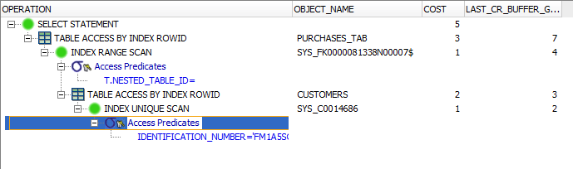Figure 11: Operation 4 autotrace - without indexes

Operation 5
Printing of the plants, ordered by the number of items sold (10 times a month)
Regarding operation 5, we need to execute an ordering of the result set in order to answer to the query.
SELECT * FROM plants ORDER BY (number_sold) DESC;
Let’s look at its cost:
As we could expect, the highest cost comes from the ordering operation. We can try and optimize this query by inserting a b-tree index on the attribute upon which the ordering has to be executed; but, even if we would manage to reduce the cost, operation 5 is so seldomly executed (only 10 times a month), that the gain in efficiency would be unnoticeable. Thus, we decide not to create an index, because that would only lead to higher costs of data manipulation operations.
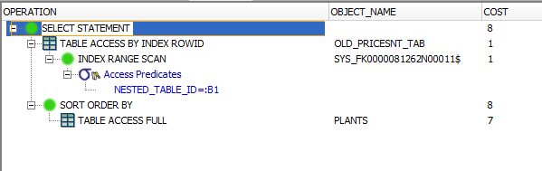Figure 12: Operation 5 autotrace - without indexes

Additional features

Populate Procedures
To populate the Database with plausible (kinda) data, a set of procedures was created:
- POPULATE_CUSTOMERS: inserts into the Customers table a variable number (given in input) of records; a third of the data will be of retailers customers, the remainder will be of private individuals.
- POPULATE_PLANTS: inserts into the Plants table a variable number of records (the number is given as an input of the procedure); half of the data will belong to the “green” type of plants (i.e. without a color), and the other half to “flowery” plants, which have an array of three colors (between red, yellow, blue, violet, white, pink, orange and NULL) each. All plants come with 5 old prices.
- POPULATE_PURCHASES: inserts into the Customer’s Purchases nested table a number of record limited to a maximum value (given in input). Each of the purchase will have 3 plants purchased.
- POPULATE_SUPPLIERS: populates the Suppliers table with a number of record given in input.
- POPULATE_SUPPLIES: populates the Supplies table with a given number (given in input) of rows; each supply has a reference to an existing Supplier; each record has 2 plants purchased subrows.

Triggers
Some triggers have been implemented in the systems:
- supplies_auto_increment_id: keeps updated an auto-increment value which is used as a primary key in the Supplies table; it also prevents inserts of supplies regarding plants which do not exist.
- increase_plants_in_stock: increases the in_stock attribute of a Plant when a new supply is made;
- decrease_plants_in_stock: decreases the in_stock attribute of a Plant when a new purchase is made by a customer. It also prevents the insertion of a purchase involving a quantity which is greater than the in-stock availability of that plant.
- [currently doesn’t work] plants_insert_check_type: prevents the inserting of a plant of type ‘f’ (flowery), but with no colors assigned, and the inserting of a plant of type ‘g’ (green) but with one or more colors assigned;

Other functionalities
Other than the extensions in the database structure, two more operations were introduced:
- Op 6: Update a plant price
From the website an operator can update the price of a plant by its ID. The current price will be replaced by the new one and will be inserted in the plants’ old prices, with the appropriate dates.
This operation is performed by the UPDATE_PRICE procedure, which is attached to the documentation in the operations.sql file.
- Op 7: Search of a plant by its name
From the website an operator can search for a plant’s data by making a research based on the plants common name. The matching results, which include the typed string anywhere in the common_name field, will be shown to the user.
The query to perform for this operation is the following:
SELECT * FROM plants WHERE common_name LIKE ('%partial_name%');

Deployment, Website and Servlet

System Deployment
The Oracle database is installed in a Windows 7 virtual machine, in the version J2EE 10g (10.1.3.4.0).
To create the database and to populate it, the file SetDatabase.sql was created: it is sufficient to run the entire script to have it all ready; it is worth noting that the populate procedures execution will take a while to be performed.
A script EmptyDatabase.sql has been created to delete all the tables, triggers and procedures from the database and leave it empty.

Website front-end
A website was created ad hoc to interact with the Oracle database. HTML, CSS and Javascript were used to implement the client-side, in particular JQuery and Bootstrap libraries, while for the server-side Java was used to create a servlet. The latter receives requests from the users and queries the database to return the desired data.
The website has been called “Plantsdom” and here we will report some screens of it.
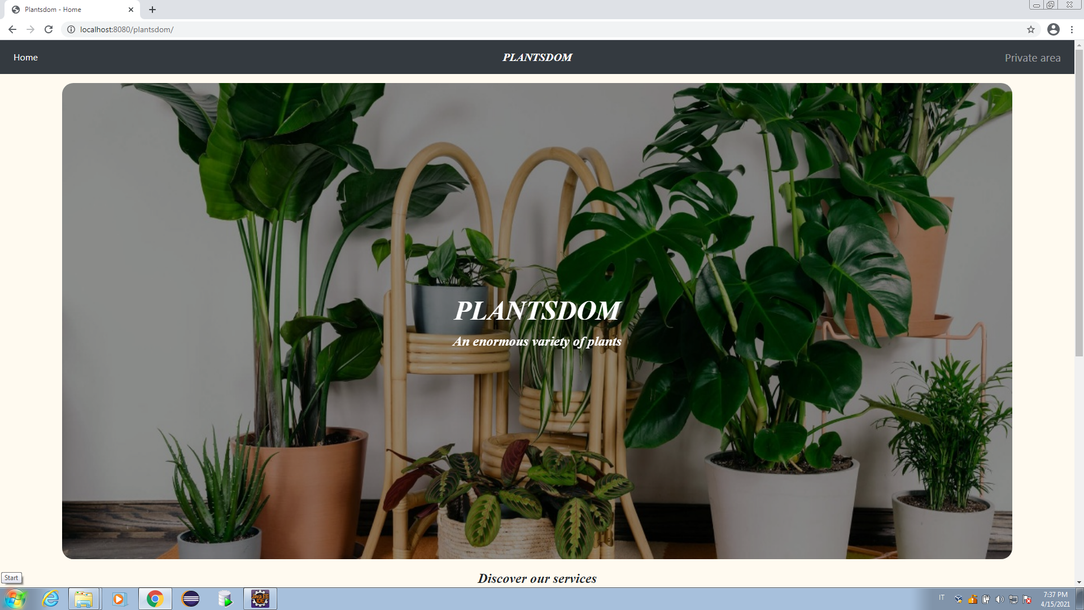Figure 13: Website Homepage
We have the homepage, which presents the website, and the “Private area” (reachable from the link in the top-right corner or in the bottom of the page) in which an operator can interact with the Java Servlet. In the latter, the user can select between all the operations (from Operation 1 to 5), insert data and view results.
In particular Bootstrap Tables was used to implement tables for inserting multiple plants of a purchase: we can see them in Operations 1, 2 and 7.
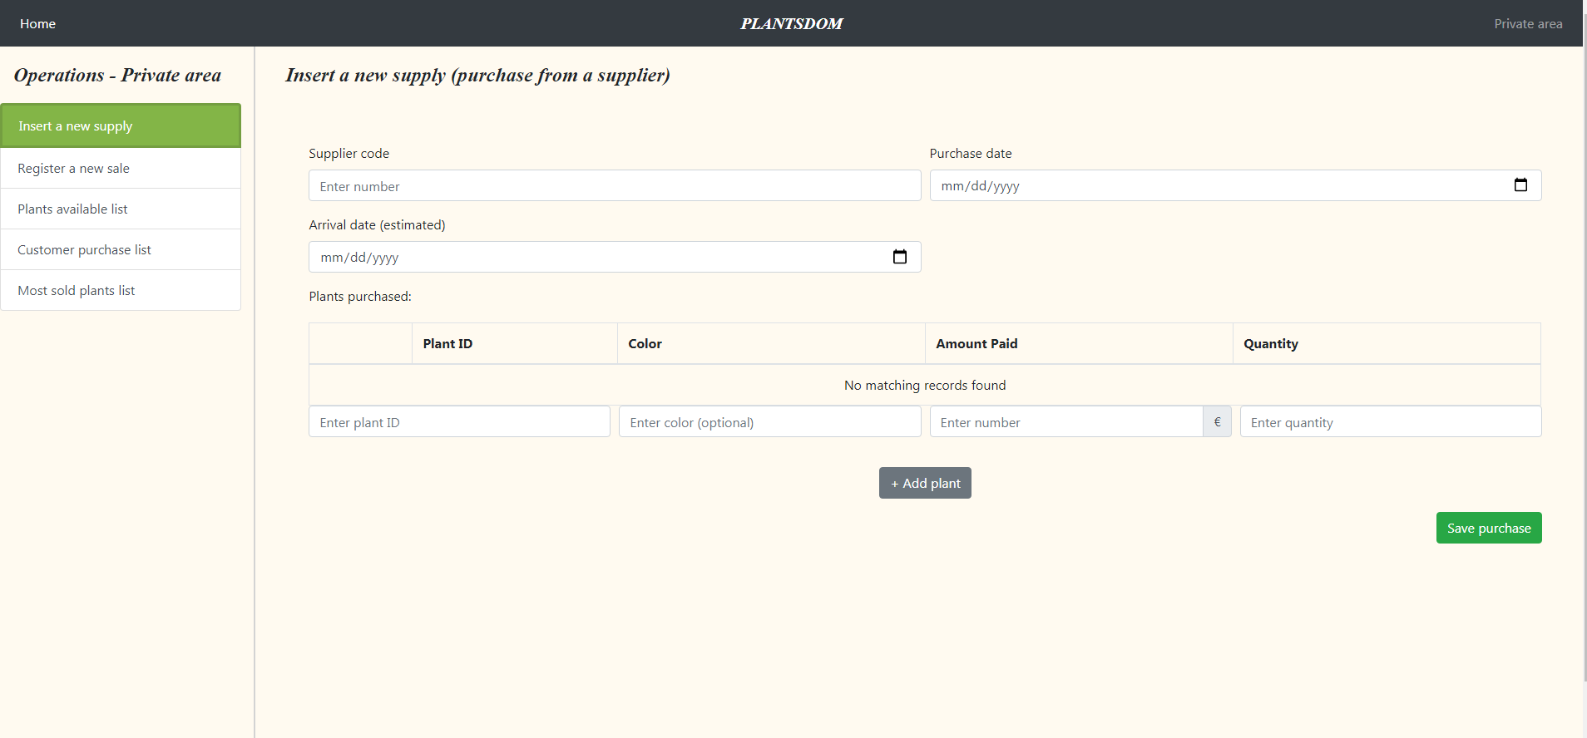Figure 14: Website "Private Area" – Operation 1

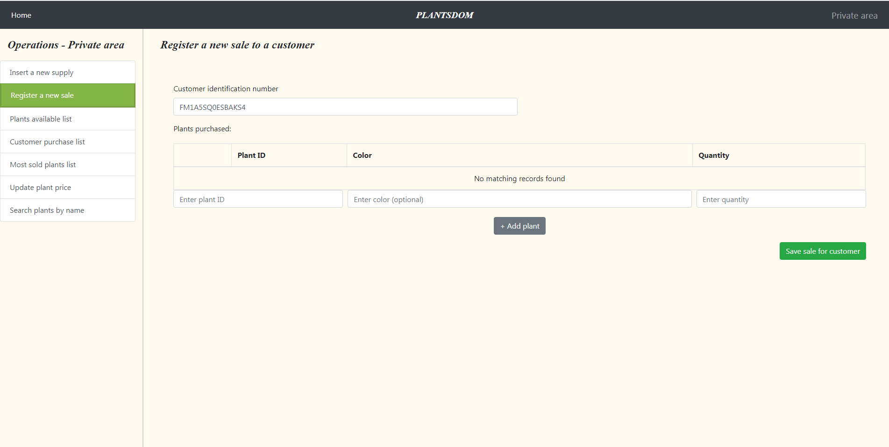Figure 15: Website "Private Area" – Operation 2
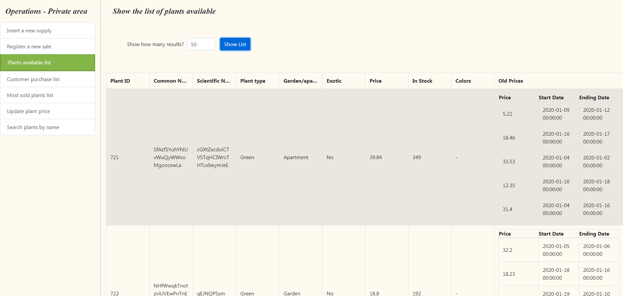Figure 16: Website "Private Area" - Operation 3, results of a query
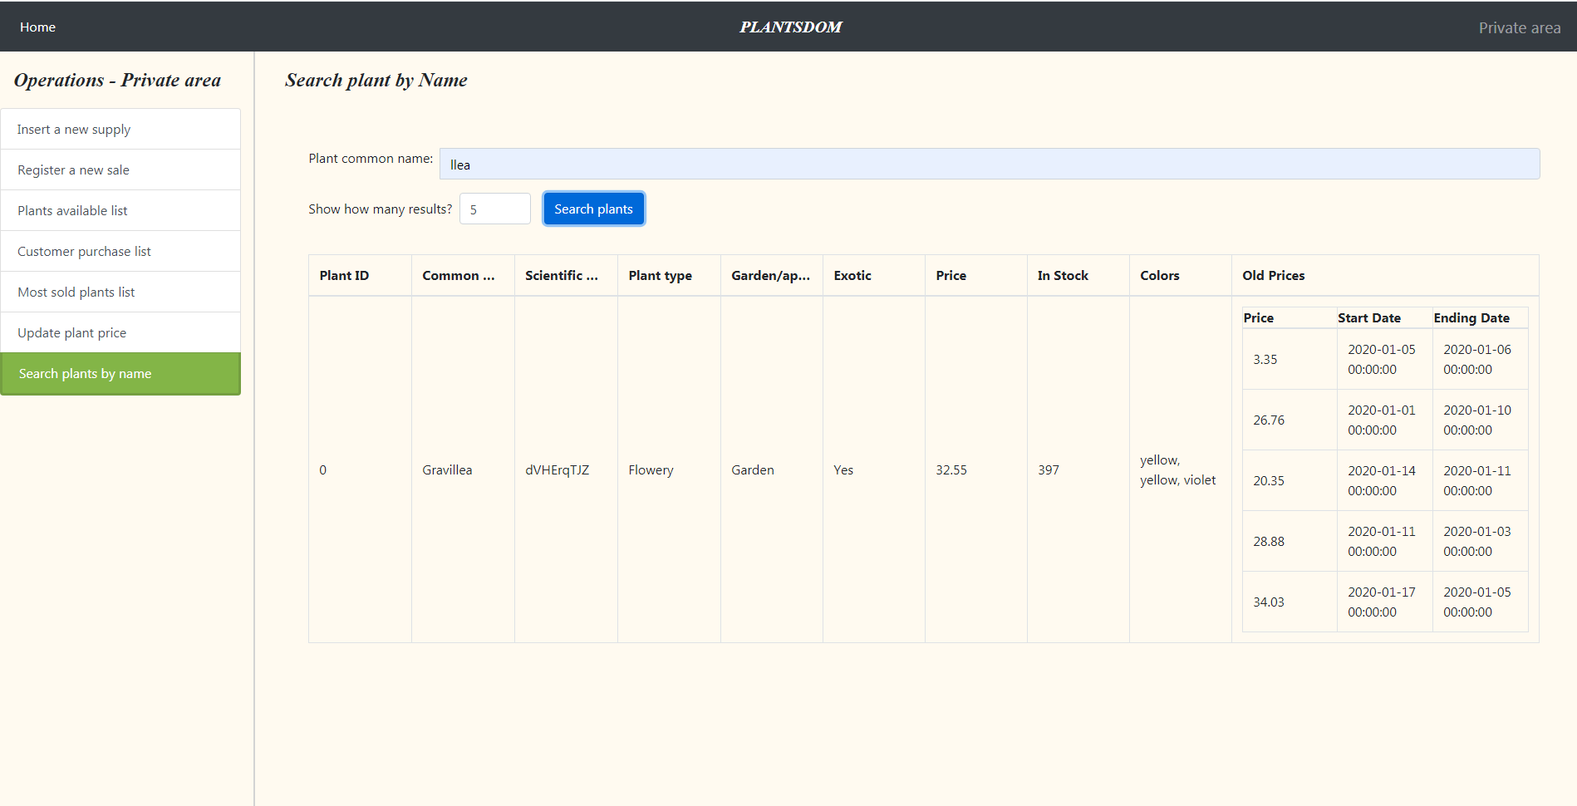Figure 17: Website "Private Area" - Operation 7, results of the search of "llea"

Website back-end: Servlet
As we’ve told the back-end is a Java Servlet, which is the controller of the application: it intercepts the users’ requests, makes requests to the database and returns the data, which the views will output to the users.
This is the Servlet.java class, which based on the request method and operation called, will invoke the proper operation: these operations are contained in the DBOperations.java file.
For POST requests the doPost() method selects the right operation between:
- Operation 1: calls the insertSupply() method (in the DBOperation class), giving as parameters the supplier_code, the purchase_date, the arrival_date and the plants_purchased (the ids, the quantities, the amounts paid and the colors);
- Operation 2: calls the insertPurchase() method, which takes in input the customer_code, and the plants_purchased information (the ids, the quantities, and the colors);
- Operation 6: calls the updatePrice() method, which takes the plant_id to update and the new_price to set.
For GET requests the doGet() method selects an operation between:
- Operation 3: calls the getAvailablePlants() method;
- Operation 4: calls the getCustomerPurchases() method, taking in input the customer_code;
- Operation 5: calls the getMostSoldPlants() method;
- Operation 7: calls the getPlantByName() method, taking in input the common_name string to look for.
The operations functions contained in the DBOperations class have dependencies on another class, called DatabaseOracle (contained in the DatabaseOracle.java file): the latter contains all the connectivity, conversions and utility functions to correctly form the requests to the Oracle database. This class mainly uses the oracle.sql package.
To avoid SQL injections prepared statements were adoperated to securely get the parameters from the users requests before using them into the queries.
Results from the DB were translated into JSON Objects using the org.json package: the Operations.jsp view, therefore, takes the JSON response and builds the tables with the results to show them to the user.
The user can query up to 500 results and can choose to visualize only a limited part, but this only affects the client side: the server will always return all the data.

Conclusions
This project has the intent of showing the capability of designing and implementing an Oracle database system. Furthermore, also a Java backend system was implemented to query the database from the final user’s point of view. I learnt new technologies and discovered that there were many many more that I could have chosen for the implementation of this project, some of them which are surely more powerful than the ones used. The downside was the learning time that many of them required, even to be understood, so I hope I made some good technical choices. I also tried to get the best usability level as possible with the use of some front-end web technologies, but in a limited period of time it has not been completely possible.
Some future work could surely include the creation of the Model classes with Jpublisher, to have a better flexibility and robustness in the creation of other functionalities; another crucial point is the improvement of the user interaction with the database, like giving more feedback to the user (since now the feedback given by the system is really poor) and some auto-completement features for the operations that require user inputs.

