**Title: StockOverflow**

**Team: Bits Pls**

**Short Intro:**

The main goal of StockOverflow is to serve as a research tool for stocks based on a specified price range. Additionally, it will serve as a gateway for young investors to educate themselves about trading. Further into the development of StockOverflow we want to allow users to practice stock market investing by using “play” money. Websites such as<http://www.wallstreetsurvivor.com/>  already have this feature but we plan to offer more resources and information than most competitors do for free.

**Original Contributions:** Very few companies organize stocks by price range. This makes finding “penny stocks” for amateur or new investors difficult and discouraging. Finding credible information and tools that are free is incredibly difficult as well. As mentioned above, StockOverflow aims to make these obstacles for new traders obsolete.

**Broader Impact:** Our target audience is a younger crowd (15-20 years old) who have an interest in investing. We want to make searching for affordable stocks easy and informative. If we can get younger individuals interested in finances and investing then we can help them become more financially literate. Later in life those skills will benefit them with understanding how important it is to invest for the future and retirement.

**Proposed System Architecture:**  
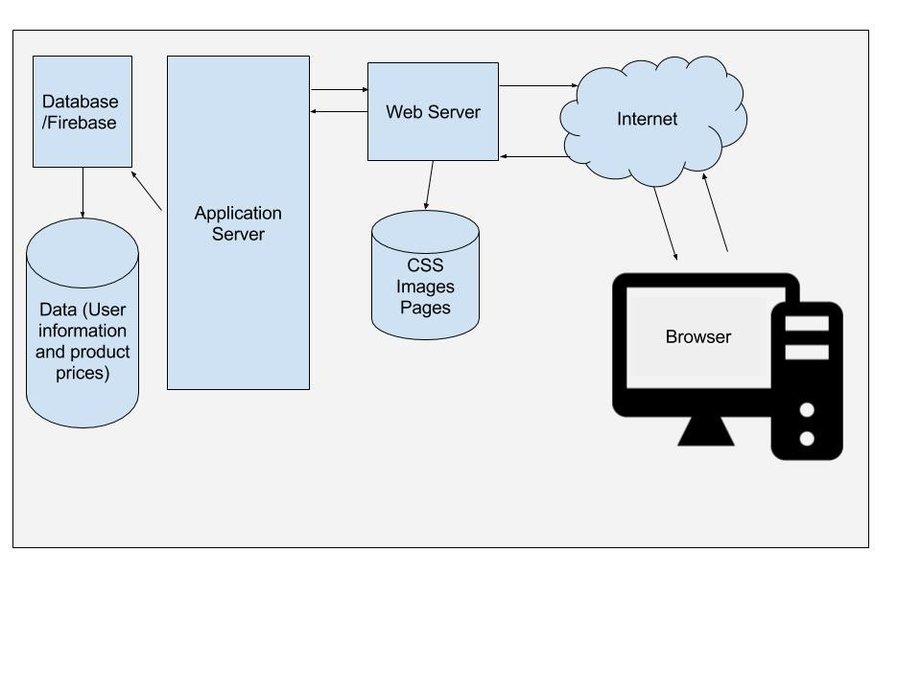

**Technical Details:**

·    Database: Firebase, a database created by Google.

·    Web Host: GoDaddy! , a DNS provider.

·    Software:

* R (programming language)
* Python
* HTML/CSS
* JavaScript

**Related Work:**

<http://www.octoparse.com/tutorial/scraping-stock-data-on-yahoo-finance/>

   Above link: This will be the starting point for scraping stock data and organizing it with Python.

<http://bigdata.teradata.com/US/Big-Data-Quick-Start/Process-and-Structure/>

Above link: Once we’ve scrapped the data we will need to make sense of it and figure out how to structure it so we can efficiently search through the data.

<http://www.algotrades.net/>

Above link: The following link is to a site which covers the basics of algorithmic trading. We will need some basic algorithms for our searches and to assist in creating a mock trading environment.

**Planned Time-Line (High-Level Overview):**

·    February: Finalize the user interface and begin scraping stock data

·    March: Optimize queries and begin creating a stock trading simulator

·    April: Test and refine smaller details

·    May: Present and launch

**Team Members and Responsibilities:** No one in our team has experience building an application like this or dealing with such massive volumes of data. As we progress in knowledge we plan on branching out into what we want to focus on individually. For now, we’re focusing on creating a detailed plan of action.

**Conclusion:**  By the end of this project we hope to present a well-polished and fully functioning website. While we do anticipate many challenges, we think that hardest challenge will be scraping the stock data. After that everything else will be a matter of creating algorithms, queries, and making the website. We also look at this term project as more than just a grade, we see this as a way to push ourselves and to expand our knowledgebase. We want this project to be something we can put on our resumes and talk to future employers about.