Name: Corey Hamren
Batch code: LISUM03
Submission date: 09/11/2021

Model from Jupyter -
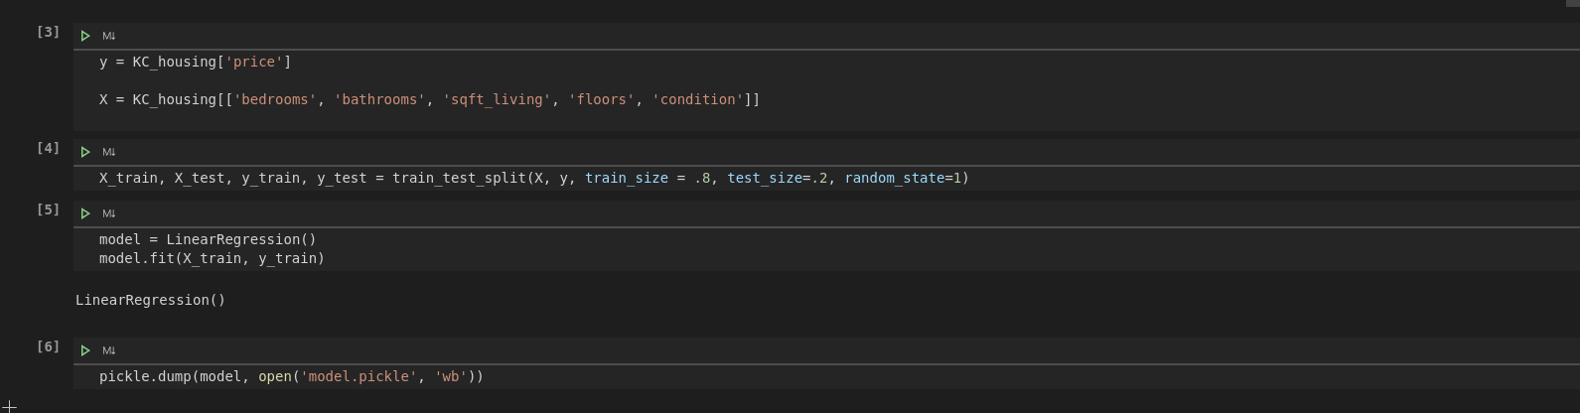
Flask app -
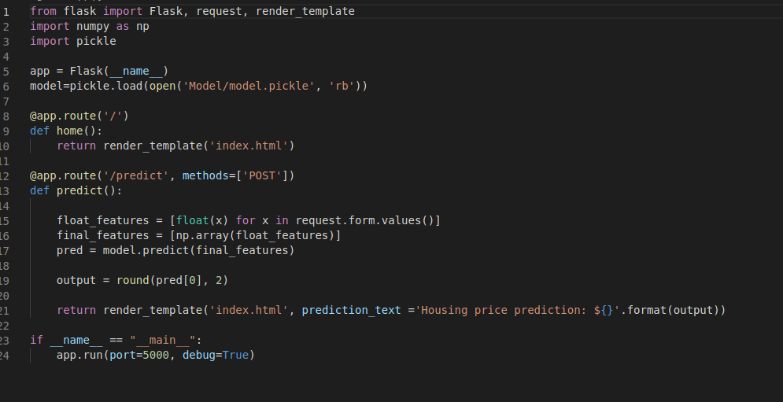

HTML -

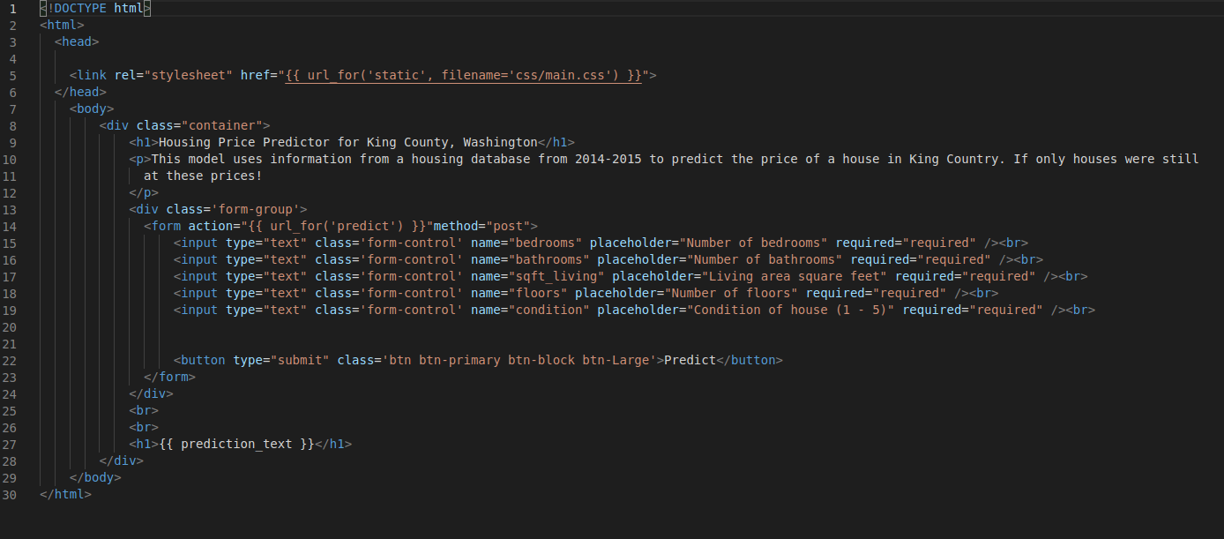

Flask Page -

