### **🔹 Step 1: Create a VPC**

1. Go to the **VPC Dashboard** → Click **Create VPC**
2. Choose **VPC only**
3. Fill in the details:  
   * **Name**: myVpc01
   * **IPv4 CIDR block**: 10.0.0.0/16
   * **Enable DNS hostnames**: ✅ Yes
4. Click **Create VPC**

**Screenshot:-**

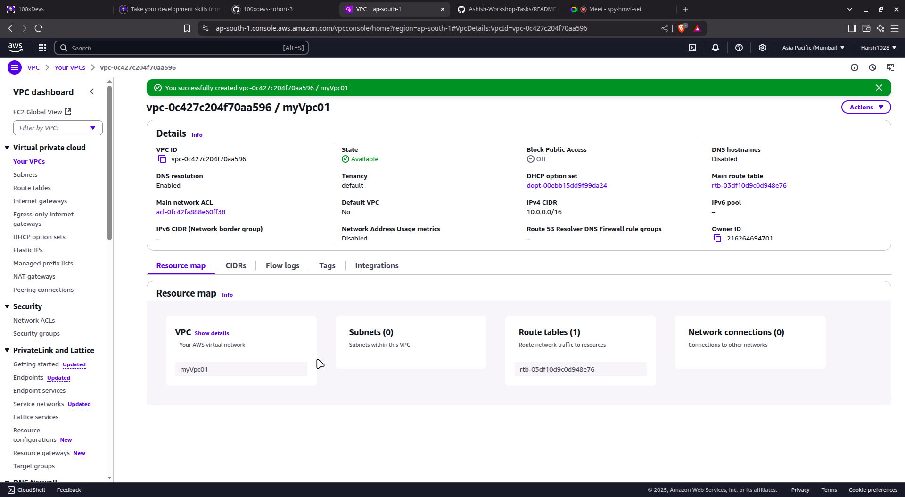

### **🔹 Step 2: Create Subnets**

1. Go to **Subnets** → Click **Create subnet**
2. Select your VPC (**MyVPC**)
3. Add **two subnets**:  
   * **Public Subnet**
     + Name: subnetPublic
     + Availability Zone: ap-south-1a
     + CIDR block: 10.0.1.0/16

**Screenshot:-**

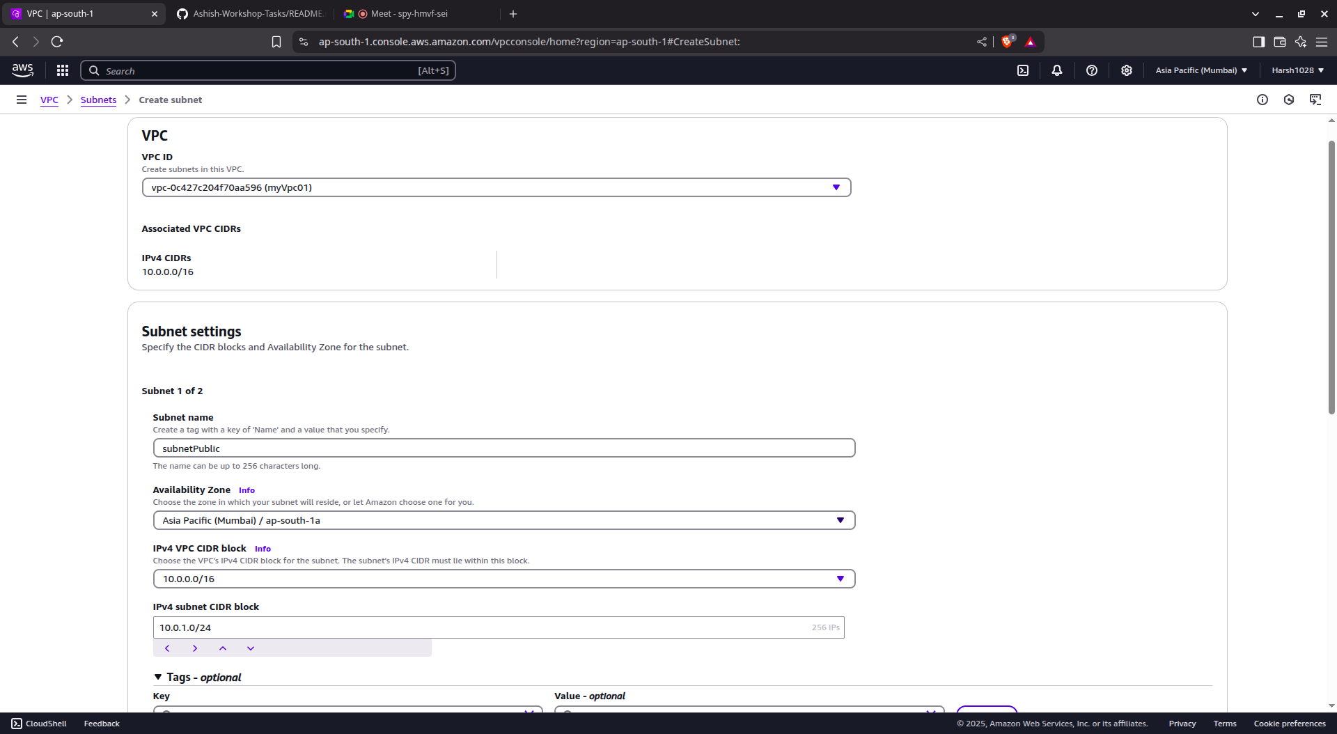

* + **Private Subnet**
    - Name: subnetPrivate
    - AZ: Same as above
    - CIDR block: 10.0.2.0/24

**Screenshot:-**

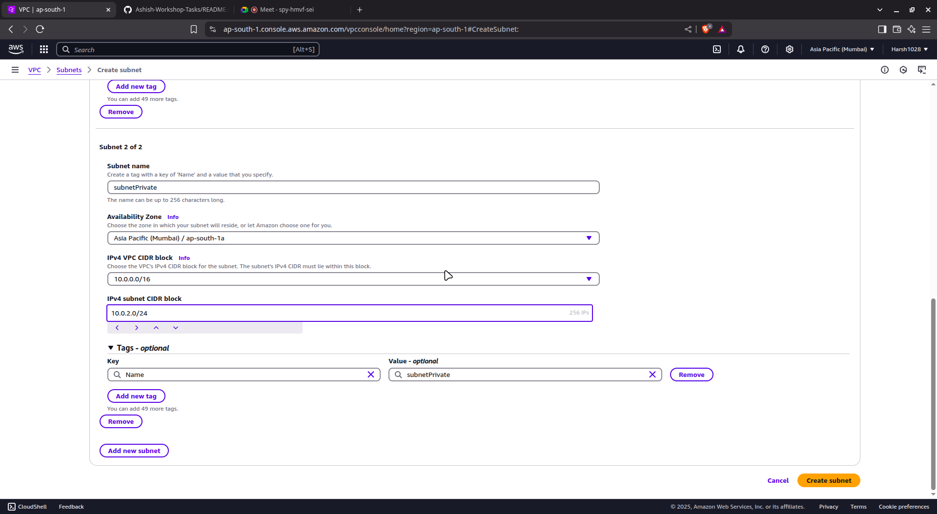

1. Click **Create subnet**

### **🔹 Step 3: Create and Attach Internet Gateway (IGW)**

1. Go to **Internet Gateways** → Click **Create internet gateway**
2. Name it: dalal→ Click **Create**
3. After creation, click **Attach to VPC**, select myVpc01, and confirm

**Screenshot:-**

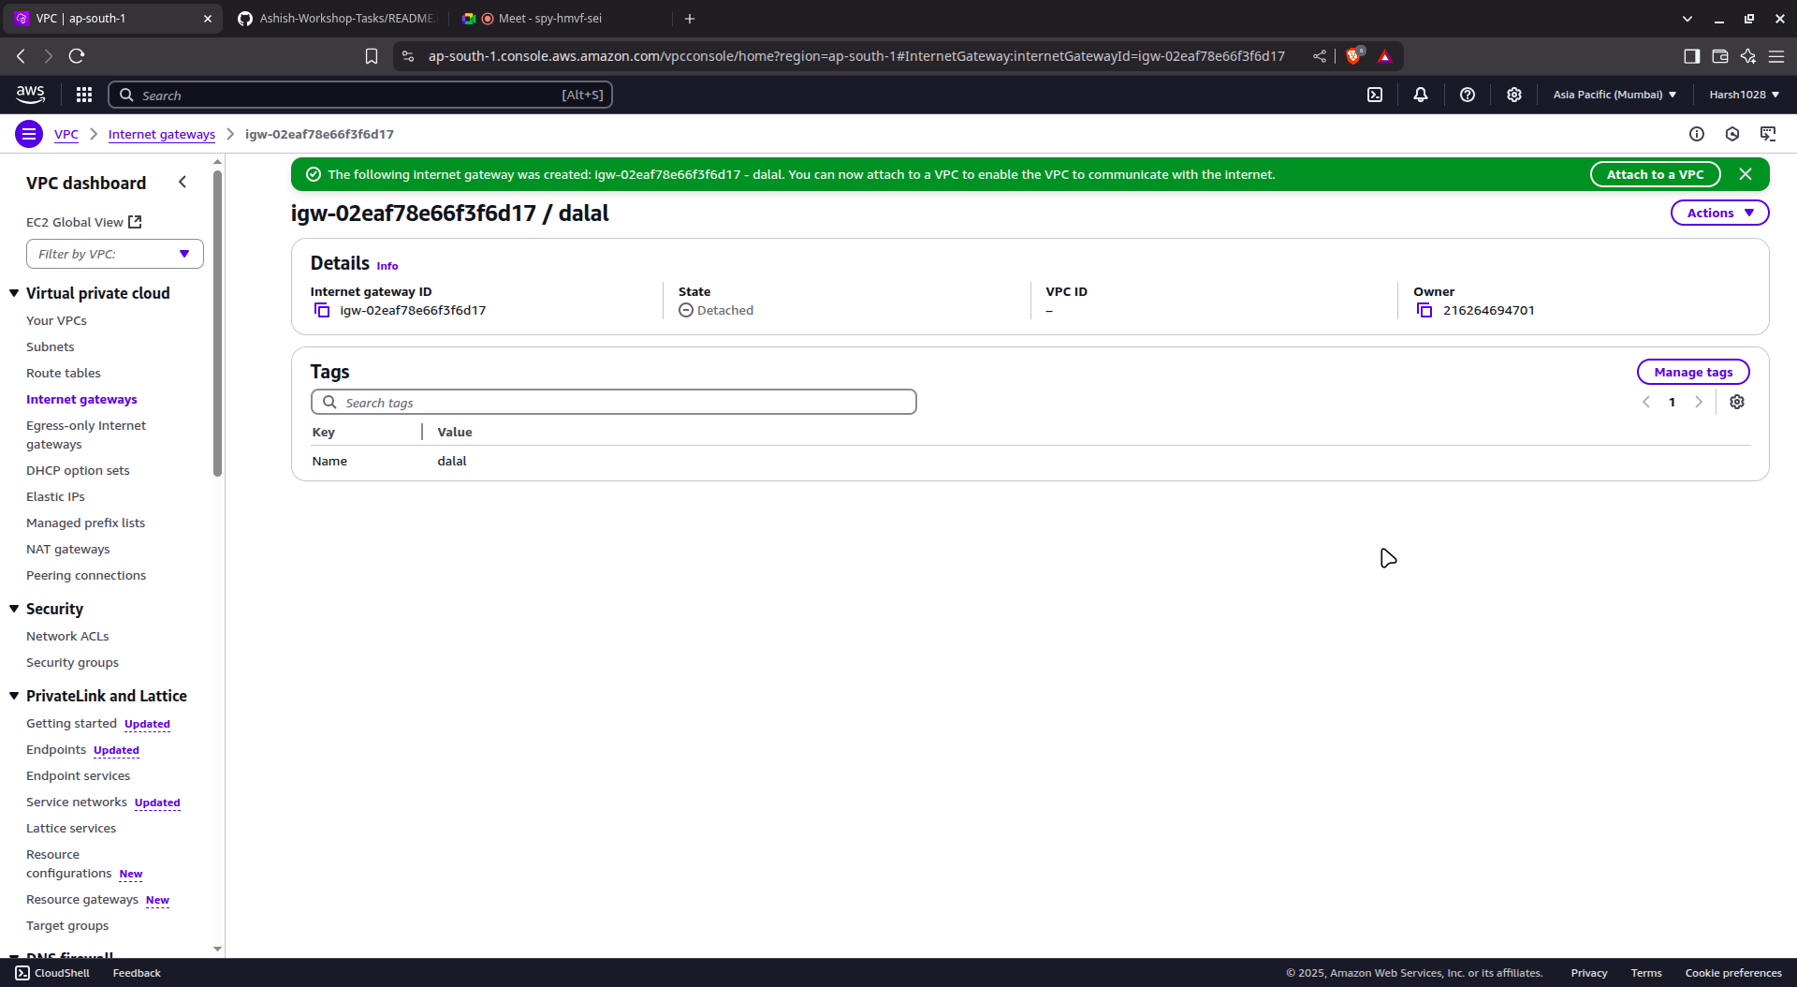

### **🔹 Step 4: Create NAT Gateway**

1. Go to **Elastic IPs** → Click **Allocate Elastic IP address** → Allocate

**Screenshot:-**

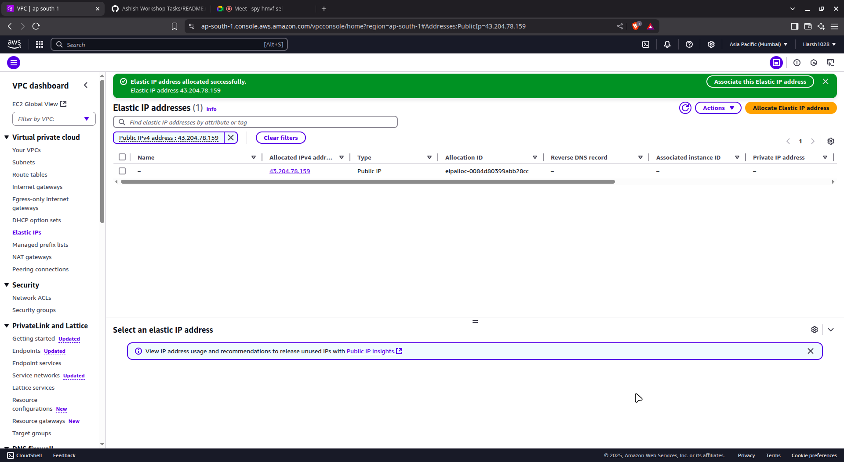

1. Go to **NAT Gateways** → Click **Create NAT gateway**:  
   * **Subnet**: Select subnetPublic
   * **Elastic IP**: Choose the one you just created
   * **Name**: MyNATGateway

**Screenshot:-**

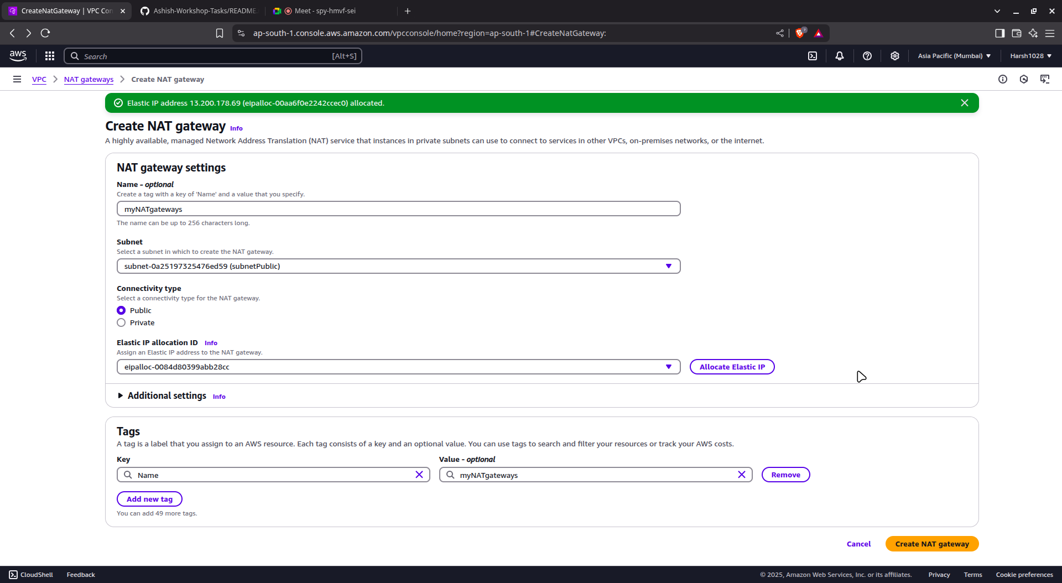

1. Click **Create NAT Gateway** and wait for status to become *Available*

**Screenshot:-**

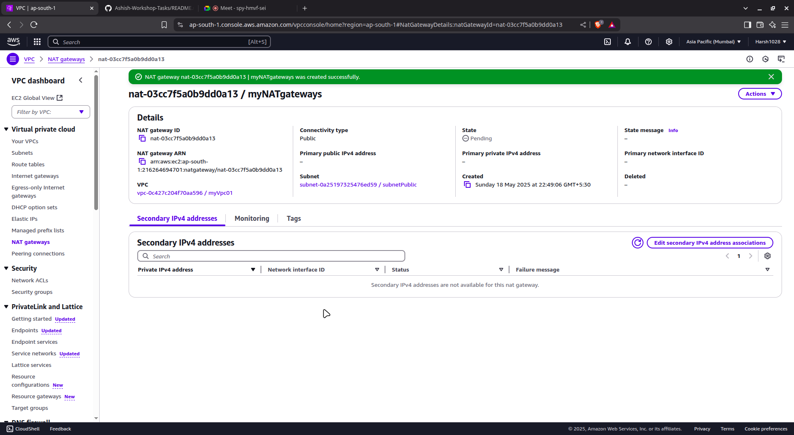

### **🔹 Step 5: Create Route Tables**

#### **📍 Public Route Table**

1. Go to **Route Tables** → Click **Create route table**
   * Name: RouteTablePublic
   * VPC: myVpc01

**Screenshot:-**

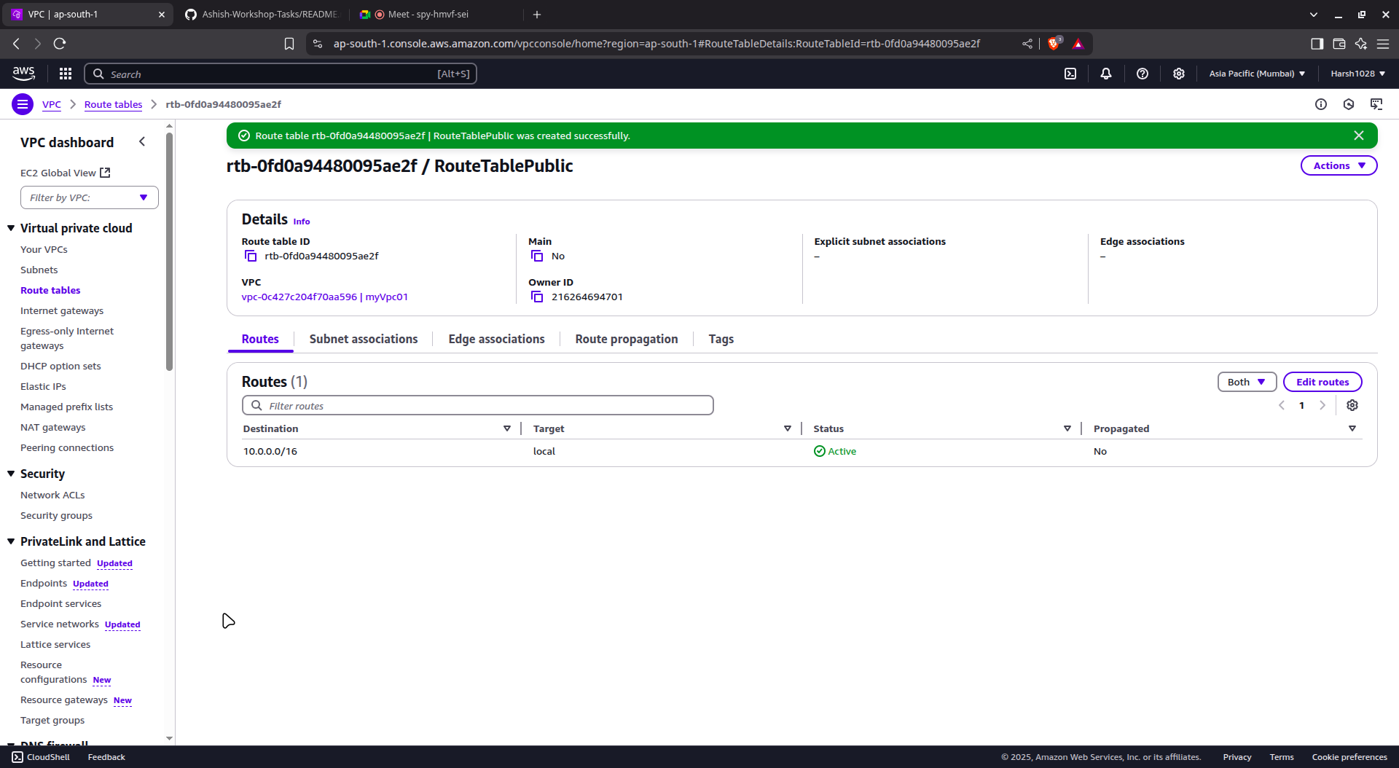

1. Click on the route table → **Routes** → **Edit routes**
   * Destination: 0.0.0.0/0
   * Target: **Internet Gateway** → dalal

**Screenshot:-**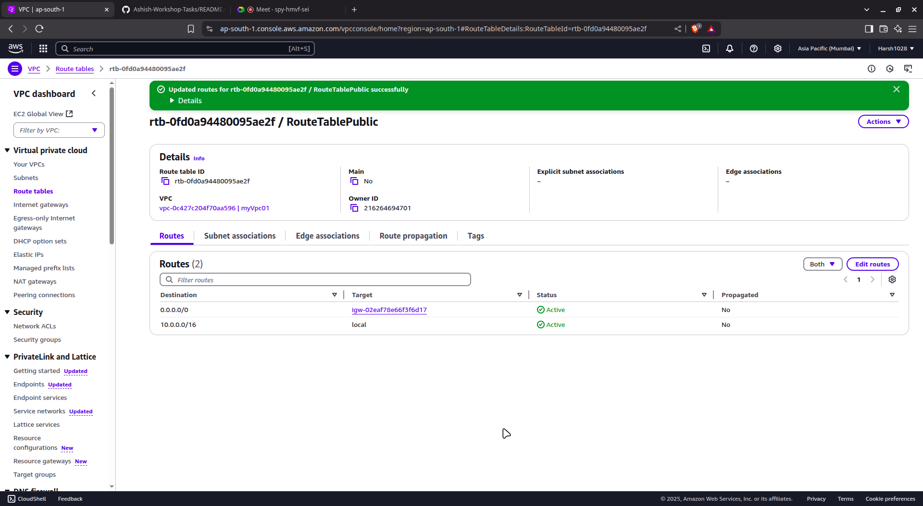

1. Go to **Subnet Associations** → Associate with subnetPublic

**Screenshot:-**  
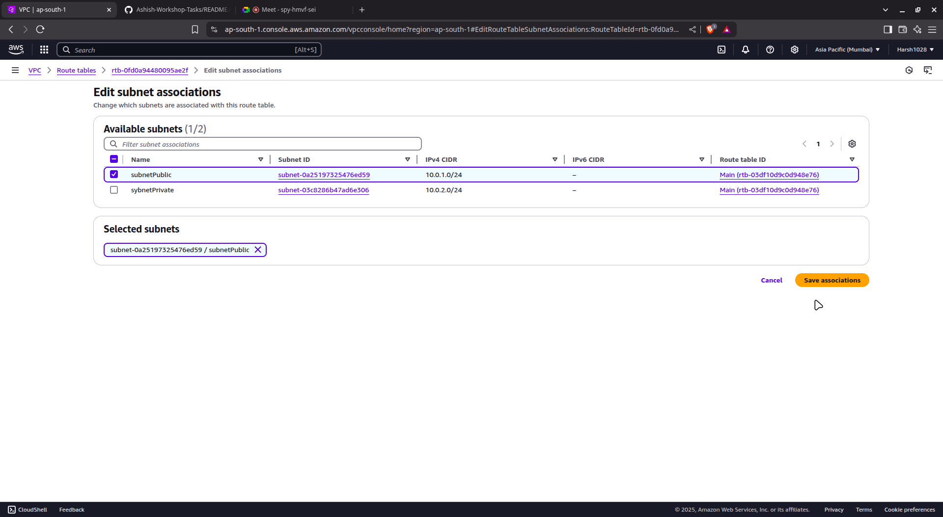

#### **📍 Private Route Table**

1. Go to **Route Tables** → Click **Create route table**
   * Name: RouteTablePrivate
   * VPC: myVpc01

**Screenshot:-**  
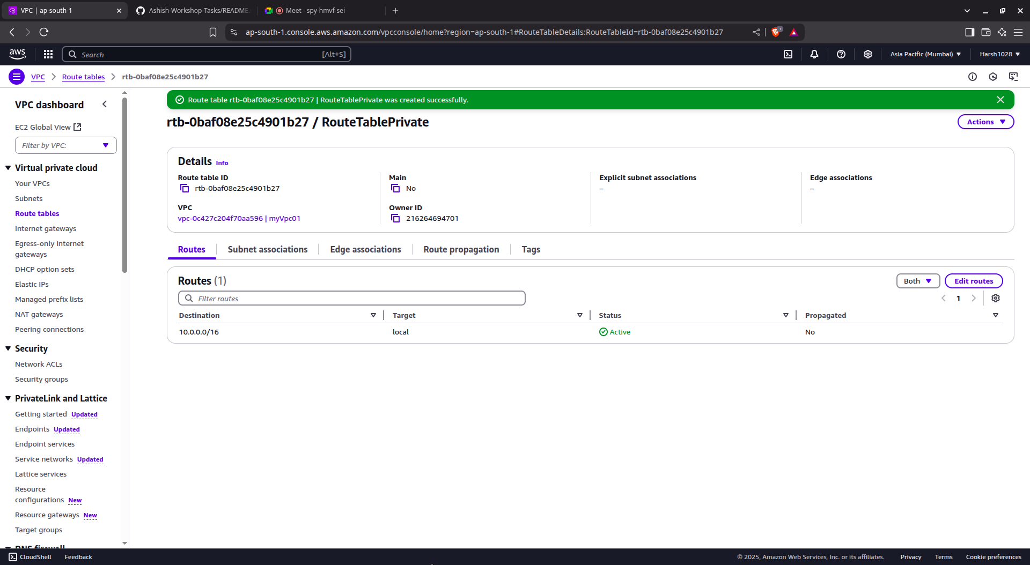

1. Click on the route table → **Routes** → **Edit routes**
   * Destination: 0.0.0.0/0
   * Target: **NAT Gateway** → myNATgateway

**Screenshot:-**

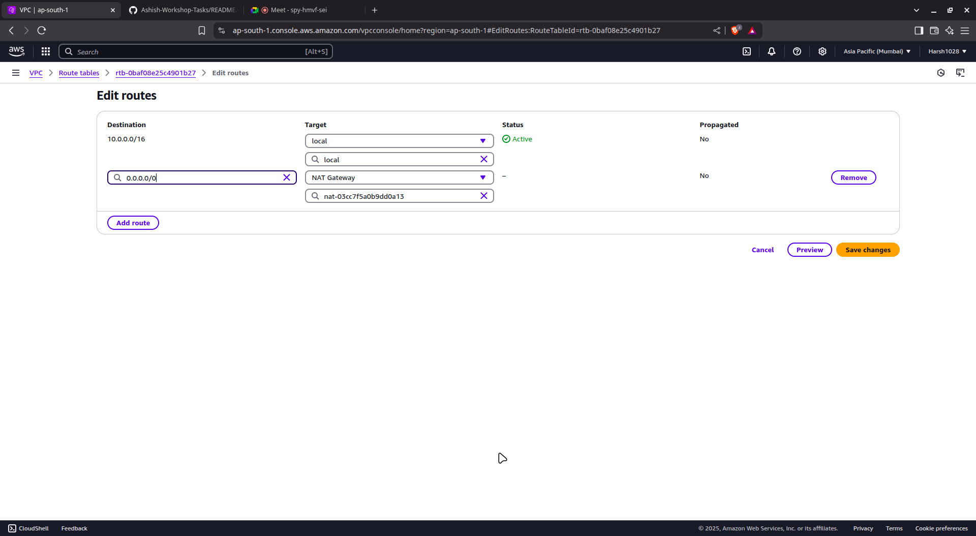

1. Go to **Subnet Associations** → Associate with subnetPrivate

**Screenshot:-**

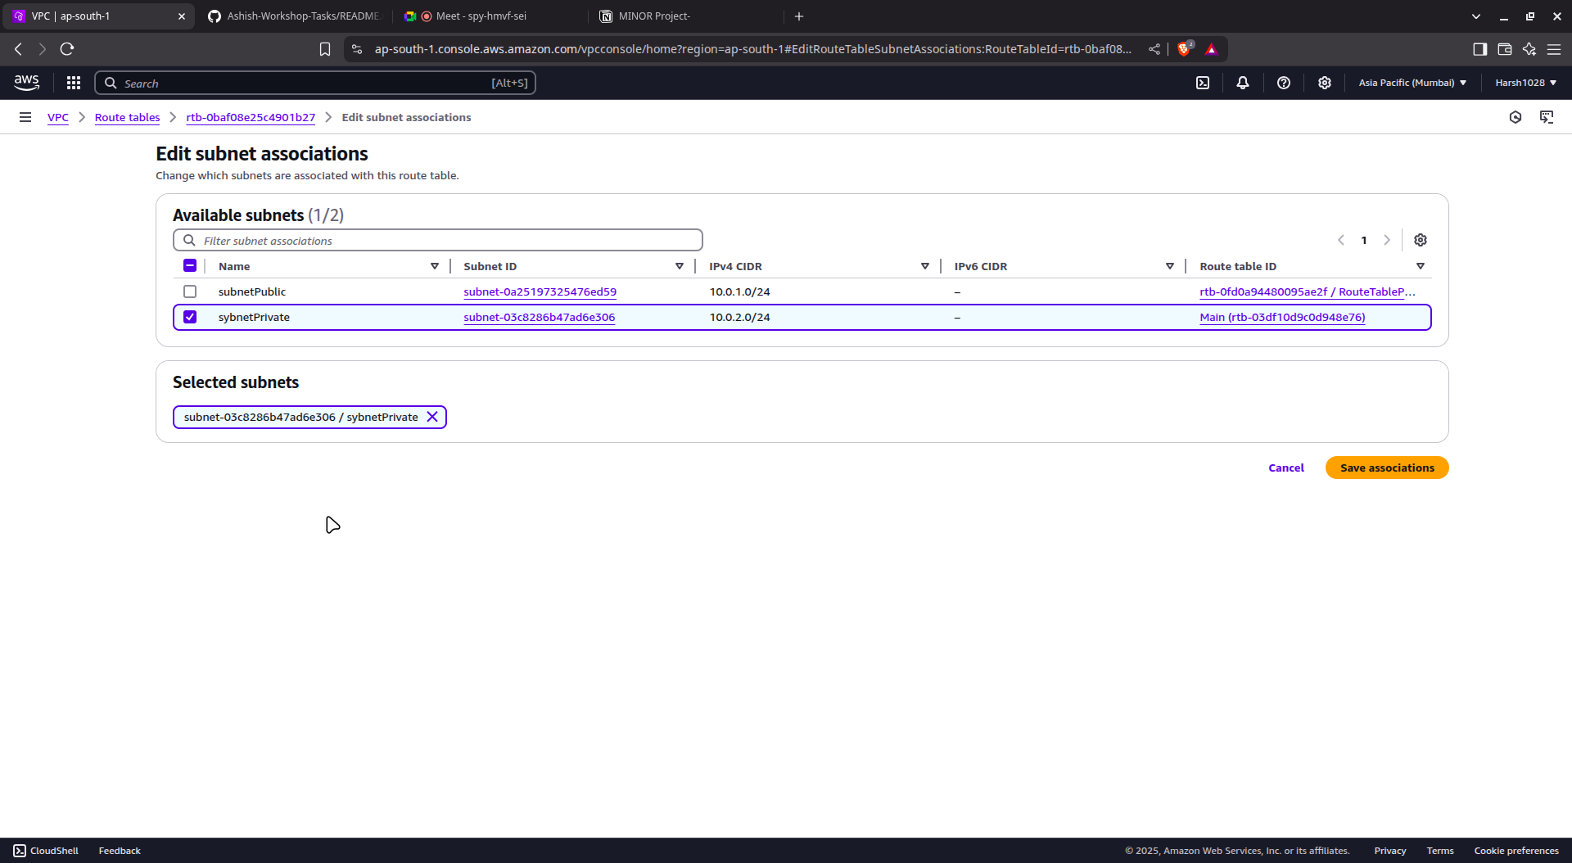

### **🔹 Step 6: Create Security Groups**

#### **🔐 Bastion SG**

1. Go to **Security Groups** → Click **Create**
   * Name: BastionSG
   * VPC: myVpc01
2. Inbound Rules:  
   * **Type**: SSH
   * **Port**: 22
   * **Source**: Your IP (e.g., 203.0.113.25/32)
3. Outbound Rules: Leave as default (Allow All)

**Screenshot:-**

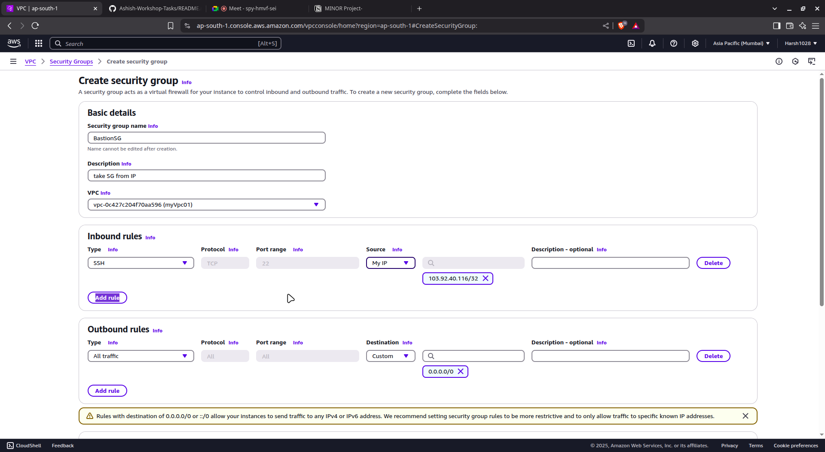

#### **🔐 Backend EC2 SG**

1. Create another security group:  
   * Name: BackendEC2SG
   * VPC: myVpc01
2. Inbound Rules:  
   * **Type**: SSH
   * **Port**: 22
   * **Source**: 10.0.1.0/24 (Public Subnet CIDR)
3. Outbound Rules: Leave as default

**Screenshot:-**

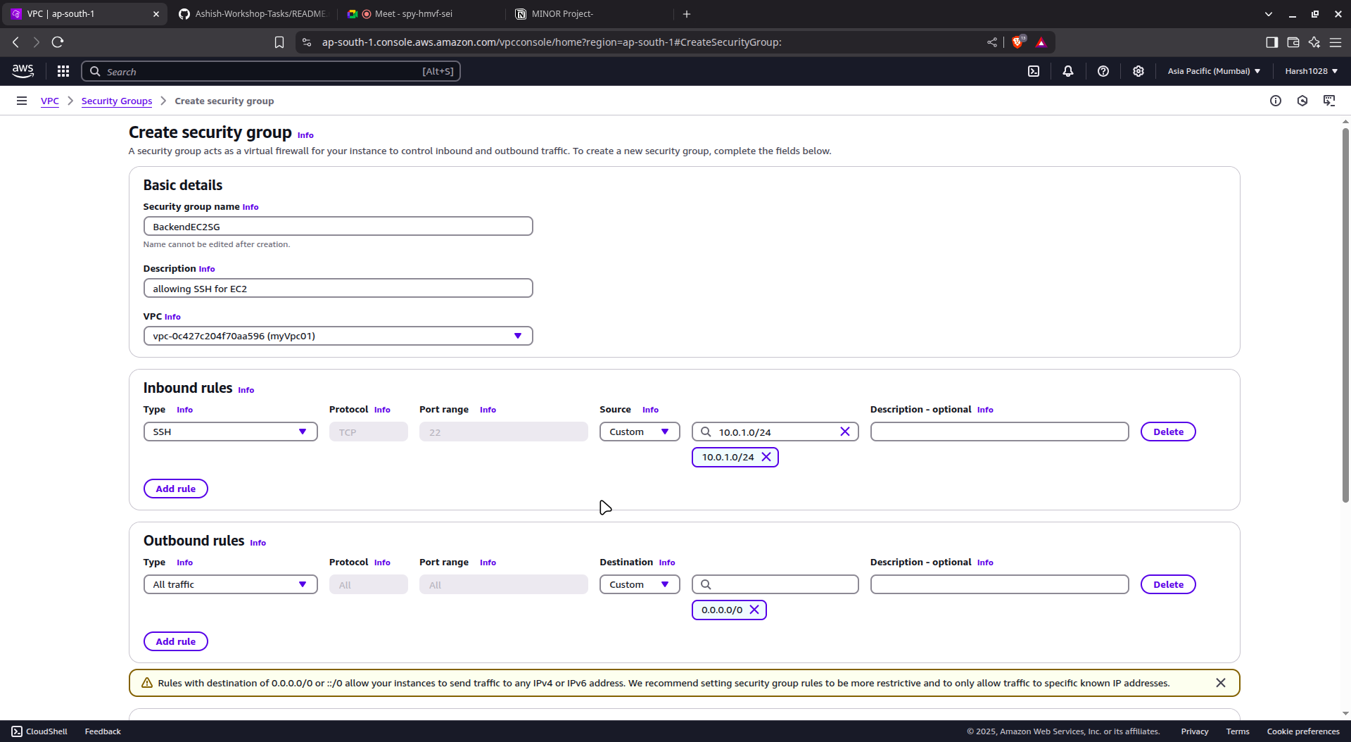

### **🔹 Step 7: Launch EC2 Instances**

#### **🚀 Bastion Host (Public Subnet)**

1. Go to **EC2 Dashboard** → Launch Instance
2. Name: BastionHost
3. AMI: Ubuntu
4. Instance Type: t2.micro
5. Key Pair: Use or create .pem file
6. Network:  
   * VPC: myVpc01
   * Subnet: subnetPublic
   * Auto-assign Public IP: ✅ *Enable*
7. Security Group: Select BastionSG
8. Launch Instance

**Screenshot:-**

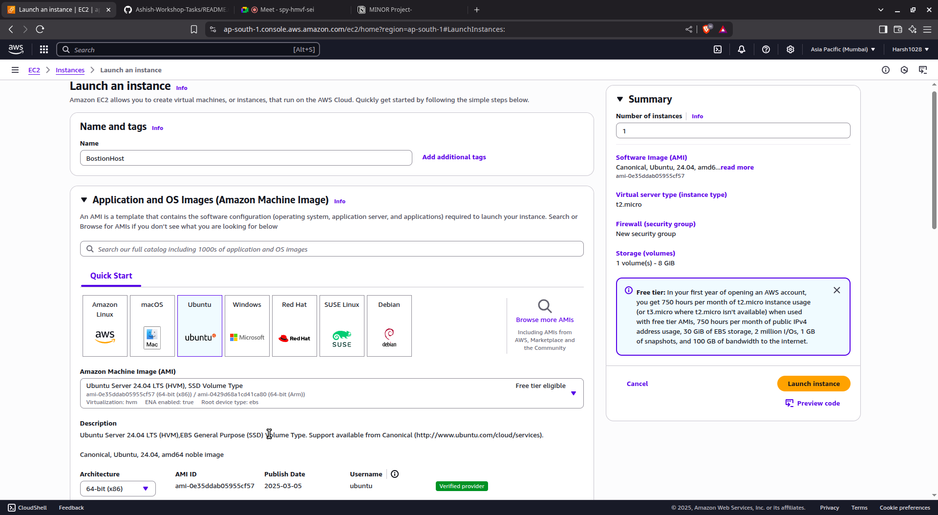

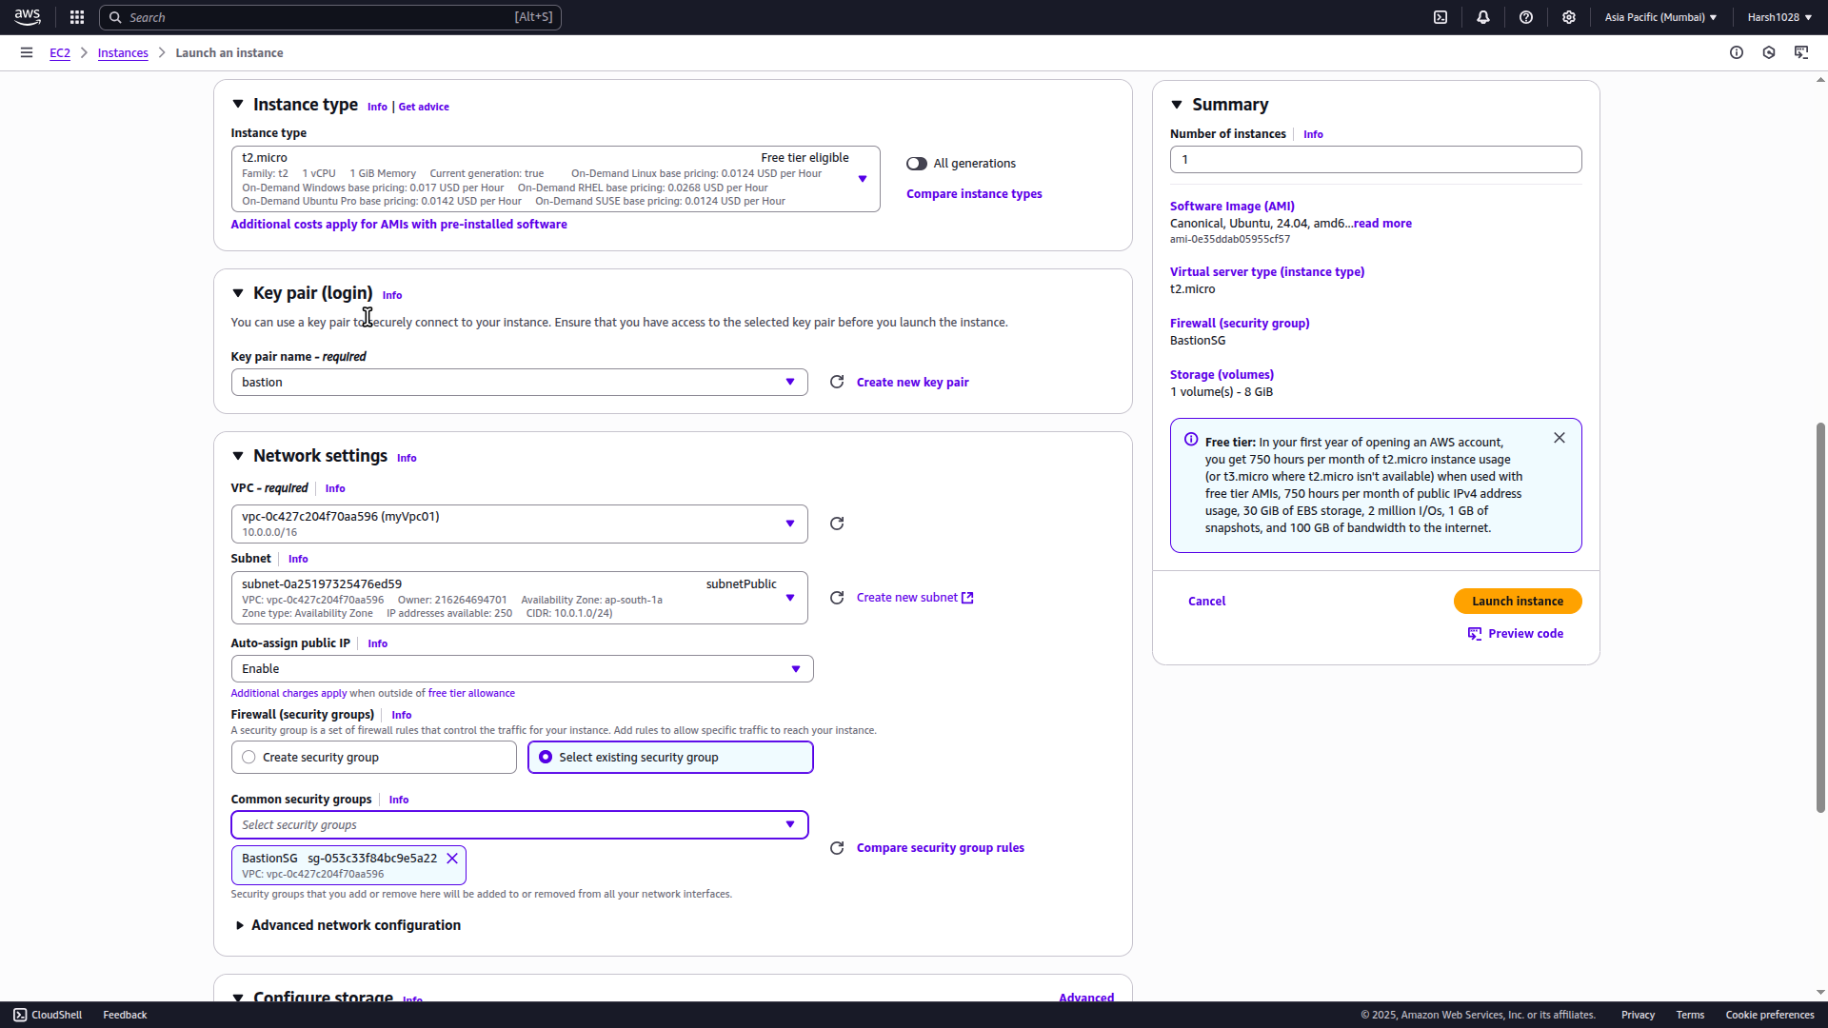

#### **🚀 Backend Instance (Private Subnet)**

1. Launch another instance
2. Name: BackendInstance
3. AMI: ubuntu
4. Instance Type: t2.micro
5. Key Pair: Same .pem file
6. Network:  
   * VPC: myVpc01
   * Subnet: subnetPrivate
   * Auto-assign Public IP: ❌ *Disable*
7. Security Group: Select BackendEC2SG
8. Launch Instance

**Screenshot:-**

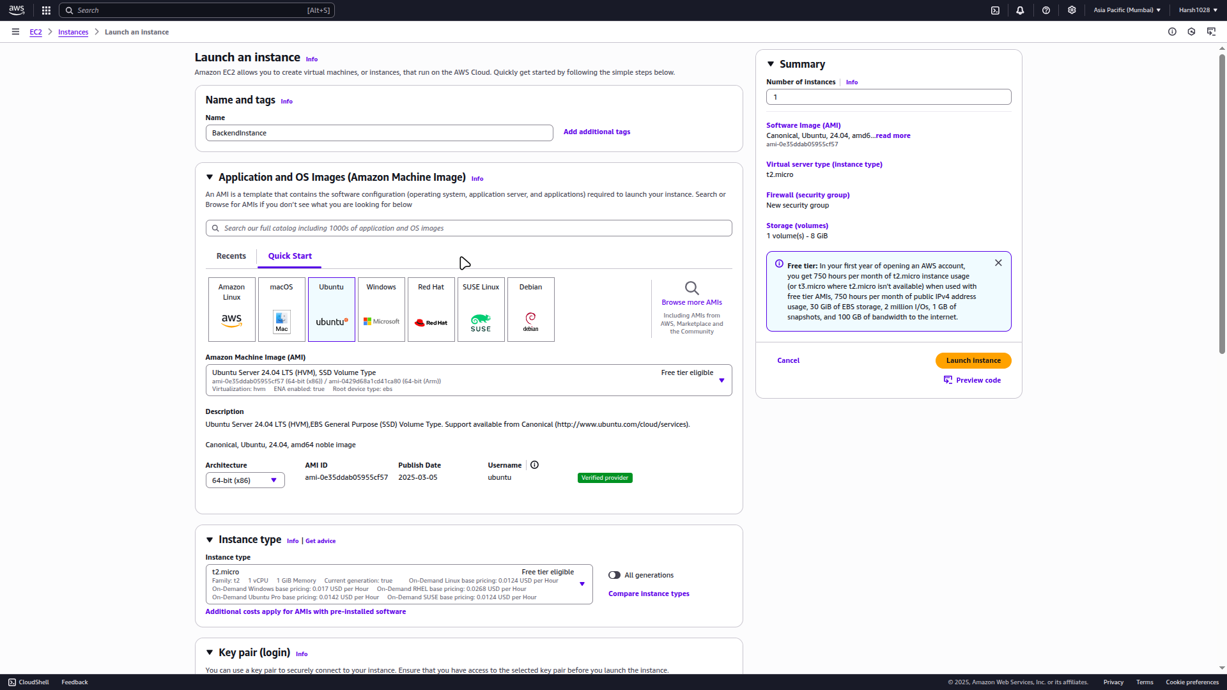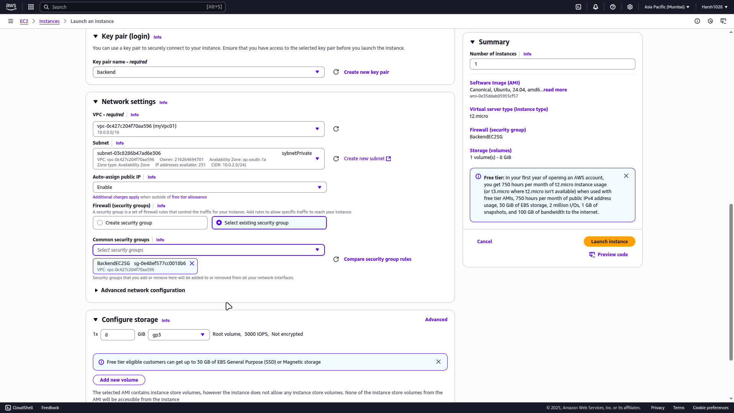

### **🔹 Step 8: Validation**

#### **Connect to Bastion Host**

ssh -i my-key.pem ec2-user@<bastion-public-ip>

**Screenshot:-**

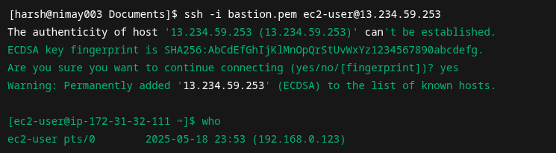

#### **From Bastion → Connect to Backend EC2**

ssh -i my-key.pem ec2-user@<private-instance-private-ip>

**Screenshot:-**

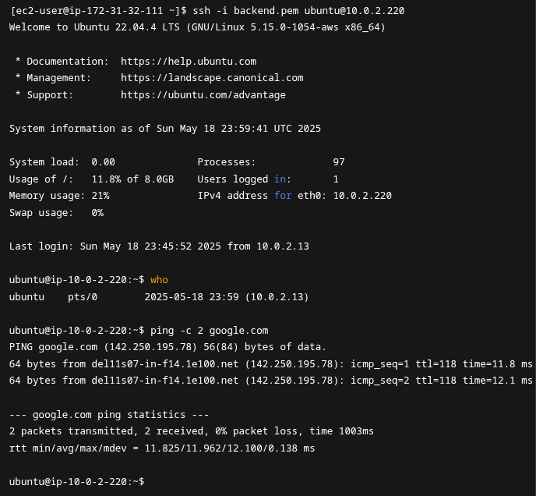

#### **Test Internet Access from Backend (via NAT)**

Run these commands from **backend EC2** (after connecting via Bastion):

bash

CopyEdit

ping google.com

sudo apt update

**Screenshot:-**

