Conservation Prioritization of Multiple Belizean Land Parcels VIA Local and Regional Avifaunal Assessment

Alex Isenberg

# INTRODUCTION

The Central American jewel of Belize, with its rich mosaic of tropical habitats, serves as an aviary sanctuary to a kaleidoscope of bird species, playing a pivotal role in the region's ecological fabric. The Maya Golden Landscape itself totals 311,610-hectacres and includes the primary biological corridor in southern Belize. This corridor remains as the last surviving broadleaf forest link connecting the Maya Mountains and the lowland broadleaf forests which extend outward to the coastal regions (Voight et al., 2019). The conservation of these habitats is not merely a matter of preserving the ornithological diversity; it is an intrinsic component of maintaining the ecological equilibrium, ensuring the survival of numerous species, and fostering the resilience of local ecosystems and protection against unsustainable land use practices of the region such as slash-and-burn agriculture.(Voight et al., 2019)

In the field of environmental science, the quantification and analysis of biodiversity are foundational to the strategic selection of conservation areas. The conservation organization's mission in Belize is emblematic of the critical decisions that must be made in the face of finite resources. This report will synthesize field data, remote sensing information, and established ecological metrics to guide the organization towards a data-driven decision for land acquisition.

The urgency of this work is underscored by the rapid changes occurring in Belize where land degradation and habitat fragmentation have been of imperative focus for the conservation and preservation of flora and fauna.(Flowers et al., 2020). Birds, often heralded as indicators of environmental health, provide a window into the vitality of the habitats they inhabit. (Smits & Fernie, 2013). By assessing avian biodiversity in conjunction with vegetative structures, conservationists can identify key areas that not only harbor rich avian populations but also possess the ecological robustness to sustain them.

This report will navigate through layers of data, drawn from the synergy between vegetation and bird communities, to deliver a recommendation that aligns with the conservation group's ethos. It is a harmonization of scientific rigor with conservation praxis, aimed at preserving the avian symphony of Belize for generations to come.

# METHODS

To ascertain the avian diversity within distinct parcels of land in the Punta Gorda, Gallon Jug, Cockscomb Basin, and Belmopan regions of Belize, we employed a two-pronged approach: analyzing field data at both local and regional scales, and interpreting remote sensing information. This methodology aligns with the MacKinnon lists technique as detailed by(O'Dea et al., 2004) 2004, which is designed for rapid assessment of biodiversity in field conditions.

## Data Collection:

Local Scale: Bird surveys were conducted using the MacKinnon list technique within the confines of the specific parcels marked for potential acquisition. Observers systematically recorded the first ten species encountered during each survey walk until a total of ten species were noted. This process was repeated across 15 different survey dates, ensuring a robust representation of the local avifauna. The MacKinnon lists (ML) technique has been demonstrated to efficiently and consistently produce species abundance indices for tropical forest bird populations. with high consistency within and between observers. (MacLeod et al., 2011). It is for these properties the ML methodology was adopted for this study.

Regional Scale: Surrounding each local parcel, a broader 15-mile-diameter circle was defined, centered on key locations within Belize. Within these circles, bird species occurrence and abundance data were collated through teams of observers who conducted single-day surveys, encapsulating a larger ecological context.

## Vegetation Analysis:

Concurrent with avifaunal surveys, the major vegetation communities within both the local parcels and regional circles were documented using Geographical Information Systems (GIS) analyzed remote sensing data. The landscape classes included in this study consisted of: agricultural, urban, wetland, water, mangrove, lowland pine forests, lowland broadleaf forests, submontane pine forest, and submontane broadleaf forest. This analysis provided a graphical representation of the vegetative structures, crucial for understanding the habitats and ecological niches that support diverse bird populations.

## Data Analysis:

Using the collected data, we calculated diversity indices to quantify the levels of biodiversity present. This included the total number of taxa (S), Dominance (D), the Shannon index (H), and Equitability (J), each offering a different lens through which to view the ecological tapestry of the regions studied.

Species detection line graphs, based on the MacKinnon data, were created to visualize the accumulation of species detections over the survey period, providing insight into the richness and detectability of species within each area.

## Ethical Considerations:

All fieldwork was conducted with strict adherence to ethical guidelines for wildlife observation, minimizing disturbance to both avifauna and their habitats. Local environmental regulations and international conservation standards were followed to ensure the integrity of the ecosystems under study.

# RESULTS

(instructions) Familiarize yourself with the data provided in the Excel workbooks bird_data.xls and the documents diversity indices.pdf and veg_analyses.pdf

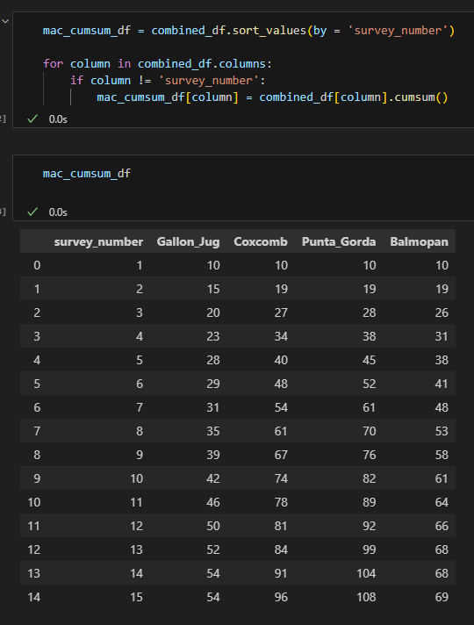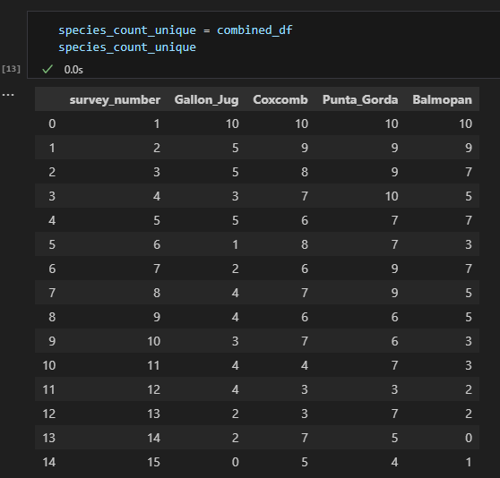

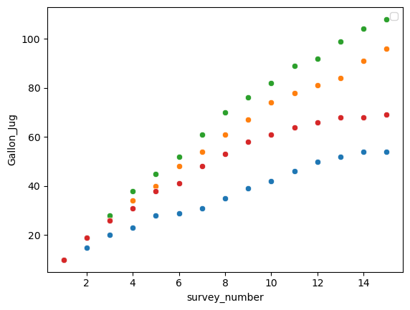

* Read and understand [O’Dea et al](https://ezproxy.snhu.edu/login?url=https://search.ebscohost.com/login.aspx?direct=true&db=asn&AN=11843725&site=ehost-live&scope=site). (2004), especially pages 55–56

Milestone One: *Data Exploration and Preparation for Analysis*  
In this milestone, due as part of **Module Two**, you will submit drafts of two critical elements of your final project:

In order to complete those critical elements, you will need to first:

* Familiarize yourself with the data provided in the Excel workbooks bird_data.xls and the documents diversity indices.pdf and veg_analyses.pdf
* Read and understand [O’Dea et al](https://ezproxy.snhu.edu/login?url=https://search.ebscohost.com/login.aspx?direct=true&db=asn&AN=11843725&site=ehost-live&scope=site). (2004), especially pages 55–56

# DISCUSSION

# LITERATURE CITED

Flowers, B., Huang, K.-T., & Aldana, G. O. (2020). Analysis of the Habitat Fragmentation of Ecosystems in Belize Using Landscape Metrics. *Sustainability (Basel, Switzerland)*, *12*(7), 3024. <https://doi.org/10.3390/su12073024>

MacLeod, R., Herzog, S. K., Maccormick, A., Ewing, S. R., Bryce, R., & Evans, K. L. (2011). Rapid monitoring of species abundance for biodiversity conservation: Consistency and reliability of the MacKinnon lists technique. *Biological conservation*, *144*(5), 1374-1381. <https://doi.org/10.1016/j.biocon.2010.12.008>

O'Dea, N., Watson, J. E. M., & Whittaker, R. J. (2004). Rapid assessment in conservation research: a critique of avifaunal assessment techniques illustrated by Ecuadorian and Madagascan case study data. *Diversity & distributions*, *10*(1), 55-63. <https://doi.org/10.1111/j.1472-4642.2004.00050.x>

Smits, J. E. G., & Fernie, K. J. (2013). Avian wildlife as sentinels of ecosystem health. *Comparative immunology, microbiology and infectious diseases*, *36*(3), 333-342. <https://doi.org/10.1016/j.cimid.2012.11.007>

Voight, C., Hernandez-Aguilar, K., Garcia, C., & Gutierrez, S. (2019). Predictive Modeling of Future Forest Cover Change Patterns in Southern Belize. *Remote sensing (Basel, Switzerland)*, *11*(7), 823. <https://doi.org/10.3390/rs11070823>