**JAYPEE INSTITUTE OF INFORMATION TECHNOLOGY, NOIDA**

**BTech Semester 1**

**Physics Project Based Learning**



TOPIC-  **Application of Atomic Structure in**

**Medical Science**

SUBMITTED BY:

***Prerna***

***NBTG11867***

***B2***

SIGNIFICANCE OF ATOMIC STRUCTURE

*Atomic and electronic structures of semiconductor interfaces are explained, focusing on fundamental physics revealed by recent researches. To understand atomic structures, it is essential to understand how the interface is formed and how stable the interface is. We consider these by illustrating the epitaxial growth and oxidation processes and explaining key concepts such as the growth diagram, growth modes, stress release, and defect generation. On the other hand, the most important quantities to characterize the interface electronic structures are the Schottky barrier and the band offset, because they govern most transport and optical properties around interfaces. The origins of these quantities are explained, using key concepts such as the interface states, charge neutrality level, band bending, and Fermi-level pinning. Prospects for future trend of interface investigations are also illustrated.*

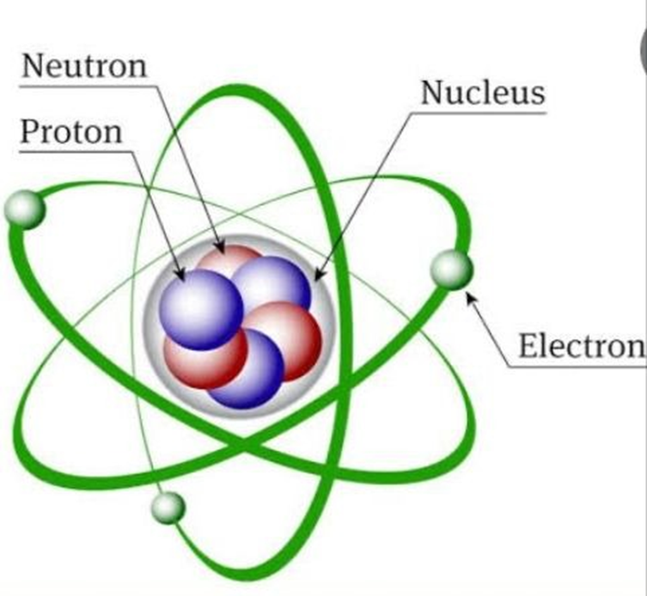

*atomic physics, the scientific study of the structure of the atom, its energy states, and its interactions with other particles and with electric and magnetic fields. Atomic physics has proved to be a spectacularly successful application of quantum mechanics, which is one of the cornerstones of modern physics.*

**PRACTICAL APPLICATIONS OF ATOMIC STRUCTURE IN**

**PHARMACEUTICALS**

*Perhaps the area of most rapid growth in the application of subatomic science is the field of nuclear medicine, which uses* *radioactive decay to diagnose and treat various diseases. Diagnosis is based upon the physiology of the tissue or organ of interest, and the treatment relies on tracing the localized metabolism or on the uptake of the radioactive particle by means of specific targets, such as receptors or antigens. Radionuclides are bound to a specific ligand, which then targets a particular part of the body or particular cells or molecule.*

*Nuclear imaging is divided into three categories: planar or conventional scintigraphy, Single Photon Emission Computed Tomography (SPECT), and Positron Emission Tomography (PET). All three techniques rely on the detection of gamma radiation. The tracers used for scintigraphy and SPECT emit gamma radiation, which is directly measured.*

*Radiation oncology is another field of medicine utilizing ionizing particles to treat diseases. This field is versatile, and can be used in a number of situations. Most commonly, radiation therapy is used to treat malignant diseases, and can be used alone as treatment, or in concert with surgery or chemotherapy to provide for an augmented response. In addition, radiation therapy can be used to treat or prevent benign conditions that involve cell growth or inflammation, such as keloid scars or heterotopic ossification. Fundamentally, high energy photon-based radiation therapy relies on subatomic double strand DNA breaks that ultimately results in cancer mitotic cell-death.*

*Computed tomography (CT) is an imaging procedure that uses special xray equipment to create detailed pictures, or scans, of areas inside the body. It is sometimes called computerized tomography or computerized axial tomography (CAT). CT imaging is also used to detect abnormal brain function or deposits in adult patients with cognitive impairment who are being evaluated for Alzheimer’s disease and other causes of cognitive decline.*

*Internal therapy utilizes a source of radiation delivered inside the body, such as brachytherapy and nuclear medicine therapy. Internal therapy with radioisotopes, differently from conventional radiotherapy, exploits pathophysiological* *processes such as metabolic pathways, receptor or antigen binding. Classical examples are therapy with iodine-131 of relapsed/metastatic*

*thyroid cancer, Radioimmunotherapy (RIT) with the anti-CD20 antibody ibritumomab-tiuxetan in non-Hodgkin’s lymphomas and Peptide Receptor Radionuclide Therapy (PRRT) with radiolabeled somatostatin analogues 90Y-octreotide or 177Lu-octreotate.*

CONCEPTS OF PHYSICS-1 USED IN PBL

*Atoms in magnetic field: What is the effect of magnetic field on atoms?*

*Effect of a Magnetic Field on an Atomic Orbital. We consider the*

*effect of a magnetic field on the motion of an atomic electron in its*

*orbit. The usual treatment deals with the change in magnetic dipole*

*moment assuming the electron's speed changes but the radius of its*

*orbit remains unchanged.*

*Magnetic fields are produced by moving electric charges. Everything*

*is made up of atoms, and each atom has a nucleus made of neutrons*

*and protons with electrons that orbit around the nucleus. Since the*

*orbiting electrons ≠are tiny moving charges, a small magnetic field is*

*created around each atom*

**REFERENCES**

[**https://www.britannica.com/science/atomic-physics**](https://www.britannica.com/science/atomic-physics)

[**https://phys.libretexts.org/Bookshelves/University_Physics/Book%3A_University_Physics_(OpenStax)/Book%3A_**](https://phys.libretexts.org/Bookshelves/University_Physics/Book%3A_University_Physics_(OpenStax)/Book%3A_)

**https://www.sciencedirect.com/topics/physics-and-astronomy/atomic-structure**