***NAME : Himanshu Dixit***

***ENROLL NO. : B64178***

***BATCH : B10***

***ENGLISH LAB WEEK-6***

**Question 1:**

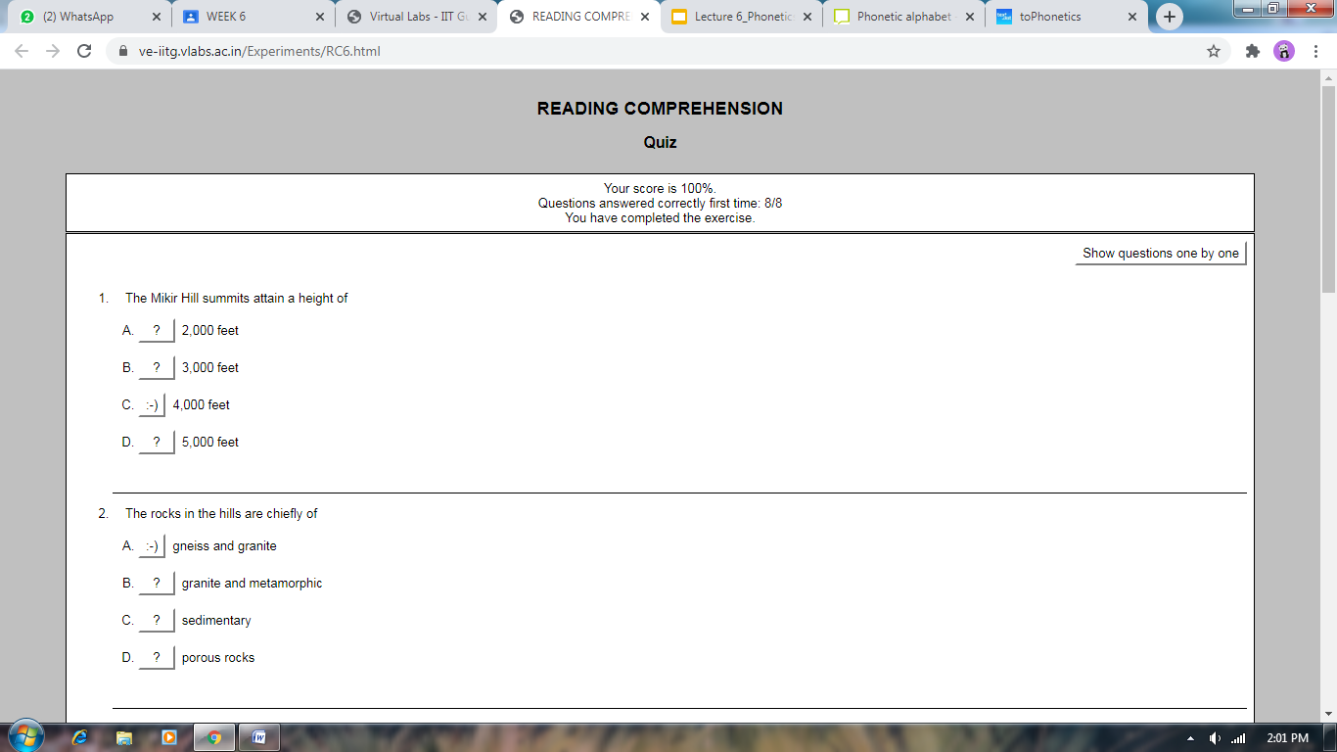

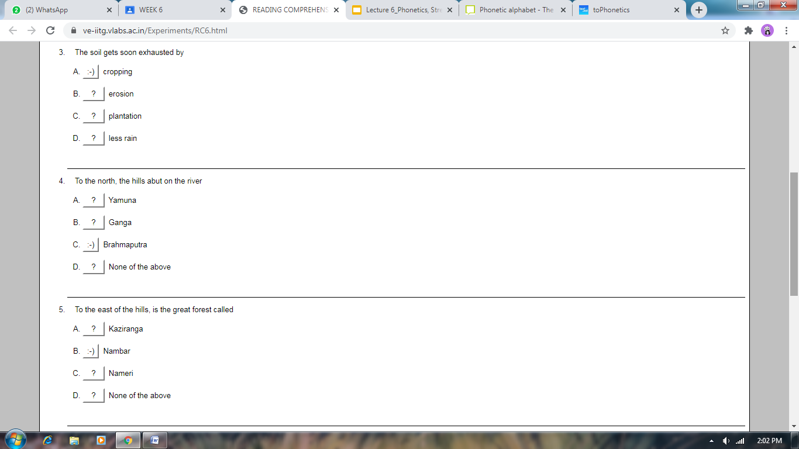

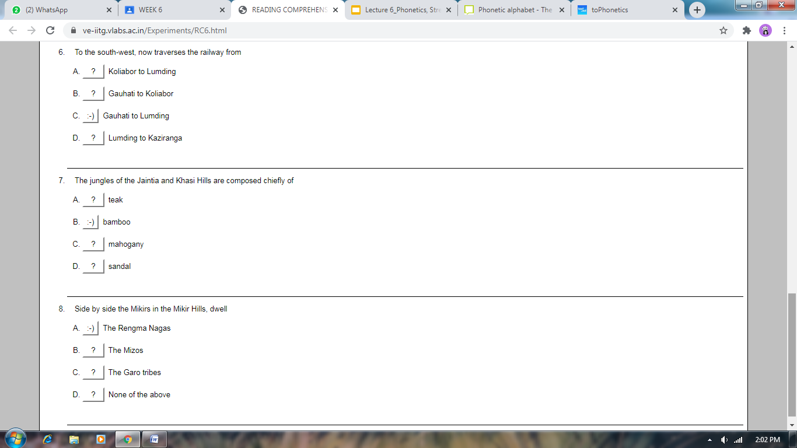

**Question 2:**

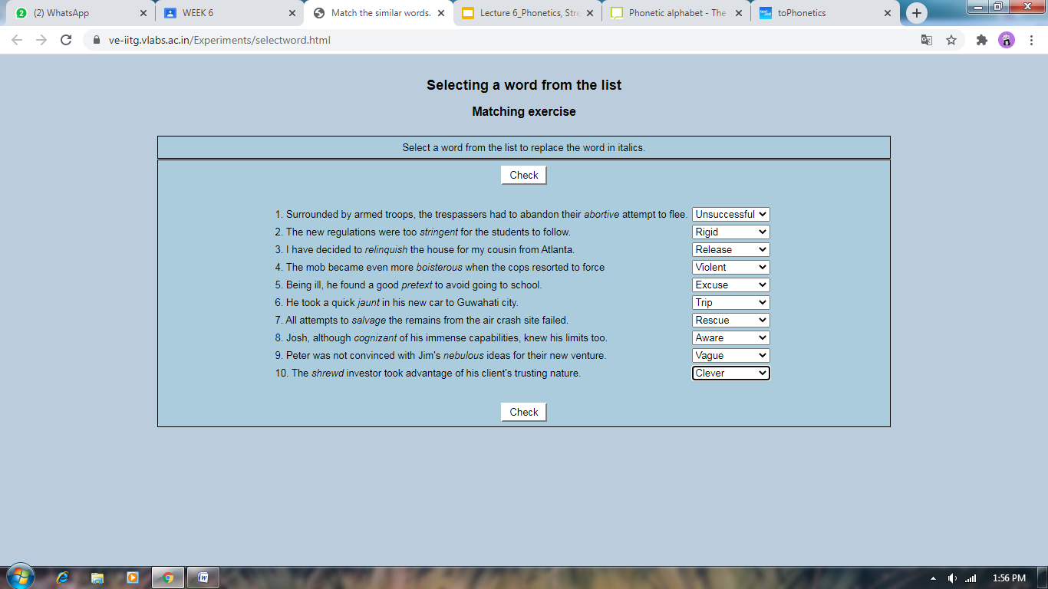

**Question 3:**

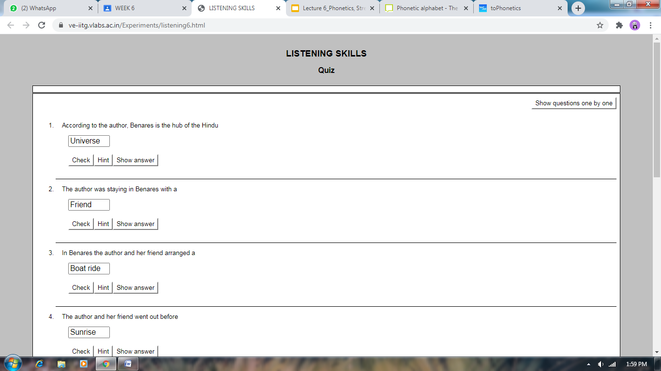

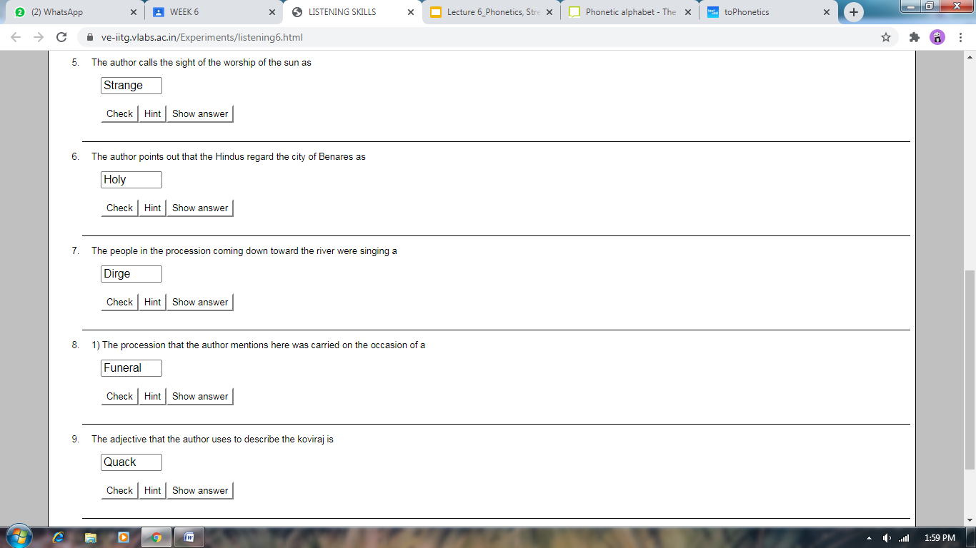

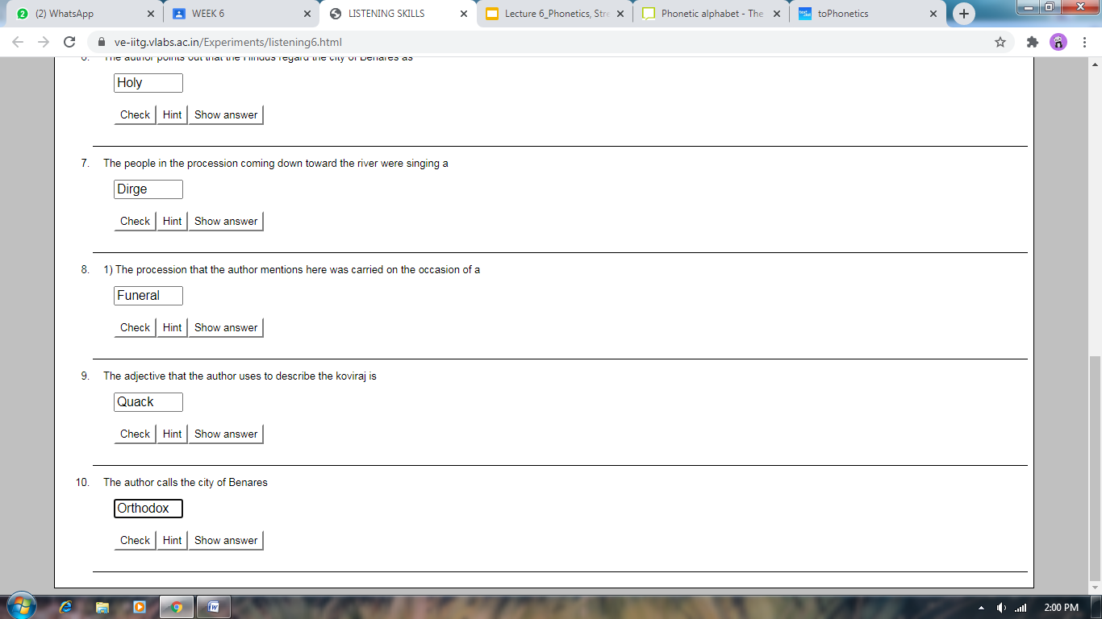

**Question 4: (speaking activity)**

**Vowel word:**

Ship,sheep,bed,bad,put**,**boot

**Dipthong word:**

Bite,boil,bait