***JAYPEE INSTITUTE OF INFORMATION***

***TECHNOLOGY, NOIDA , SECTOR-62***



***MATHS-2***

***PROJECT BASED LEARNING***

***ORTHOGONALITY OF FUNCTION AND IT’S APPLICATION***

***SUBMITTED TO:***

***Mr. ANUJ BHARADWAJ sir***

***BY :***

***TEAM MEMBERS (B10 BATCH):***

* ***HIMANSHU DIXIT (21103262)***
* ***AMAN UPADHYAY (21103263)***
* ***LAKSHAY ARORA (21103264)***
* ***HARSH DHARIWAL (21103265)***
* ***AJNEYA SINGH PANWAR(21103266)***

***(BTECH – CSE 2nd SEMESTER)***

***acknowledgement***

*We extend our sincere thanks to* ***Jaypee Institute of Information and Technology*** *which provided us with the opportunity to make the project which helped us implement and practice skills we have**learned till now. We also take this opportunity to express a deep sense of gratitude to* ***Mr. Anuj Bharadwaj sir*** *for his cordial support, valuable suggestions and**guidance. We would like to thank our friends and family for the support and**encouragement they have given us during the course of work.*

* *HIMANSHU DIXIT (21103262)*
* *AMAN UPADHYAY (21103263)*
* *LAKSHAY ARORA (21103264)*
* *HARSH DHARIWAL (21103265)*
* *AJNEYA SINGH PANWAR (21103266)*

***introduction***

*Orthogonal is commonly used in mathematics, geometry, statistics, and software engineering. Most generally, it's used to describe things that have rectangular or right-angled elements. More technically, in the context of vectors and functions, orthogonal means “having a product equal to zero.*

*In mathematics, orthogonal functions belong to a function space that is a vector space equipped with a bilinear form. When the function space has an interval as the domain, the bilinear form may be the integral of the product of functions over the interval.*

*Two functions are orthogonal with respect to a weighted inner product if the integral of the product of the two functions and the weight function is identically zero on the chosen interval.*

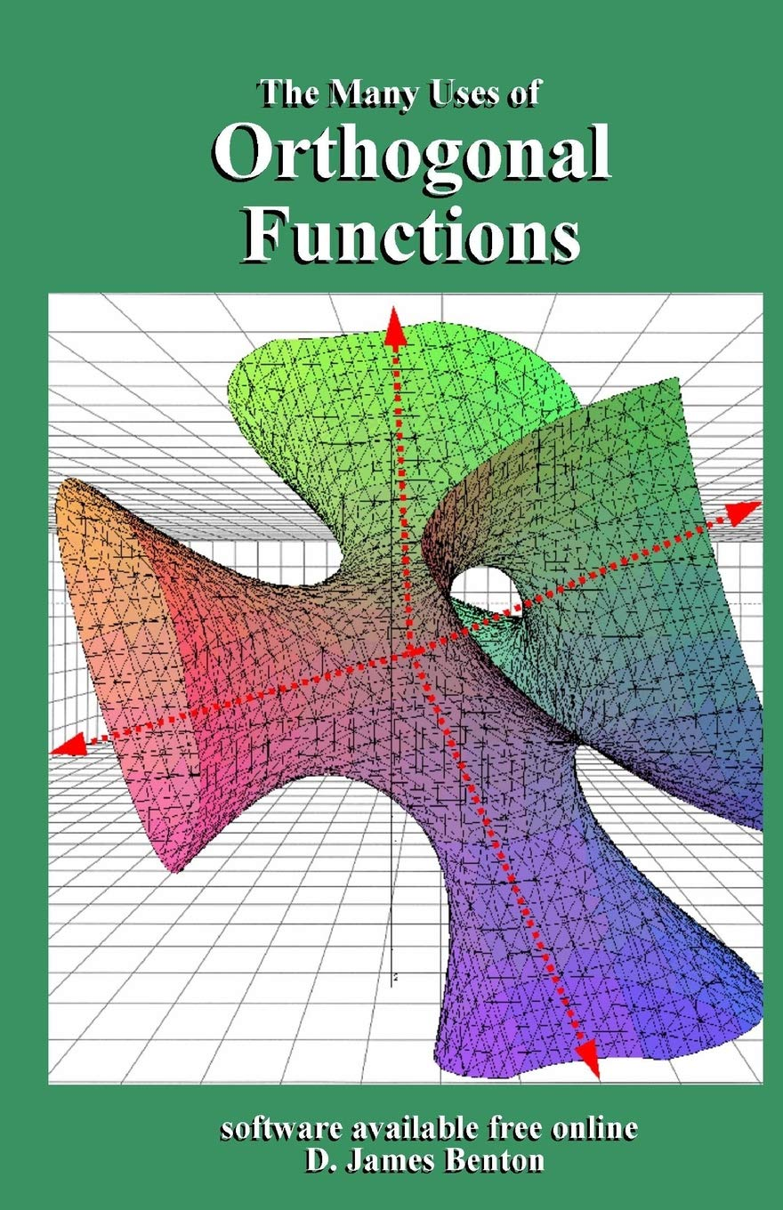

***DEFINE ORTHOGONAL FUNCTION***

***references***

* [*https://www.researchgate.net/publication/250342226_Orthogonal_Function_Techniques_for_the_Identification*](https://www.researchgate.net/publication/250342226_Orthogonal_Function_Techniques_for_the_Identification_of_Nonlinear_Mechanical_Systems)
* [*https://en.wikipedia.org/wiki/Orthogonality_principle*](https://en.wikipedia.org/wiki/Orthogonality_principle)
* *www.google.com*
* [*https://tutorial.math.lamar.edu/classes/de/PeriodicOrthogonal.aspx*](https://tutorial.math.lamar.edu/classes/de/PeriodicOrthogonal.aspx)
* *George B. Arfken & H*
* *ans J. Weber (2005) Mathematical Methods for Physicists, 6th edition, chapter 10: Sturm-Liouville Theory — Orthogonal Functions*

***THANK YOU***