***NAME : Himanshu Dixit***

***ENROLL NO. : B64178***

***BATCH : B10***

***Software Development Lab – II [15B17CI271]***

***Assignment Sheet***

***Week 2***

***Q1.*** *WAP Write a program in C++ to dynamically allocate memory for two variables of data type  integer and float using new operator. Print the values of these variables and then deallocate the  memory using delete operator.*

***Solution :***

#include <iostream>

using namespace std;

int main()

{

int *n = NULL;

n = new int;

float *f = NULL;

f = new float;

cout<<"Enter the integer value : ";

cin>>*n;

cout<<"Enter the float value : ";

cin>>*f;

cout<<"\nValue of int variable is : "<<*n;

cout<<"\nValue of float variable is : "<<*f;

delete n;

delete f;

return 0;

}

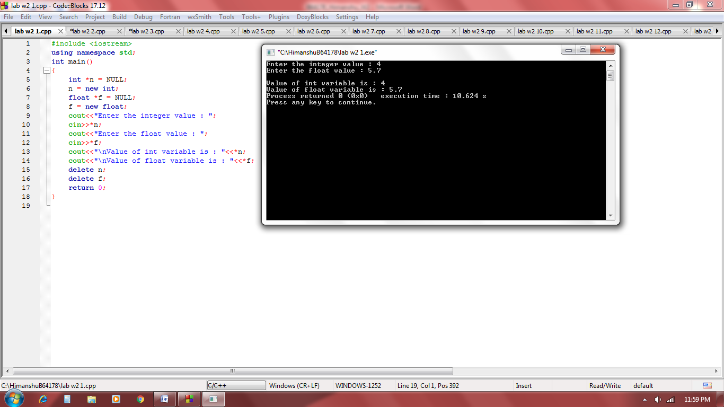

***Q2.*** *Assume there are three integer elements in the array A= {10,100,200} and are stored at  addresses 0xbfa088b0, 0xbfa088b4, 0xbfa088b8*

***Note****: The address can vary from system to system.*

*WAP in C++ to perform following operations using pointer arithmetic.*

*1. Increment a Pointer (++)*

*Sample output after incrementing pointer:*

*Address of var[0] = 0xbfa088b0*

*Value of var[0] = 10*

*Address of var[1] = 0xbfa088b4*

*Value of var[1] = 100*

*Address of var[2] = 0xbfa088b8*

*Value of var[2] = 200*

*2. Decrement a Pointer (--)*

*Sample output after decrementing pointer:*

*Address of var[3] = 0xbfdb70f8*

*Value of var[3] = 200*

*Address of var[2] = 0xbfdb70f4*

*Value of var[2] = 100*

*Address of var[1] = 0xbfdb70f0*

*Value of var[1] = 10*

***Solution :***

#include <iostream>

using namespace std;

int main()

{

int *a = NULL;

a = new int[3];

cout<<"Enter 3 elements array : ";

for(int i=0; i<3; i++)

cin>>*(a+i);

cout<<"Incrementing Pointer"<<endl;

for(int i=0;i<3;i++){

cout<<"address of var ["<<i<<"] = "<<a<<endl;

cout<<"value of var ["<<i<<"] = "<<*a<<endl;

a++;

}

a--;

cout<<"\n\ndecrementing pointer"<<endl;

for(int i=2;i>=0;i--){

cout<<"address of var ["<<i<<"] = "<<a<<endl;

cout<<"value of var ["<<i<<"] = "<<*a<<endl;

a--;

}

delete[] a;

return 0;

}

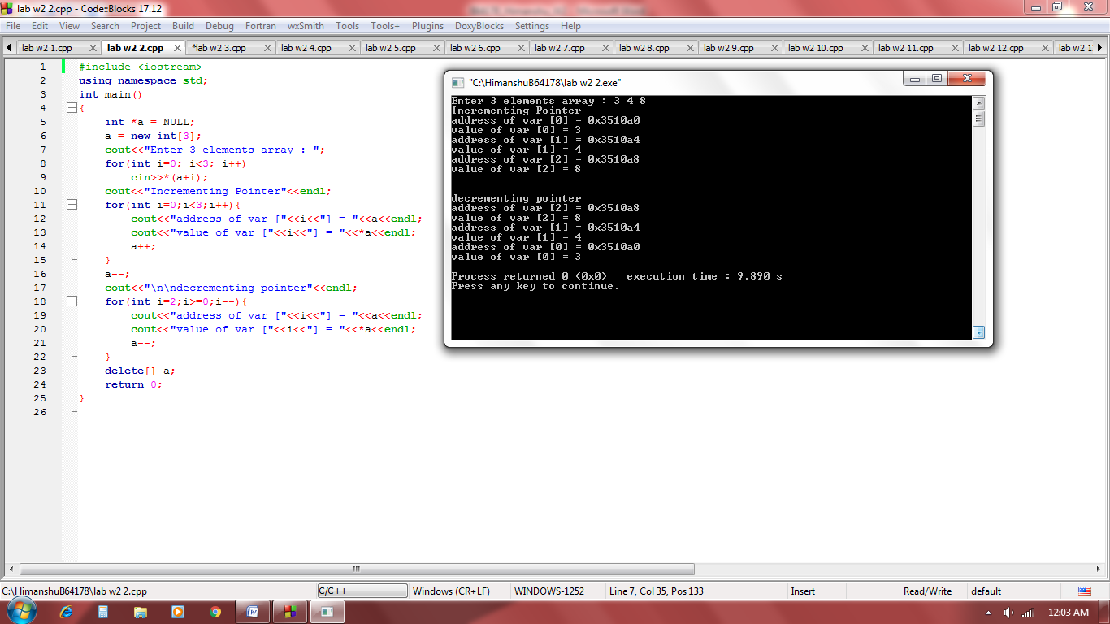

***Q3.*** *WAP in C++ to store CGPA of n number of students using dynamic memory allocation. Where  n is the number of students entered by the user. Display the details of the students.*

***Solution :***

#include <iostream>

using namespace std;

int main()

{

int *n = NULL;

n = new int;

cout<<"Enter the number of students : ";

cin>>*n;

int *m = NULL;

m = new int[*n];

cout<<"Enter the CGPA of "<<*n<<" students \n";

for(int i=0; i< *n; i++)

cin>>*(m+i);

cout<<endl;

for(int i=0; i< *n; i++)

{

cout<<"\nthe CGPA of "<<i+1<<" students ";

cout<<*(m+i);

}

delete n;

delete[] m;

return 0;

}

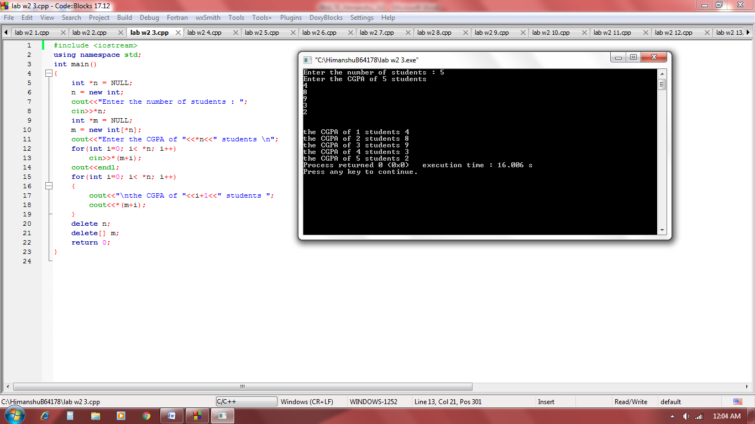

***Q4.*** *What will be the output of following codes? Give a suitable explanation:*

|  |  |
| --- | --- |
| *a)* | *b)* |
| *#include <iostream>*  *using namespace std;*  *int main()*  *{*  *char lfc [20];*  *inti;*  *for(i = 0; i< 10; i++)  *(lfc + i) = 65 + i;  *(lfc + i) = ' ';*  *cout<<lfc;*  *return(0);*  *}* | *#include <iostream>*  *using namespace std;*  *int main()*  *{*  *char *ptr;*  *char Str[] = "abcdefg"; ptr = Str;*  *ptr += 5;*  *cout<<ptr;*  *return 0;*  *}* |

***Solution :***

1. *Output is : ABCDEFGHIJ*

*In lfc array , while in for loop lfc array is stored by the ascii value 65 to 74 so at the time of printing actual character on that ascii value is printing.*

1. *Output is : fg*

*Base address of Str is stored in ptr and pointer of ptr is move to 5th position so at time of printing it will print array from 6th position .*

***Q5.*** *WAP to find the largest integer from amongst n integers stored in an array.*

***Solution :***

#include <iostream>

using namespace std;

int find_largest(int *n, int a[])

{

int max= *(a+0);

for(int i=1; i<*n; i++)

if(max<*(a+i))

max=*(a+i);

return max;

}

int main()

{

int *n = new int;

cout<<"Enter the size ";

cin>>*n;

int *a = new int[*n];

cout<<"Enter the elements ";

for(int i=0; i<*n; i++)

cin>>*(a+i);

int ans = find_largest(n,a);

cout<<"Largest integer in array is : "<<ans;

delete n;

delete[] a;

return 0;

}

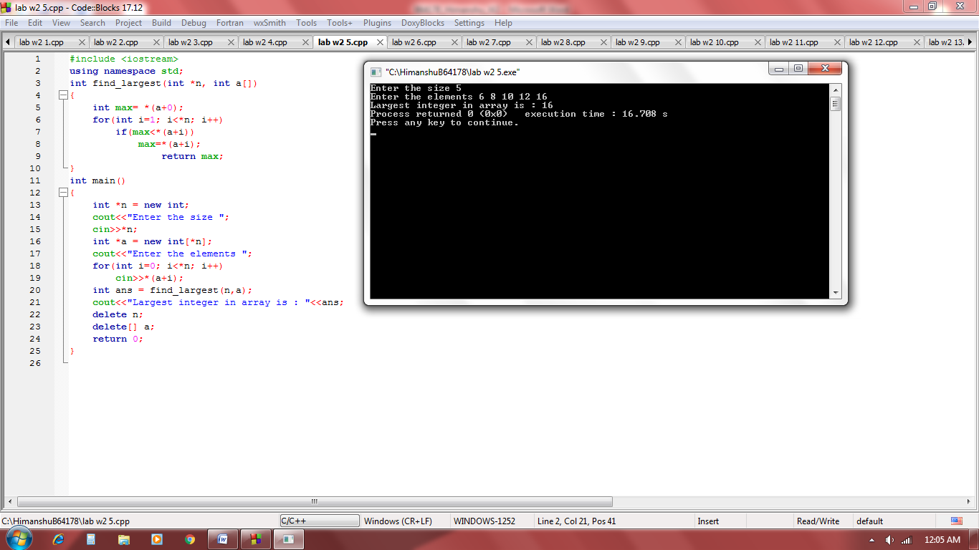

***Q6.*** *WAP to calculate the sum of n integers stored in an array. Ask user to enter the n integers at  run time.*

***Solution :***

#include <iostream>

using namespace std;

int find_sum(int *n, int a[])

{

int sum = 0;

for(int i=1; i<*n; i++)

sum+= *(a+i);

return sum;

}

int main()

{

int *n = new int;

cout<<"Enter the size ";

cin>>*n;

int *a = new int[*n];

cout<<"Enter the elements ";

for(int i=0; i<*n; i++)

cin>>*(a+i);

int ans = find_sum(n,a);

cout<<"sum of integers in array is : "<<ans;

delete n;

delete[] a;

return 0;

}

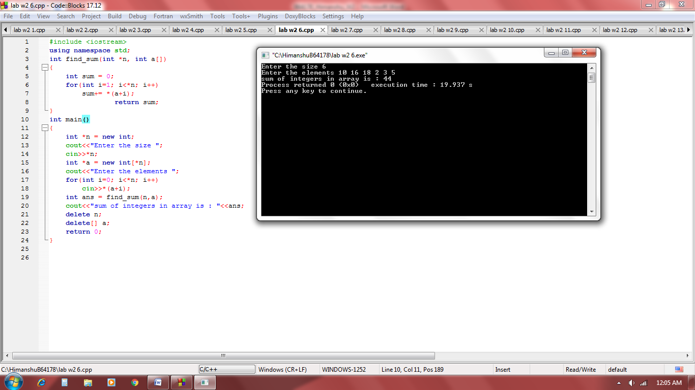

***Q7.*** *WAP to find out whether a given integer is present in a given array of integers or not.A suitable  message should be displayed on screen for both the cases. If the integer is present, then print all the  indexes at which it is present in the array. Ask user to input the integer to be searched.[Use static  array with pre-defined integer values]*

***Solution :***

#include <iostream>

using namespace std;

int main()

{

int n,c=0;

int arr[] = {1,2,3,1,6,7,8,2,5,6,10};

cout<<"Enter the number to be searched : ";

cin>>n;

for(int i=0; i<11; i++)

{

if(arr[i]==n)

{

cout<<"\nfound in index "<<i;

c++;

}

}

if(c==0)

cout<<"\nNumber is not found";

return 0;

}

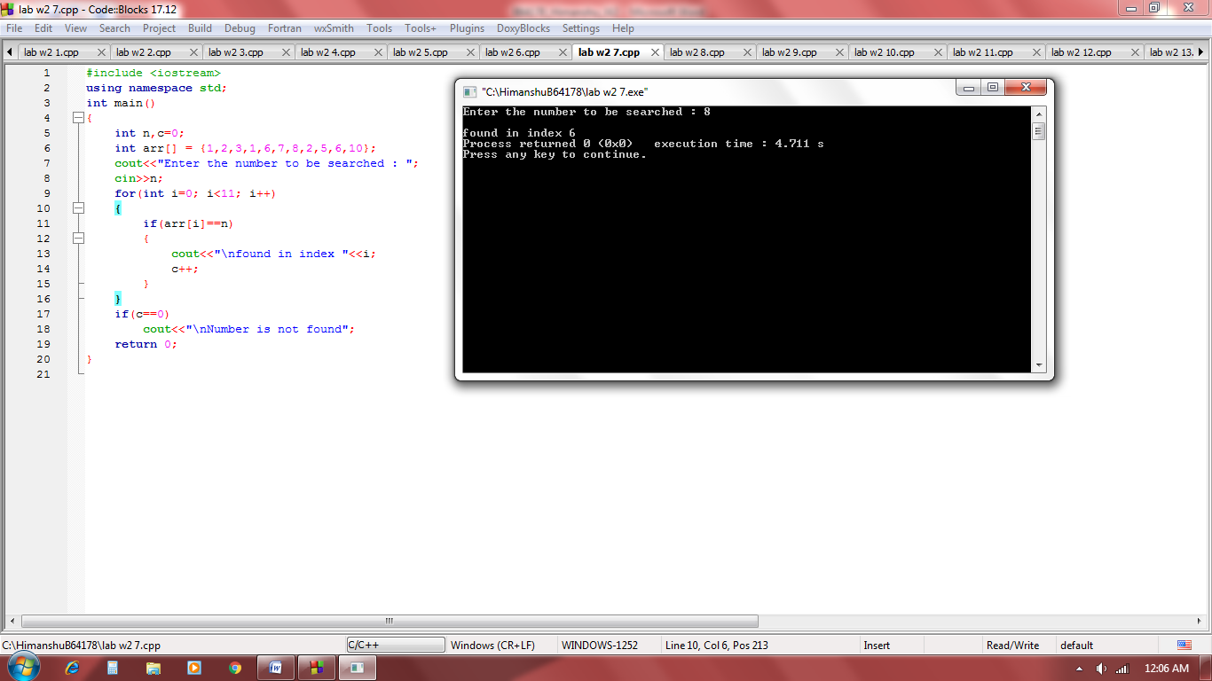

***Q8.*** *Modify the program in Q3, to read the array dynamically at run time, i.e., ask the user to enter  n integer values.*

***Solution :***

#include <iostream>

using namespace std;

int main()

{

int *n = NULL;

n = new int;

cout<<"Enter the number of students : ";

cin>>*n;

float *m = NULL;

m = new float[*n];

cout<<"Enter the CGPA of "<<*n<<" students \n";

for(int i=0; i< *n; i++)

cin>>*(m+i);

cout<<endl;

for(int i=0; i< *n; i++)

{

cout<<"\nthe CGPA of "<<i+1<<" students ";

cout<<*(m+i);

}

delete n;

delete[] m;

return 0;

}

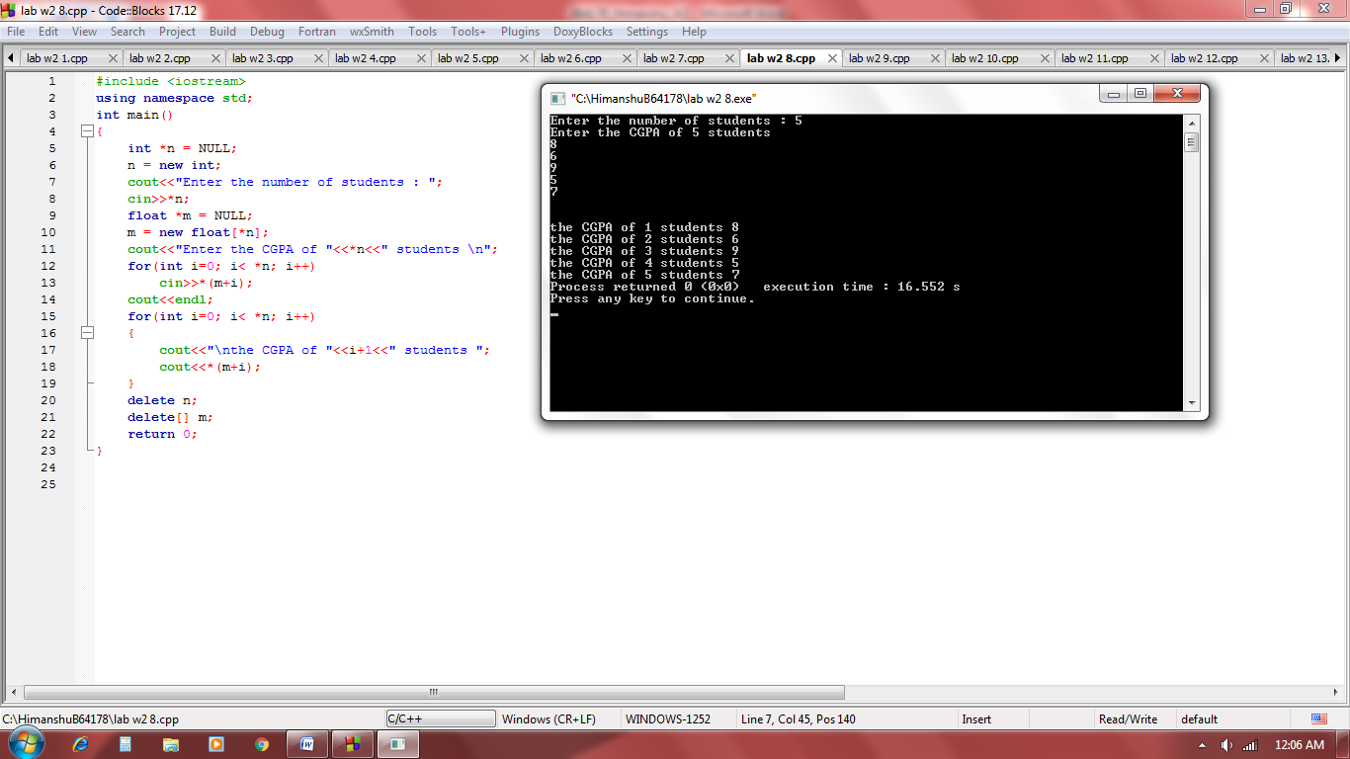

***Q9.*** *WAP to sort a given array in ascending order using pointers. Then reverse the sorted array  using pointers and print the original, sorted and reversed arrays. [Use static array with pre-defined  integer values]*

***Solution :***

#include <iostream>

using namespace std;

int main()

{

int arr[] = {6, 8,9,2,3, 4, 11};

int o[7],r[7];

for(int i=0; i<7; i++)

*(o+i) = *(arr+i);

for(int i=0; i<7; i++)

{

for(int j=i+1; j<7; j++)

{

if(*(arr+i) > *(arr+j))

{

int temp = *(arr+j);

*(arr+j) = *(arr+i);

*(arr+i) = temp;

}

}

}

int k=6;

for(int i=0; i<7; i++)

{

*(r+i) = *(arr+k);

k--;

}

cout<<"Original array is :";

for(int i=0; i<7; i++)

cout<<*(o+i)<<" ";

cout<<"\n\nsorted array is :";

for(int i=0; i<7; i++)

cout<<*(arr+i)<<" ";

cout<<"\n\nreverse array is :";

for(int i=0; i<7; i++)

cout<<*(r+i)<<" ";

return 0;

}

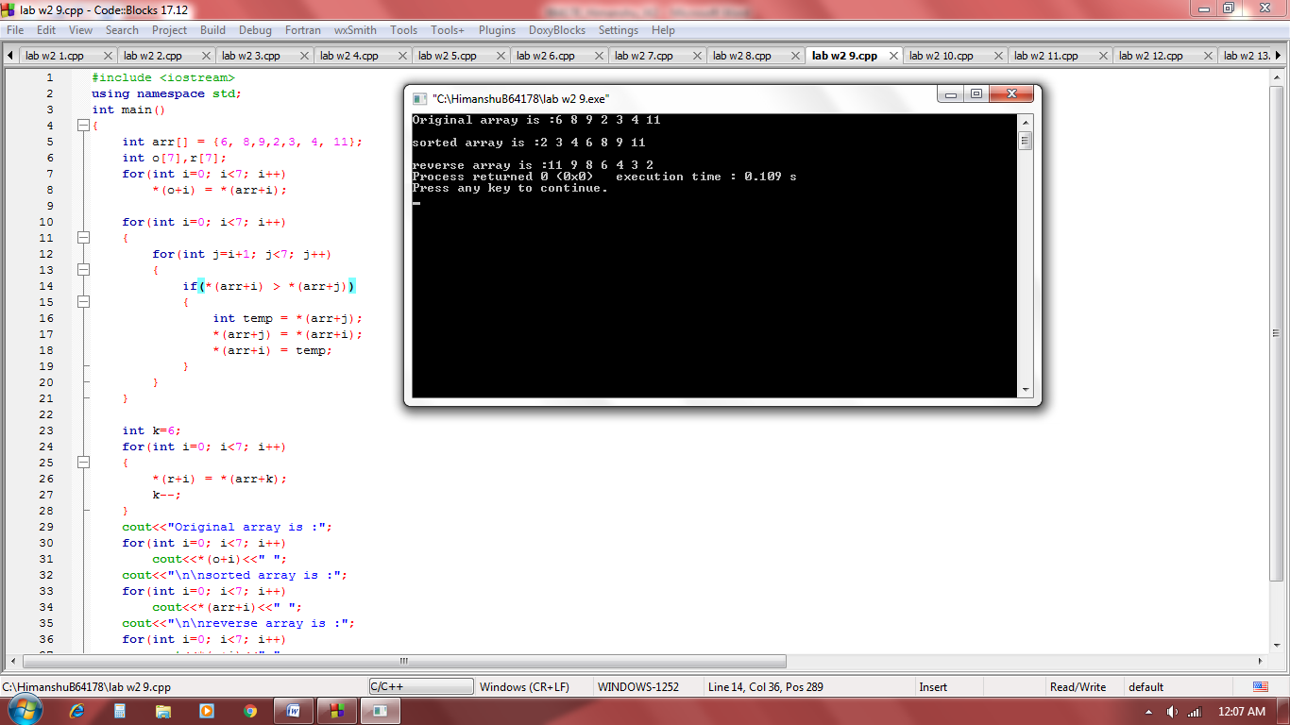

***Q10.*** *What will be the output of following codes? Give a suitable explanation:*

*#include <bits/stdc++.h>*

*using namespace std;*

*int main()*

*{*

*int arr[] = { 3, 5, 6, 7, 9 };*

*int *p = arr;*

*int (*ptr)[5] = &arr;*

*cout << "p = "<< p <<", ptr = " << ptr << endl;*

*cout << "*p = "<< *p <<", *ptr = " << *ptr << endl;*

*cout << "sizeof(p) = "<< sizeof(p) <<*

*", sizeof(*p) = " << sizeof(*p) << endl;*

*cout << "sizeof(ptr) = "<< sizeof(ptr) <<*

*", sizeof(*ptr) = " << sizeof(*ptr) << endl;*

*return 0;*

*}*

***Solution :***

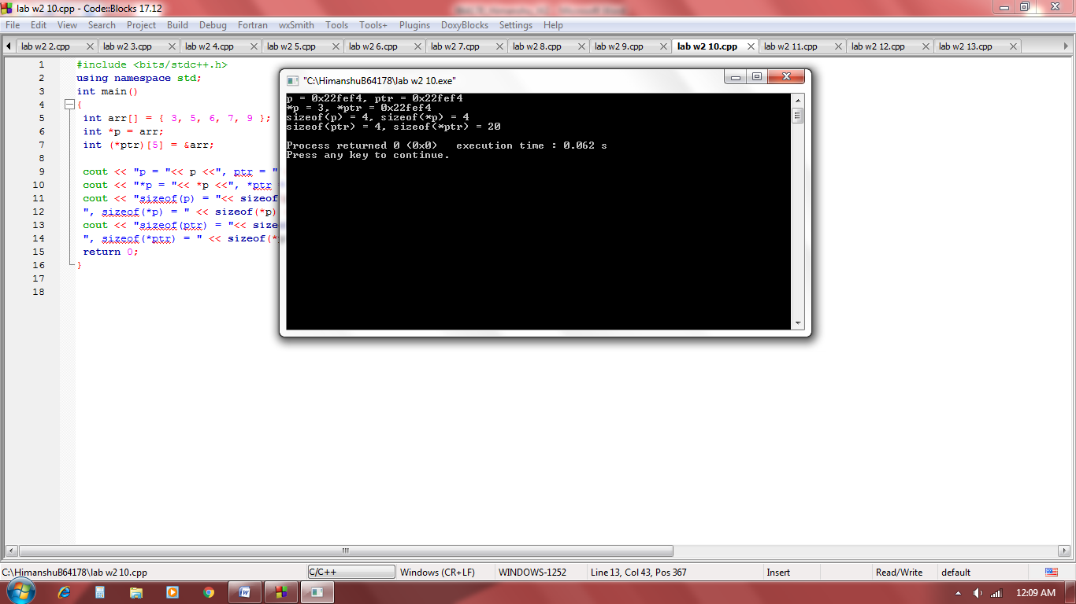

*\*p pointing towards 1st element of array*

*\*ptr pointing to array of five elements and it is 2d array by scriting method.*

***Q11****. WAP to dynamically allocate memory to a 2D array and print the values.*

***Solution :***

#include <iostream>

using namespace std;

int main()

{

int r,c;

cout<<"enter rows and coloumns : ";

cin>>r>>c;

int *a = new int[r * c];

/*or

int **a = new int *[r];

for(int i=0; i<r; i++)

a[i] = new int[n]; */

for(int i=0; i<r; i++)

{

for(int j=0; j<c; j++)

cin>>*(a + i * c + j);

}

for(int i=0; i<r; i++)

{

for(int j=0; j<c; j++)

cout<<*(a + i * c + j)<<" ";

cout<<endl;

}

delete[] a;

return 0;

}

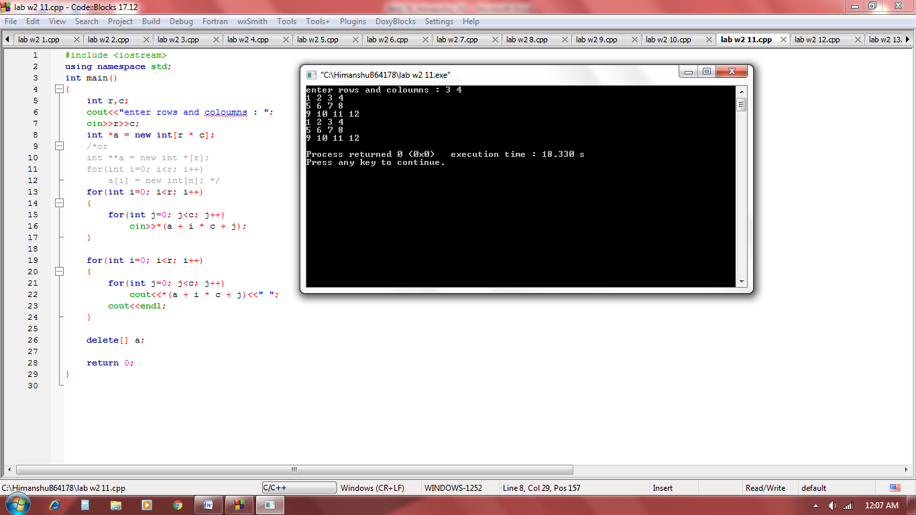

***Q12.*** *WAP to print elements of a 2-D array by scripting a pointer to an array.*

***Hint****: int (*ptr)[4];*

*ptr = arr;*

***Solution :***

#include <iostream>

using namespace std;

int main()

{

int a[3][4] = { {1,2,3,4},{5,6,7,8},{9,10,11,12} };

int (*ptr)[4];

ptr = a;

for(int i=0; i<3; i++)

{

for(int j=0; j<4; j++)

cout<< *(*(ptr + i) + j)<<" ";

cout<<endl;

}

return 0;

}

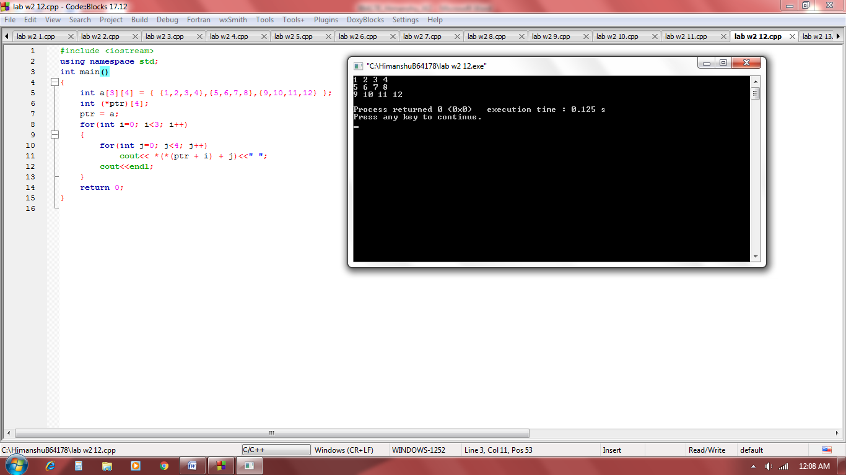

***Q13****. WAP to print the values and address of each element of a 3-D array.*

***Solution :***

#include <iostream>

using namespace std;

int main()

{

int arr[2][3][2] =

{

{

{5, 10},

{6, 11},

{7, 12},

},

{

{20, 30},

{21, 31},

{22, 32},

}

};

int i, j, k;

for (i = 0; i < 2; i++)

{

for (j = 0; j < 3; j++)

{

for (k = 0; k < 2; k++)

cout << *(*(*(arr + i) + j) +k) << "\t";

cout <<"\n";

}

cout<<endl;

}

cout<<"Address of each elements: \n";

for (i = 0; i < 2; i++)

{

for (j = 0; j < 3; j++)

{

for (k = 0; k < 2; k++)

cout << (*(*(arr + i) + j) +k) << "\t";

cout <<"\n";

}

cout<<endl;

}

return 0;

}

