***NAME : Himanshu Dixit***

***ENROLL NO. : 21103262***

***BATCH : B10***

***Software Development Lab – II [15B17CI271]***

***Assignment Sheet***

***Week 4***

***Q1.*** *WAP in C++ to create a class Wall having private data members length and  height. Create a parameterized constructor and a copy constructor to initialize these  private data members. Define a member function to return the area. Demonstrate  the working of each member function.*

***Solution:***

#include<iostream>

using namespace std;

class wall{

    int length;

    int height;

public:

    wall(int l,int h)

    {

        length = l;

        height = h;

    }

    wall(wall &c2)

    {

        length = c2.length;

        height = c2.height;

    }

    int Area()

    {

        int area=length*height;

        return area;

    }

};

int main()

{

    int l,h;

    cout<<"Enter the length : ";

    cin>>l;

    cout<<"Enter the height : ";

    cin>>h;

    wall obj(l,h);

    wall c1=obj;

    cout<<"\nArea is : "<<c1.Area();

    return 0;

}

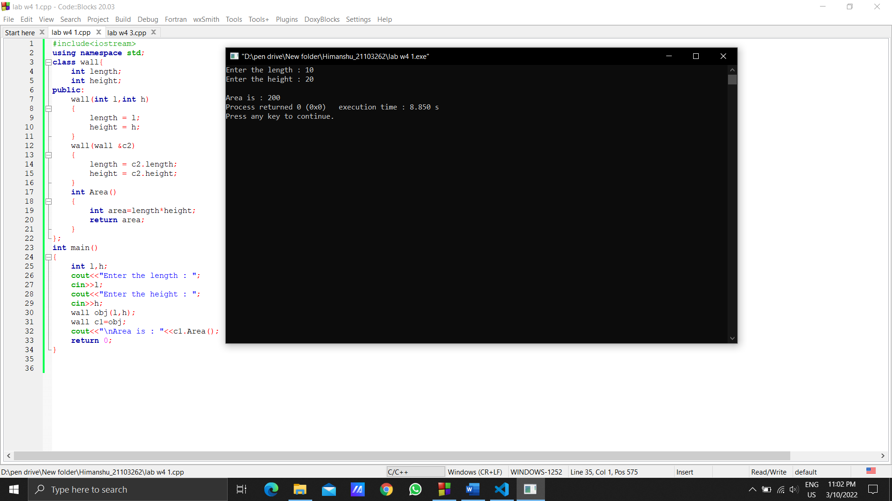

***Q2.*** *Create a class String with two private members (char * s; and int size;) to store a  string and it’s length. Define a constructor, a copy constructor and a destructor. Add  a member function that prints the string. Demonstrate the working of each function.*

***Solution:***

#include<iostream>

using namespace std;

class String

{

char *s;

int size;

public:

String(char *s1)

{

s=s1;

}

String(String &s2)

{

s=s2.s;

}

void display()

{

cout<<"\nString is : "<<s;

}

~String()

{

delete[] s;

}

};

int main()

{

int num;

cout<<"Enter the Size : ";

cin>>num;

char *k=new char[num];

cout<<"Enter the STRING : ";

cin>>k;

String s(k);

String s1=s;

s1.display();

return 0;

}

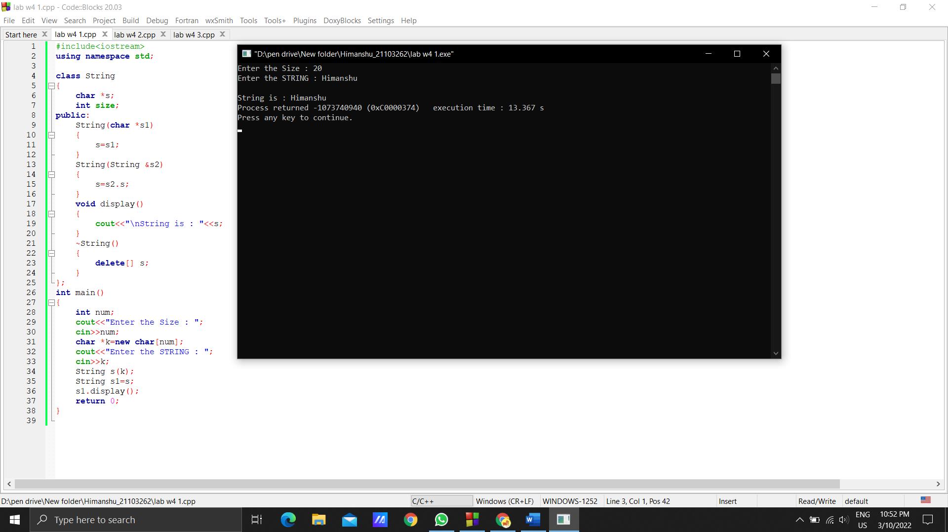

***Q3.*** *What is the output of the following program?*

*#include <iostream>*

*using namespace std;*

*class Demo*

*{*

*private:*

*//static data members*

*static int X;*

*static int Y;*

*public:*

*//static member function*

*static void Print()*

*{*

*cout <<"Value of X: " << X << endl;*

*cout <<"Value of Y: " << Y << endl;*

*}*

*};*

*//static data members initializations*

*int Demo :: X =10;*

*int Demo :: Y =20;*

*int main()*

*{*

*Demo OB;*

*//accessing class name with object name*

*cout<<"Printing through object name:"<<endl;*

*OB.Print();*

*//accessing class name with class name*

*cout<<"Printing through class name:"<<endl;*

*Demo::Print();*

*return 0;*

*}*

***Solution:***

Printing through object name:

Value of X: 10

Value of Y: 20

Printing through class name:

Value of X: 10

Value of Y: 20

***Q4.*** *Define two classes ClassA and ClassB. ClassA has a private integer numA and  ClassB has a private integer numB. Use friend function to add numA and numB of  these classes.*

***Solution:***

#include <iostream>

using namespace std;

class B;

class A

{

int numA;

public:

void setdata(int i)

{

numA=i;

}

friend int sum(A &a,B &b);

};

class B

{

int numB;

public:

void setdata(int j)

{

numB=j;

}

friend int sum(A &a,B &b);

};

int sum(A &a,B &b)

{

int sum=a.numA + b.numB;

return sum;

}

int main()

{

int num1,num2;

cout<<"Enter number 1 for class A : ";

cin>>num1;

cout<<"Enter number 2 for class B : ";

cin>>num2;

A a;

a.setdata(num1);

B b;

b.setdata(num2);

cout<<"\nSum is : "<<sum(a,b);

return 0;

}

