***NAME : Himanshu Dixit***

***ENROLL NO. : 21103262***

***BATCH : B10***

***Software Development Lab – II [15B17CI271]***

***Assignment Sheet***

***Week 5***

***Q1)*** *Write a C++ program given that there are two base classes namely class A and  class B from which class C is inherited. The class A contains member function  getBase() and reads “Base” value as user input from keyboard. Class B contains  member function getHeight() and reads “Height” value as user input from keyboard.  The derived class C inherits all the public members of A and B and computes the area  of the triangle.*

*SAMPLE OUTPUT:*

*enter value of base: 4.5*

*enter value of height: 78*

*area = 175.5*

***Solution:***

#include <iostream>

using namespace std;

class A

{

protected:

int base;

public:

void getbase()

{

cout << "Enter value of base:";

cin >> base;

}

};

class B

{

protected:

int height;

public:

void getheight()

{

cout << "Enter value of height:";

cin >> height;

}

};

class C : public A, public B

{

public:

void area() { cout <<"Area = "<< base * height*.5 << endl; }

};

int main()

{

C c;

c.getbase();

c.getheight();

c.area();

return 0;

}

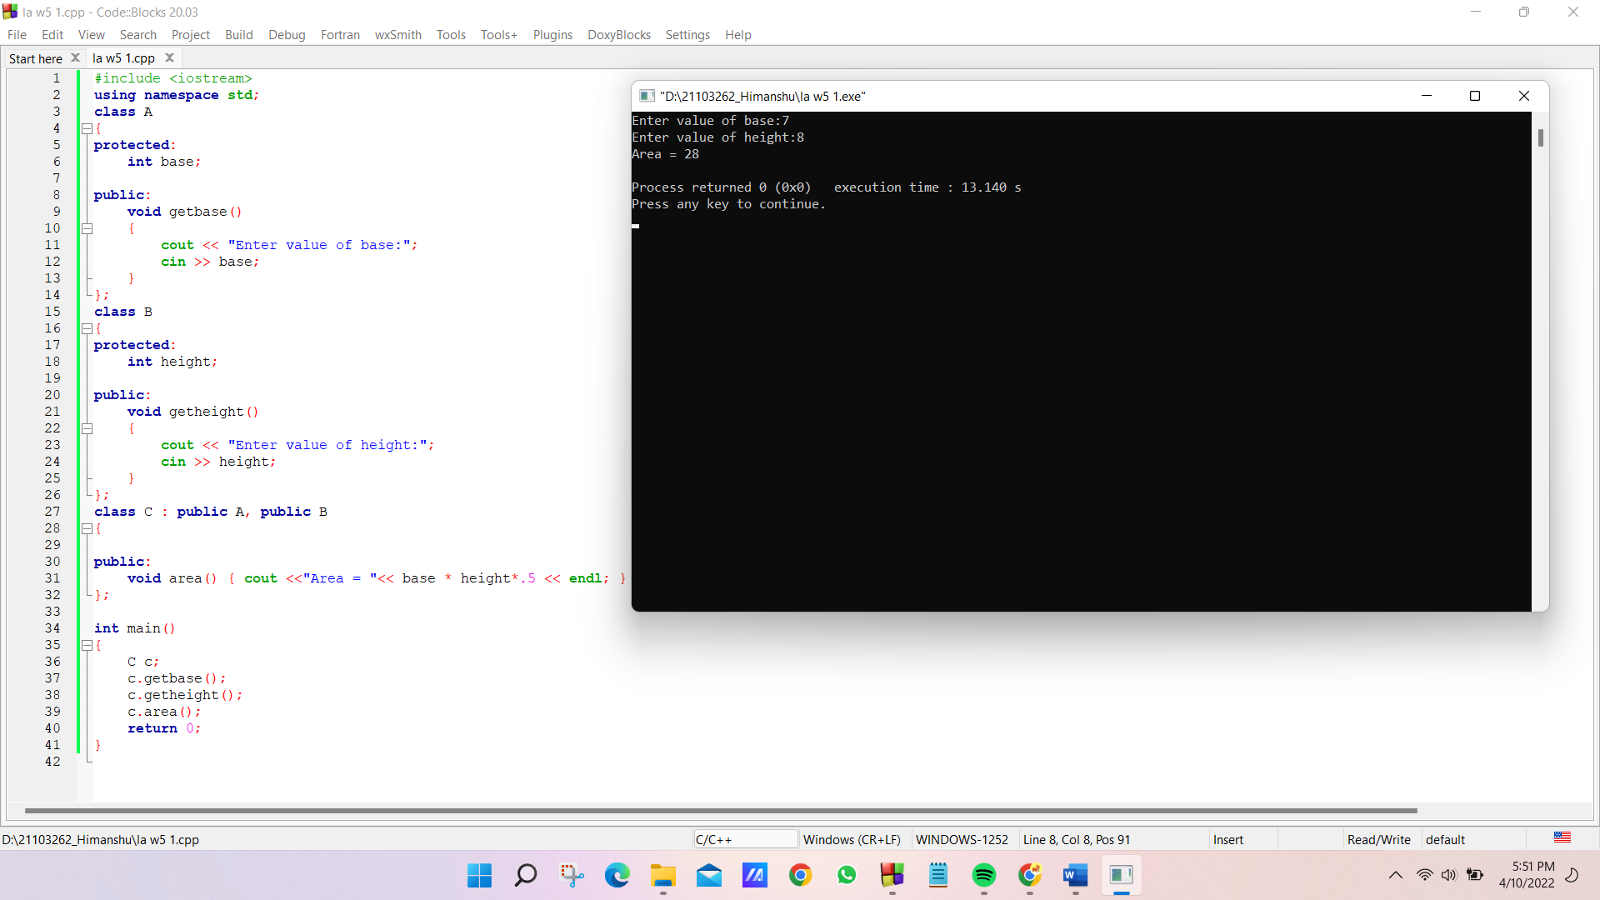

***Q2)*** *Write a C++ program, consider that there are two base classes namely class  StudentsDetails and class Marks from which class C is inherited. The class A  contains member function getDetails() that reads “students name”, “Enrollment  number” value as user input from keyboard. Class B contains member function  getMarks() and reads “5 subject marks” value as user input from keyboard. The  derived class C inherits all the public members of A and B and computes the area of  the triangle.*

*SAMPLE OUTPUT:*

*enter value of name: JOHN*

*enter value of eno.: JOHN123*

*enter value of marks [0] 89*

*enter value of marks [1] 78*

*enter value of marks [2] 67*

*enter value of marks [3] 86*

*enter value of marks [4] 57*

*Total = 377*

***Solution:***

#include <iostream>

#include <string>

#include<cstdio>

using namespace std;

class studentdetails

{

protected:

string name;

int eno;

public:

void getdetails()

{

cout << "enter name:";

fflush(stdin);

getline(cin, name);

cout << "enter Eno:";

cin>>eno;

}

};

class marks

{

protected:

int marks[5];

public:

void getmarks(){

cout << "enter marks of 5 subjects:";

for(int i=0;i<5;i++){

cin>>marks[i];

}

}

};

class C : public studentdetails, public marks

{

public :

C(){

getdetails();

getmarks();

cout<<"Total="<<total();

}

int total(){

return(marks[0]+marks[1]+marks[2]+marks[3]+marks[4]);

}

};

int main()

{

C c;

return 0;

}

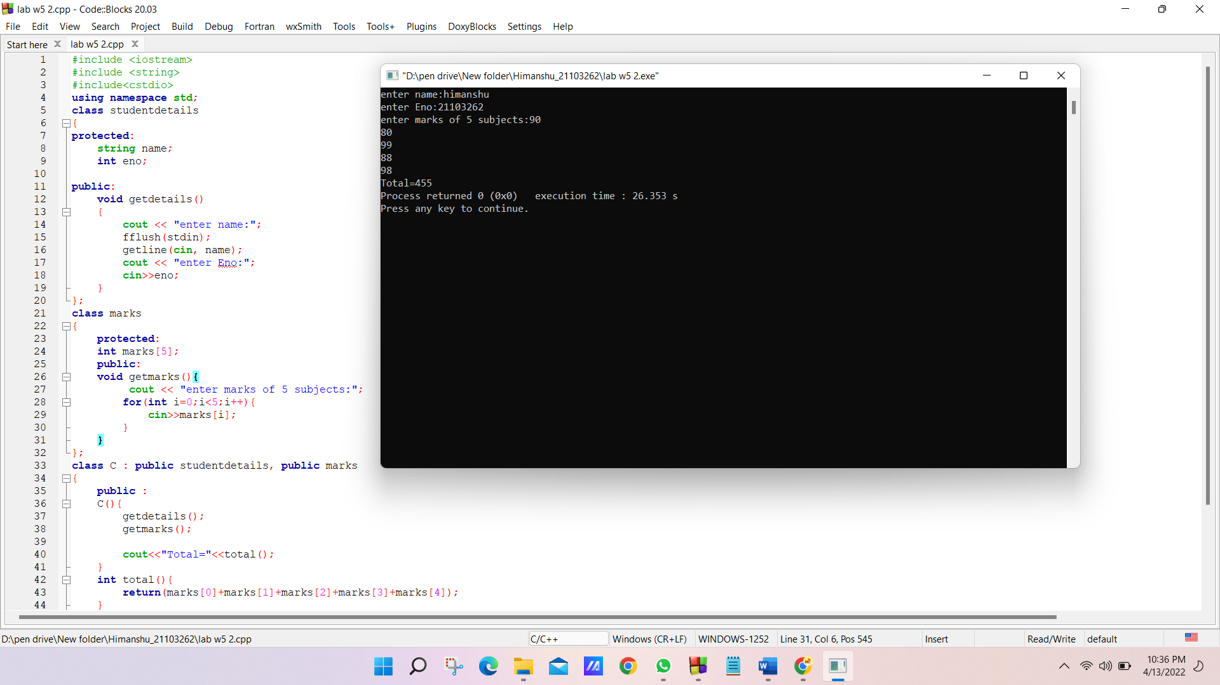

***Q3)*** *Based on the virtual function concept, write the main function for the following  code to display the derived class values given by user at run time.*

*#include <iostream>*

*using namespace std;*

*class base {*

*public:*

*char fname[20];*

*char surname[20];*

*public:*

*virtual void calculate()*

*{*

*cout << "enter fname:";*

*cin>> fname;*

*cout << "enter surname";*

*cin >> surname;*

*}*

*void display()*

*{*

*cout << "welcome" << fname << surname<<endl;*

*}*

*};*

*class derived : public base {*

*public:*

*void calculate()*

*{*

*cout << "enter derived_fname:";*

*cin>>fname;*

*cout << "enter derived_ surname";*

*cin>>surname;*

*}*

*void display()*

*{*

*cout << "welcome to derived" << fname << surname<<endl;   }*

*};*

*int main()*

*{*

*//WRITE YOUR CODE HERE.*

*//****Solution:***

base *p;

p=new derived;

p->calculate();

p->display();

return 0;

*}*

***Q4)*** *Given a snippet of the program to create a base class named as base_food_Items with a virtual function named as order and total_Price . Create a derived class name  Chinese. Then calculate the total_price of food items based on variables quantity and  item_price.*

*#include <iostream>*

*using namespace std;*

*class base_food_items {*

*public:*

*char item_name[20];*

*int quantity;*

*int item_price;*

*public:*

*virtual void order()*

*{*

*cout << "enter item name:";*

*cin>> item_name;*

*cout << "enter quantity";*

*cin>> quantity;*

*cout << "Item price";*

*cin >> item_price;*

*}*

*void total_price()*

*{*

*cout<<"order is: " << item_name<<"\t"<<"quantity:"<<quantity<<endl;   cout << "total price=" << item_price*quantity<<endl;   }*

*};*

***Solution:***

class chinese : public base_food_items

{

public:

chinese()

{

order();

total_price();

}

};

int main()

{

chinese a;

return 0;

}

***Q5)*** *Write a C++ program to show the functionality of the abstract classes. Output:*

*This is Display1() method of Derived Class*

*This is Display2() method of Derived Class*

***Solution:***

#include <iostream>

#include <string>

using namespace std;

class base

{

public:

virtual void Display1() = 0;

virtual void Display2() = 0;

};

class derived:public base

{

public:

derived()

{

Display1();

Display2();

}

void Display1() { cout << "This is Display1() method of Derived Class\n"; }

void Display2() { cout << "This is Display2() method of Derived Class"; }

};

int main()

{

derived a;

return 0;

}

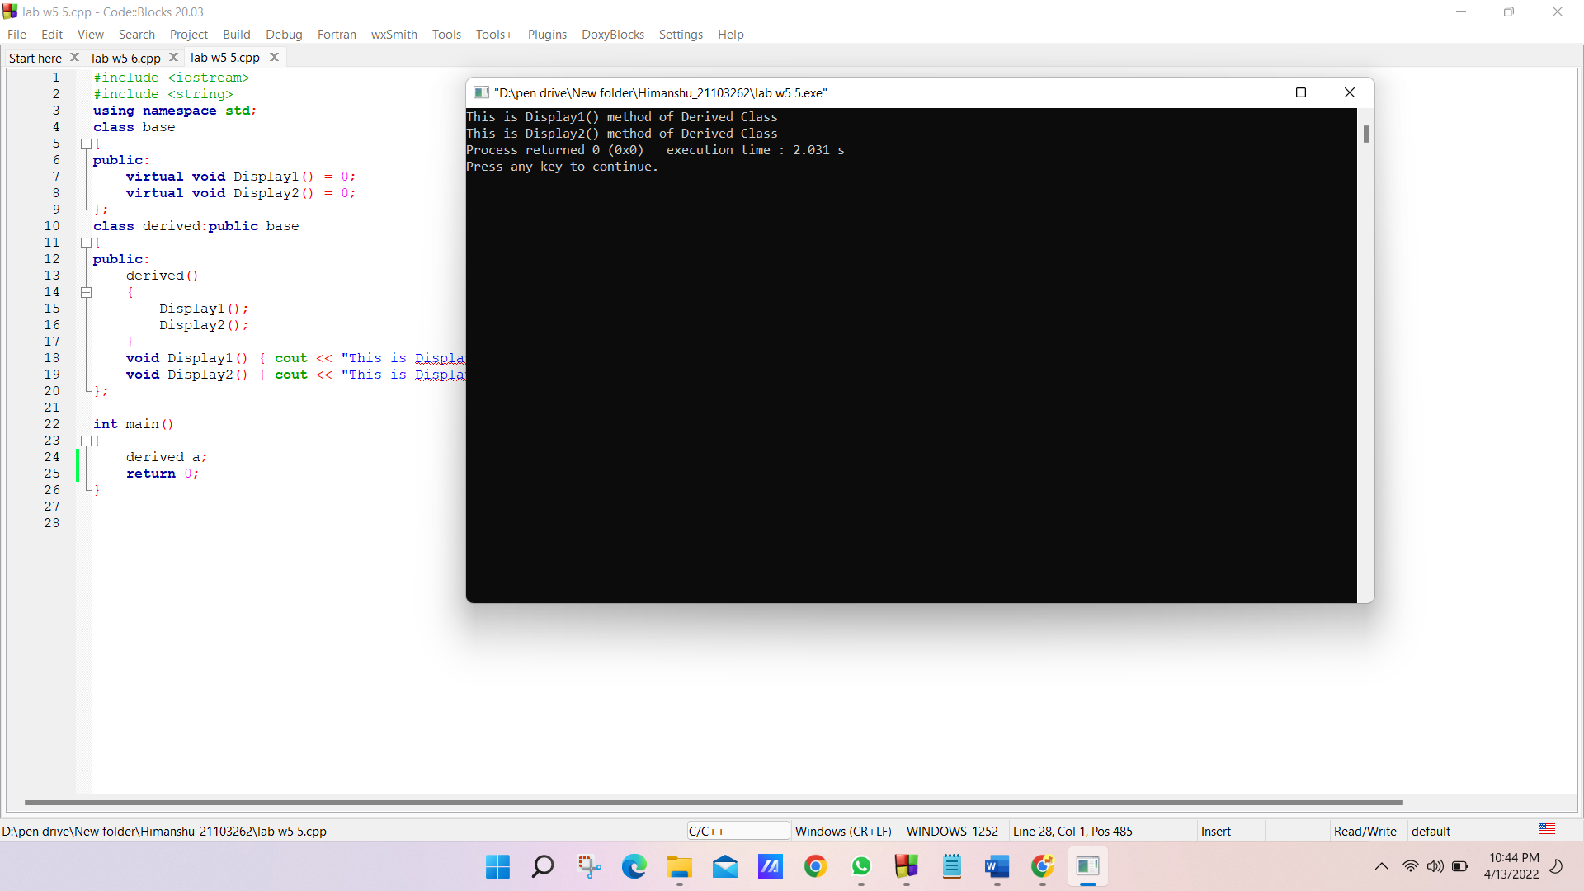

***Q6)*** *Write a program to use constructors of the abstract class to find the sum of two  numbers and display the results.*

***Solution:***

#include <iostream>

using namespace std;

class A

{

protected:

int a, b;

public:

A()

{

cin >> a >> b;

}

virtual void add() = 0;

};

class B : public A

{

public:

void add() { cout << "Sum of a and b is:" << a + b; }

};

int main()

{

A *b;

b = new B;

b->add();

return 0;

}

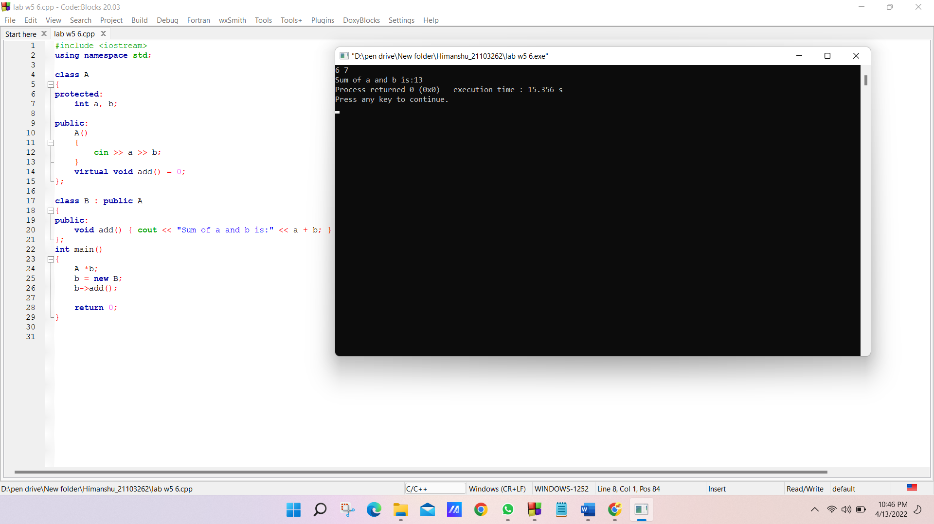

***Q7 A)*** *What is the output of the following code?*

*#include<iostream>*

*using namespace std;*

*class Base { };*

*class Derived: public Base {};*

*int main() {*

*Base *base_ptr = new Derived;*

*Derived *derived_ptr = dynamic_cast<Derived*>(base_ptr);*

*if(derived_ptr != NULL)*

*cout<<"It is working";*

*else*

*cout<<"cannot cast Base* to Derived*";*

*return 0;*

*}*

***Solution:***

*The given code will give an error due to dynamic casting of a pointer pointing to a class not containing any virtual function.*

***Q7 B)*** *Rewrite the above code to rectify the error*

***Solution:***

#include <iostream>

using namespace std;

class Base

{

virtual void show (){}

};

class Derived : public Base

{

};

int main()

{

Base *base_ptr = new Derived;

Derived *derived_ptr = dynamic_cast<Derived *>(base_ptr);

if (derived_ptr != NULL)

cout << "It is working";

else

cout << "cannot cast Base* to Derived*";

return 0;

}

