***NAME : Himanshu Dixit***

***ENROLL NO. : 21103262***

***BATCH : B10***

***Software Development Lab – II [15B17CI271]***

***Assignment Sheet***

***Week 9***

***1.*** *Write a program to implement the exception handling with multiple catch  Statements. You have to take three input values from user as Integer value,  Character value and double value. For each above values you’ll have to handle  it with the catch statement.*

***Solution:***

#include <iostream>

using namespace std;

int main()

{

int i;

char c;

double d;

int choice;

try

{

cout<<"Enter int,char and double value : ";

cin>>i>>c>>d;

cout<<"Enter which is exception 1. integer ,, 2. character ,, 3. double ";

cin>>choice;

if(choice==1)

throw i;

else if(choice==2)

throw c;

else if(choice==3)

throw d;

else throw;

}

catch(int i){

cout<<"catch "<<i;

}

catch(char c){

cout<<"catch "<<c;

}

catch(double d){

cout<<"catch "<<d;

}

catch(...){

cout<<"catch nothing";

}

return 0;

}

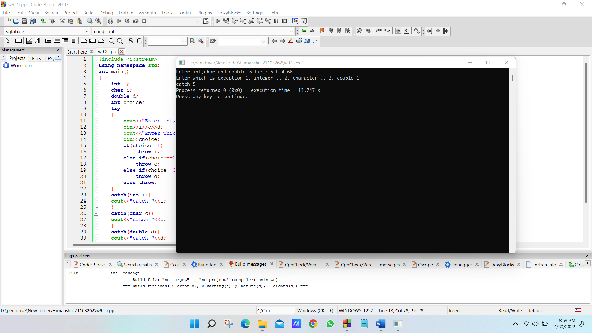

***2.*** *What output is produced by the following code?*

*int wait_time = 46;*

*try*

*{*

*cout << "Try block entered.\n";*

*if (wait_time > 30)*

*throw wait_time;*

*cout << "Leaving try block.\n";*

*}*

*catch(int thrown_value)*

*{*

*cout << "Exception thrown with\n"*

*<< "wait_time equal to " << thrown_value << endl;*

*}*

*cout << "After catch block." << endl;*

***Solution:***

*Try block entered.*

*Exception thrown with*

*wait_time equal to 46*

*After catch block.*

***3.*** *What would be the output produced by the code in Question 2 if we make the following change? Change the line*

*int wait_time = 46;*

*to*

*int wait_time = 12;*

***Solution:***

*Try block entered.*

*Leaving try block.*

*After catch block.*

***4.*** *What happens when a throw statement is executed? This is a general question. Tell what happens in general, not simply what happens in the code in Question  2 or some other sample code.*

***Solution:***

*Its execution causes the instance to be thrown.whatever variable we throw that will will gone direct to catch statement by skipping the code. In question 2 throwing wait_time variable will direct gone to catch statement by skip the cout statement.*

***5.*** *What is the output produced by the following program?*

*#include <iostream>*

*using namespace std;*

*void sample_function(double test) throw (int);*

*int main()*

*{*

*try*

*{*

*cout << "Trying.\n";*

*sample_function(98.6);*

*cout << "Trying after call.\n";*

*}*

*catch(int)*

*{*

*cout << "Catching.\n";*

*}*

*cout << "End of program.\n";*

*return 0;*

*}*

*void sample_function(double test) throw (int)*

*{*

*cout << "Starting sample_function.\n";*

*if (test < 100)*

*throw 42;*

*}*

***Solution:***

*Trying.*

*Starting sample_function.*

*Catching.*

*End of program.*

***6.*** *What is the output produced by the program in Question 5 if the following  change were made to the program?*

*Change sample_function(98.6);*

*in the try block to*

*sample_function(212);*

***Solution:***

*Trying.*

*Starting sample_function.*

*Trying after call.*

*End of program.*

***7.*** *What happens when an exception is never caught?*

***Solution:***

*If an exception is not caught (with a catch block), the runtime system will abort the program (i.e. crash) and an exception message will print to the console. The message typically includes: name of exception type.*

***8.*** *Can you nest a try block inside another try block?*

***Solution:***

*Yes we can make nested try block.*

***8.*** *What will be the output of the following code snippet?*

*void myFunction(int test) {*

*try{*

*if (test)*

*throw test;*

*else*

*throw "Value is zero";*

*}*

*catch (int i) {*

*cout << "CaughtOne " ;*

*}*

*catch (const char *str) {*

*cout << "CaughtString ";*

*}*

*}*

*int main() {*

*myFunction(1);*

*myFunction(2);*

*myFunction(0);*

*myFunction(3);*

*return 0;*

*}*

*a) CaughtOne CaughtOne CaughtString CaughtString*

*b) CaughtOne CaughtString CaughtString CaughtOne*

*c) CaughtOne CaughtOne CaughtOne CaughtOne*

*d) CaughtOne CaughtOne CaughtString CaughtOne*

***Solution:***

*(d)*

***9.*** *What will be the output of the following code snippet?*

*#include<iostream>*

*using namespace std;*

*struct MyException : public exception { const char * what () const throw () {*

*return "C++ Exception";*

*}*

*};*

*int main() {*

*try {*

*throw MyException();*

*}catch(MyException& e) { std::cout << "MyException caught" << std::endl; std::cout << e.what() << std::endl; } catch(std::exception& e) { std::cout << "Exception caught" << std::endl; std::cout << e.what() << std::endl; }*

*}*

*a) MyException caught*

*C++ Exception*

*b) C++ Exception*

*MyException caught*

*c) Exception caught*

*C++ Exception*

*d) C++ Exception*

*MyException caught*

*Exception caught*

***Solution:***

*(a)*