***NAME : Himanshu Dixit***

***ENROLL NO. : 21103262***

***BATCH : B11***

***DSW Lab***

***Week 1***

***Solution 1 :***

<!DOCTYPE html>

<html lang="en">

<head>

<meta charset="UTF-8">

<meta http-equiv="X-UA-Compatible" content="IE=edge">

<meta name="viewport" content="width=device-width, initial-scale=1.0">

<title>Hyperlinks Exercise</title>

</head>

<body>

<p><a href="graphic bullets.html">Link to list graphic bullets.html</a></p>

<p><a href="amazon.com">Link to Amazon.com</a></p>

<p><a href="book1.gif"><img src="https://www.adazing.com/wp-content/uploads/2019/02/open-book-clipart-03.png" width="40px" alt=""></a></p>

<pre>

He we are at our jump ....

</pre>

<p><a href="#top">back to top</a></p>

<ol type="A">

<li></li>

<li></li>

<li></li>

<li></li>

</ol>

</body>

</html>

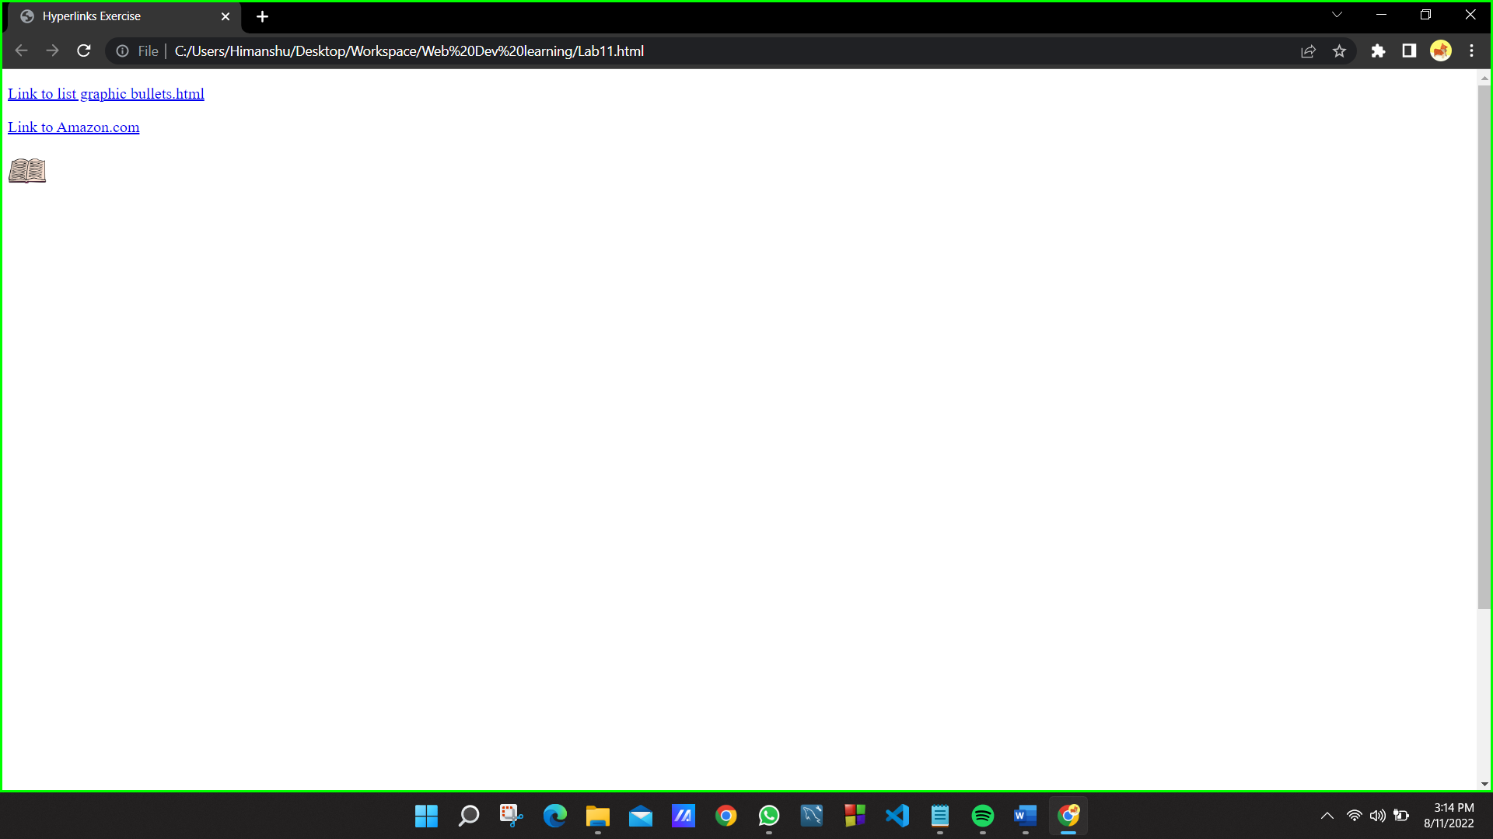

***Solution 2 :***

<!DOCTYPE html>

<html lang="en">

<head>

<meta charset="UTF-8">

<meta http-equiv="X-UA-Compatible" content="IE=edge">

<meta name="viewport" content="width=device-width, initial-scale=1.0">

<title>Test Alignment</title>

</head>

<body>

<ol>

<li><b>one</b>

<ol type="a">

<li>uno</li>

<li>hanna</li>

</ol>

</li>

<li>

<b>two</b>

<ol type="a">

<li>dos</li>

<li>dool</li>

</ol>

</li>

<li>

<b>three</b>

<ol type="a">

<li>tres</li>

<li>set</li>

</ol>

</li>

</ol>

<br><br>

<ul>

<li>Cherry

<ul>

<li>Carabier</li>

<li>Malibu</li>

</ul>

</li>

<li>Ford

<ul>

<li>Escort</li>

<li>F100</li>

</ul>

</li>

<li>Mazda

<ul>

<li>626</li>

</ul>

</li>

</ul>

<br>

<p style="display: inline;"><u>Fruit</u></p>

<pre> Apples, Oranges, Peers, Pluma</pre>

<span><u>Vegetables</u><span>

<ul style="list-style : none;">

<li>Corn

<ul style="list-style : none;"

<li><em>on the cob</em></li>

<li>cream</li>

<li>Carrots</li>

<li>Green Beans</li>

</body>

</html>

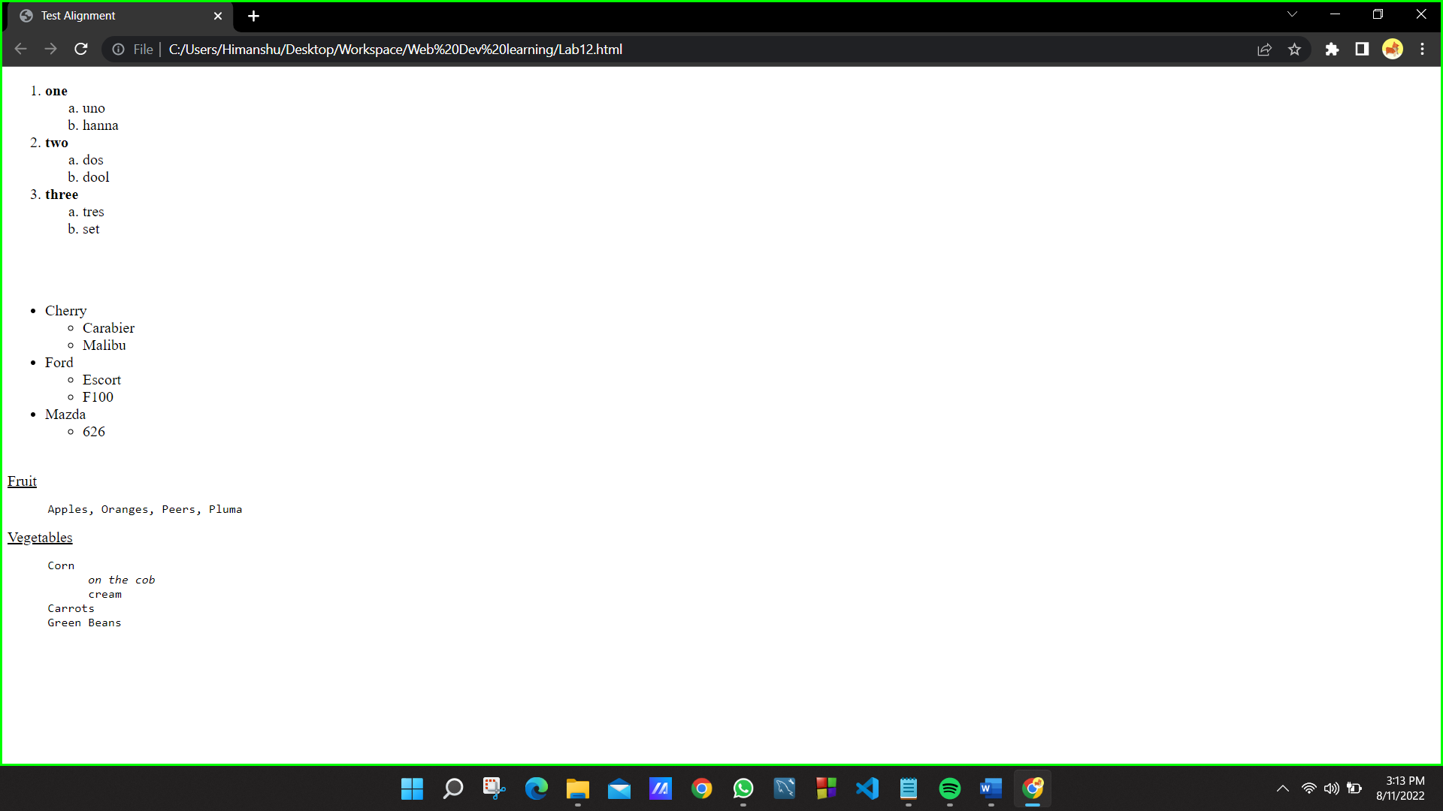

***Solution 2 :***

<!DOCTYPE html>

<html lang="en">

<head>

<meta charset="UTF-8">

<meta http-equiv="X-UA-Compatible" content="IE=edge">

<meta name="viewport" content="width=device-width, initial-scale=1.0">

<title>Form</title>

</head>

<body>

<!-- <p>Please fill the form.</p> -->

<form action="">Please fill the form. <br><br>

<p>First Name:<input type="text"></p>

<p>Last Name:<input type="text"></p>

<p>Permanent Address:<br><textarea name="" id="" cols="30" rows="10" placeholder=" My Address"></textarea></p>

<span>I ma currently residing in</span>

<select name="" id="">

<option value="">Hotel</option>

<option value="">Hostel</option>

</select>

<br><br>

<div>

My Branch<input type="radio">CSE/IT <input type="radio">ECE <input type="radio">BIOTECH

</div>

<br>

<br>

<div>

Hobbies<br>Reading<input type="checkbox"> Music<input type="checkbox"> Others<input type="checkbox">

</div>

<br>

<input type="submit">

</form>

</body>

</html>

