**Advanced Executive Program in Cybersecurity**

Virtual Internship Project Problem Statement



**Penetration Tester**

**Problem statement:**

You are working as a Penetration Tester for El Banco Bank. You are running a gray-box penetration test to probe for vulnerabilities that hackers with nefarious intent might be able to exploit to gather secure data and intelligence.

As a first step, you must gather more information about the target's environment and network-related information using the tools at your disposal.

**Background of the problem statement:**

El Banco Bank is one of the fastest growing banks in Europe with more than 1200 branches across the country and manages €200 billion in assets.

Handling millions of dollars of banking transactions per day, its customers hugely depend upon the security of their banking data. The recent surge in cyber-attacks and data breaches has become a significant issue for every organization.

**Expected deliverables:**

**TASK 1:**

Perform a half-open scan against the target network to quickly identify all open ports in the network

“*nmap -sS 172.31.47.0/24*”

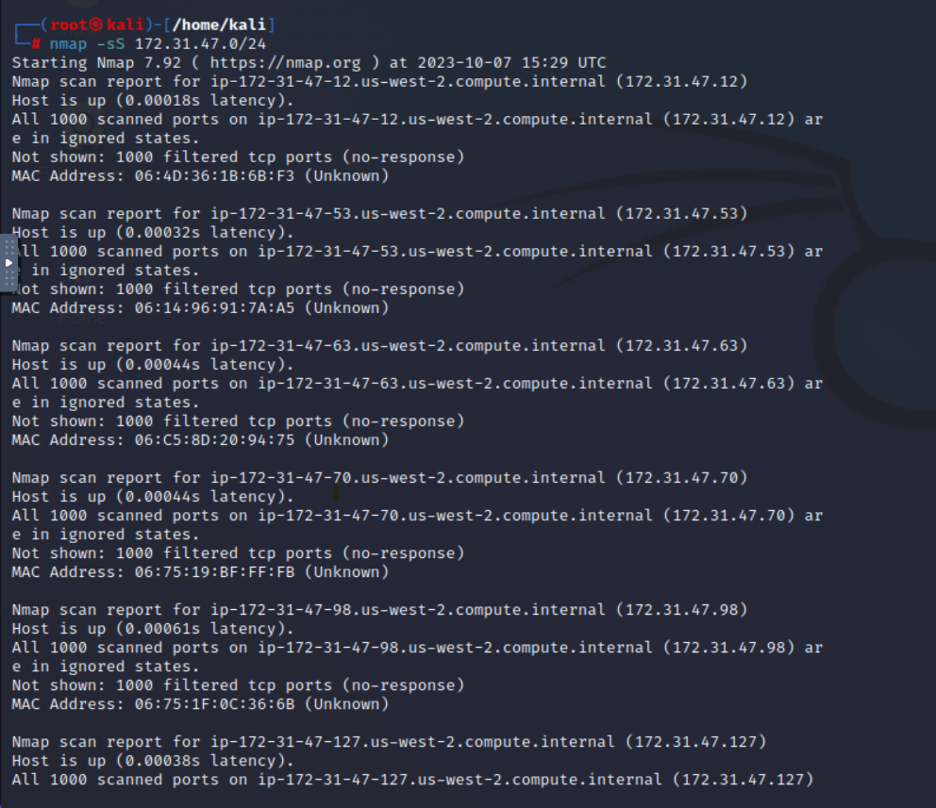

**TASK 2:**

Perform an aggressive mode that enables OS detection, version detection, script scanning, and traceroute in the network

“*nmap -A 172.31.46.74*”

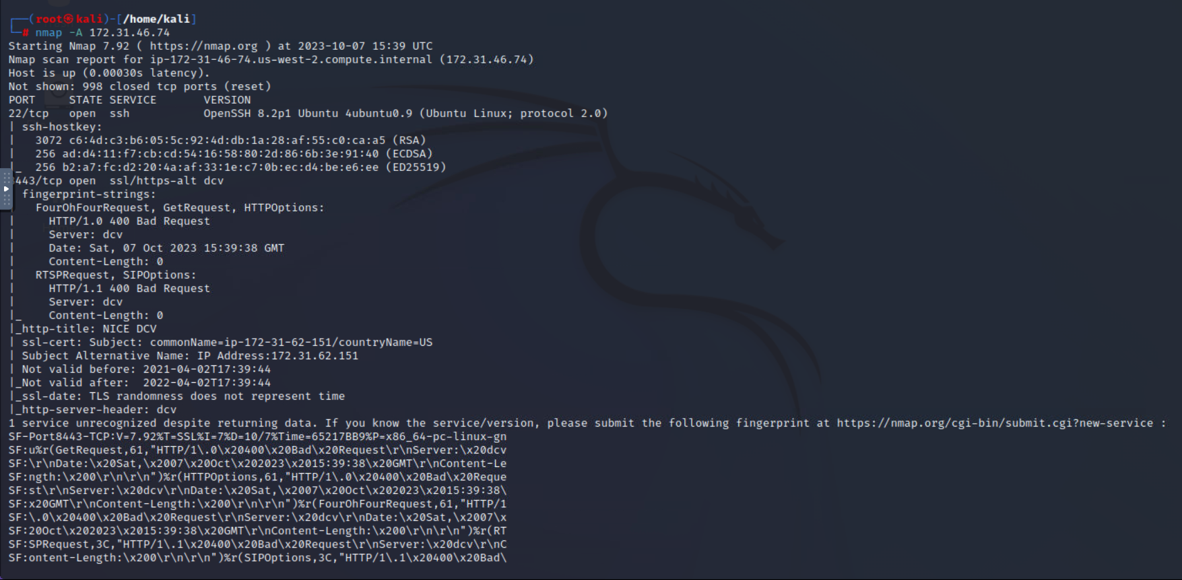

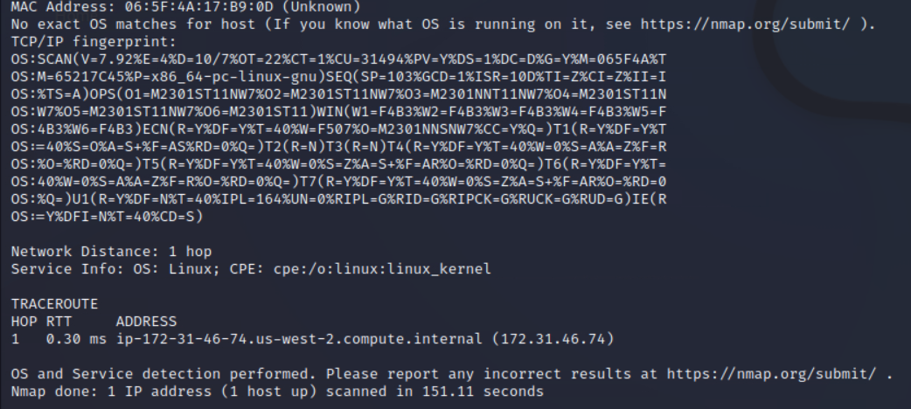

**TASK 3:**

While examining web server logs, you notice some HyperText Transfer Protocol (HTTP) GET requests that look suspicious. You need to carefully examine the logs, identify the attacks, and determine the appropriate mitigation control.

**Log #1:**

|  |
| --- |
| "18.66.78.71 - - [22/Dec/2021:16:18:20 +0300] "GET /media/system/js/caption.js HTTP/1.1" 200 751 "http://18.66.78.71/?wvstest=javascript:domxssExecutionSink(1,%22'%5C%22%3E%3Cxsstag%3E()locxss%22)" "Mozilla/5.0 (Windows NT 6.1; WOW64) AppleWebKit/537.21 (KHTML, like Gecko) Chrome/41.0.2228.0 Safari/537.21"" |

**Log #2**

|  |
| --- |
| "18.66.78.71 - - [22/Dec/2021:15:20:03 +0300] "GET /DVWA/vulnerabilities/fi/?page=%2f..%2f..%2f..%2f..%2f..%2f..%2f..%2f..%2f..%2f..%2fetc%2fpasswd HTTP/1.1" 200 2190 "http://18.66.78.71/DVWA/" "Mozilla/5.0 (Windows NT 6.3; WOW64) AppleWebKit/537.36 (KHTML, like Gecko) Chrome/41.0.2272.16 Safari/537.36"" |

**Log #3**

|  |
| --- |
| "18.66.78.71 - - [22/Dec/2021:15:19:59 +0300] "GET /DVWA/vulnerabilities/fi/?page=%27AND%201%3dcast(0x5f21403264696c656d6d61%20as%20varchar(8000))%20or%20%271%27%3d%27 HTTP/1.1" 200 1433 "http://18.66.78.71/DVWA/" "Mozilla/5.0 (Windows NT 6.3; WOW64) AppleWebKit/537.36 (KHTML, like Gecko) Chrome/41.0.2272.16 Safari/537.36"" |

|  |  |  |
| --- | --- | --- |
| Log Number | Attack Type | Mitigation control |
| 1 | XSS Attack | Input Validation |
| 2 | Path / Directory Traversal | Access Control |
| 3 | SQL Injection | Input Validation/ Parameterized query |