22AIE 112 Data Structures and Algorithms
Lab Sheet 1
Array
Date:13/5/2023 RollNo:AM.EN.U4AIE22009

1. Write a program to search for an element in a sorted array efficiently.

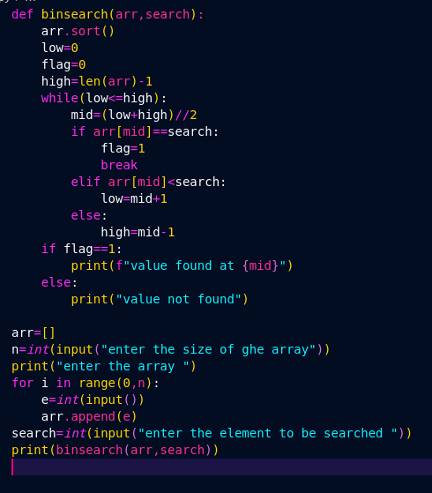
Code:

Ouput:
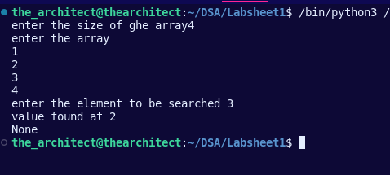

2.Write a program to search for the second occurrence of ‘6’ in an array and replace it
with ‘7’.

Code:
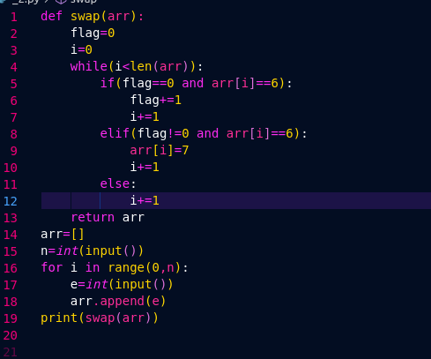

Output:
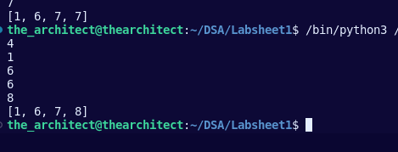

3.Write a program to perform the following operations on array
a. Creation
b. Insertion (at start, at end, using index, based on value)
c. Deletion (at start, at end, using index, based on value)
d. Traversal
e. Searching an element. (based on value, based on index)

Code: a)

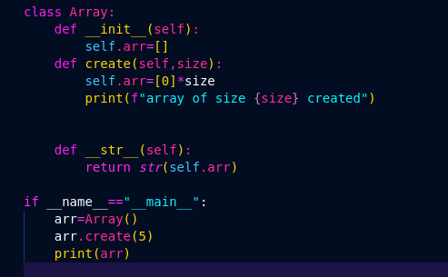

Output:
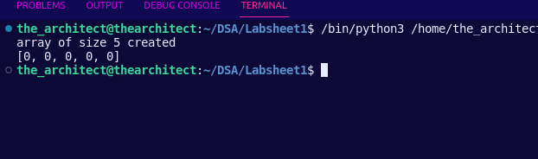
Code: b)
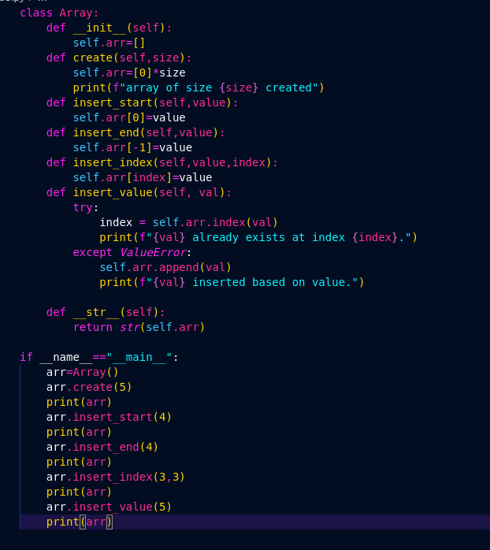
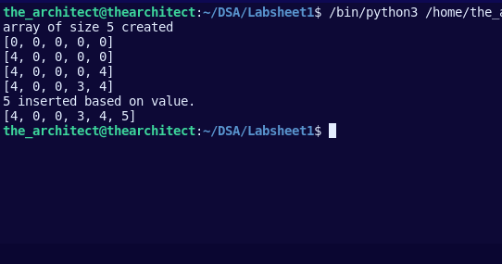
Output
Code c)

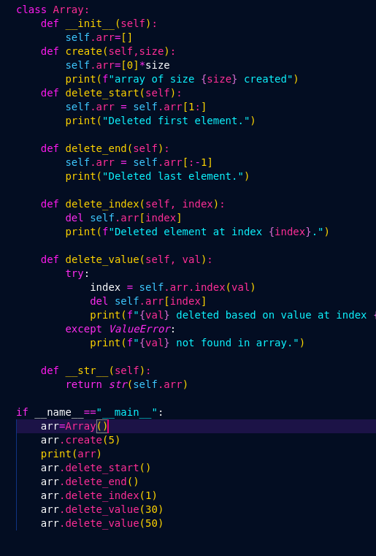

Output:

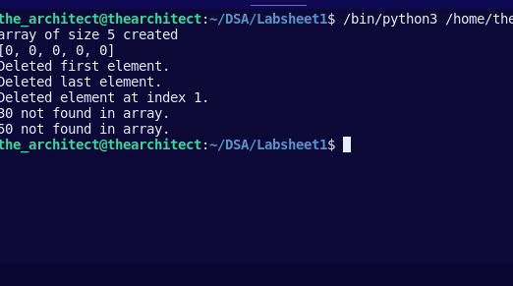

Code d)

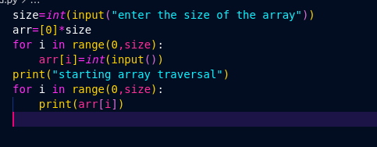

Output

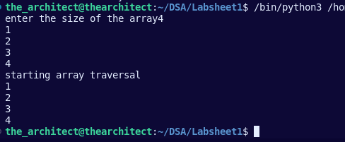

Code e)

class Array:
def __init__(self):
self.arr = []

def create(self, n):
self.arr = [0] * n
print(f"Array of size {n} created.")

def insert_start(self, val):
self.arr = [val] + self.arr
print(f"{val} inserted at start.")

def insert_end(self, val):
self.arr.append(val)
print(f"{val} inserted at end.")

def insert_index(self, index, val):
self.arr.insert(index, val)
print(f"{val} inserted at index {index}.")

def insert_value(self, val):
try:
index = self.arr.index(val)
print(f"{val} already exists at index {index}.")
except ValueError:
self.arr.append(val)
print(f"{val} inserted based on value.")

def delete_start(self):
self.arr = self.arr[1:]
print("Deleted first element.")

def delete_end(self):
self.arr = self.arr[:-1]
print("Deleted last element.")

def delete_index(self, index):
del self.arr[index]
print(f"Deleted element at index {index}.")

def delete_value(self, val):
try:
index = self.arr.index(val)
del self.arr[index]
print(f"{val} deleted based on value at index {index}.")
except ValueError:
print(f"{val} not found in array.")

def traverse(self):
print("Array elements:")
for val in self.arr:
print(val)

def search_by_value(self, val):
try:
index = self.arr.index(val)
print(f"{val} found at index {index}.")
except ValueError:
print(f"{val} not found in array.")

def search_by_index(self, index):
try:
val = self.arr[index]
print(f"Value at index {index} is {val}.")
except IndexError:
print(f"Index {index} is out of range.")

if __name__ == "__main__":
arr = Array()
arr.create(5)
arr.insert_start(10)
arr.insert_end(20)
arr.insert_index(2, 30)
arr.insert_value(40)
arr.insert_value(20)
arr.delete_start()
arr.delete_end()
arr.delete_index(1)
arr.delete_value(30)
arr.delete_value(50)
arr.traverse()
arr.search_by_value(40)
arr.search_by_index(2)
arr.search_by_index(5)

Output:
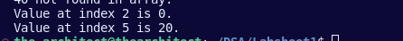

4. Given an array with n numbers split it from a specified position, and move the first
part of array and append it to the end.
Example: Given A=[12,10,5,6,22,52] and position =2
Your function should return the modified array as:[5,6,22,52,12,10]

Code :
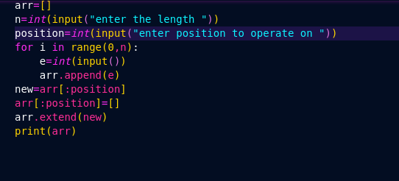
Output:

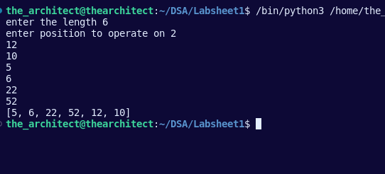

5.Given a sorted array of nums, remove the duplicates such that each element appears
only once and return the new length.
Example: Given nums = [0,0,1,1,1,2,2,3,3,4]
Your function should return length = 5, with the first five elements being
modified as 0, 1, 2, 3, and 4 respectively.

Code:
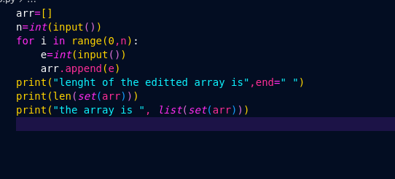

Output:
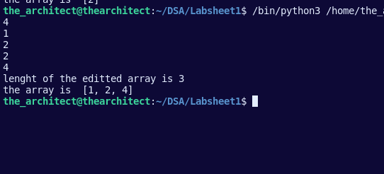

6.Given an array of integers, return indices of the two numbers such that they add up to
a specific target. You may assume that each input would have exactly one solution, and
you may not use the same element twice.
Example: Given nums = [2, 7, 11, 15], target = 9,
Because nums[0] + nums[1] = 2 + 7 = 9, then return [0, 1]

Code:
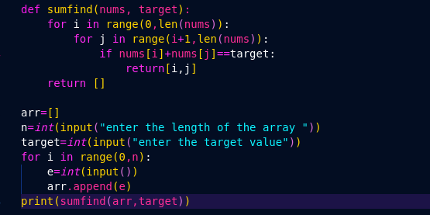

Output:
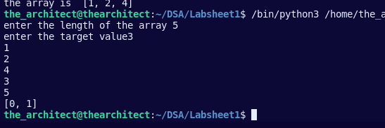

7.Given an array nums and a value val, remove all instances of that value in the array
and return the new length. The order of elements can be changed.
Example: Given nums = [0,1,2,2,3,0,4,2], val = 2,
Your function should return length = 5, with the first five elements of nums
Containing 0, 1, 3, 0, and 4.

Code:
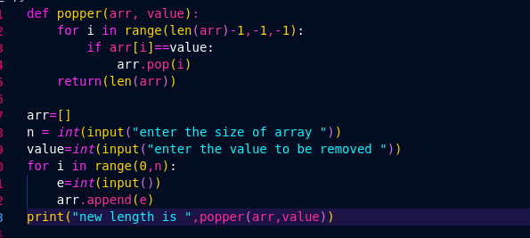

Output:
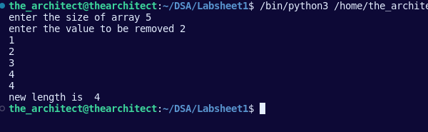

8.Given an array of n elements to find if an integer x appears more than n/2 times in a
sorted array of n integers.
Example: Given A=[0,1,2,4,4,4,4,4]
Your function should return 4 appears 5 times

Code:
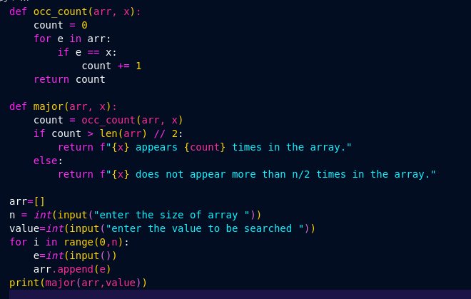

Output

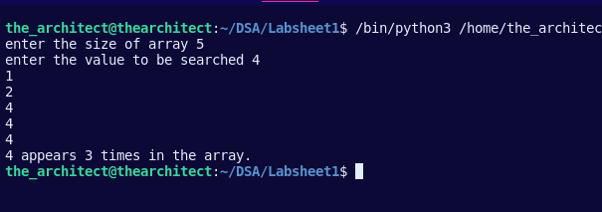

9. Write a program to merge elements of two sorted arrays A and B of size p and
q, by maintaining the sorted order i.e. fill A with first p smallest elements and fill B
with remaining elements.
Example: Input :
intA[] = { 1, 5, 6, 7, 8, 10 },int B[] = { 2, 4, 9 }
Output: Sorted Arrays:
A: [1, 2, 4, 5, 6, 7], B: [8, 9, 10]

Code:
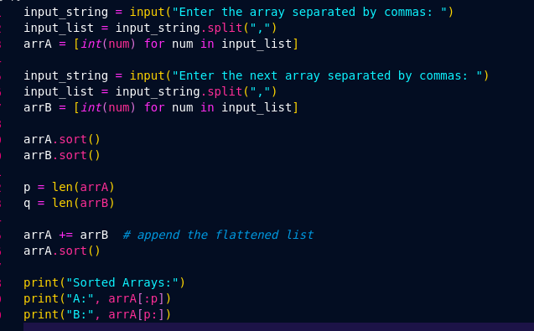

Output:

