22AIE112 DATA STRUCTURES AND ALGORITHMS
LABSHEET 7
TREE
Date : 30/7/23 Roll No : AM.EN.U4AIE2209

1.

#include <stdio.h>
#include <stdlib.h>

struct TreeNode {
int value;
struct TreeNode* left;
struct TreeNode* right;
};

struct TreeNode* createTreeNode(int value) {
struct TreeNode* newNode = (struct TreeNode*)malloc(sizeof(struct TreeNode));
newNode->value = value;
newNode->left = NULL;
newNode->right = NULL;
return newNode;
}

void insertTreeNode(struct TreeNode** root, int value) {
if (*root == NULL) {
*root = createTreeNode(value);
return;
}

if (value < (*root)->value) {
insertTreeNode(&((*root)->left), value);
} else {
insertTreeNode(&((*root)->right), value);
}
}

void inorderTraversal(struct TreeNode* root) {
if (root == NULL) {
return;
}

inorderTraversal(root->left);
printf("%d ", root->value);
inorderTraversal(root->right);
}

int main() {
struct TreeNode* root = NULL;

while (1) {
printf("Binary Search Tree Operations:\n");
printf("1. Insert a node.\n");
printf("2. Inorder traversal.\n");
printf("3. Exit.\n");

int choice;
printf("Enter your choice: ");
scanf("%d", &choice);

switch (choice) {
case 1:
printf("Enter the value to be inserted: ");
int value;
scanf("%d", &value);
insertTreeNode(&root, value);
break;

case 2:
printf("Inorder Traversal of the Tree: ");
inorderTraversal(root);
printf("\n");
break;

case 3:
exit(0);
break;

default:
printf("Invalid choice. \n");
break;
}
}

return 0;
}

Output

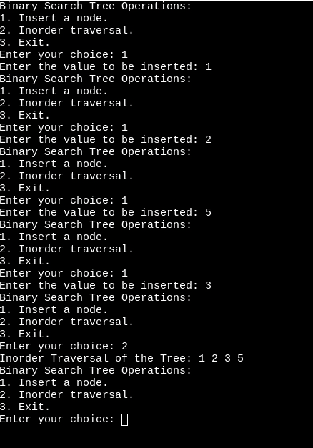

2.

#include <stdio.h>
#include <stdlib.h>

struct node {
int data;
struct node* left;
struct node* right;
};

struct node* create_node(int data) {
struct node* new_node = (struct node*)malloc(sizeof(struct node));
new_node->data = data;
new_node->left = NULL;
new_node->right = NULL;
return new_node;
}

void insert_node(struct node** root, int data) {
if (*root == NULL) {
*root = create_node(data);
return;
}

if (data < (*root)->data) {
insert_node(&((*root)->left), data);
} else {
insert_node(&((*root)->right), data);
}
}

void inorder(struct node* root) {
if (root == NULL) {
return;
}

inorder(root->left);
printf("%d ", root->data);
inorder(root->right);
}

void preorder(struct node* root) {
if (root == NULL) {
return;
}

printf("%d ", root->data);
preorder(root->left);
preorder(root->right);
}

void postorder(struct node* root) {
if (root == NULL) {
return;
}

postorder(root->left);
postorder(root->right);
printf("%d ", root->data);
}

int main() {
struct node* root = NULL;

while (1) {
printf("1. Insert a node.\n");
printf("2. Inorder traversal.\n");
printf("3. Preorder traversal.\n");
printf("4. Postorder traversal.\n");
printf("5. Exit.\n");

int choice;
printf("Enter your choice: ");
scanf("%d", &choice);

switch (choice) {
case 1:
printf("Enter the data to be inserted: ");
int data;
scanf("%d", &data);
insert_node(&root, data);
break;

case 2:
printf("Inorder Traversal of the Tree: ");
inorder(root);
printf("\n");
break;

case 3:
printf("Preorder Traversal of the Tree: ");
preorder(root);
printf("\n");
break;

case 4:
printf("Postorder Traversal of the Tree: ");
postorder(root);
printf("\n");
break;

case 5:
exit(0);
break;

default:
printf("Invalid choice. \n");
break;
}
}

return 0;
}
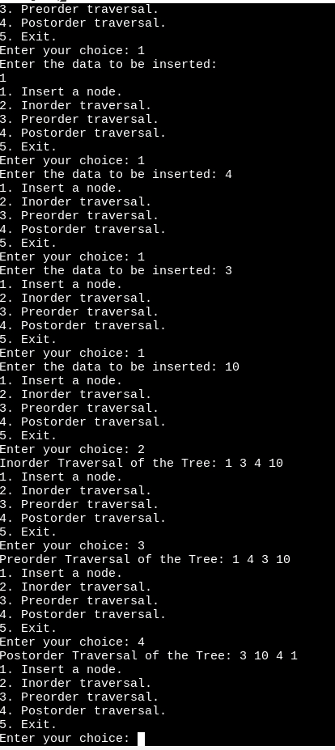

3.
#include <stdio.h>
#include <stdlib.h>

struct node {
int data;
struct node* left;
struct node* right;
};

struct node* create_node(int data) {
struct node* new_node = (struct node*)malloc(sizeof(struct node));
new_node->data = data;
new_node->left = NULL;
new_node->right = NULL;
return new_node;
}

void insert_node(struct node** root, int data) {
if (*root == NULL) {
*root = create_node(data);
return;
}

if (data < (*root)->data) {
insert_node(&((*root)->left), data);
} else {
insert_node(&((*root)->right), data);
}
}

void inorder(struct node* root) {
if (root == NULL) {
return;
}

inorder(root->left);
printf("%d ", root->data);
inorder(root->right);
}

struct node* find_min_node(struct node* root) {
while (root->left != NULL) {
root = root->left;
}
return root;
}

struct node* delete_node(struct node* root, int data) {
if (root == NULL) {
return root;
}

if (data < root->data) {
root->left = delete_node(root->left, data);
} else if (data > root->data) {
root->right = delete_node(root->right, data);
} else {
if (root->left == NULL) {
struct node* temp = root->right;
free(root);
return temp;
} else if (root->right == NULL) {
struct node* temp = root->left;
free(root);
return temp;
}

struct node* temp = find_min_node(root->right);
root->data = temp->data;
root->right = delete_node(root->right, temp->data);
}

return root;
}

int main() {
struct node* root = NULL;

while (1) {
printf("1. Insert a node.\n");
printf("2. Inorder traversal.\n");
printf("3. Delete a node.\n");
printf("4. Exit.\n");

int choice;
printf("Enter your choice: ");
scanf("%d", &choice);

switch (choice) {
case 1:
printf("Enter the data to be inserted: ");
int data;
scanf("%d", &data);
insert_node(&root, data);
break;

case 2:
printf("Inorder Traversal of the Tree: ");
inorder(root);
printf("\n");
break;

case 3:
printf("enter the data to delete: ");
int val;
scanf("%d", &val);
delete_node(root, val);
break;

case 4:
exit(0);
break;

default:
printf("Invalid choice. \n");
break;
}
}

return 0;
}

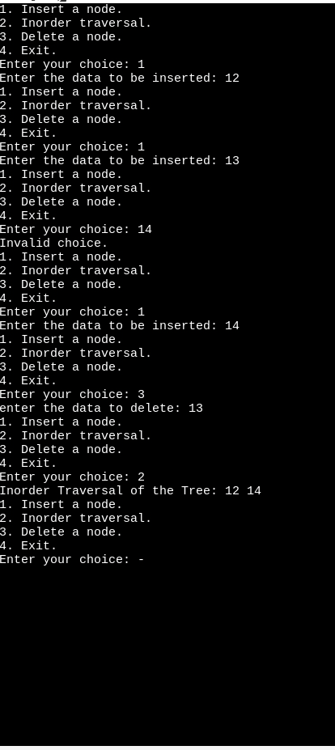

4.
#include <stdio.h>
#include <stdlib.h>

struct node {
int data;
struct node* left;
struct node* right;
};

struct node* create_node(int data) {
struct node* new_node = (struct node*)malloc(sizeof(struct node));
new_node->data = data;
new_node->left = NULL;
new_node->right = NULL;

return new_node;
}

void insert_node(struct node** root, int data) {
if (*root == NULL) {
*root = create_node(data);
return;
}

if (data < (*root)->data) {
insert_node(&((*root)->left), data);
} else {
insert_node(&((*root)->right), data);
}
}

void inorder(struct node* root) {
if (root == NULL) {
return;
}

inorder(root->left);
printf("%d ", root->data);
inorder(root->right);
}

struct node* search_val(struct node* root, int data) {
if (root == NULL || root->data == data) {
return root;
}

if (data < root->data) {
return search_val(root->left, data);
} else {
return search_val(root->right, data);
}
}

int main() {
struct node* root = NULL;

while (1) {
printf("1. Insert a node.\n");
printf("2. Inorder traversal.\n");
printf("3. Search an element.\n");
printf("4. Exit.\n");

int choice;
printf("Enter your choice: ");
scanf("%d", &choice);

switch (choice) {
case 1:
printf("Enter the data to be inserted: ");
int data;
scanf("%d", &data);
insert_node(&root, data);
break;

case 2:
printf("Inorder Traversal of the Tree: ");
inorder(root);
printf("\n");
break;

case 3:
printf("Enter the value to be searched: ");
int val;
scanf("%d", &val);
struct node* result = search_val(root, val);
if (result != NULL) {
printf("%d is found in the tree\n", val);
} else {
printf("%d is not found in the tree\n", val);
}
break;

case 4:
exit(0);
break;

default:
printf("Enter a valid choice!!!\n");
break;
}
}

return 0;
}
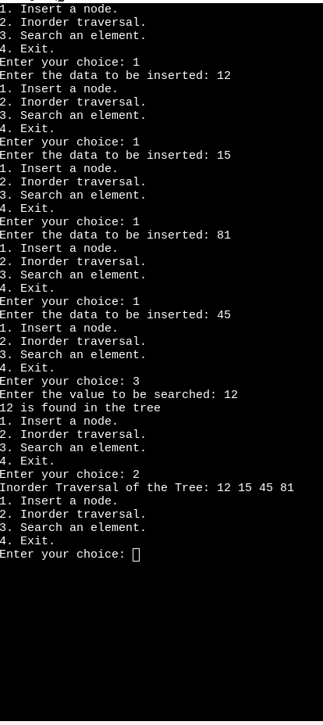

5.
#include <stdio.h>
#include <stdlib.h>

struct node{
int data;
struct node* left;
struct node* right;
};

struct node* create_node(int data){
struct node* new_node = (struct node*)malloc(sizeof(struct node));
new_node->data = data;
new_node->left = NULL;
new_node->right = NULL;

return new_node;
}

void insert_node(struct node **root, int data){
if(*root == NULL){
*root = create_node(data);
return;
}

if((*root)->data > data){
insert_node(&((*root)->left), data);
} else{
insert_node(&((*root)->right), data);
}
}

void inorder(struct node *root){
if(root == NULL){
return;
}

inorder(root->left);
printf("%d ", root->data);
inorder(root->right);
}

int find_min(struct node* root){
if(root == NULL){
printf("The Tree is empty!!");
return -1;
}

while(root->left != NULL){
root = root->left;
}

return root->data;
}

int find_max(struct node *root){
if(root == NULL){
printf("Tree is empty!!");
return -1;
}

while(root->right != NULL){
root = root->right;
}

return root->data;
}

int main(){
struct node *root = NULL;

while(1){
printf("1. Insert a node in the Tree. \n");
printf("2. Inorder Traversal of the Tree. \n");
printf("3. Find the minimum value. \n");
printf("4. Find the maximum value. \n");
printf("5. Exit. \n");

int choice;
printf("enter your choice: ");
scanf("%d", &choice);

switch(choice){
case 1:
printf("enter data to be inserted: ");
int data;
scanf("%d", &data);
insert_node(&root, data);
break;

case 2:
printf("Inorder Traversal of the Tree: ");
inorder(root);
printf("\n");
break;

case 3:
{
int min_val = find_min(root);
if(min_val != -1){
printf("Minimum value of the tree = %d\n", min_val);
}
}
break;

case 4:
{
int max_val = find_max(root);
if(max_val != -1){
printf("Maximum value of the tree = %d\n", max_val);
}
}
break;

case 5:
exit(0);
break;

default:
printf("enter a valid choice!!!\n");
break;
}
}
}

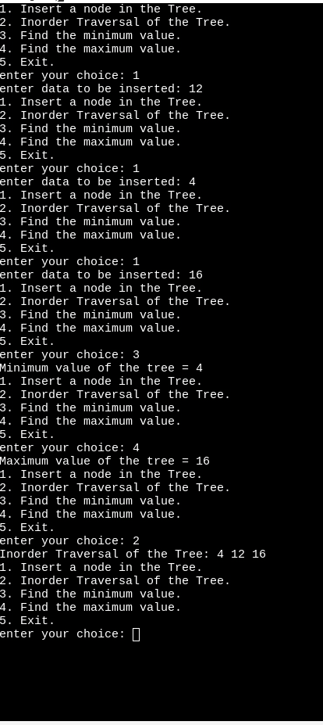

6.
#include <stdio.h>
#include <stdlib.h>

struct node {
int data;
struct node* left;
struct node* right;
};

struct node* create_node(int data) {
struct node* new_node = (struct node*)malloc(sizeof(struct node));
new_node->data = data;
new_node->left = NULL;
new_node->right = NULL;

return new_node;
}

void insert_node(struct node** root, int data) {
if (*root == NULL) {
*root = create_node(data);
return;
}

if (data < (*root)->data) {
insert_node(&((*root)->left), data);
} else {
insert_node(&((*root)->right), data);
}
}

void inorder(struct node* root) {
if (root == NULL) {
return;
}

inorder(root->left);
printf("%d ", root->data);
inorder(root->right);
}

int tree_height(struct node* root) {
if (root == NULL) {
return -1;
}

int left_height = tree_height(root->left);
int right_height = tree_height(root->right);

return (left_height > right_height) ? left_height + 1 : right_height + 1;
}

int main() {
struct node* root = NULL;

while (1) {
printf("1. Insert a node. \n");
printf("2. Inorder traversal. \n");
printf("3. Height of the tree. \n");
printf("4. Exit. \n");

int choice;
printf("enter your choice: ");
scanf("%d", &choice);

switch (choice) {
case 1:
printf("enter data to be inserted: ");
int data;
scanf("%d", &data);
insert_node(&root, data);
break;

case 2:
printf("Inorder Traversal of the Tree: ");
inorder(root);
printf("\n");
break;

case 3:
{
int height = tree_height(root);
printf("The height of the tree = %d\n", height);
}
break;

case 4:
exit(0);
break;

default:
printf("enter a valid choice !!!\n");
break;
}
}
return 0;
}

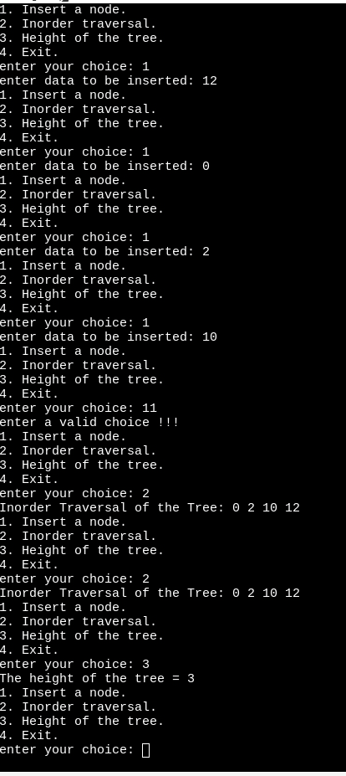

7.
#include <stdio.h>
#include <stdlib.h>

struct node {
int data;
struct node* left;
struct node* right;
};

struct node* create_node(int data) {
struct node* new_node = (struct node*)malloc(sizeof(struct node));
new_node->data = data;
new_node->left = NULL;
new_node->right = NULL;
return new_node;
}

void insert_node(struct node** root, int data) {
if (*root == NULL) {
*root = create_node(data);
return;
}

if (data < (*root)->data) {
insert_node(&((*root)->left), data);
} else {
insert_node(&((*root)->right), data);
}
}

void inorder(struct node* root) {
if (root == NULL) {
return;
}

inorder(root->left);
printf("%d ", root->data);
inorder(root->right);
}

void reverse_inorder(struct node* root, int k, int* count, int* result) {
if (root == NULL) {
return;
}

reverse_inorder(root->right, k, count, result);

(*count)++;
if (*count == k) {
*result = root->data;
return;
}

reverse_inorder(root->left, k, count, result);
}

int find_kth_largeval(struct node* root, int k) {
int count = 0;
int result = -1; // This will hold the kth largest value

reverse_inorder(root, k, &count, &result);

return result;
}

int main() {
struct node* root = NULL;

while (1) {
printf("1. Insert a node.\n");
printf("2. Inorder traversal.\n");
printf("3. Find the kth largest value. \n");
printf("4. Exit.\n");

int choice;
printf("Enter your choice: ");
scanf("%d", &choice);

switch (choice) {
case 1:
printf("Enter the data to be inserted: ");
int data;
scanf("%d", &data);
insert_node(&root, data);
break;

case 2:
printf("Inorder Traversal of the Tree: ");
inorder(root);
printf("\n");
break;

case 3:
{
int k;
printf("Enter the value of k: ");
scanf("%d", &k);
int kth_largest = find_kth_largeval(root, k);
printf("The %dth largest value in the tree: %d\n", k, kth_largest);
}
break;

case 4:
exit(0);
break;

default:
printf("Invalid choice. \n");
break;
}
}

return 0;
}
