22AIE112 DATA STRUCTURES AND ALGORITHMS
LABSHEET 6
QUEUE
Date : 23/7/23 Roll No : AM.EN.U4AIE2209

1.Design a menu driven program to implement a queue using a dynamic array. Include the options for enqueue, dequeue and display operations

#include <stdio.h>
#include <stdlib.h>

#define MAX_SIZE 100

int* createQueue() {
int* queue = (int*)malloc(MAX_SIZE * sizeof(int));
return queue;
}

int isFull(int front, int rear) {
return ((rear + 1) % MAX_SIZE == front);
}

int isEmpty(int front, int rear) {
return (front == -1);
}

void enqueue(int* queue, int* front, int* rear, int data) {
if (isFull(*front, *rear)) {
printf("Queue is full. Enqueue operation not possible\n");
return;
}

if (*front == -1)
*front = 0;

*rear = (*rear + 1) % MAX_SIZE;
queue[*rear] = data;

printf("Enqueued element: %d\n", data);
}

int dequeue(int* queue, int* front, int* rear) {
if (isEmpty(*front, *rear)) {
printf("Queue is empty \n");
return -1;
}

int data = queue[*front];
if (*front == *rear)
*front = *rear = -1;
else
*front = (*front + 1) % MAX_SIZE;

printf("Dequeued element: %d\n", data);
return data;
}

void display(int* queue, int front, int rear) {
if (isEmpty(front, rear)) {
printf("Queue is empty.\n");
return;
}

printf("Queue elements: ");
int i = front;
while (i != rear) {
printf("%d ", queue[i]);
i = (i + 1) % MAX_SIZE;
}
printf("%d\n", queue[rear]);
}

void destroyQueue(int* queue) {
free(queue);
}

int main() {
int* queue = createQueue();
int front = -1;
int rear = -1;
int opCode, data;

while (1) {
printf("\nChoose the queue operation:\n");
printf("1. Enqueue\n");
printf("2. Dequeue\n");
printf("3. Display\n");
printf("4. Exit\n");
printf("Enter your opCode: ");
scanf("%d", &opCode);

switch (opCode) {
case 1:
printf("Enter the element to enqueue: ");
scanf("%d", &data);
enqueue(queue, &front, &rear, data);
break;
case 2:
dequeue(queue, &front, &rear);
break;
case 3:
display(queue, front, rear);
break;
case 4:
destroyQueue(queue);
printf("Exiting....\n");
return 0;
default:
printf("Invalid Op code\n");
}
}

return 0;
}

Output
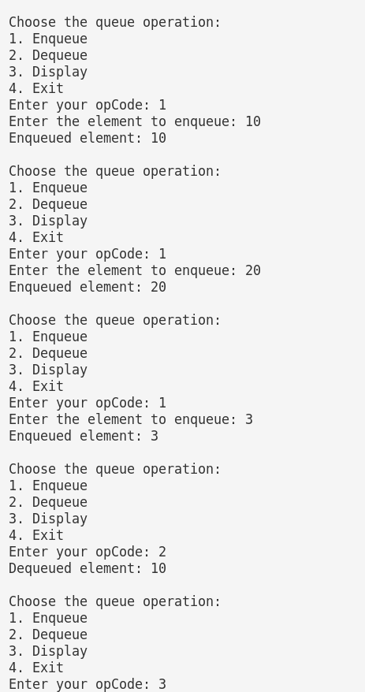

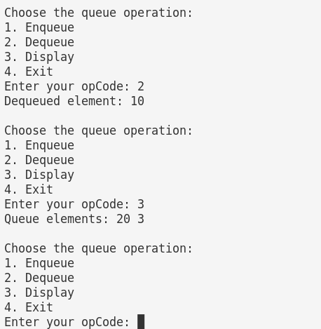

2.Design a menu driven program to implement a circular queue using a dynamic array. Include the options for enqueue, dequeue and display operations

#include <stdio.h>
#include <stdlib.h>

#define MAX_SIZE 100

int* createQueue(int maxSize) {
int* queue = (int*)malloc(maxSize * sizeof(int));
return queue;
}

int isFull(int front, int rear, int size) {
return ((rear + 1) % size == front);
}

int isEmpty(int front, int rear) {
return (front == -1);
}

void enqueue(int* queue, int* front, int* rear, int size, int data) {
if (isFull(*front, *rear, size)) {
printf("Queue is full. Cannot enqueue.\n");
return;
}

if (isEmpty(*front, *rear))
*front = 0;

*rear = (*rear + 1) % size;
queue[*rear] = data;

printf("Enqueued element: %d\n", data);
}

int dequeue(int* queue, int* front, int* rear, int size) {
if (isEmpty(*front, *rear)) {
printf("Queue is empty. Cannot dequeue.\n");
return -1;
}

int data = queue[*front];

if (*front == *rear)
*front = *rear = -1;
else
*front = (*front + 1) % size;

printf("Dequeued element: %d\n", data);
return data;
}

void display(int* queue, int front, int rear, int size) {
if (isEmpty(front, rear)) {
printf("Queue is empty.\n");
return;
}

printf("Queue elements: ");
int i = front;
do {
printf("%d ", queue[i]);
i = (i + 1) % size;
} while (i != (rear + 1) % size);
printf("\n");
}

void destroyQueue(int* queue) {
free(queue);
}

int main() {
int maxSize, choice, data;
int* queue;
int front = -1;
int rear = -1;

printf("Enter the maximum size of the queue: ");
scanf("%d", &maxSize);
queue = createQueue(maxSize);

while (1) {
printf("\nChoose the queue Operation\n");
printf("1. Enqueue\n");
printf("2. Dequeue\n");
printf("3. Display\n");
printf("4. Exit\n");
printf("Enter your choice: ");
scanf("%d", &choice);

switch (choice) {
case 1:
printf("Enter the element to enqueue: ");
scanf("%d", &data);
enqueue(queue, &front, &rear, maxSize, data);
break;
case 2:
dequeue(queue, &front, &rear, maxSize);
break;
case 3:
display(queue, front, rear, maxSize);
break;
case 4:
destroyQueue(queue);
printf("Exit..\n");
return 0;
default:
printf("Invalid choice!!\n");
}
}

return 0;
}

Output
