Lab Sheet 1

Name: Aniketh Vijesh
Roll No: AM.EN.U4AIE22009

Output for Publisher Subscriber

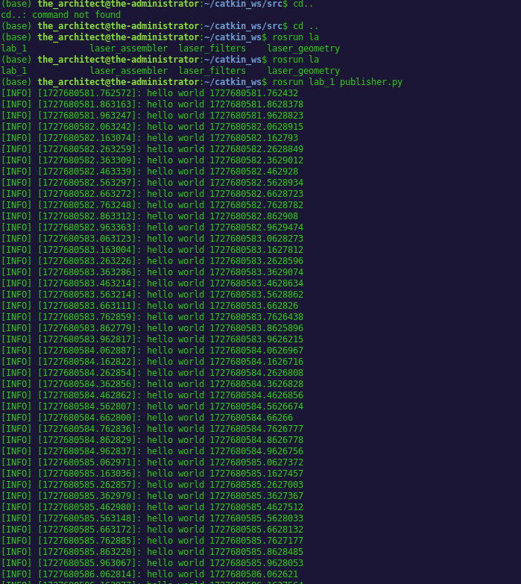

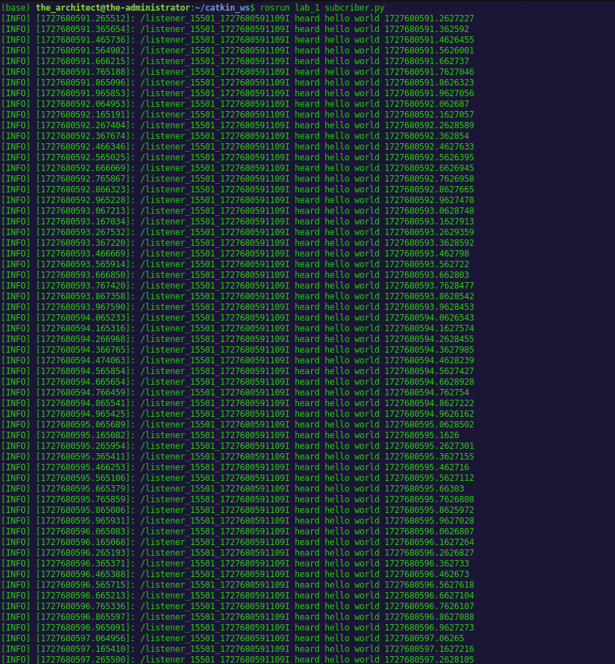

● Create a package called assignment_1 with dependencies rospy in your catkin
workspace
Your Code:

Making Package and installing the needed dependency

cd ~/catkin_ws/src
catkin_create_pkg assignment_1 rospy

Building worksapce
cd ~/catkin_ws
catkin_make

Sourcing the workspace
source devel/setup.bash

● In the source folder of your package assignment_1 create a publisher python file
move_circle.py which makes the turtlesim to execute a single circular(approximate)
trajectory.
Your Code:

#!/usr/bin/env python

import rospy
from geometry_msgs.msg import Twist

def move_circle():
# Initialize the node
rospy.init_node('move_circle', anonymous=True)

# Create a publisher for the turtle's velocity
velocity_publisher = rospy.Publisher('/turtle1/cmd_vel', Twist, queue_size=10)

# Set a loop rate
rate = rospy.Rate(10)

# Create a Twist message to control the turtle's velocity
vel_msg = Twist()

# Set linear and angular velocity to make a circular motion
vel_msg.linear.x = 1.0 # Constant forward speed
vel_msg.angular.z = 1.0 # Constant turning speed

rospy.loginfo("Moving the turtle in a circle")

# Keep publishing the velocity command until the node is stopped
while not rospy.is_shutdown():
velocity_publisher.publish(vel_msg)
rate.sleep()

if __name__ == '__main__':
try:
move_circle()
except rospy.ROSInterruptException:
pass

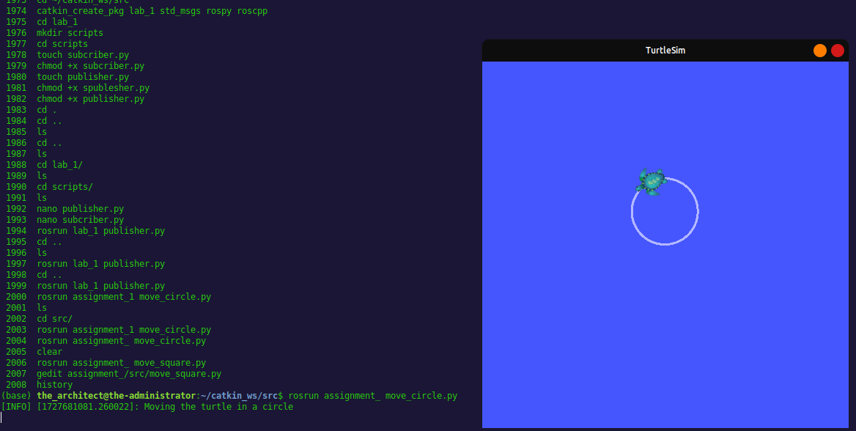
● In the source folder of your package assignment_1 create a publisher python file
move_square.py which makes the turtlesim to execute a single square(approximate)
trajectory.
Your Code:

#!/usr/bin/env python

import rospy
from geometry_msgs.msg import Twist
import time

def move_square():
# Initialize the node
rospy.init_node('move_square', anonymous=True)

# Create a publisher for the turtle's velocity
velocity_publisher = rospy.Publisher('/turtle1/cmd_vel', Twist, queue_size=10)

# Set a rate for the loop
rate = rospy.Rate(1)

# Create a Twist message to control the turtle's velocity
vel_msg = Twist()

# Function to move forward
def move_forward():
vel_msg.linear.x = 2.0 # Move forward with a constant speed
vel_msg.angular.z = 0.0
velocity_publisher.publish(vel_msg)
rate.sleep()

# Function to turn the turtle
def turn():
vel_msg.linear.x = 0.0 # Stop moving forward
vel_msg.angular.z = 1.57 # Turn 90 degrees
velocity_publisher.publish(vel_msg)
rate.sleep()

rospy.loginfo("Moving the turtle in a square")

for _ in range(4): # Move the turtle in a square (4 sides)
move_forward()
time.sleep(2) # Move for 2 seconds
turn()
time.sleep(1) # Turn for 1 second

# Stop the turtle after the loop
vel_msg.linear.x = 0.0
vel_msg.angular.z = 0.0
velocity_publisher.publish(vel_msg)

if __name__ == '__main__':
try:
move_square()
except rospy.ROSInterruptException:
pass

