22AIE303 Lab Sheet 3

Name : Aniketh Vijesh

Roll No : AM.EN.U4AIE22009

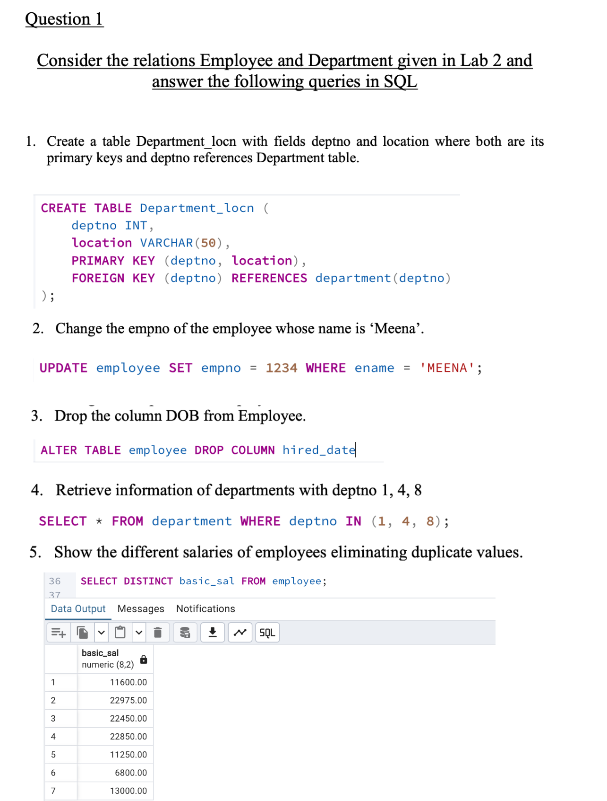
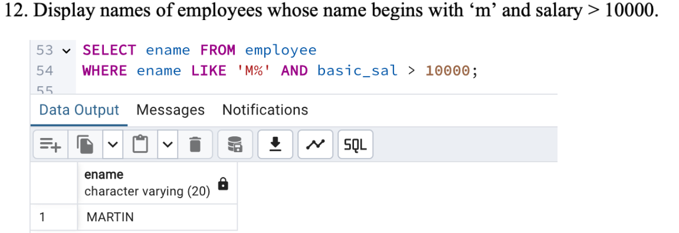
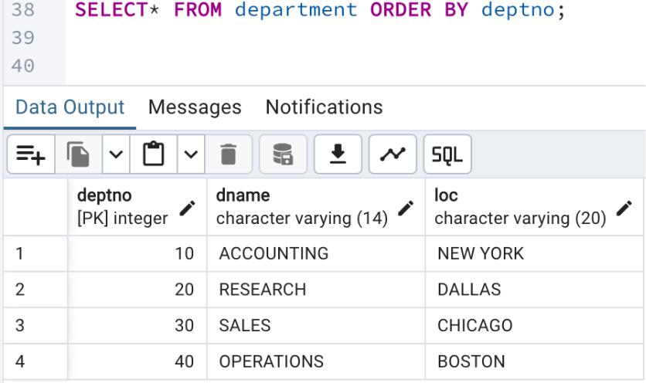
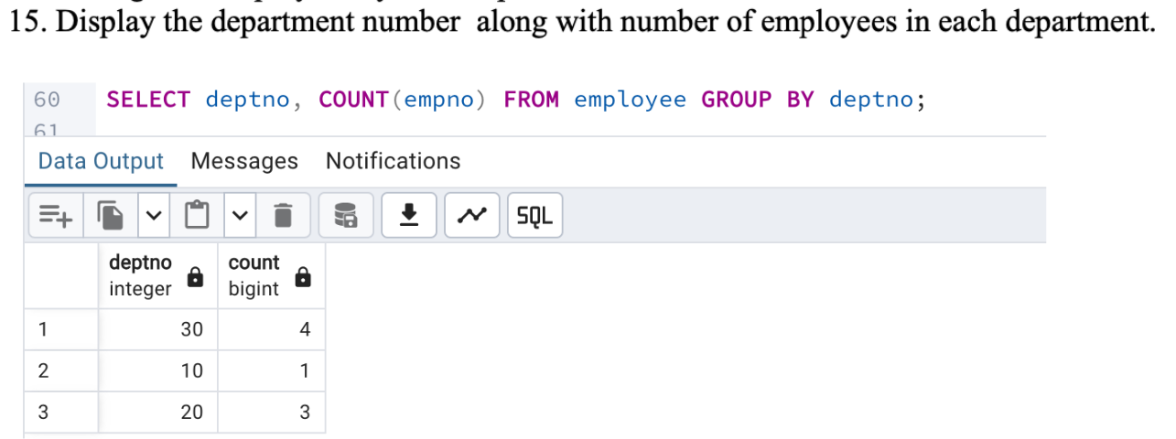
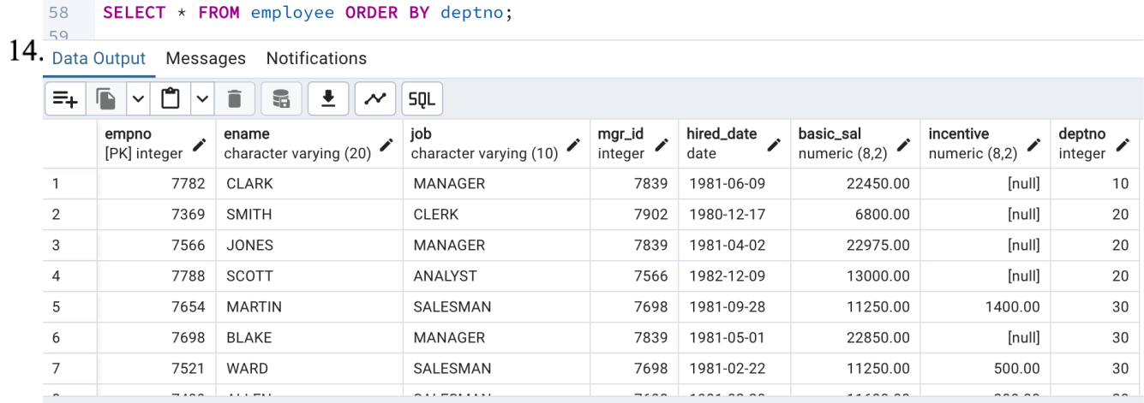
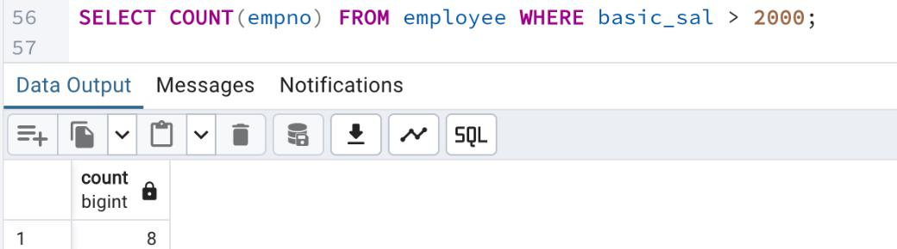
QUESTION 2 PART 1

Consider the following relations

Customer(cno,cname,ctype)

Cust_FD(cno,fd_no,fd_amt,int_rate)

Cust_Loan(cno,ln_no,ln_type,ln_amt)
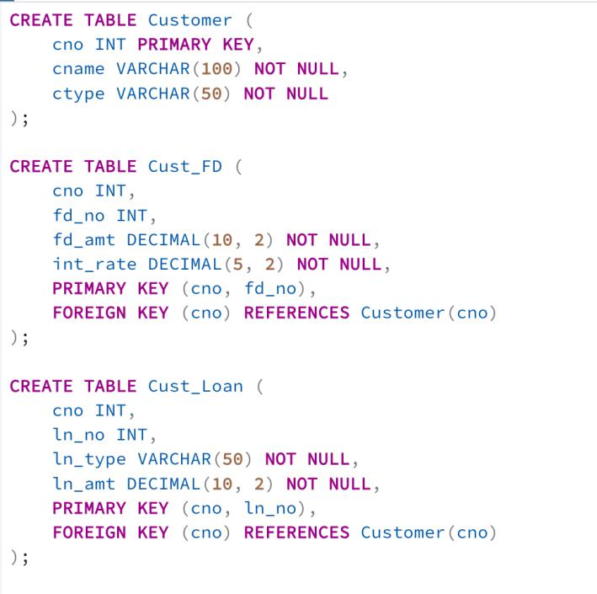

1) List the cno of those customers who have both loan and FD at bank
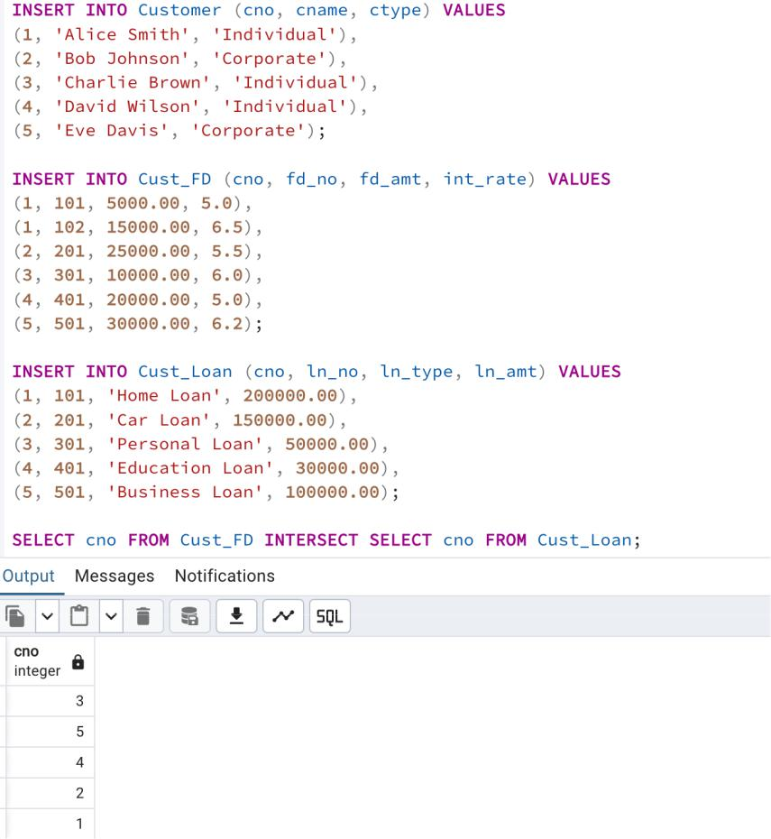
2) List the cno of customers who have either a loan or an FD
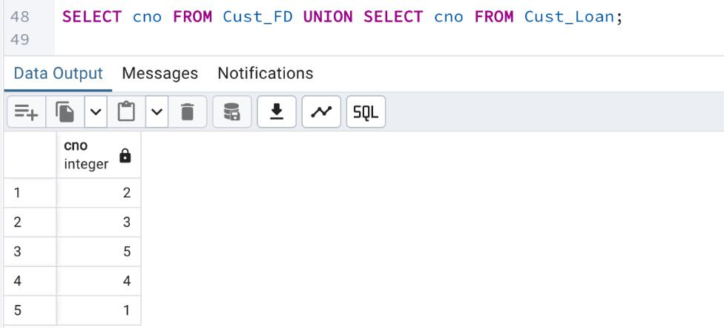

3) List those customers who have an FD but not a loan
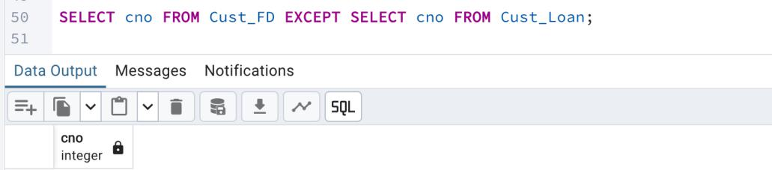

PART 2

Emp_Details(eno,ename,sal,br_no)

Account(ac_no,cno,veri_emp_no,ac_type)
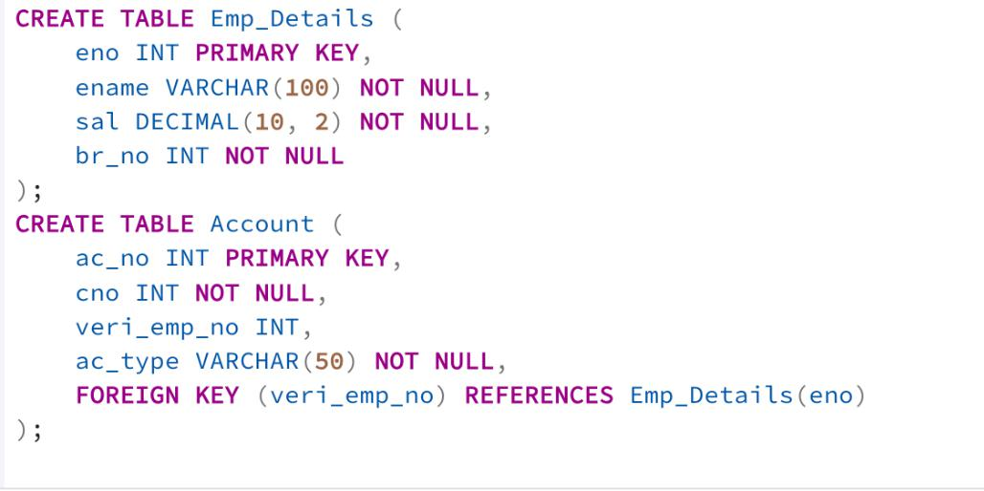
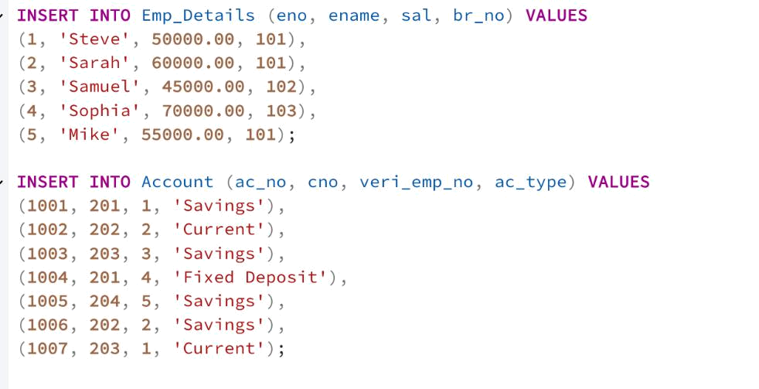

1) Find the number of employees in each branch
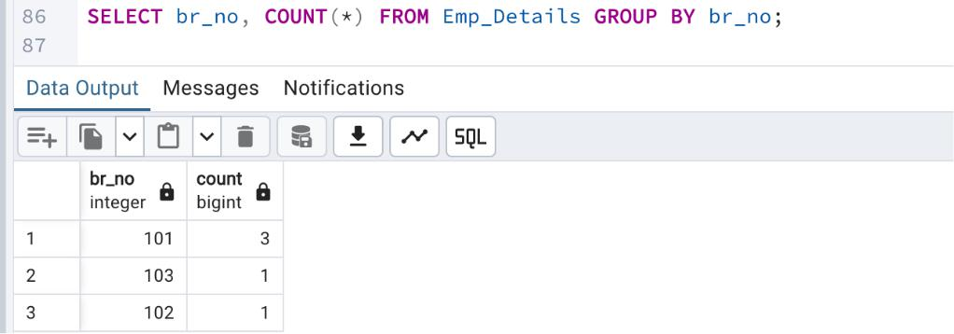

2) Find the total no: of accounts verified by each employee
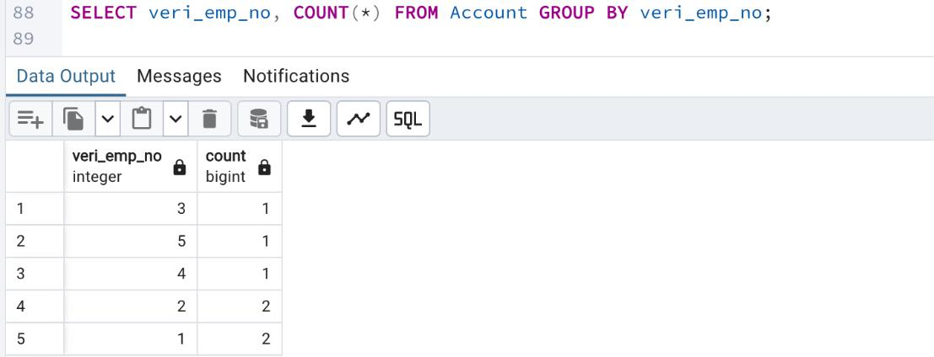

3) Find the total no: of accounts of ac_type savings
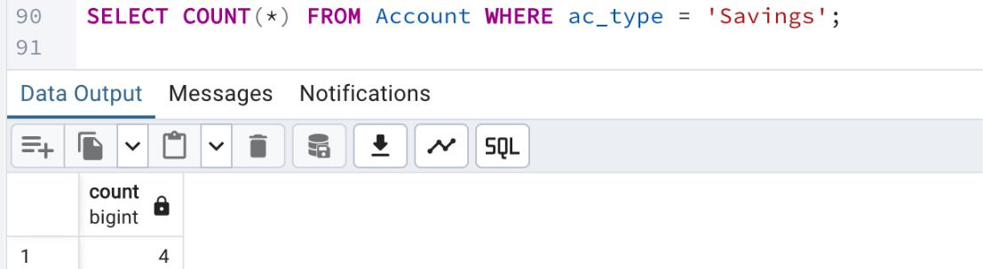
4) Find the customers having more than one account
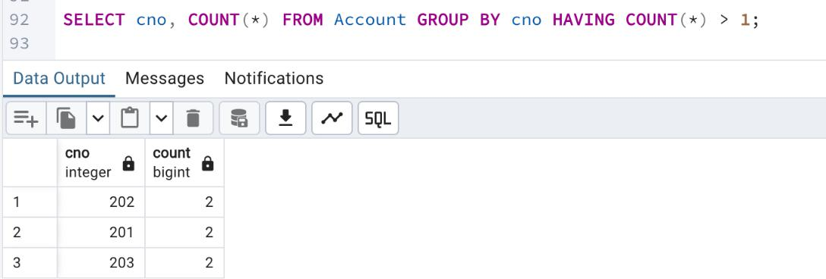

5) List the customers in ascending order of their name
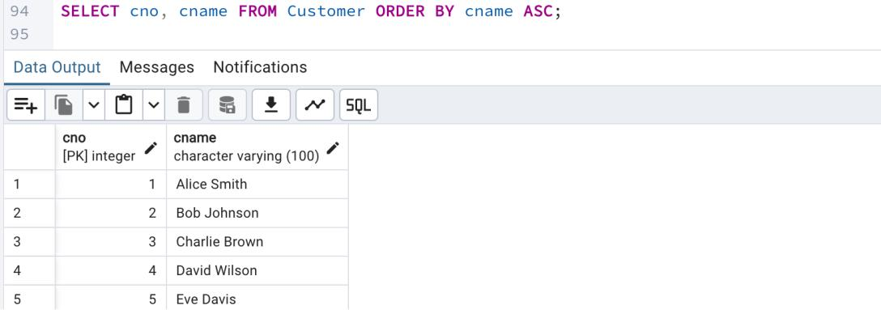

6) List those employees whose name starts with letter "S" and ends with letter "E"
