Relations Function

# V1.0.1

**Overview**

**Release Date: 5/5/2021**



The Relations function is meant to provide the ability to allow parent/child relations levels within Resilient to link incidents “manually”. This function allows users sync notes from child to parent and vice versa, close all child incidents under a parent, and update the parent when the status of the child changes.

This document outlines the functionality of function as it relates to Resilient.

# Installation

# Integration

# 

# Required Permissions

# 

|  |  |
| --- | --- |
| **Name** | **Permissions** |
| **Org Data** | Read |
| **Function** | Read |
| **All Incidents** | Read |
| **All Incidents Status** | Edit |
| **All Incidents Fields** | Edit |
| **All Incidents Notes** | Edit |

To install the function run the following commands to update the Resilient Environment:

* sudo pip install --upgrade pip
* sudo pip install --upgrade setuptools
* sudo pip install --upgrade resilient-circuits

Then run the following command to install the function:

* sudo pip install --upgrade fn\_relations-1.0.0.tar.gz

To configure this newly installed function run the following commands per the instructions:

**New environment:**

* resilient-circuits config –c

**Existing environment:**

* resilient-circuits config –u –l fn-relations

There is nothing needed in app.config document as of version 1.0.0. Therefore, finish by customizing Resilient for the relations function.

* resilient-circuits customize –y –l fn-relations

Run resilient-circuits or restart the service.

* resilient-circuits run
* systemctl restart resilient\_circuits

# AppHost

To install the App: open Resilient, navigating to the Administration page, Apps tab and select Install:

* sudo pip install open Resilient, navigating to the Administration page and Apps tab
* select Install, uploading the zip file for fn\_relations, and following the steps to install
* Choose the AppHost server to deploy the app
* Select Deploy

# Release Notes

|  |  |  |
| --- | --- | --- |
| Version | Date | Notes |
| 1.0.0 | 07/2020 | Initial Release |
| 1.0.1 | 05/2021 | Add AppHost Support |

# Design Changes

# The design that is recommended to layout the new fields and data tables is following:

# If Relation Level is: Parent

# New Tab: Child Incidents

# - Add Relations Child Incidents data table

# Summary Section:

# - Add Relation Level

# C:\.python_envs\dev_resilient\fn_relations\doc\screenshots\Parent_Build.PNG

# If Relation Level is: Child

# Summary Section:

# - Add Relation Level

# - Parent ID

# C:\.python_envs\dev_resilient\fn_relations\doc\screenshots\Child_Build.PNG

# Function Descriptions

Once the function has been deployed, you can access use the functions within Resilient. The available functions are pictured below.

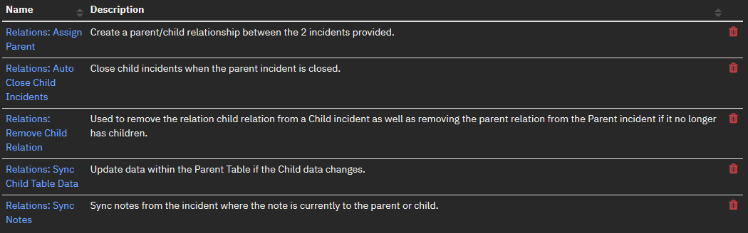

# Workflow Descriptions

The example workflows are meant to be used as a guide to understand how to properly use the function. The pre-process scripts are designed to be used out of the box and there is no need for post-process scripts as there will be no need to data manipulation after the function is complete.

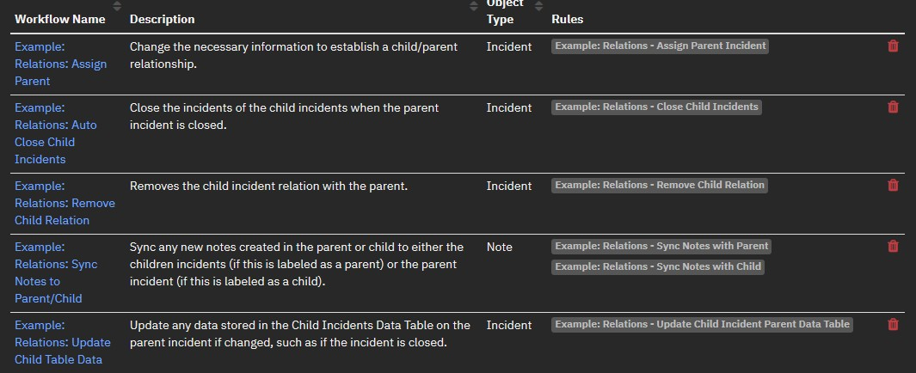

# Rule Descriptions

The rules are designed to be a guide as to how to setup your rules. They are setup as to only appear on simulation only to cut back on the clutter brought in on live incidents while testing and tweaking this function. If you want to make the example rules available, just remove the simulation requirement.

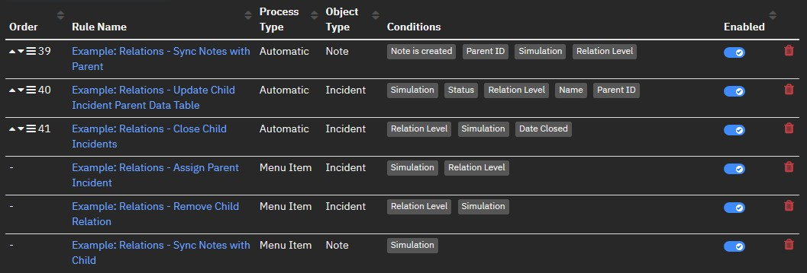

# Using the Function

Adding a Child to a parent.

Requirements:

Parent Incident must already be created and user need to know Parent Incident ID. And the incidents you are going to be turning into a child incident can’t have an active relation.

Instructions:

1. Either select the incident in the Incidents View of Resilient pictured below or go to the next step if you are already in a single incident.

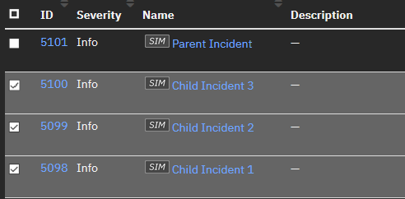

1. Select the Menu in the top right and select the “Example: Relations – Assign Parent Incident”.

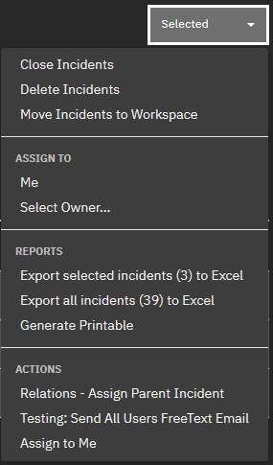

1. If multiple incidents were selected, it may ask if you are sure you want to apply it to all of the selected incidents. Select “OK”.

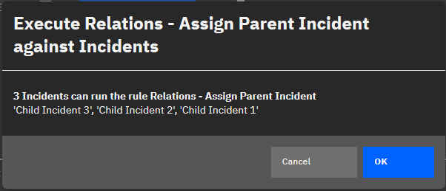

1. Enter in the Parent Incident ID

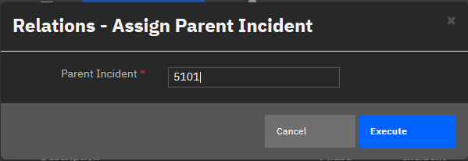

Results: The following things will be updated.

Child Incident:

Incident fields Relation Level is set to Child and Parent ID is added as a clickable field to open a new tab of the parent incident located in the summary section to the right within the incident.

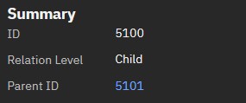

Artifact Related Parent Incident is added with the parent ID to correlate the incidents within the application.

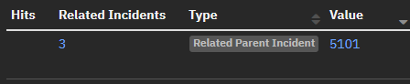

Parent Incident: \*If this is not already a parent.

Incident field Relation Level is set to Parent located in the summary section to the right within the incident.

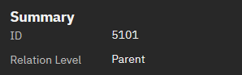

The same artifact above is created.

The incident is added to the Relations Child Incidents data table located in the new tab Child Incidents (the Incident ID of each incident is clickable).

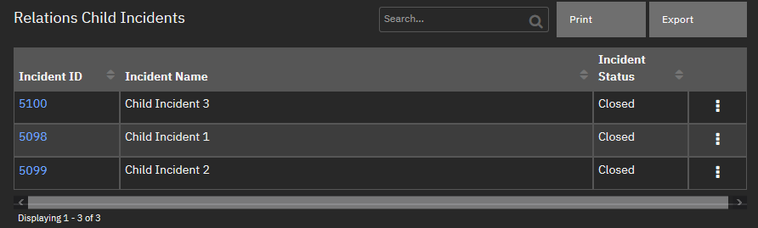

Any notes on the child are synced to the parent with the top 3 lines of the following note added to the beginning of any synced notes followed by the actual note.

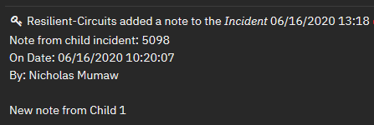

Removing a Child from a Parent: Requirements:

Incident must have a Relation Level of Child already.

Instructions:

1. Either select the incident in the Incidents View of Resilient pictured below or go to the next step if you are already in a single incident.



1. Select the Menu in the top right and select the “Example: Relations – Remove Child Relation”.

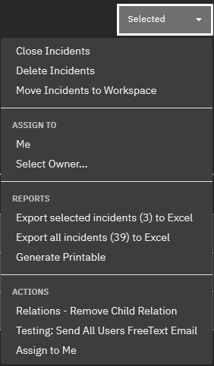

1. If multiple incidents were selected, it may ask if you are sure you want to apply it to all of the selected incidents. Select “OK”.



1. Choose if you want to remove the synced notes between this relationship.

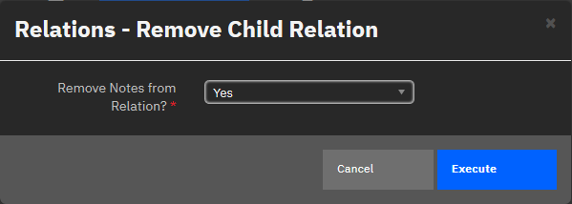

Results: The following things will be removed.

Child Incident:

Fields Relation Level and Parent ID values will be removed. Artifact Related Parent Incident will be removed.

If you selected to remove Notes, Any notes synced down from the parent will also be removed.

Parent Incident:

The child will be removed from the Relations Child Incidents data table.

If you selected to remove Notes, Any notes synced from the child to the parent will also be removed.

If that was the last child of the parent, the Artifact field Relation level, artifact Related Parent Incident, and Child Incidents Tab will be removed.

Syncing Notes from Child to Parent: Requirements:

The incident must have a Relation Level of Child.

Instructions:

1. All notes from the child are automatically synced with the parent.

Results:

Parent Incident:

Any notes on the child are synced to the parent with the top 3 lines of the following note added to the beginning of any synced notes followed by the actual note.



Syncing Notes from Parent to Child: Requirements:

The incident must have a Relation Level of Parent. The note must already have been added to the parent incident.

Instructions:

1. Within the parent Note tab, click the vertical ellipsis on the note you want to sync and select the “Example: Relations – Sync Notes with Child”.

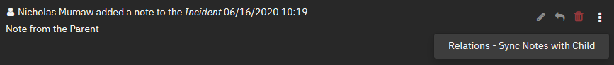

Results:

Children Incident:

Any note synced will sync with all the children with the top 3 lines of the following note added to the beginning followed by the actual note.

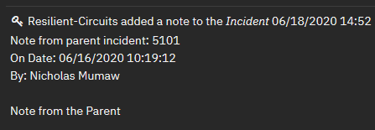

Notes:\*\*\* To prevent synced parent notes to be synced back to the parent put this condition into the rule.



Updating the child details in the Data Table of the Parent: Requirements:

The incident must have a Relation Level of Child.

Instructions:

1. If the Child Incident Name or Status is changed, the data table will be automatically updated.

Results:

Parent Incident:

The child will be updated in the Relations Child Incident data table.

Closing all child incidents from the Parent: Requirements:

The incident must have a Relation Level of Parent.

Instructions:

1. Select the Menu in the top right and select the “Close Incident”.

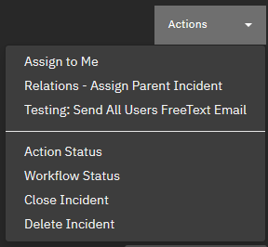

1. Confirm that you want to close this incident.

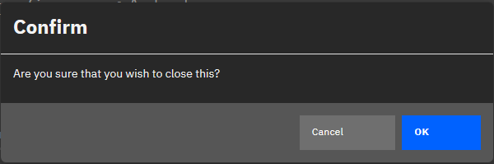

1. Fill out any fields required/desired and select “OK”.

Results:

Parent Incident:

The parent incident will be closed with the fields updated as you filled out in the form.

Child Incident:

The children will also be closed with the same field updates as the parent.

# Design of the Overall Function

Field(s) to Create: Relation Level: Select

Purpose: Determine the relation to other incidents. Options:

None Parent Child

Parent ID: Text Area (rich text)

Purpose: Show the Incident ID of the parent incident that is clickable to the parent case.

|  |  |
| --- | --- |
| Parent Incident: | Child Incident: |

 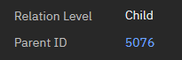

Data Table(s) to Create:

Data Table Name: Relations Child Incidents Rows:

Incident ID

Note: Clickable to the child case Incident Name

Incident Status

Parent Incident:

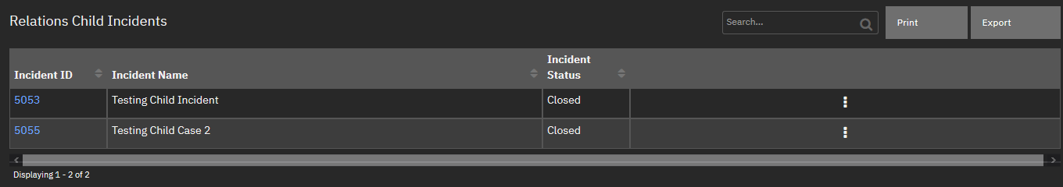

Artifact(s) to Create: Related Parent Incident

Purpose: Incident ID of the parent of all related incidents to create a relation within Resilient incidents manually.

|  |  |
| --- | --- |
| Table View: | Graph View: |

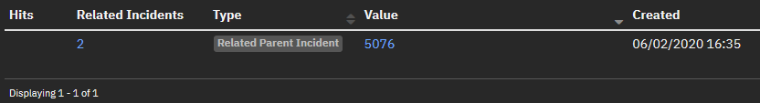 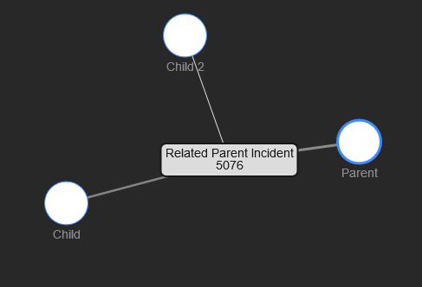

Message Destination(s) to Create: fn\_relations

Function(s) to Create: Relations: Assign Parent

Purpose: Create a parent/child relationship between the 2 incidents provided. Inputs: (\* designates required)

relations\_child\_incident\_id\*: Number relations\_parent\_incident\_id\*: Number

Relations: Sync Notes

Purpose: Sync notes from the incident where the note is currently to the parent or child. Inputs: (\* designates required)

relations\_note\_id\*: Number incident\_id\*: Number

Relations: Sync Child Table Data

Purpose: Update data within the Parent Table if the Child data changes. Inputs: (\* designates required)

relations\_child\_incident\_id\*: Number relations\_parent\_incident\_id\*: Number

Relations: Auto Close Child Incidents

Purpose: Close child incidents when the parent incident is closed. Inputs: (\*designates required)

relations\_parent\_incident\_id\*: Number Relations: Remove Child Relation

Purpose: Used to remove the child relations from a child incident as well as the parent relation if it is no longer a parent.

Inputs: (\*designates required) Relations\_child\_incident\_id\*: Number Relations\_remove\_notes: Boolean

Workflow(s) to Create:

Example: Relations: Assign Parent

Purpose: Change the necessary information to establish a child/parent relationship. Workflow Type: Incident

Example: Relations: Sync Notes to Parent/Child

Purpose: Sync any new notes created in the parent or child to either the children incidents (if this is labeled as a parent) or the parent incident (if this is labeled as a child).

Workflow Type: Note

Example: Relations: Update Child Table Data

Purpose: Update any data stored in the Child Incidents Data Table on the parent incident if changed, such as if the incident is closed.

Workflow Type: Incident Example: Relations: Auto Close Child Incidents

Purpose: Close the incidents of the child incidents when the parent incident is closed. Workflow Type: Incident

Example: Relations: Remove Child Relation

Purpose: Change the necessary information to remove the established child/parent relationship.

Workflow Type: Incident Rule(s) to Create:

Example: Relations - Assign Parent Incident Rule Deployment: Menu

Purpose: Allow the user to select which incident should be set as the parent incident and kick off the workflow to perform the necessary changes.

Rule Type: Incident Required Fields from user:

Parent Incident: Incident ID of the parent Workflow to Kickoff: Example: Relations: Assign Parent

Note(s): \*\*Incident will need to not be labeled as a child or parent already to ensure that it does not interfere with already established relationships.

Example: Relations – Sync Notes with Parent Rule Deployment: Automatic

Purpose: Automatically sync any new notes made on a child incident with a parent incident.

Rule Type: Note

Workflow to Kickoff: Example: Relations: Sync Notes to Parent/Child Example: Relations – Sync Notes with Child

Rule Deployment: Menu

Purpose: Allow a note from a parent incident to manually be synced down to the child incidents.

Rule Type: Note

Workflow to Kickoff: Example: Relations: Sync Notes to Parent/Child Notes(s): None

Example: Relations – Update Child Incident Parent Data Table Rule Deployment: Automatic

Purpose: Any changes in the data in the data table if changed will get automatically updated.

Rule Type: Incident

Workflow to Kickoff: Example Relations: Update Child Table Data

Note(s): \*\*If the incident is a child incident and has a parent id listed and if either the name or status of the incident is changed, this will kick off.

Example: Relations - Close Child Incidents Rule Deployment: Automatic

Purpose: If the parent incident is closed then close the child incidents automatically. Rule Type: Incident

Workflow to Kickoff: Example: Relations: Auto Close Child Incidents

Note(s): \*\*If the parent incident date closed has value, then it will close all child

incidents.

Example: Relations - Remove Child Relation Rule Deployment: Menu

Purpose: Allow the user to remove a child incidents parent relation to kick off the workflow to perform the necessary changes.

Rule Type: Incident Required Fields from user:

Remove Notes from Relation?: Boolean to give the user the option to remove synced notes.

Workflow to Kickoff: Example: Relations: Assign Parent Note(s): \*\*Incident will need to be labeled as a child already.

# Troubleshooting

Please feel free to reach out to me on the IBM Community or make a post in the community for any support.