THE DOCUMENT MAP
Every document in the project, its business role, and how they fit together — handbook companion chapter · IHPC · v1.0
In a professional environment, documents are not paperwork around the work — they are how an organization thinks. Each document type exists because a specific role needs a specific question answered. This chapter maps every document in our project to that business logic: who would own it in a real company, what question it answers, how often it changes, and which one wins when they disagree.
Keep this chapter with the org chart from the Real-World Structure chapter — they are two views of the same machine. That one shows the people; this one shows what the people write.

1. The Hierarchy at a Glance
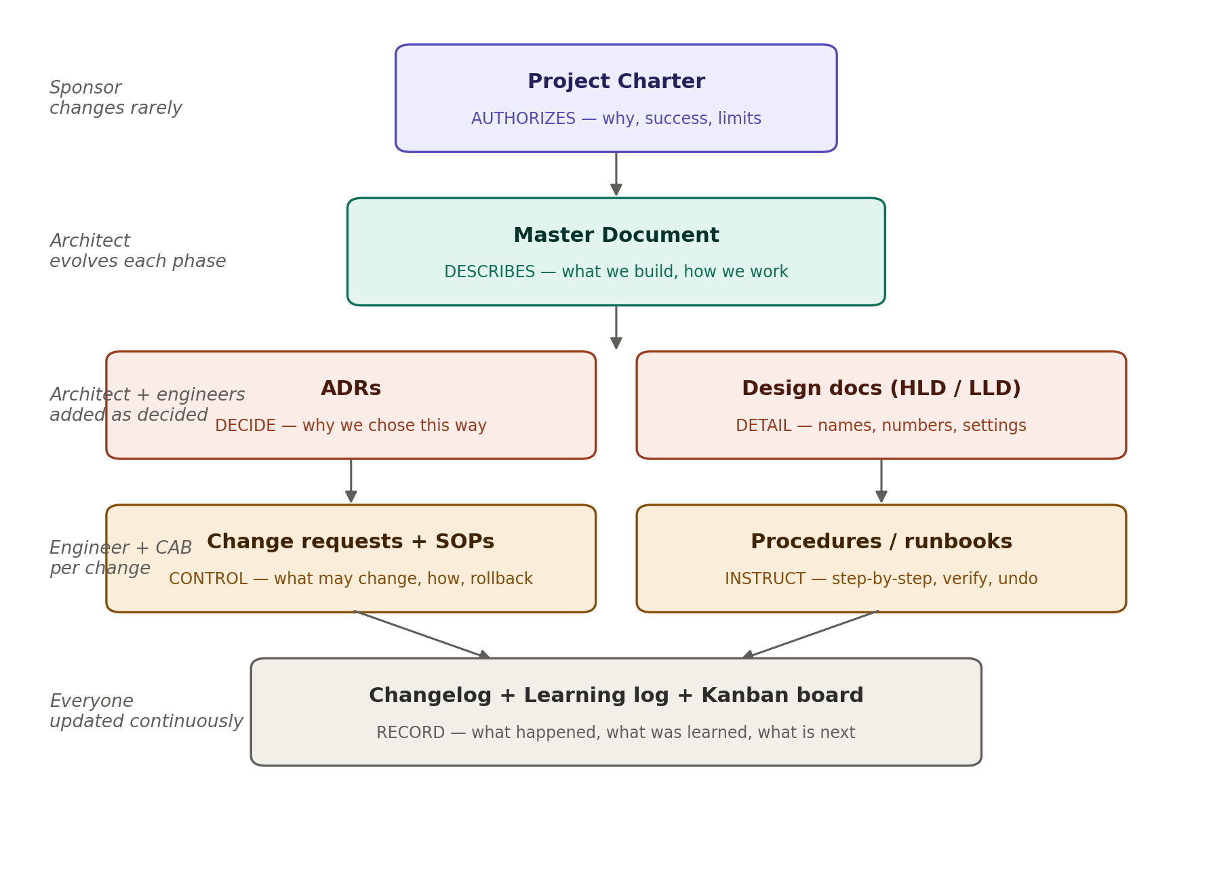
Read it top-down: each layer authorizes or informs the one beneath. The higher the document, the rarer it changes and the more authority it carries. The lower, the more often it is touched.

2. Document by Document

The permit: Project Charter
Aspect | Details
Business owner | The sponsor. In a company, changing it means going back to the steering committee.
Question it answers | Why does this project exist, and when are we done?
Contains | Problem, objective, success criteria, constraints, sponsor parameters (hourly rate, effort budget).
Change rhythm | Almost never. If the charter changes, the project itself has changed.
You need to know | It is the tripwire against scope creep. When tempted to add something fun (a Kubernetes cluster, say), the charter asks: does this serve the stated objective, or is it a new project wearing this one's clothes?

The blueprint binder: Master Document
Aspect | Details
Business owner | The solution architect, on behalf of the whole team.
Question it answers | What are we building, and how do we work?
Contains | The five domains, architecture (incl. the AD deep-dive), repo structure, workflow rules, phase roadmap.
Change rhythm | Continuously — every phase adds to it. Updating it is a recurring task, not a failure.
You need to know | When it conflicts with the charter, the charter wins. Work drifting outside what the charter authorizes is scope creep by definition.

The decision memory: ADRs
Aspect | Details
Business owner | The architect writes; the team consults forever after.
Question it answers | Why on earth did we choose it this way?
Contains | One decision per file: context, options considered, choice, consequences.
Change rhythm | Append-only. Old ADRs are never edited — a reversed decision gets a new ADR that supersedes the old.
You need to know | The trigger for writing one: any choice a future stranger could reasonably question. Hypervisor choice, segmentation model, ADFS vs modern auth — all ADR material.

The blueprints: design documents (HLD / LLD)
Aspect | Details
Business owner | Architect for the high-level design (HLD); domain engineers for the low-level design (LLD).
Question it answers | HLD: how do the pieces fit? LLD: exactly what names, numbers, addresses, settings?
Contains | HLD: zones, trust boundaries, domain layout. LLD: IP plans, VLAN IDs, naming conventions, GPO settings.
Change rhythm | Written per phase, before building. Reality and document must never disagree — if the build deviates, the document is updated.
You need to know | Big picture always precedes detail: no LLD before its HLD is settled. This ordering is what design review gates protect.

The safety system: change requests + SOPs
Aspect | Details
Business owner | The engineer raises a CR; the change manager / CAB approves. Our change-management SOP simulates that board.
Question it answers | What is about to change, what could go wrong, and how do we undo it?
Contains | CR: change, timing, risk rating, rollback plan, verification steps. SOP: the template + the rule for when a CR is required.
Change rhythm | A new CR per significant change; the SOP itself is stable.
You need to know | Skipping change management is how outages happen. In interviews, walking through a CR you filed against your own homelab is a story almost no other candidate can tell.

The recipes: procedures and runbooks
Aspect | Details
Business owner | Engineers write them; operations (the service desk — your old world) consumes them after handover.
Question it answers | How exactly is this deployed, verified, and rolled back — by someone who didn't build it?
Contains | Step-by-step deployment, validation checklist, rollback procedure — one trio per deployment.
Change rhythm | Written with each build task; corrected whenever a step proves wrong in practice.
You need to know | The quality test: could a stranger with your background execute it cold? You have read hundreds of bad runbooks in support — write the ones you wished you had received.

The running record: changelog, learning log, Kanban board
Aspect | Details
Business owner | Everyone — in our project, you in all your roles.
Question it answers | What happened, what did it cost, what was learned, what is next?
Contains | Changelog: one line per change + the monthly burn line (hours, kronor). Learning log: per-task reflections — interview gold. Board: live state of all work, Est/Act per card.
Change rhythm | Continuously; these documents only have value if maintained as you go, never reconstructed.
You need to know | The board is the only file edited directly on main. The learning log quietly becomes your personal estimation database and interview story bank.

The front door: README
Aspect | Details
Business owner | The PM — it speaks for the project to outsiders.
Question it answers | What is this repo, in ten lines, to a visitor who knows nothing?
Contains | Purpose, one-paragraph scope, pointer to the master document and handbook, note that it supersedes the old repo.
Change rhythm | Occasionally; polish it before making the repo public.
You need to know | Recruiters land here first. It is the single highest-traffic page of your portfolio.

3. The Same Map, Seen by Role
Flip the perspective: each business role produces some documents and consumes others. When you sit down to write, knowing which hat you are wearing tells you which voice to write in.

Role (your hat) | Produces | Consumes
Sponsor | Charter, business case | Changelog burn lines, phase-gate results
Project manager | Kanban board, README, status/burn reports | Everything — the PM reads it all
Solution architect | Master document, HLD, ADRs | Charter (the limits), current-state assessments
Domain engineer | LLD, CRs, procedures, configs | HLD, ADRs, doc standard, change SOP
CAB / change manager | CR approvals (in our project: your own review discipline) | CRs, rollback plans
Quality / audit | Review notes against acceptance criteria | Doc standard, acceptance criteria, the deliverables themselves
Operations (handover) | Feedback, incident reports | Runbooks, procedures, monitoring docs

4. Which Stage Produces Which Document
Third and last perspective: the seven-stage task lifecycle from the handbook, with the paper each stage leaves behind. Nothing in the lifecycle is invisible — every stage produces a trace.

Lifecycle stage | Document it produces
1. Intake | One-paragraph justification on the task's card/note (Backlog)
2. Requirements | Requirements list in the task note; card gains its 'done when' criteria (Ready)
3. Design | HLD/LLD contribution, possibly an ADR
4. Change request | A filled CR from the SOP template
5. Build | The deliverable itself + config files, on the task branch
6. Verify | Checked acceptance criteria recorded in the task note (Review)
7. Handover | Merge, changelog line, learning-log entry, board update (Done)

5. When Documents Disagree
Conflicts happen — a design doc says one thing, reality another; print says one thing, the repo another. The precedence rules, once and for all:

Rule | Meaning
Repo beats print | The printed companions teach method; the repo records truth. Paper never overrules a versioned file.
Charter beats master document | Work outside the charter's limits is scope creep, however elegant.
Newer beats older | Within the repo, the latest merged version is the truth — that is what version control is for.
Reality beats documents — briefly | If the build deviates from the design, reality wins for the moment, and the document must be updated immediately. A document that disagrees with reality is worse than no document.
Decisions require an ADR to die | An agreed decision stands until a new ADR supersedes it. No silent reversals.

The one-sentence summary
The charter authorizes, the master document describes, ADRs remember, designs specify, CRs control, procedures instruct, and the logs record — and every one of them exists because some role, someday, needs its question answered without asking you.

